

**0113 258 1150**

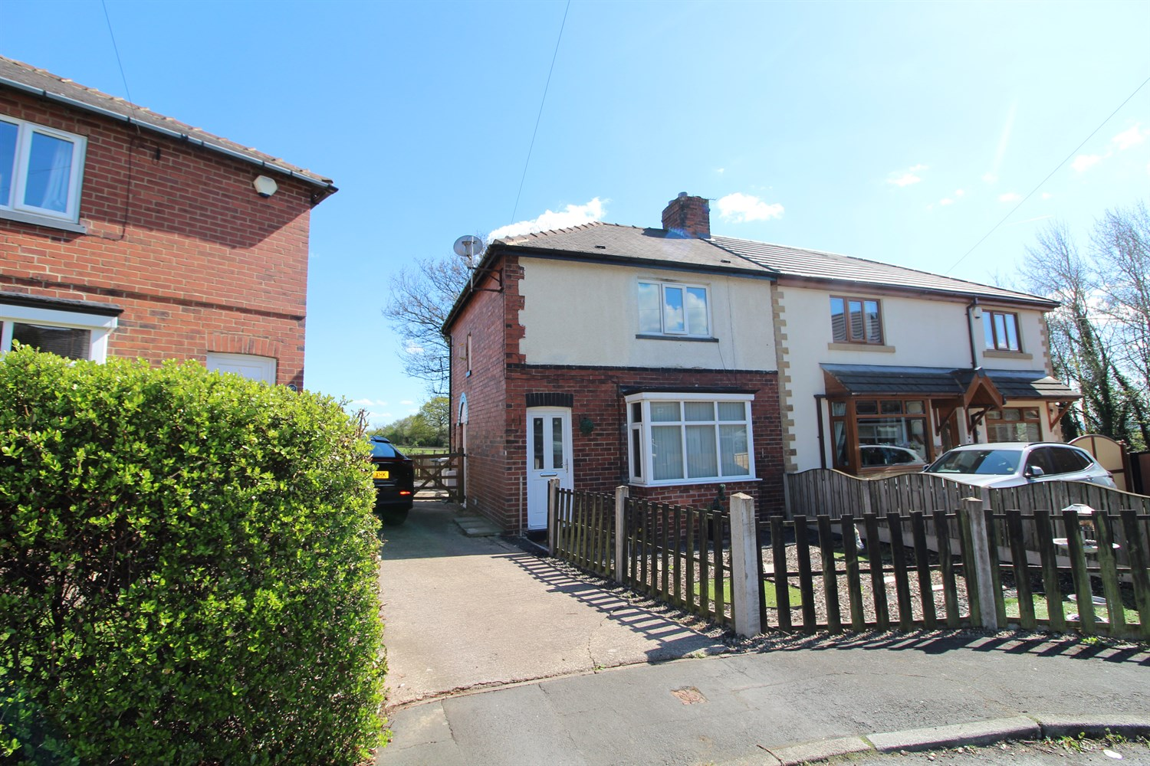



**For Sale £139,950.00**

**Sunnyfield, WF3**

**TWO DOUBLE BEDROOM SEMI-DETACHED HOUSE - VIEWS OVER OPEN FIELDS - NO CHAIN - IN NEED OF UPDATING** Adair Paxton are pleased to offer to the market this two bedroom semi-detached house situated in a quiet cul-de-sac location. The property is now in need a refurbishment and briefly comprises; Hallway, lounge, kitchen, utility/store cupboard and guest WC to the ground floor. To the first floor there are two bedrooms and a house bathroom. Externally, the property has a garden to the front and a shared driveway to the side. To the rear of the property is an enclosed garden overlooking open fields.

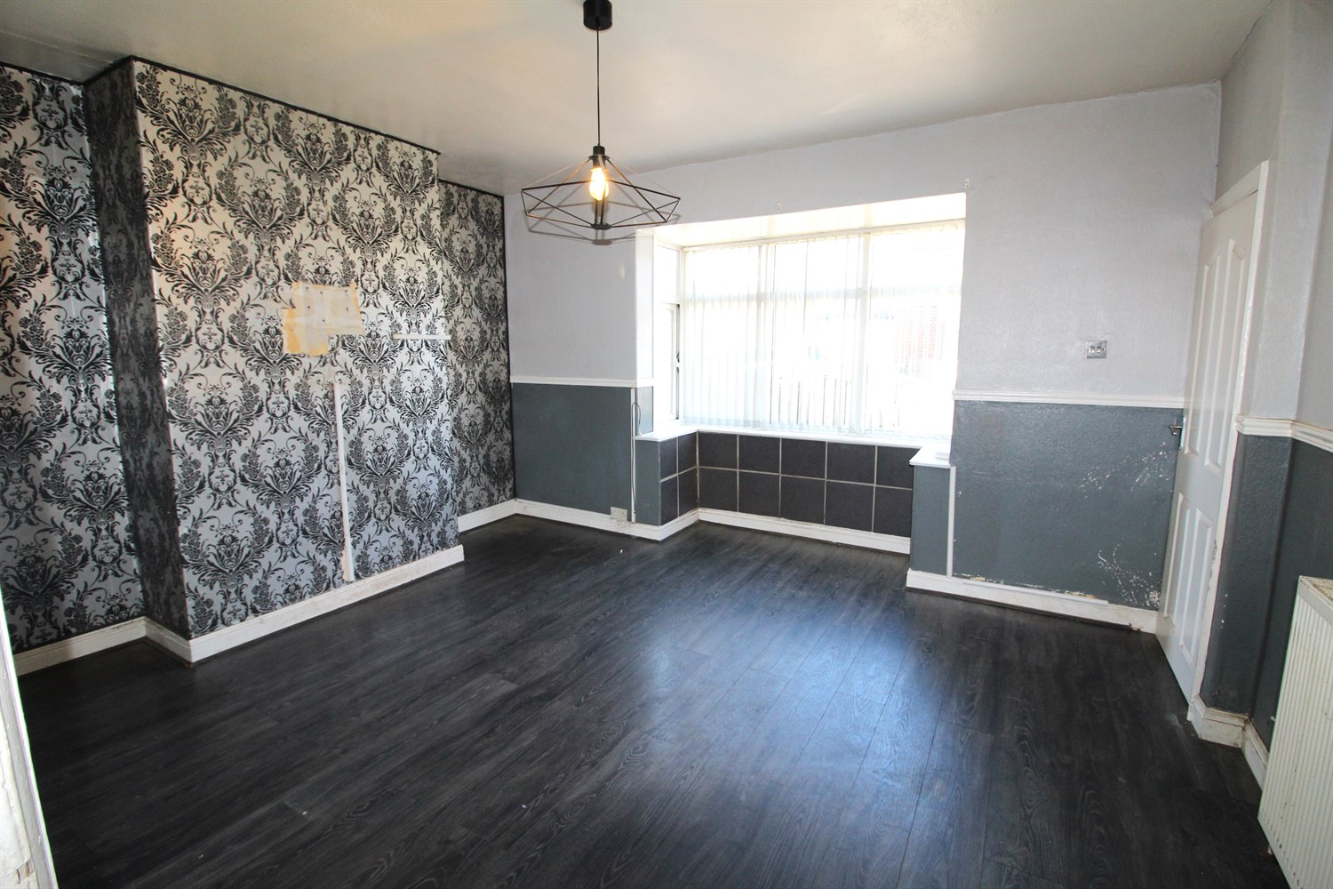

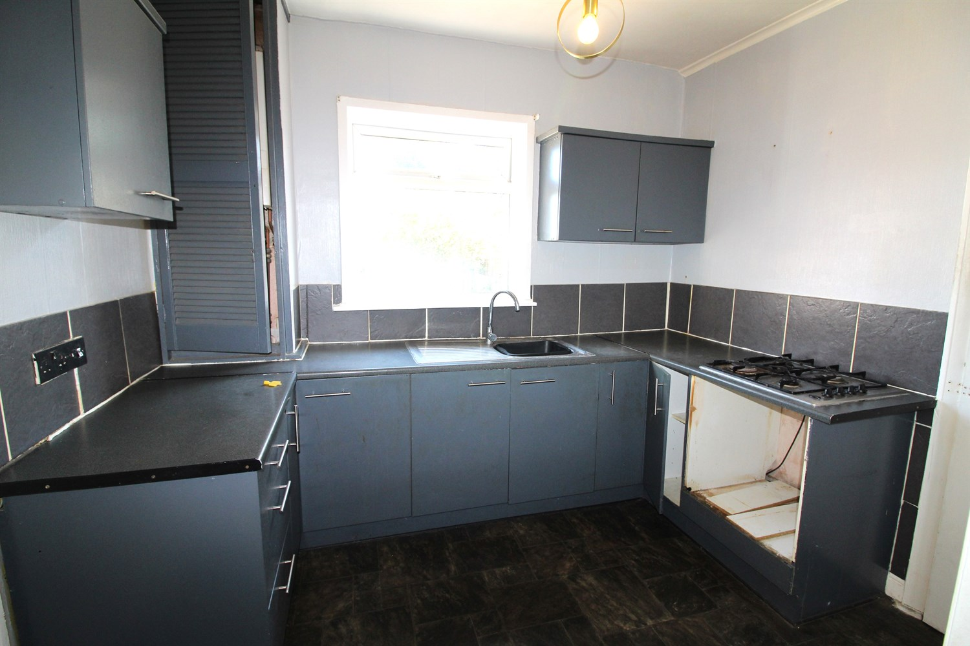

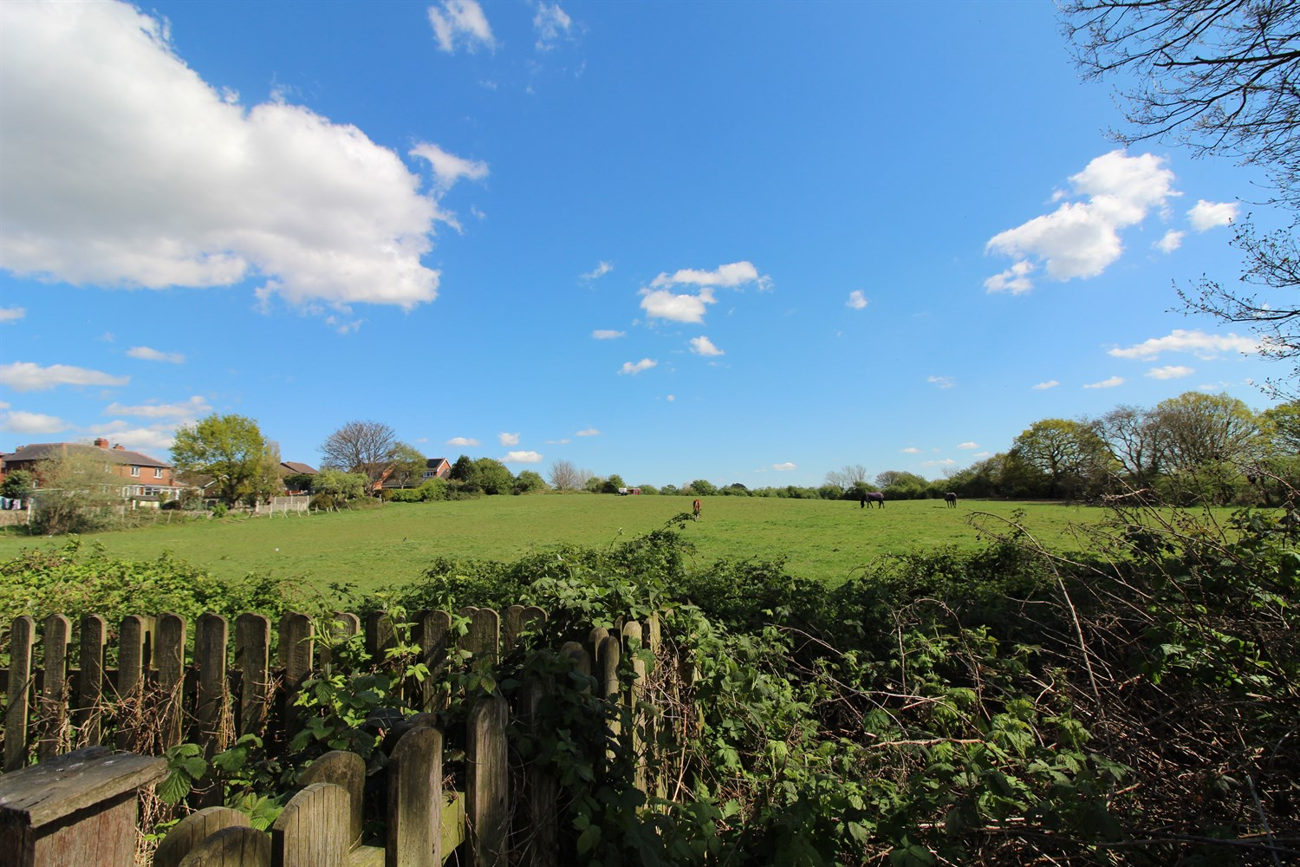

1 Bathroom(s)

1 Reception(s)

2 Bedroom(s)

00

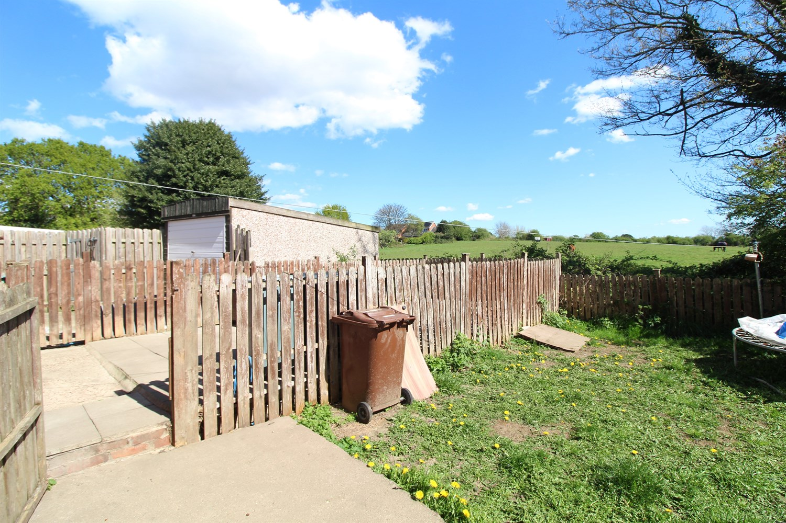

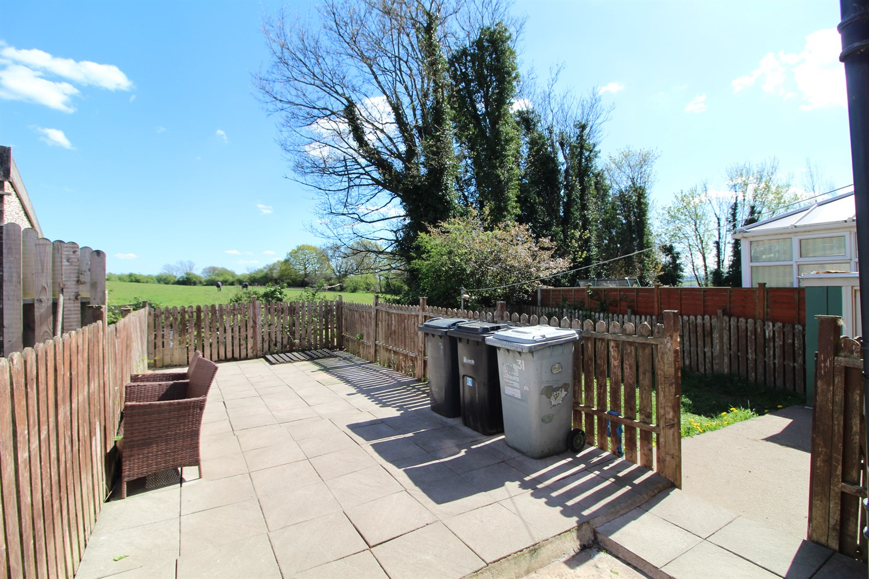

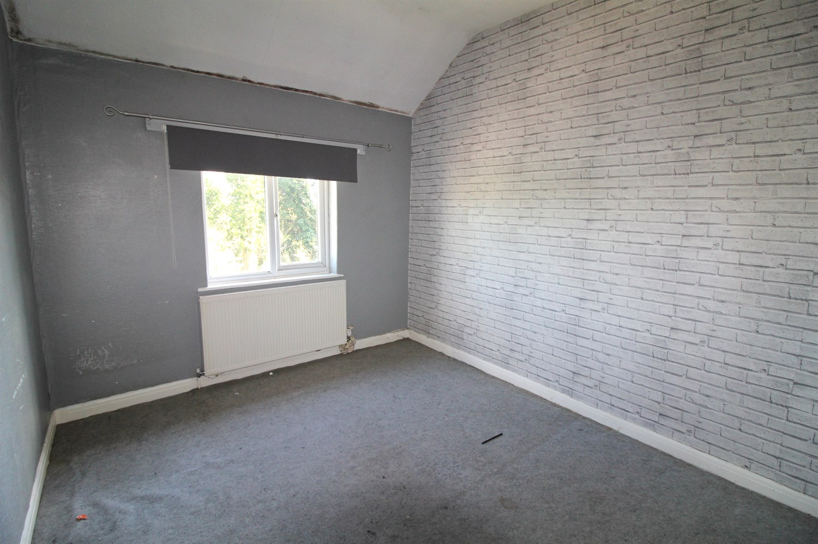

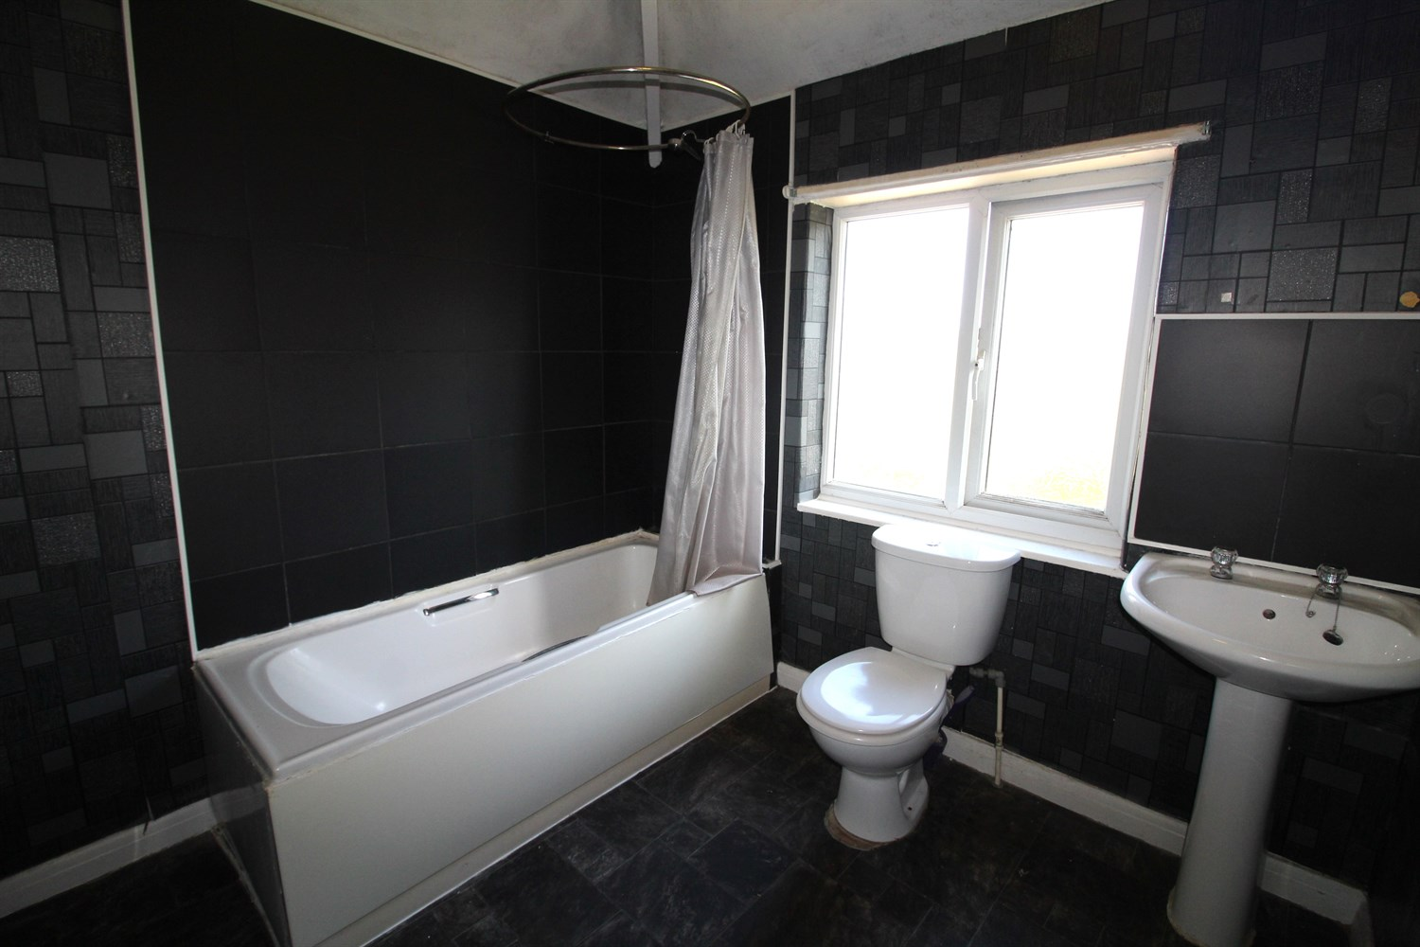

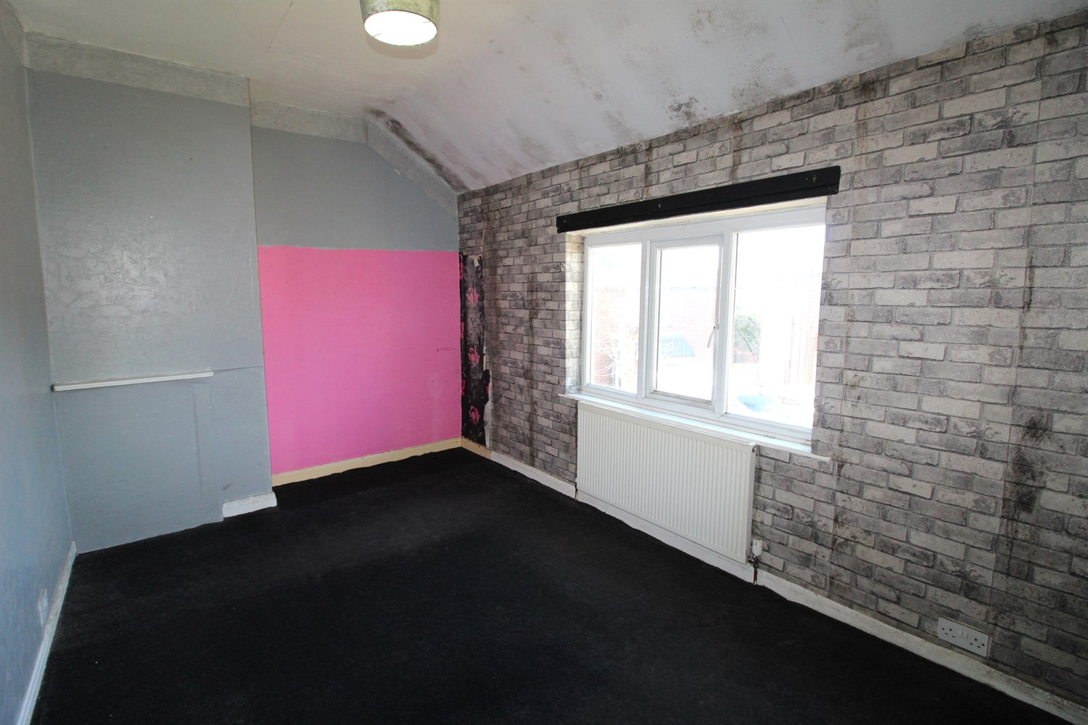

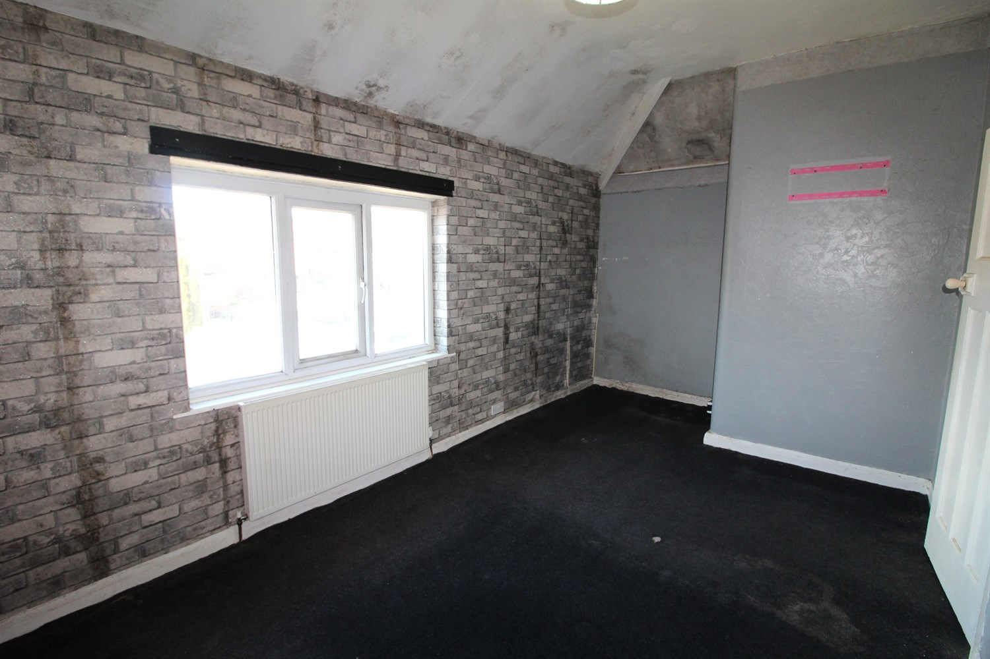

|  |
| --- |
| **Hallway**  Stairs to first floor. |
| **Lounge**  Light and airy living room with uPVC double glazed window to front. Gas central heating radiator. |
| **Kitchen**  Fitted with a range of wall, base and drawer units with worktops over. Space for oven. Gas hob. Double glazed window to rear. |
| **Store/Utility**  Large store room/utility. |
| **Guest WC**  Fitted with two piece suite comprising WC and wash hand basin. |
| **First Floor** |
| **Bedroom One**  Double bedroom with uPVC double glazed window to front. Gas central heating radiator. |
| **Bedroom Two**  Second double bedroom with uPVC double glazed window. uPVC double glazed window to rear. |
| **Bathroom**  Fitted with a three piece suite comprising bath, WC and wash hand basin. uPVC double glazed window. Gas central heating radiator. |
| **Outside**  To the front of the property is a small garden and a shared driveway leading to the rear. To the rear is an enclosed garden with views over open fields. |

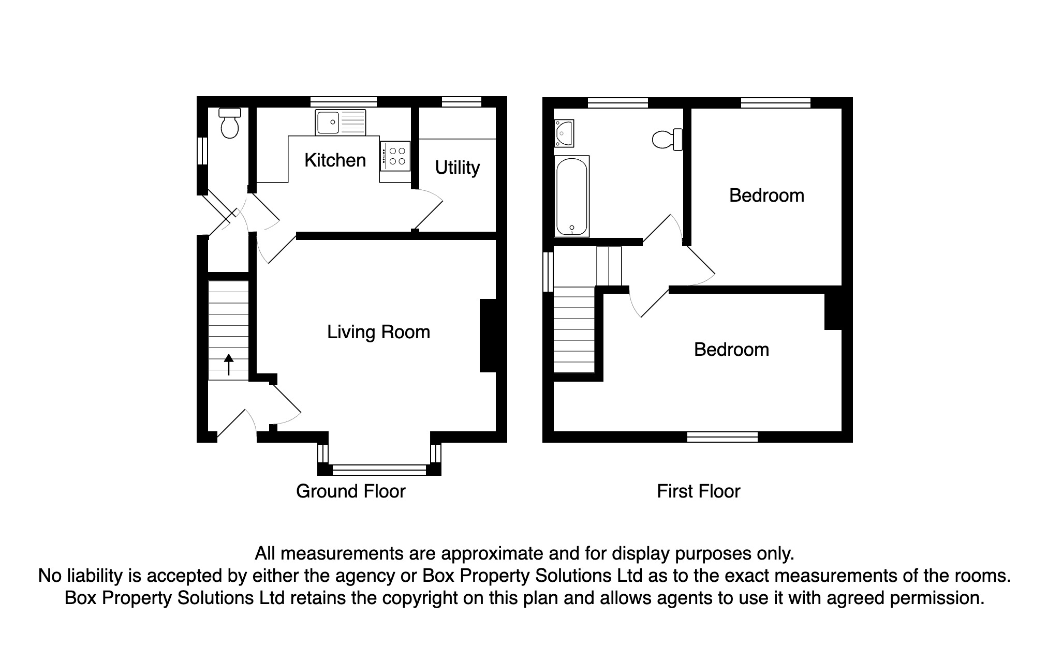

|  |  |
| --- | --- |
| These particulars are intended to give a fair description of the property, but their accuracy cannot be guaranteed, and they do not constitute an offer of contract. Intending purchasers must rely on their own inspection of the property. None of the above appliances/services have been tested by ourselves. We recommend purchasers arrange for a qualified person to check all appliances/services before legal commitment.  **Property Ref:** 5913  **For more information, please contact**  0113 258 1150 **|** [sales@adairpaxton.co.uk](mailto:sales@adairpaxton.co.uk) **|** www.adairpaxton.co.uk |  |