

**0113 258 1150**

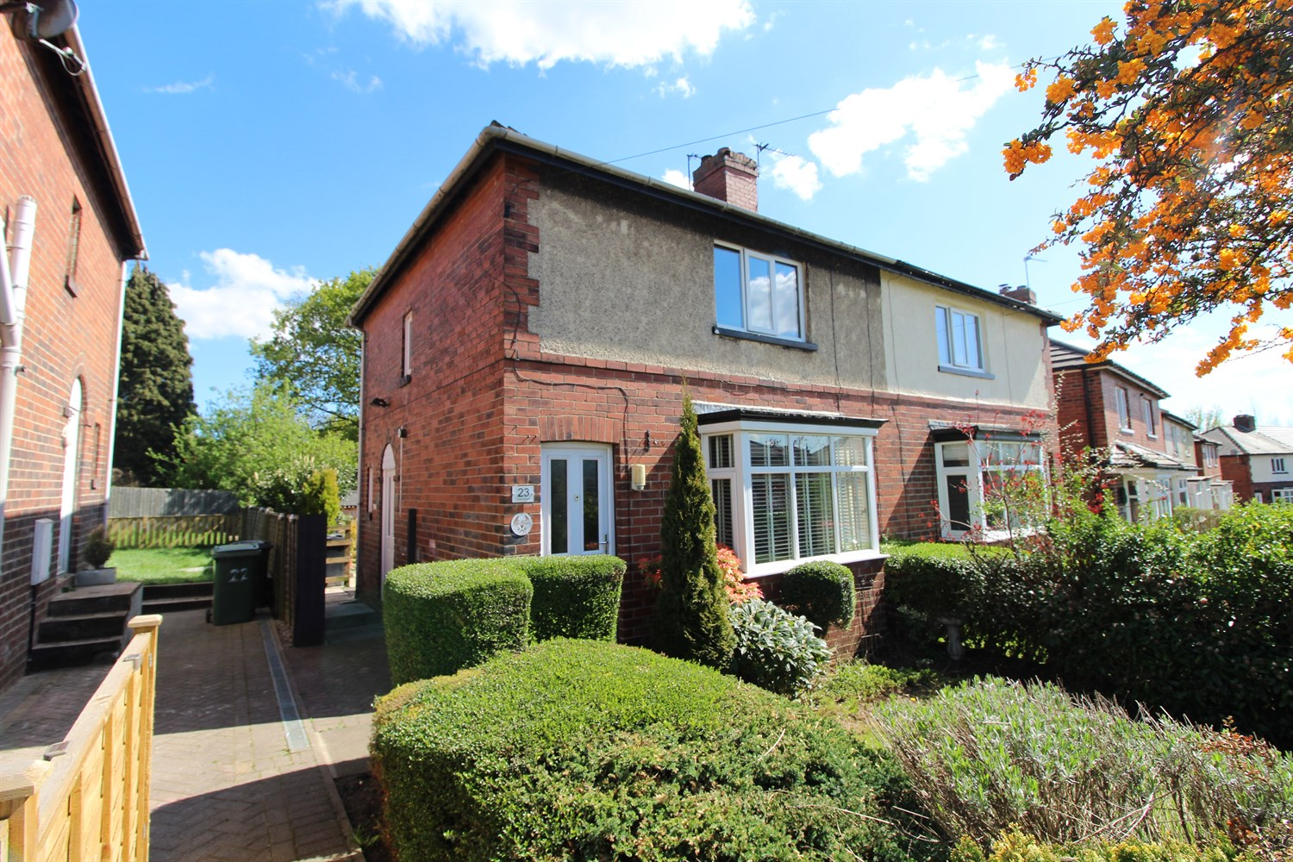



**For Sale £139,950.00**

**Sunnyfield, East Ardsley**

**THREE BEDROOM SEMI-DETACHED HOUSE - IN NEED OF UPDATING - NO CHAIN** Adair Paxton are pleased to offer this three Bedroom Semi- detached property situated in the sought after location of East Ardsley. This three bedroom house is now in need of refurbishing and briefly comprises; Lounge, kitchen, bathroom and guest WC to the ground floor. To the first floor there are three bedrooms. Externally the property has a lawned garden to the front and a paved garden to the rear. This property is offered to the market with NO ONWARD CHAIN.

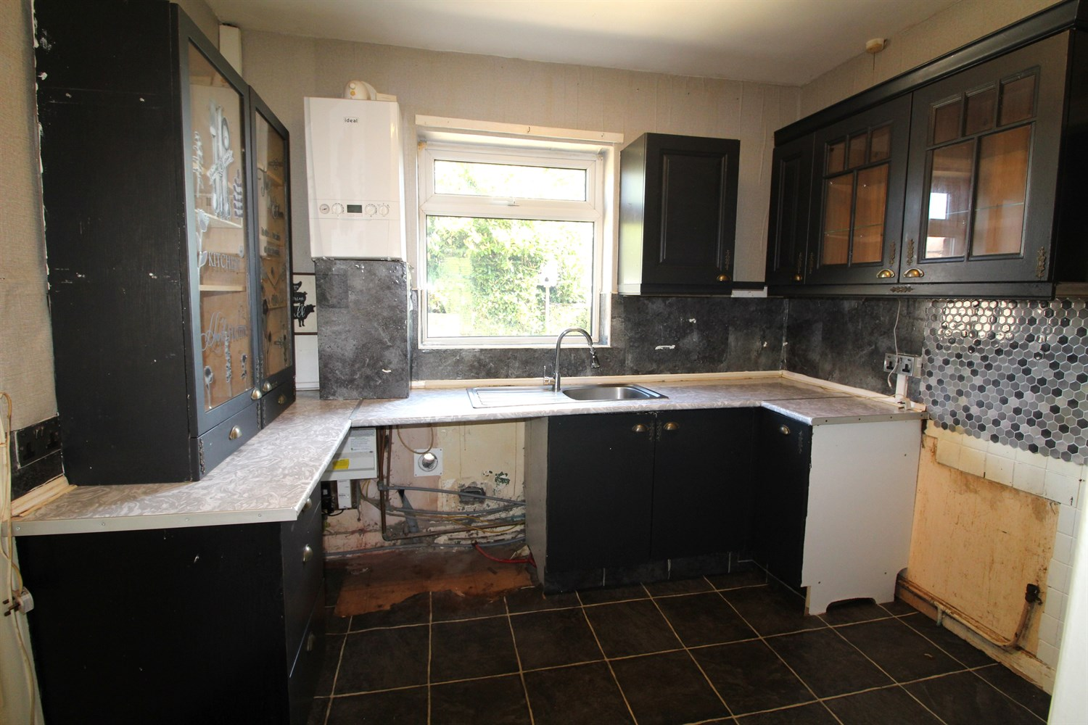

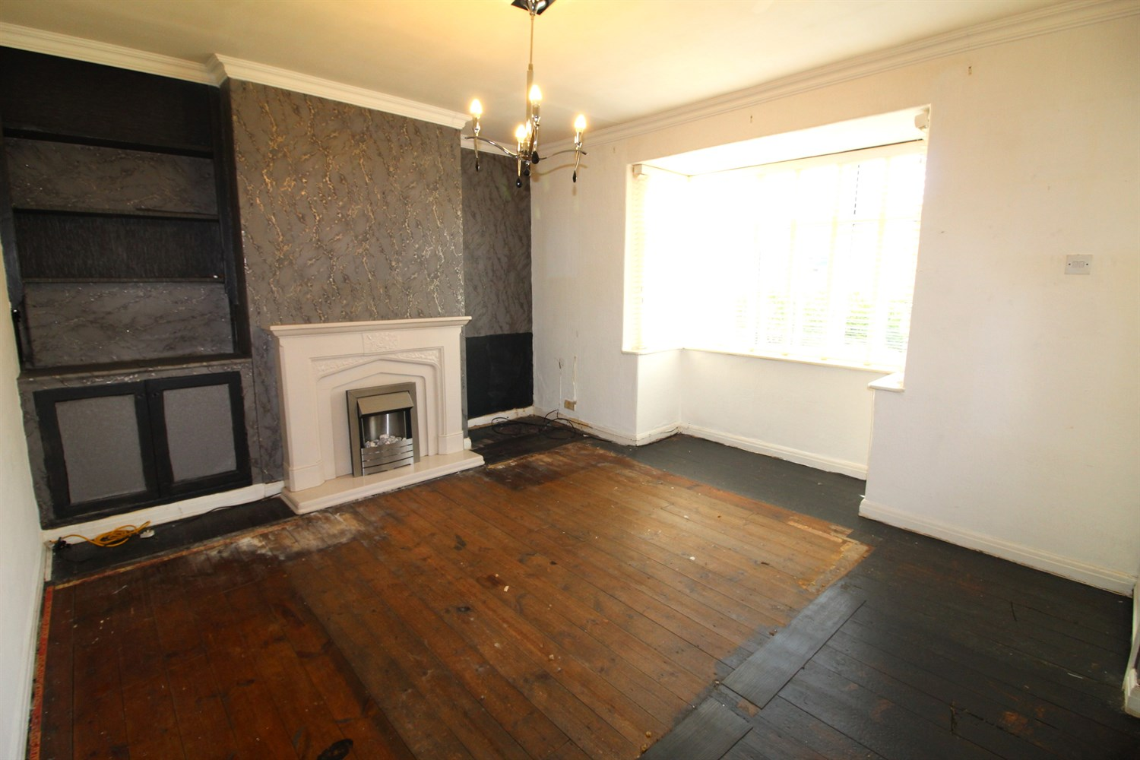

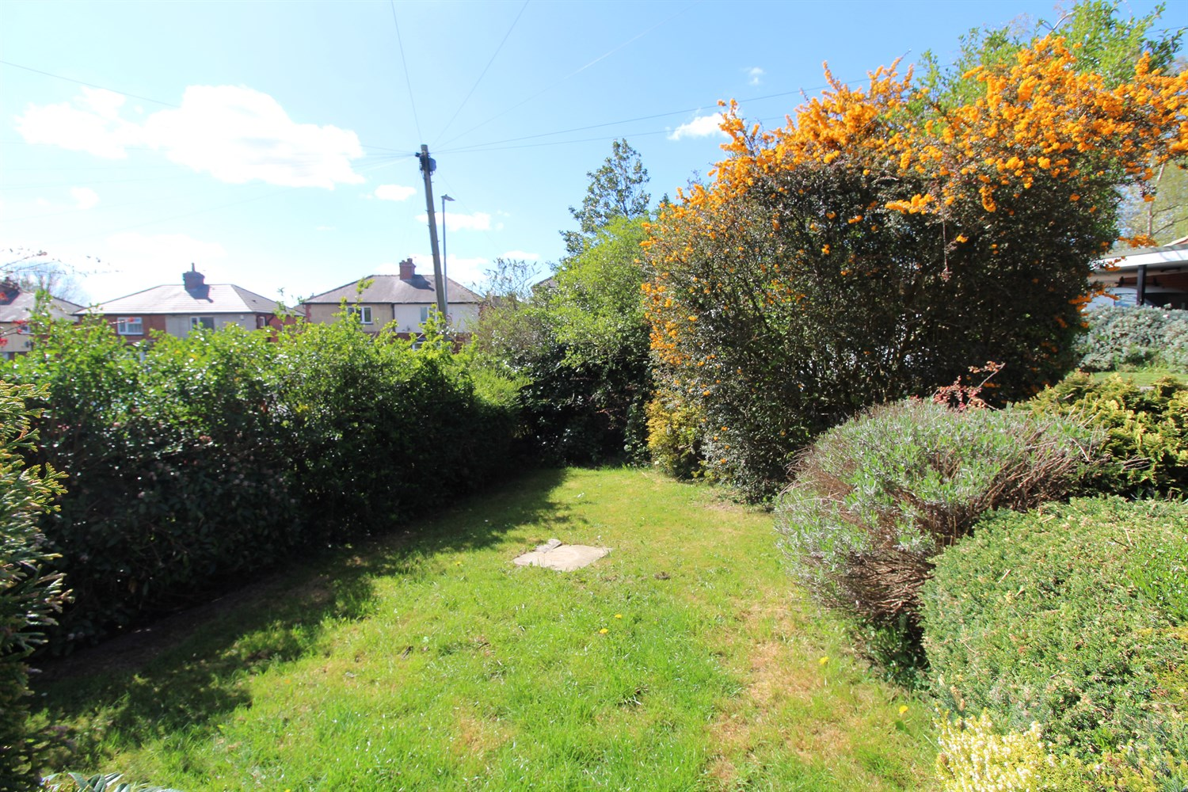

1 Bathroom(s)

1 Reception(s)

3 Bedroom(s)

00

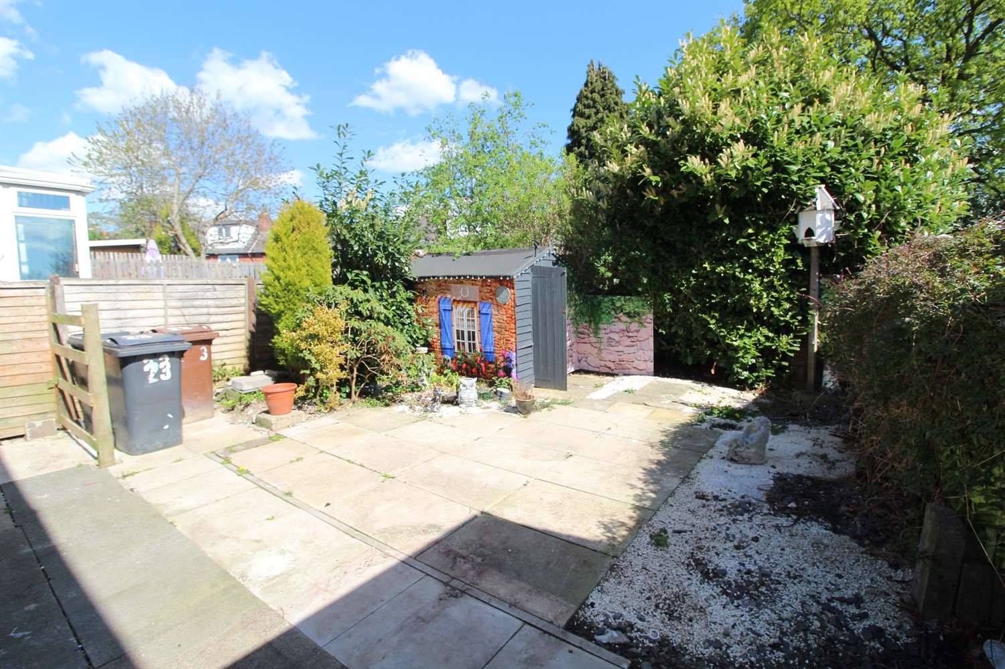

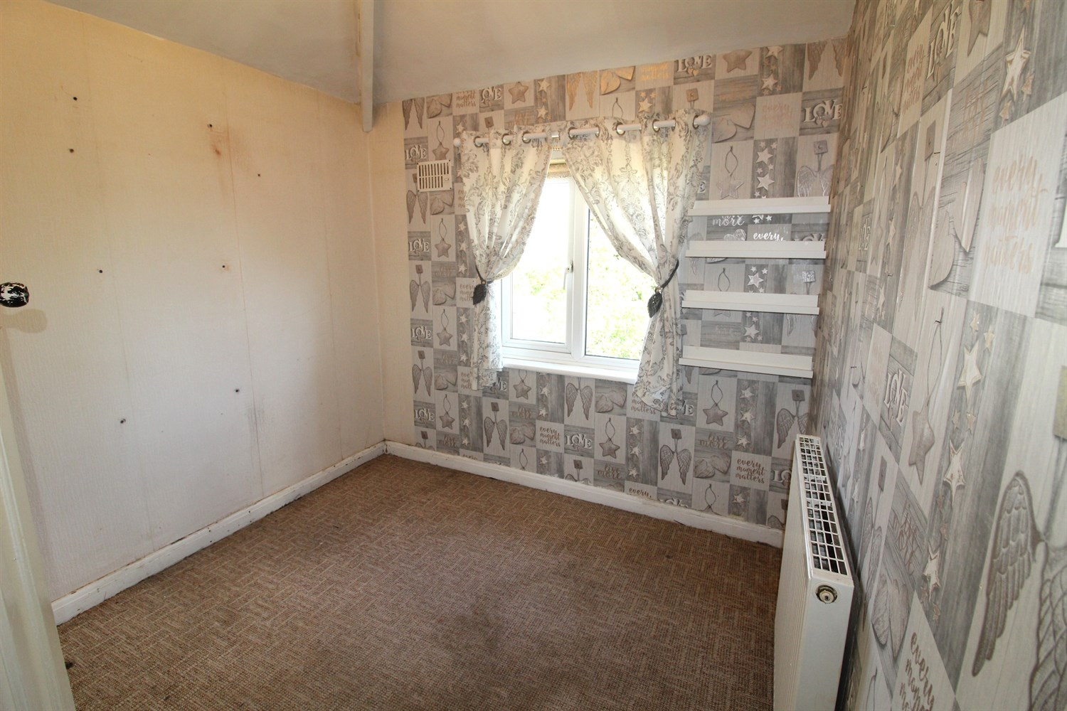

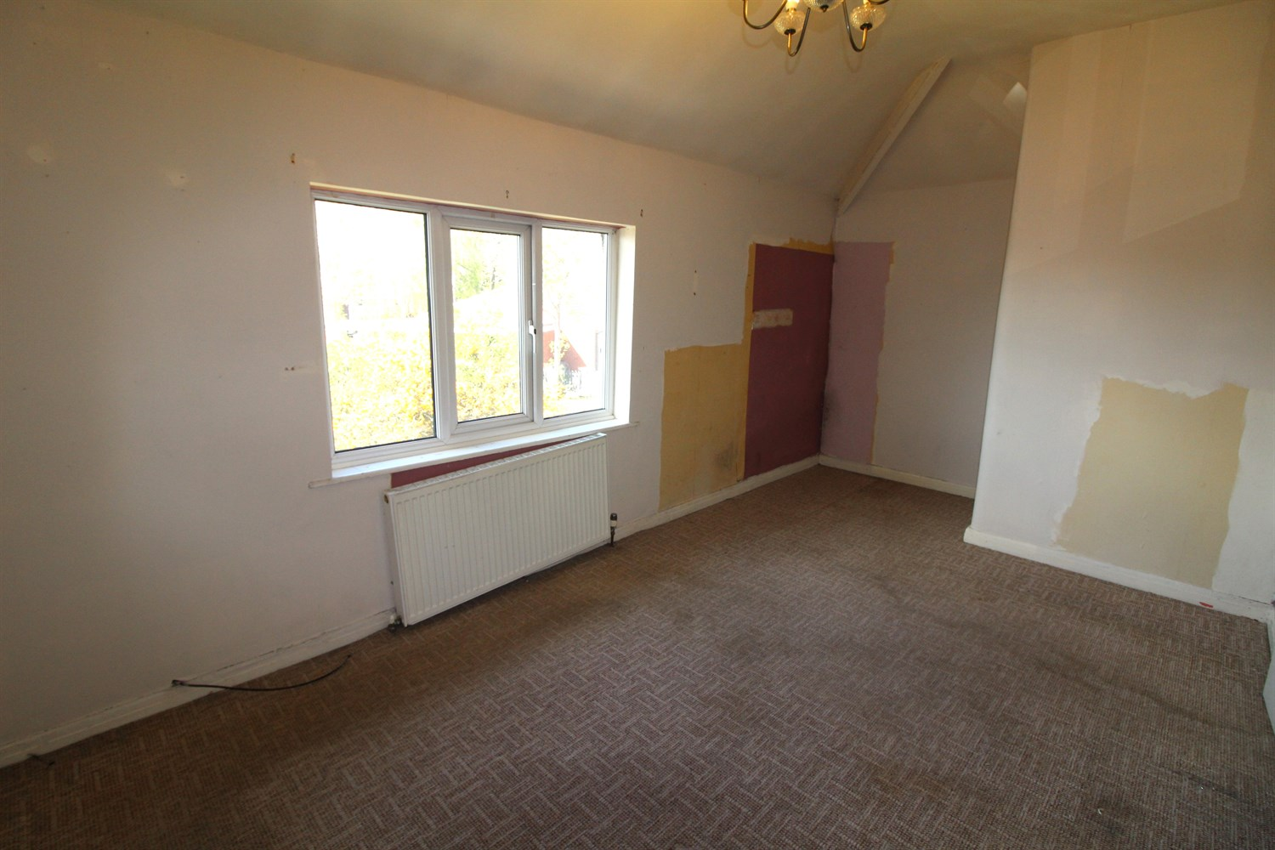

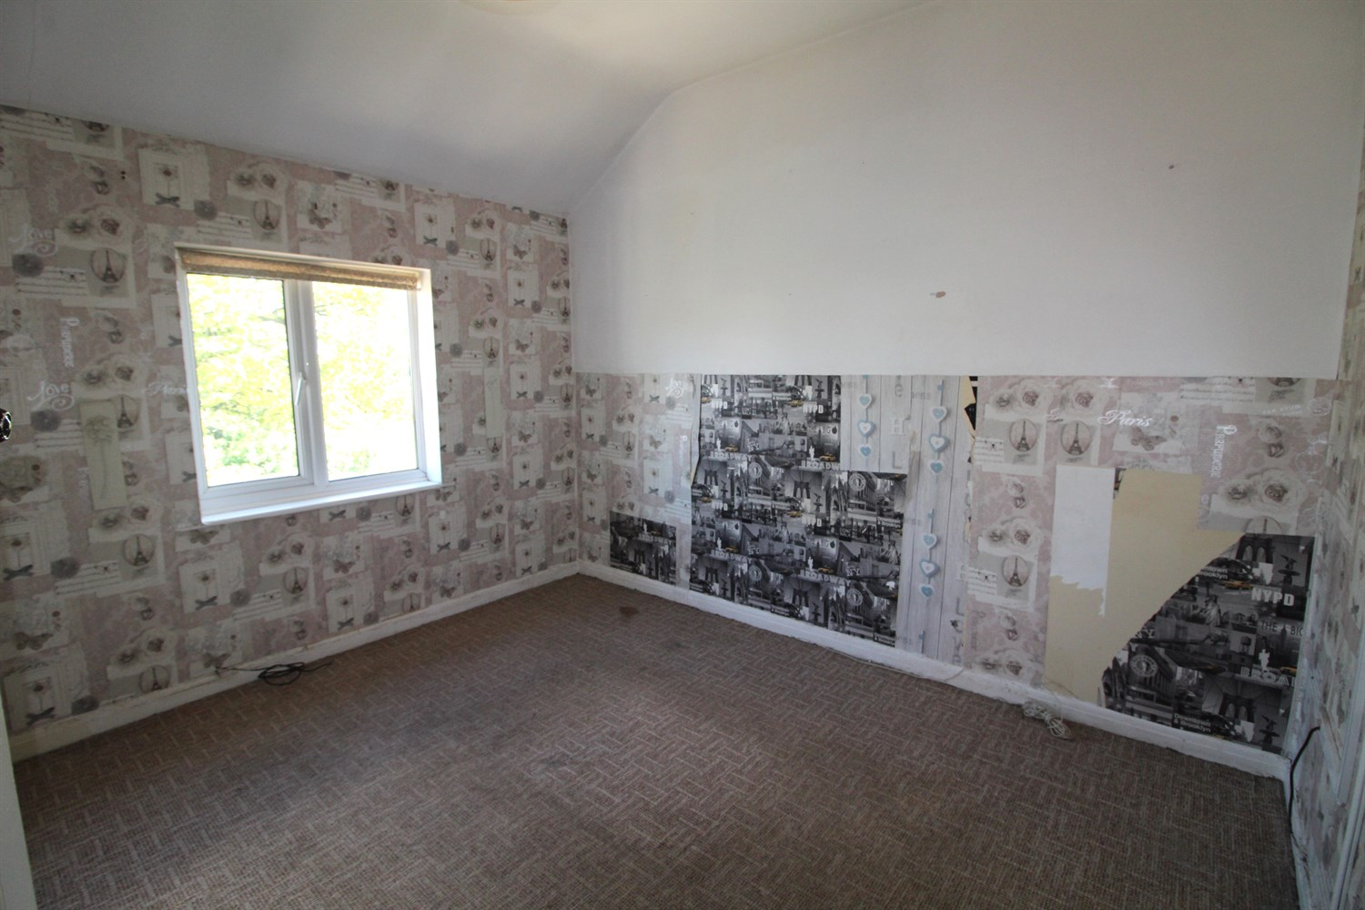

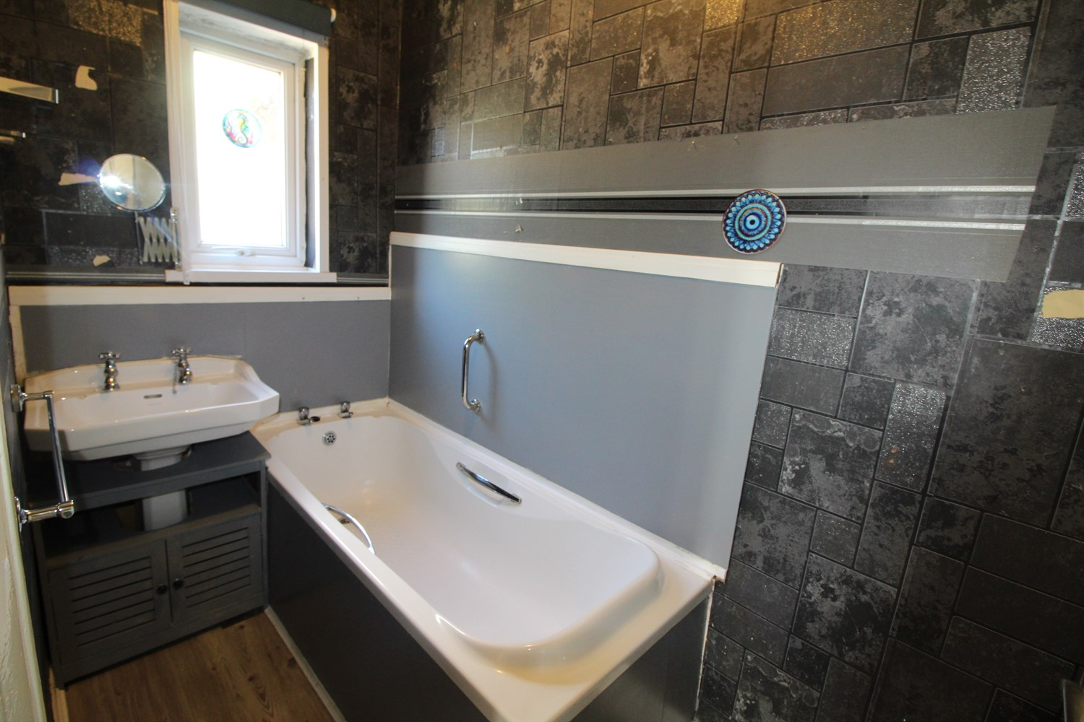

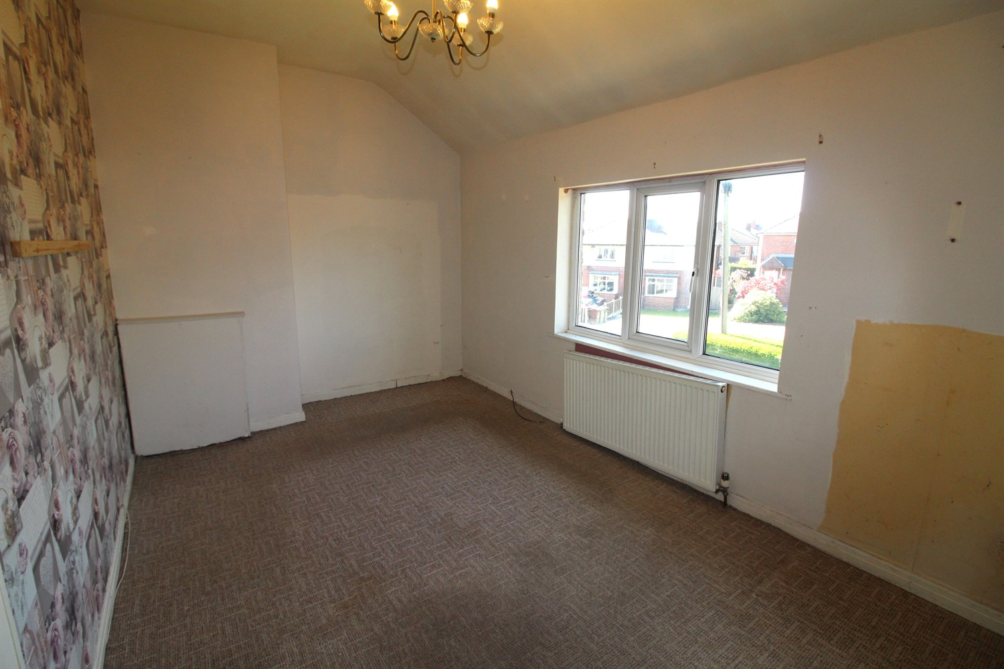

|  |
| --- |
| **Hallway**  Via front entrance door. Stairs to first floor. |
| **Lounge**  uPVC double glazed window to front. Electric fire to chimney breast. |
| **Kitchen**  Fitted with a range of wall, base and drawer units with worktops over. Space for washing machine and cooker. Stainless steel sink with mixer tap and drainer. uPVC double glazed window to rear. |
| **Bathroom**  Fitted with a two piece suite comprising; bath and wash hand basin. Double glazed window. |
| **Guest WC**  WC. uPVC double glazed window. |
| **First Floor** |
| **Bedroom 1**  Double bedroom with uPVC double glazed window to front. Gas central heating radiator. |
| **Bedroom 2**  Second double bedroom with uPVC double glazed window to rear. Gas central heating radiator. |
| **Bedroom 3**  Third bedroom with uPVC double glazed window to rear. Gas central heating radiator. |
| **Outside**  To the front of the property is a lawned garden with borders of hedges. To the rear is a low maintenance paved garden. |

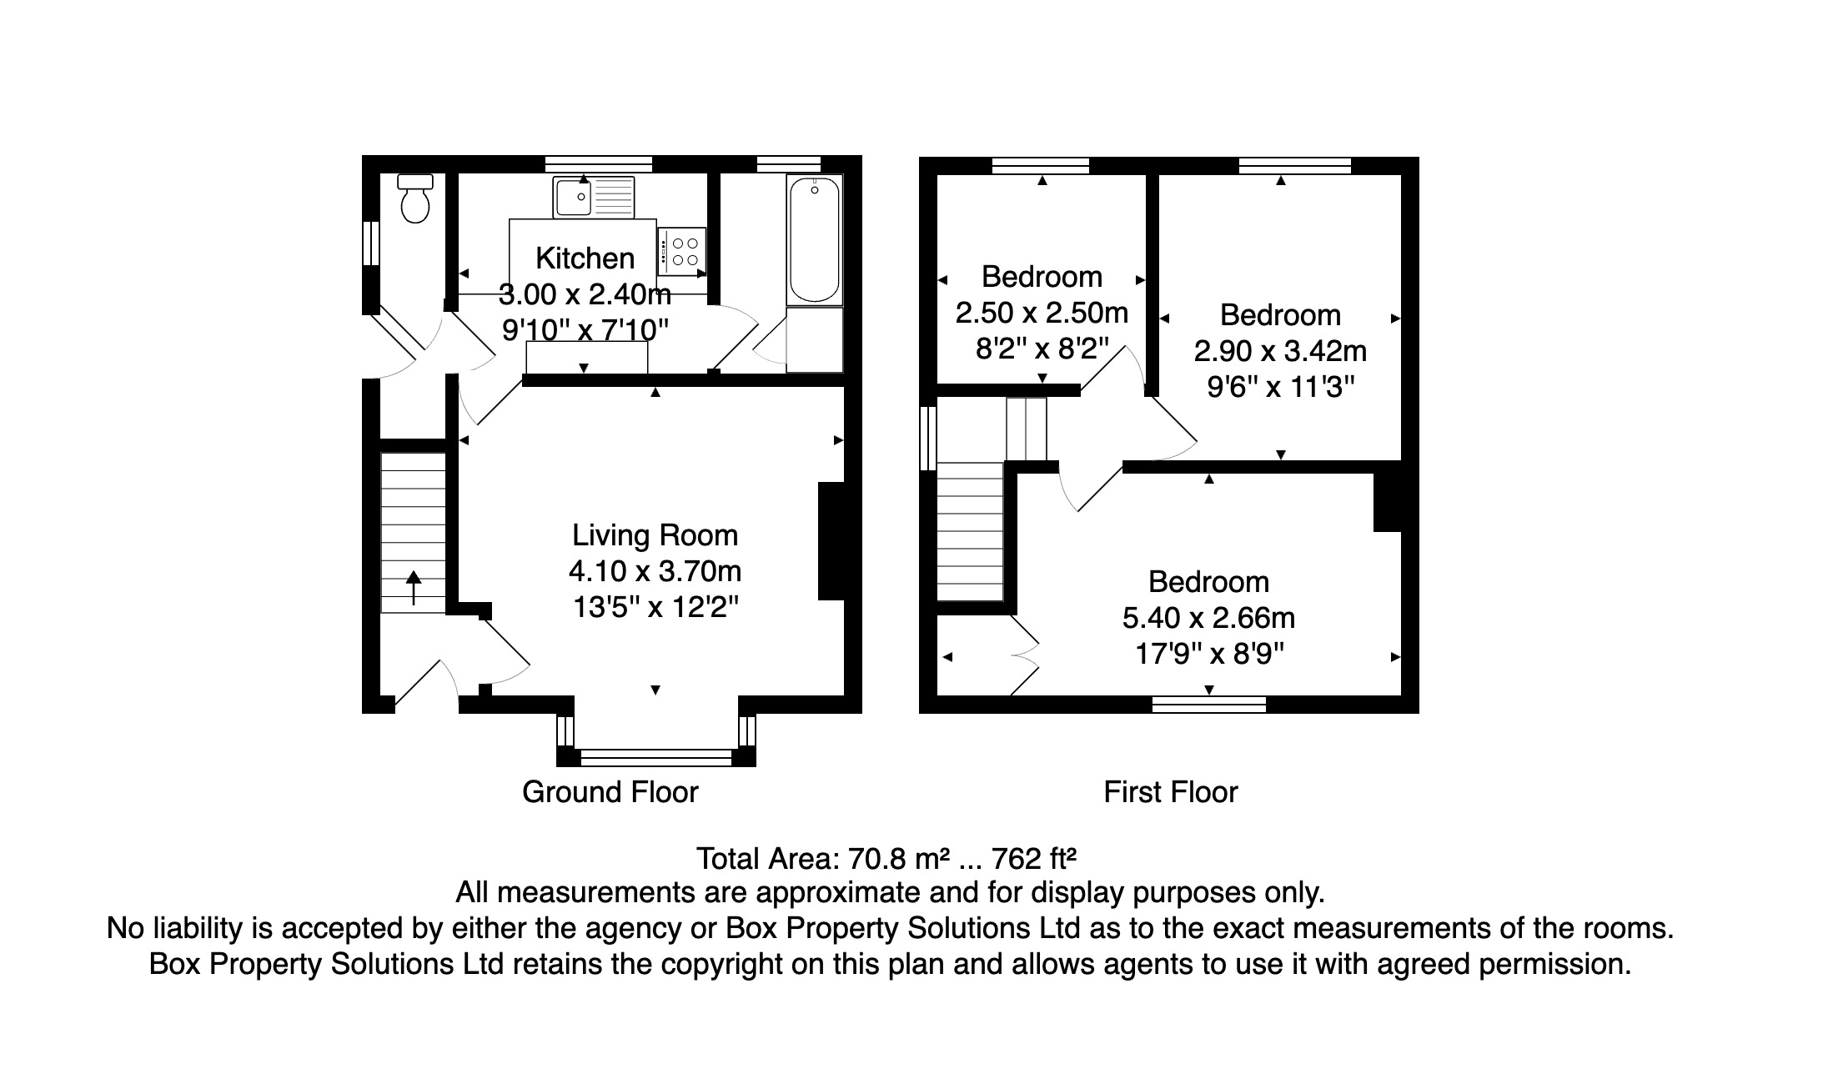

|  |  |
| --- | --- |
| These particulars are intended to give a fair description of the property, but their accuracy cannot be guaranteed, and they do not constitute an offer of contract. Intending purchasers must rely on their own inspection of the property. None of the above appliances/services have been tested by ourselves. We recommend purchasers arrange for a qualified person to check all appliances/services before legal commitment.  **Property Ref:** 5917  **For more information, please contact**  0113 258 1150 **|** [sales@adairpaxton.co.uk](mailto:sales@adairpaxton.co.uk) **|** www.adairpaxton.co.uk |  |