

Bracken Edge, Leeds, LS8
For Sale £495,000.00

**STUNNING THREE BEDROOM DETACHED HOUSE with NO ONWARD CHAIN** Adair Paxton are pleased to offer to the market this three bedroom detached house situated on the cusp of the popular Chapel Allerton area and in a quiet cul-de-sac position with woodland views to the rear. Located within the Roundhay School Catchment, this family home is in a fantastic position for local amenities, schools, shopping and commuting. This ready to move into home briefly comprises; Entrance hall, open plan kitchen/diner, living area, utility and guest WC to the ground floor. To the first floor there are two double bedrooms, a single bedroom and house bathroom. Externally the property sits on a generous plot with a driveway to the front offering off street parking for several cars. To the rear of the property is a large garden that has been mainly laid to lawn with a patio area ideal for entertaining. The rear garden offers a great deal of privacy, backing onto Gledhow Valley Woods.
0113 258 1150
0800 000 000
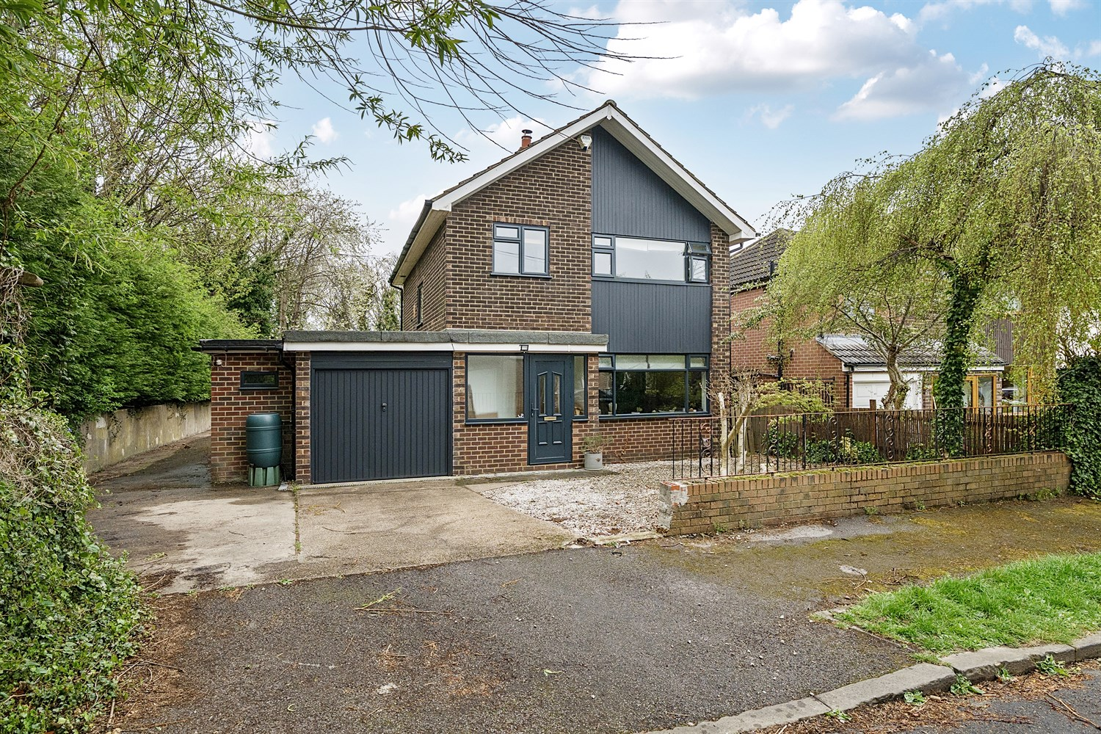



3 Bedrooms
2 Receptions
2 Bathrooms
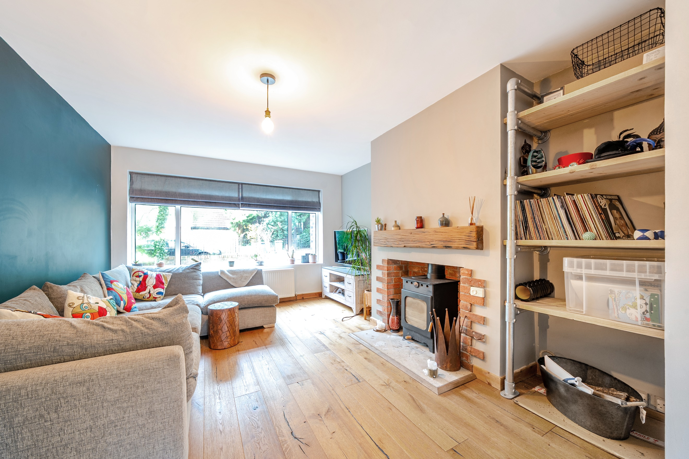
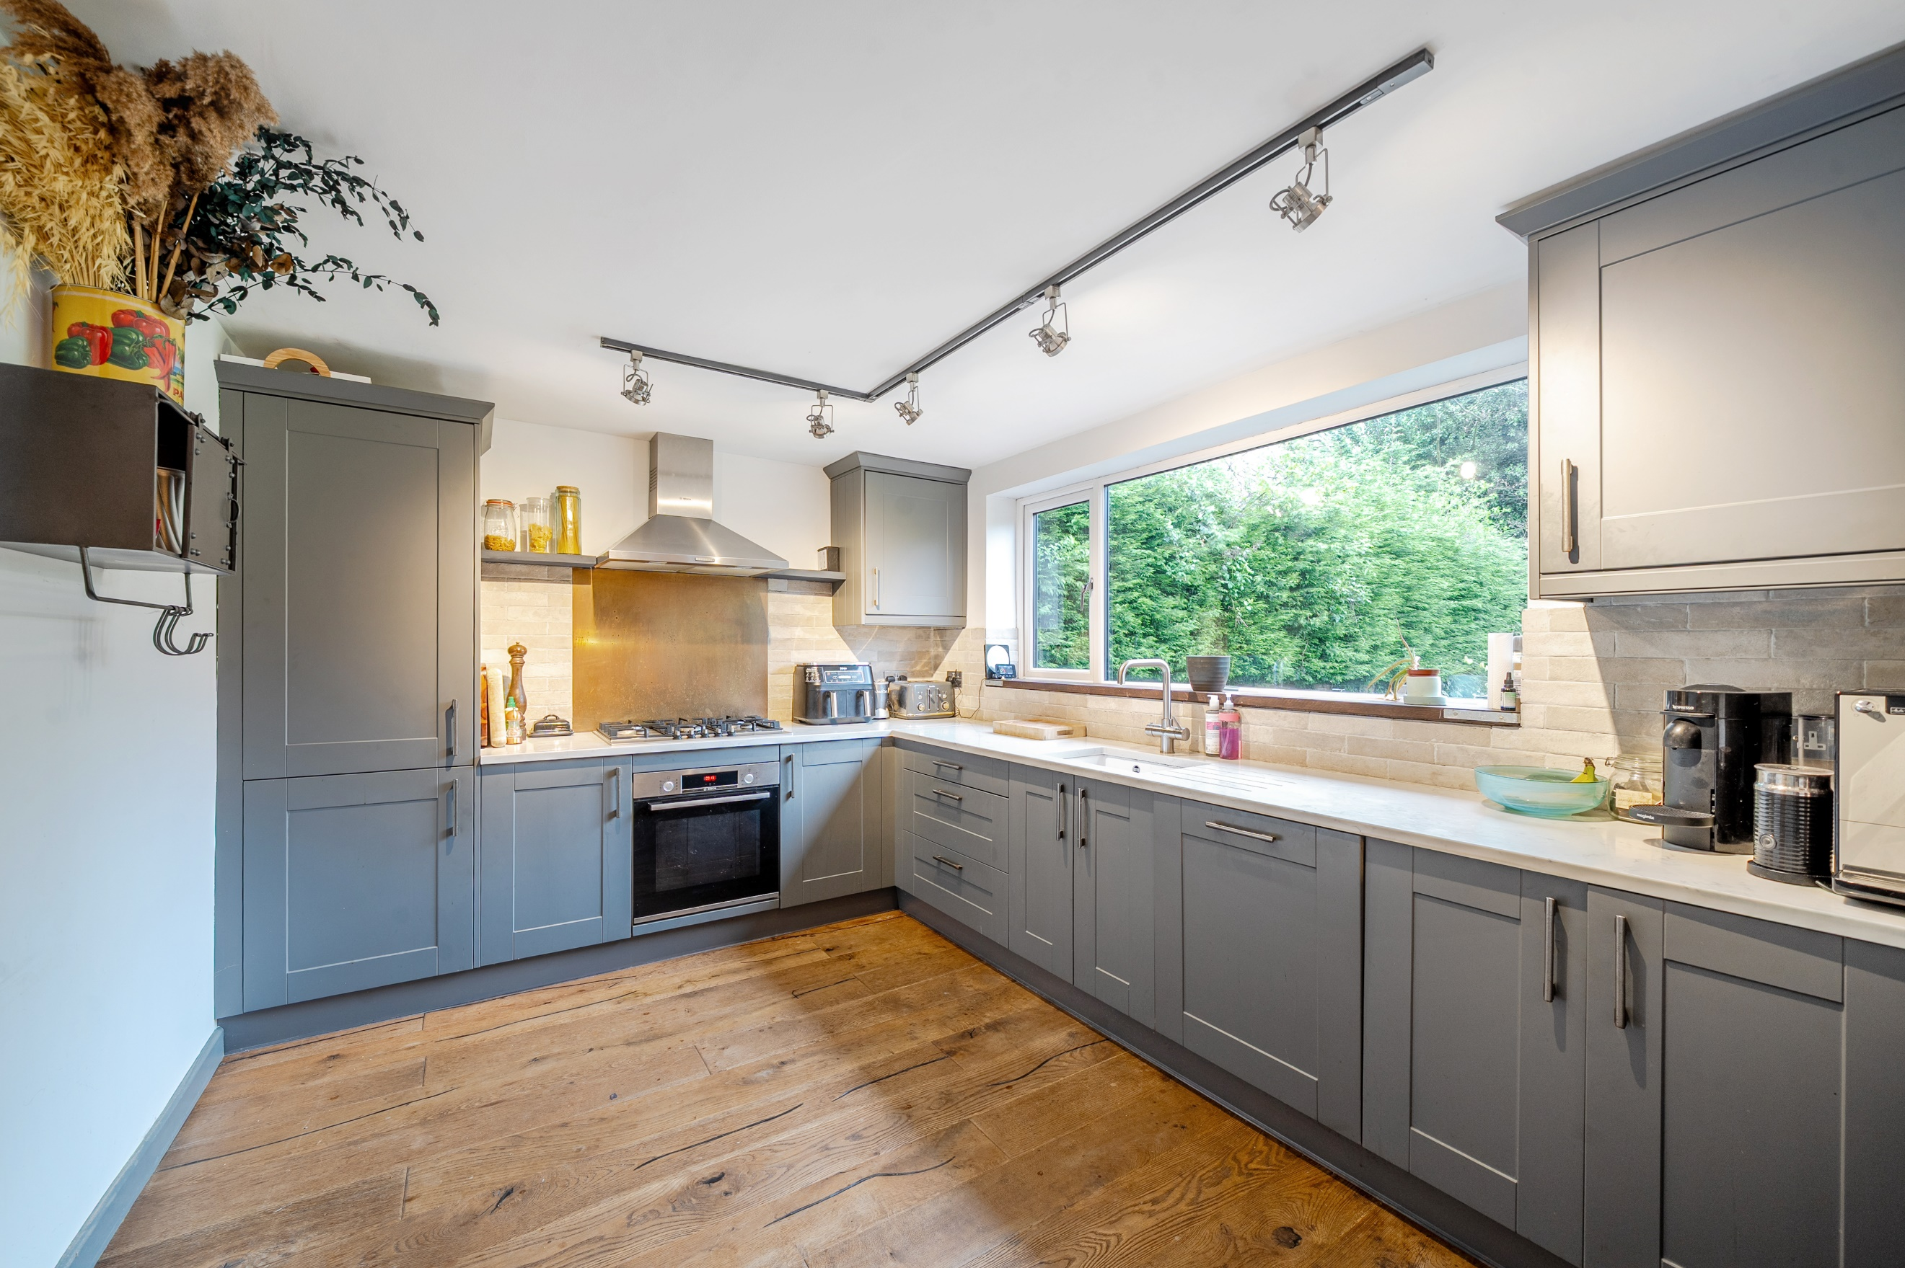
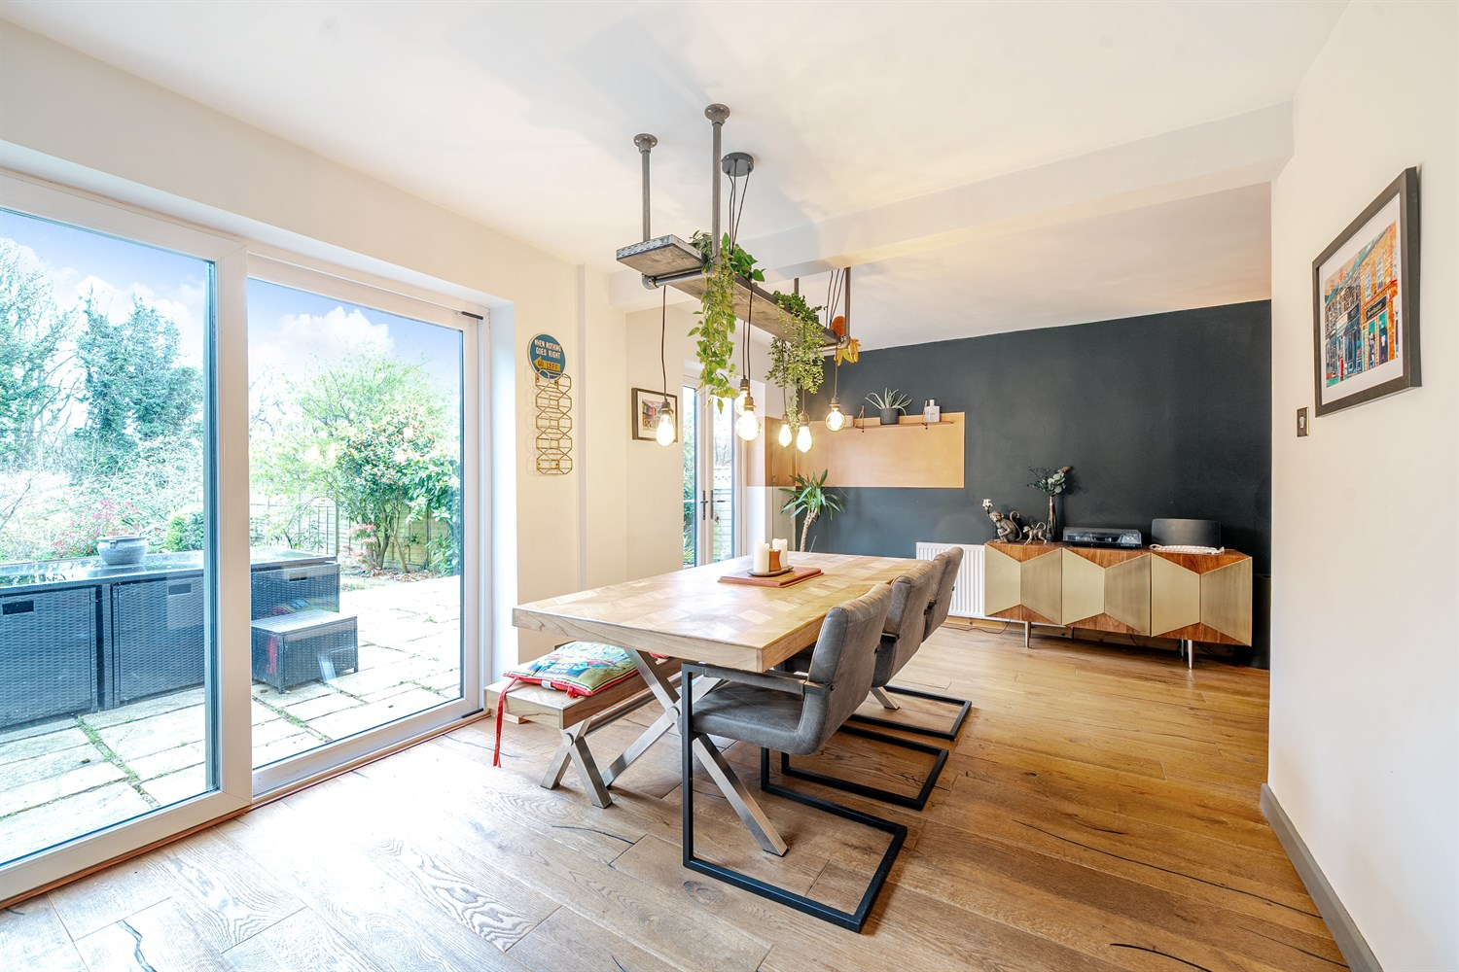
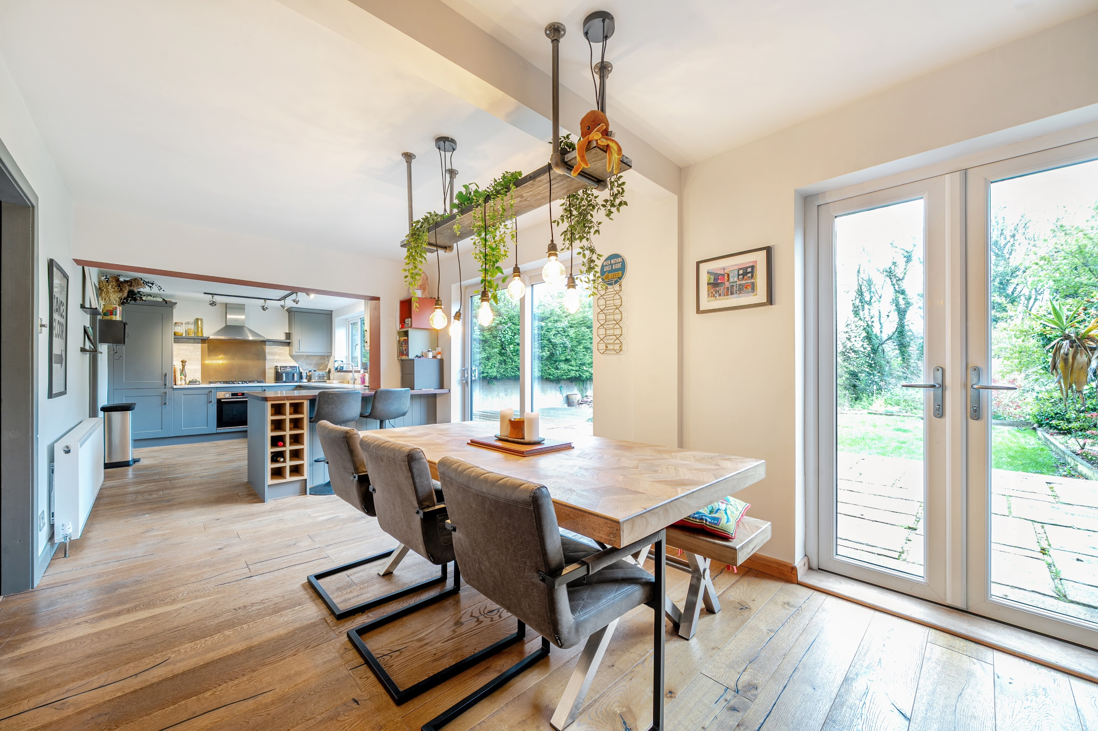
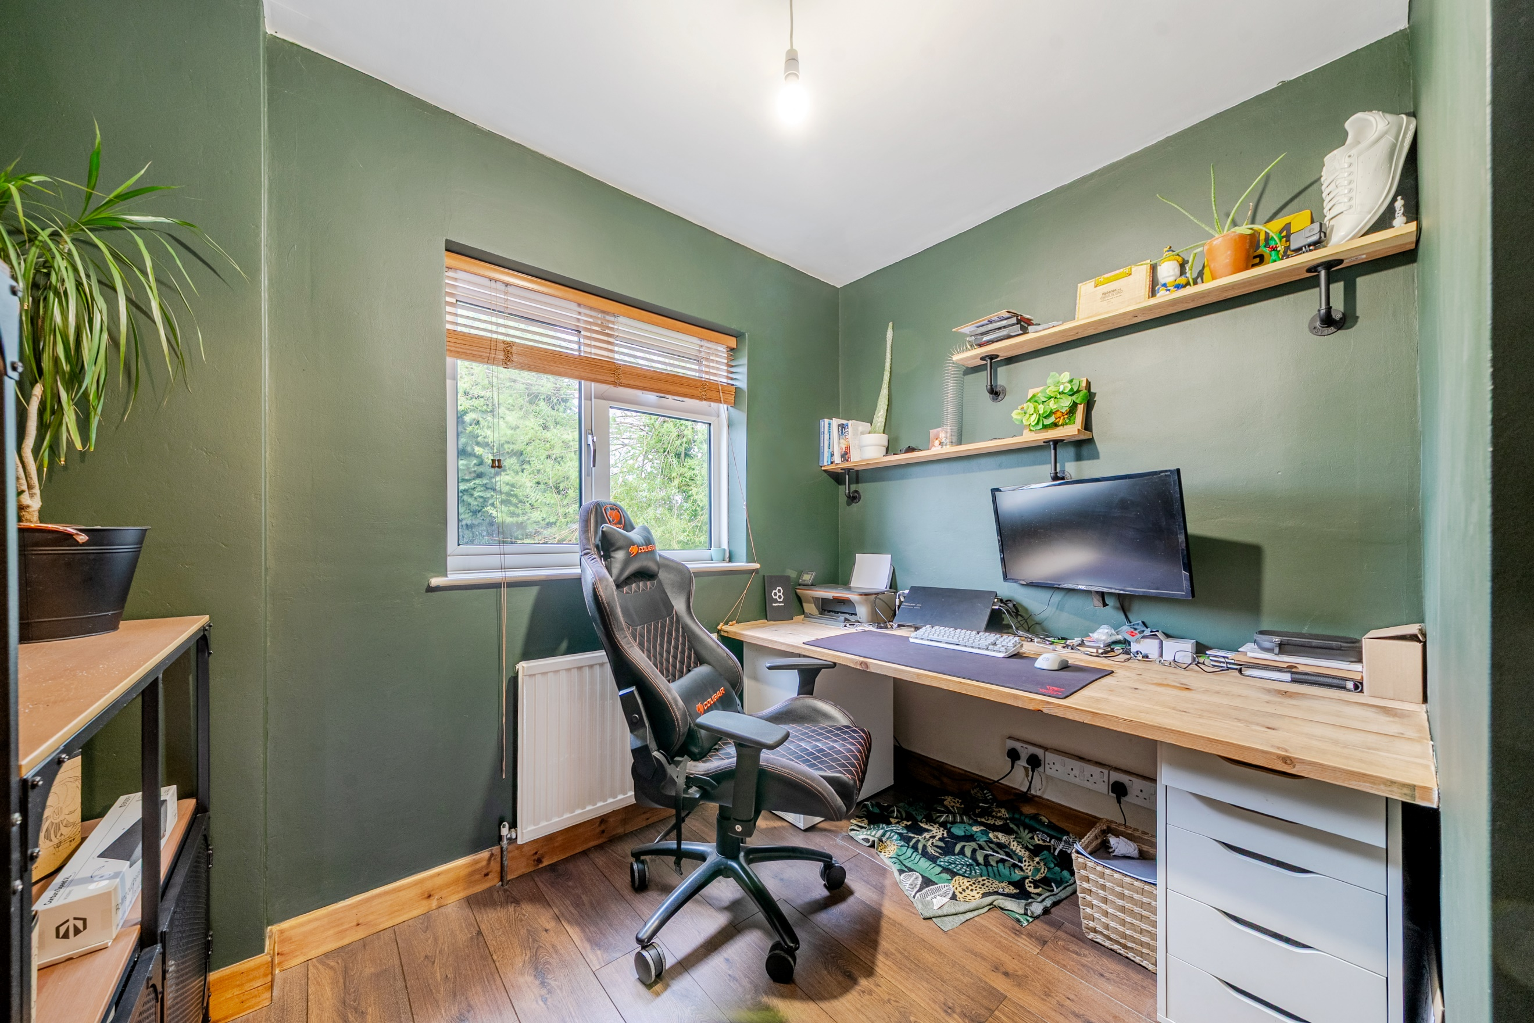
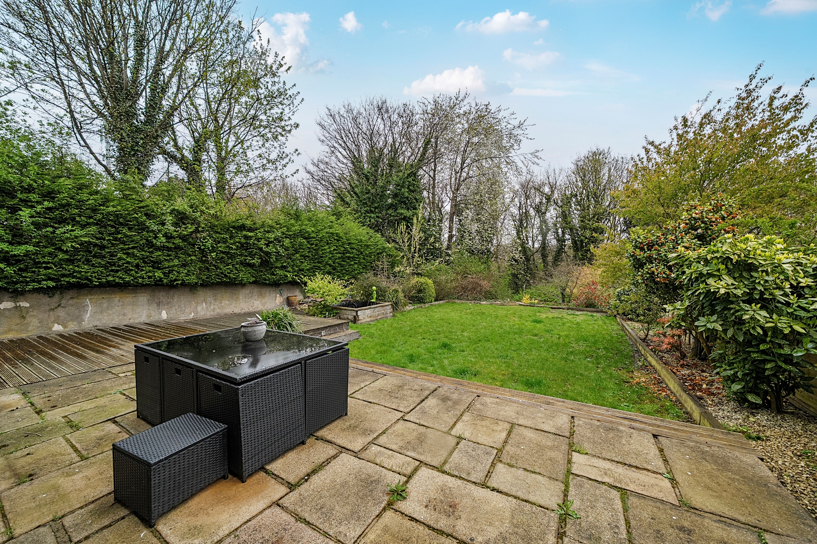
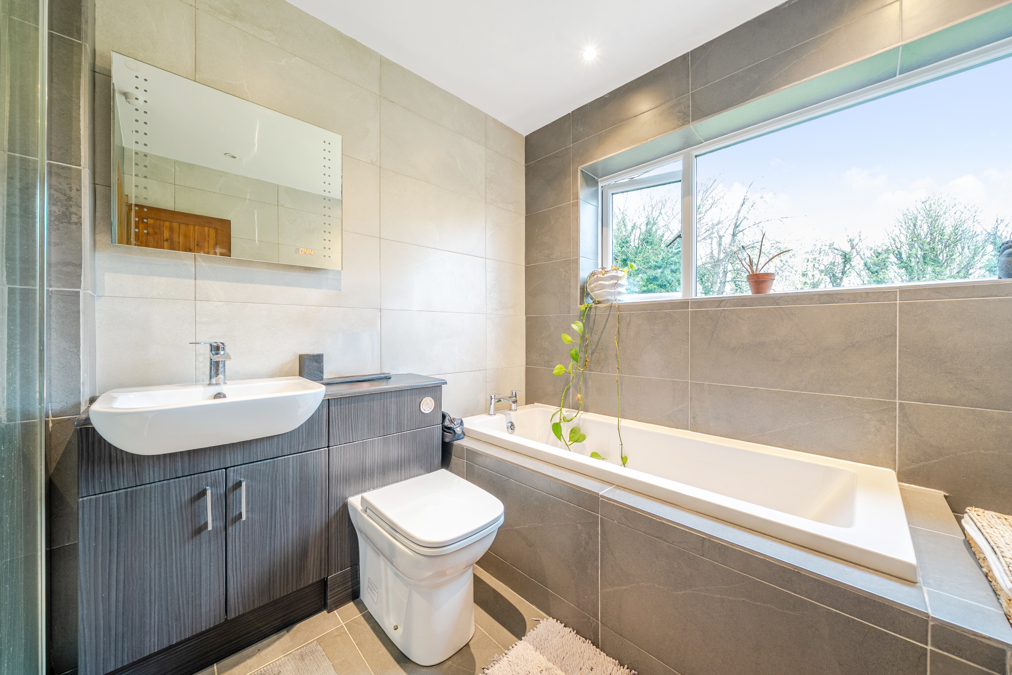
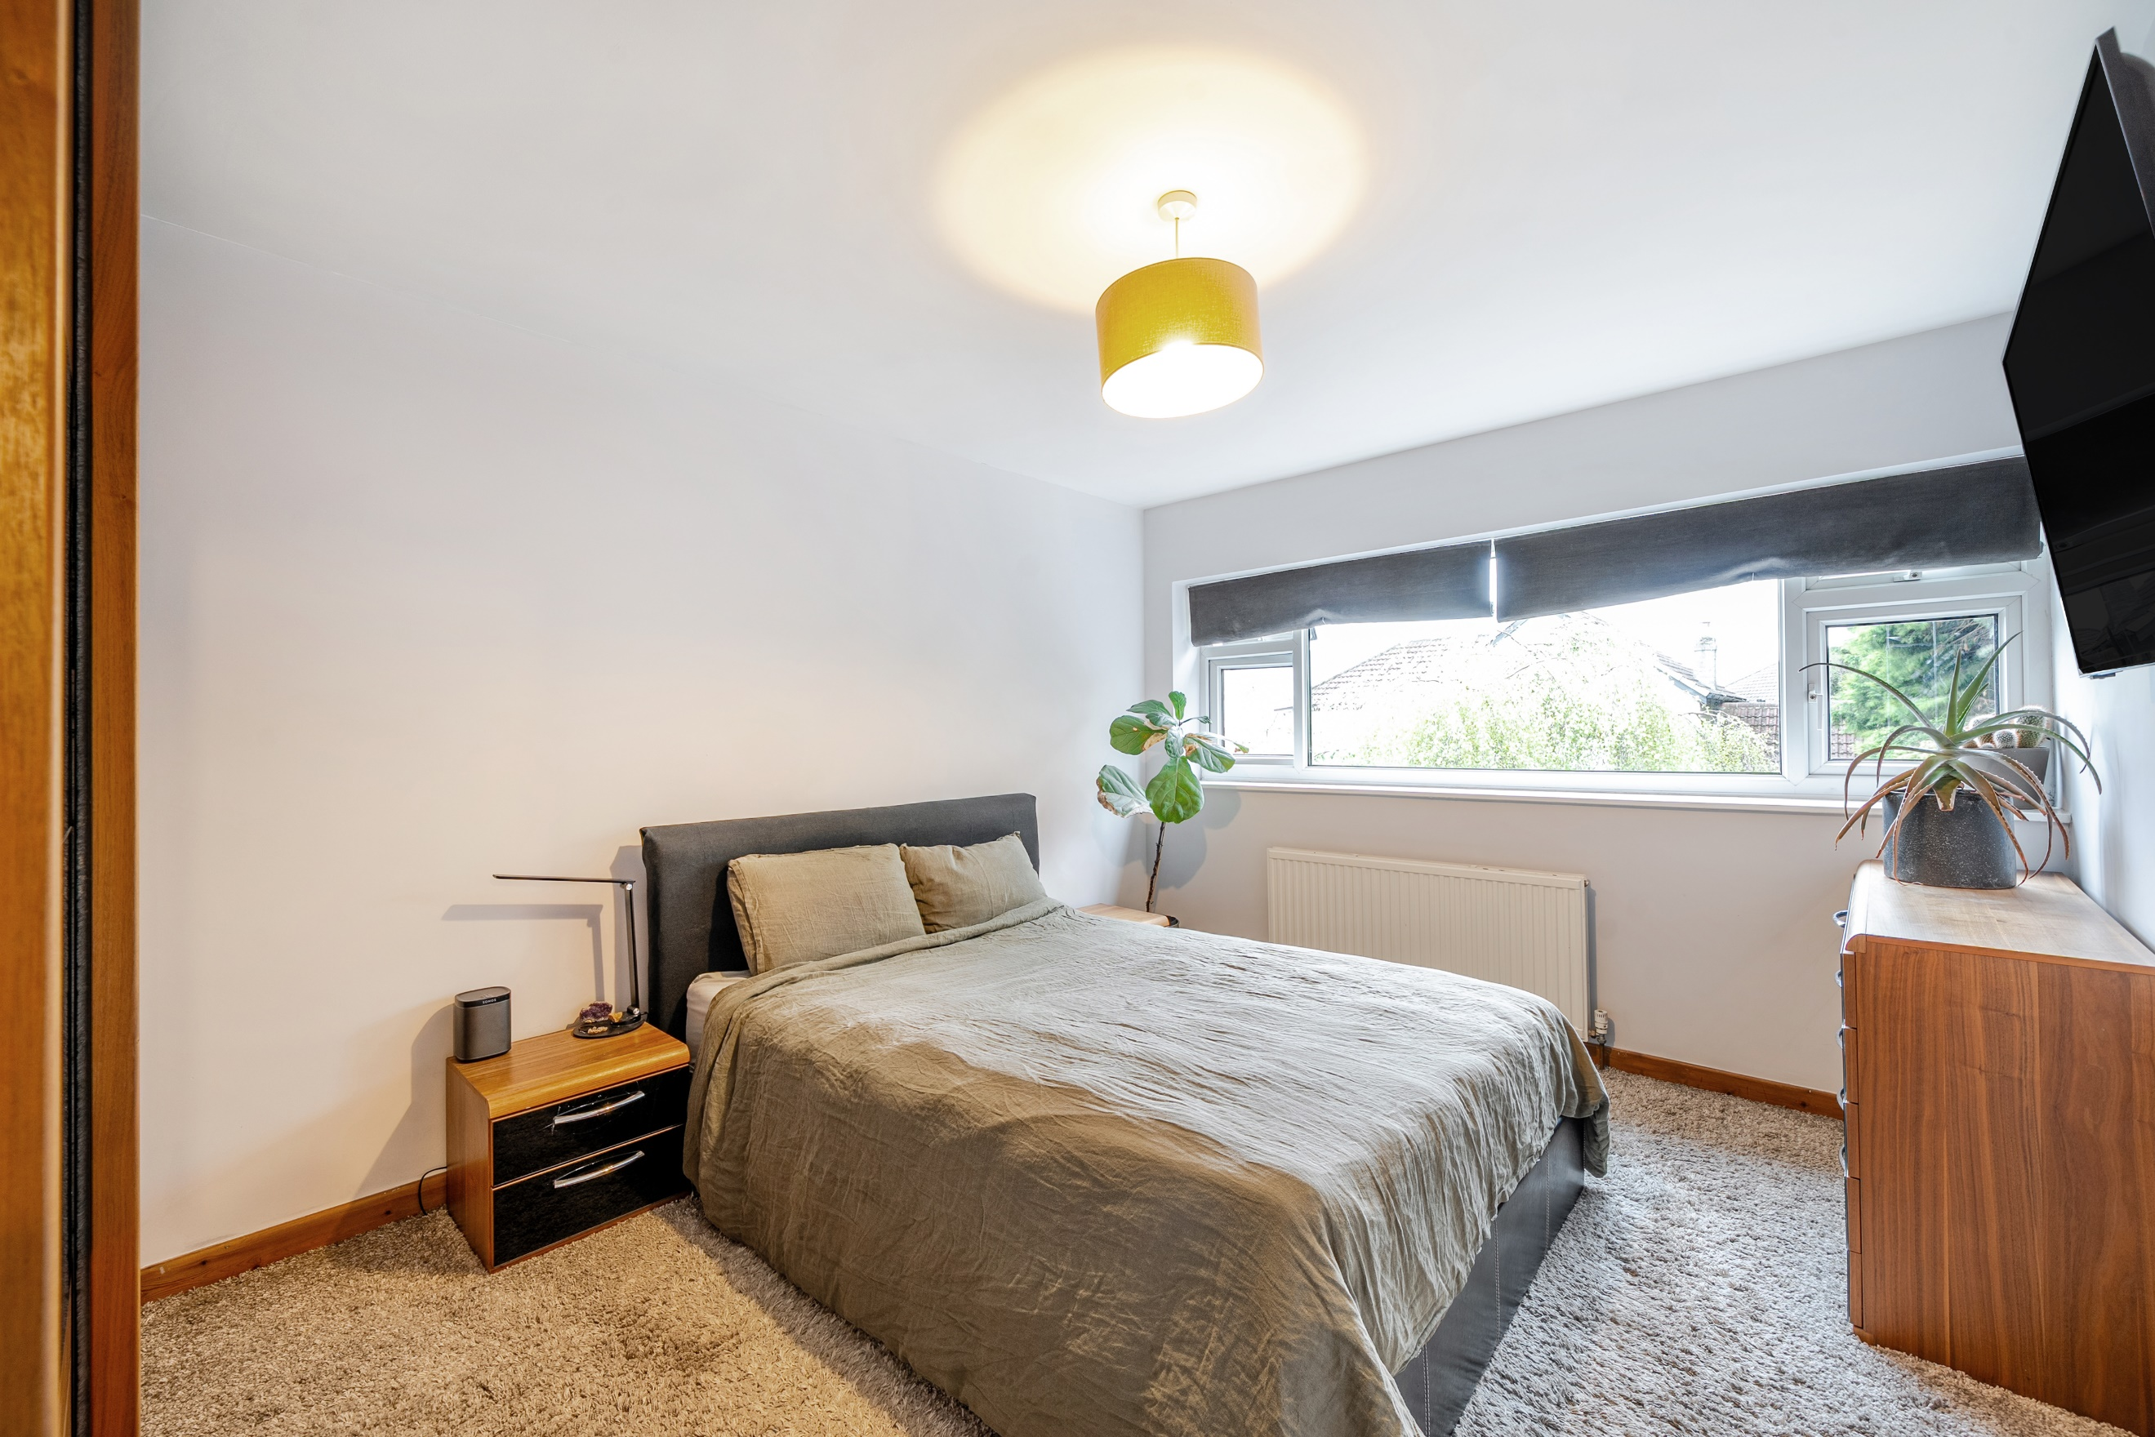

Hallway
Via front entrance porch. Gas central heating radiator. Stairs to first floor.

Open Plan Kitchen / Dining Area / Living Room 10.02m (32'10) x 7.42m (24'4)
Fitted with a range of wall, base and drawer units with worktops over. Integrated oven with gas hob and extractor hood over. Integrated fridge/freezer, dishwasher and wine cooler. 1.5 bowl sink with mixer tap and drainer. Part tiled walls. uPVC double glazed window to the rear overlooking the gardens. Gas central heating radiator. Beautiful dining area with uPVC double glazed sliding doors and uPVC double glazed patio door leading to the rear.

Lounge
Opening from the dining area. Light and airy living area with uPVC double glazed window to front. Gas central heating radiator. Chimney breast housing log burning stove.

Store 2.87m (9'5) x 1.79m (5'10)
Useful additional space, ideal to be used as a utility area or store room.

Office 3.16m (10'4) x 1.15m (3'9)
Housing combi boiler. uPVC double glazed door to side.

Guest WC
Fitted with a two piece suite comprising; WC and wash hand basin. Tiled walls and floor. Wall mounted heated towel rail.

Garage 3.54m (11'7) x 2.54m (8'4)
With up and over door to the front.

First Floor

Bedroom 1 4.26m (14') x 3.7m (12'2)
Double bedroom with uPVC double glazed window to front. Gas central heating radiator.

Bedroom 2 3.05m (10'0) x 2.68m (8'10)
Second double bedroom with uPVC double glazed window to rear. Gas central heating radiator.

Bedroom 3 3.04m (10') x 2.74m (9')
Third bedroom with uPVC double glazed window to front. Gas central heating radiator.

Bathroom
Fitted with a four piece white suite comprising; shower cubicle, bath, WC and wash hand basin. Tiled walls and floor. uPVC double glazed window. Inset ceiling spotlights.

Outside
To the front of the property is a driveway offering off street parking for several cars. To the rear is a good sized garden which has been mainly laid to lawn with borders of trees and shrubs. A patio area ideal for entertaining. The garden backs onto Gledhow Valley Woods offering a great amount of privacy.

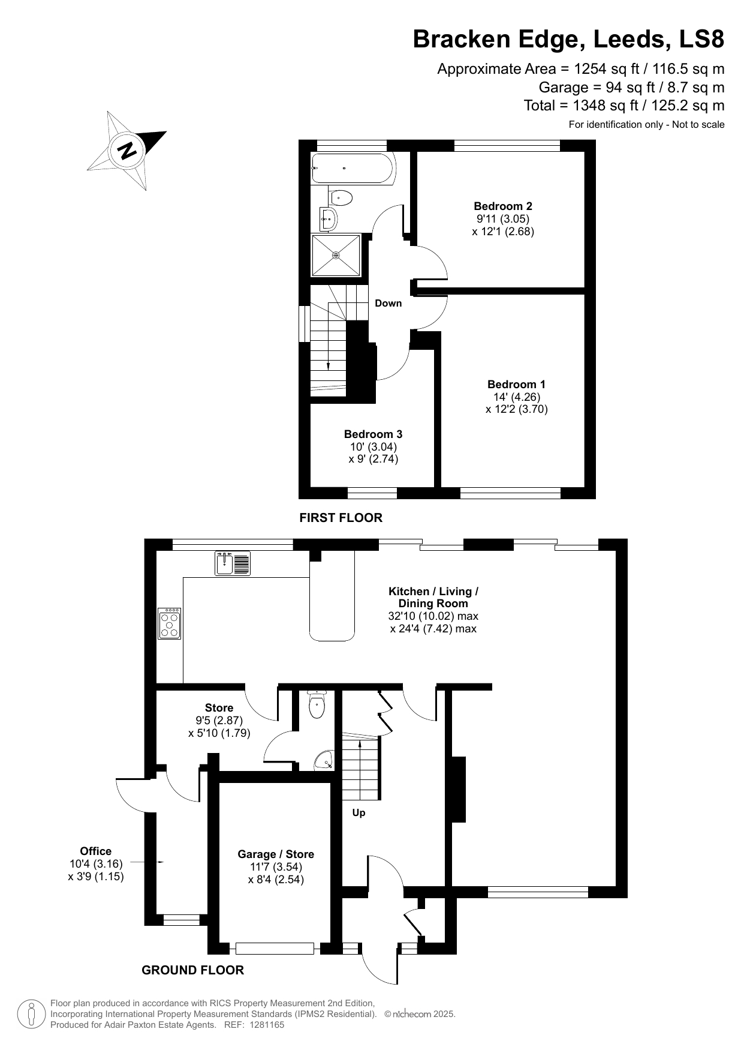

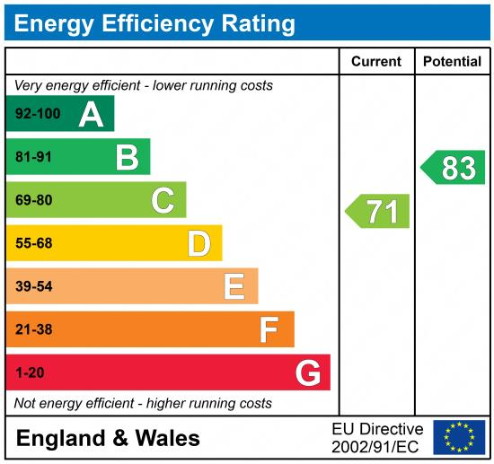

These particulars are intended to give a fair description of the property, but their accuracy cannot be guaranteed, and they do not constitute an offer of contract. Intending purchasers must rely on their own inspection of the property. None of the above appliances/services have been tested by ourselves. We recommend purchasers arrange for a qualified person to check all appliances/services before legal commitment.

Property Ref: 5875

For more information, please contact

0113 258 1150 | sales@adairpaxton.co.uk | www.adairpaxton.co.uk

