

**0113 258 1150**

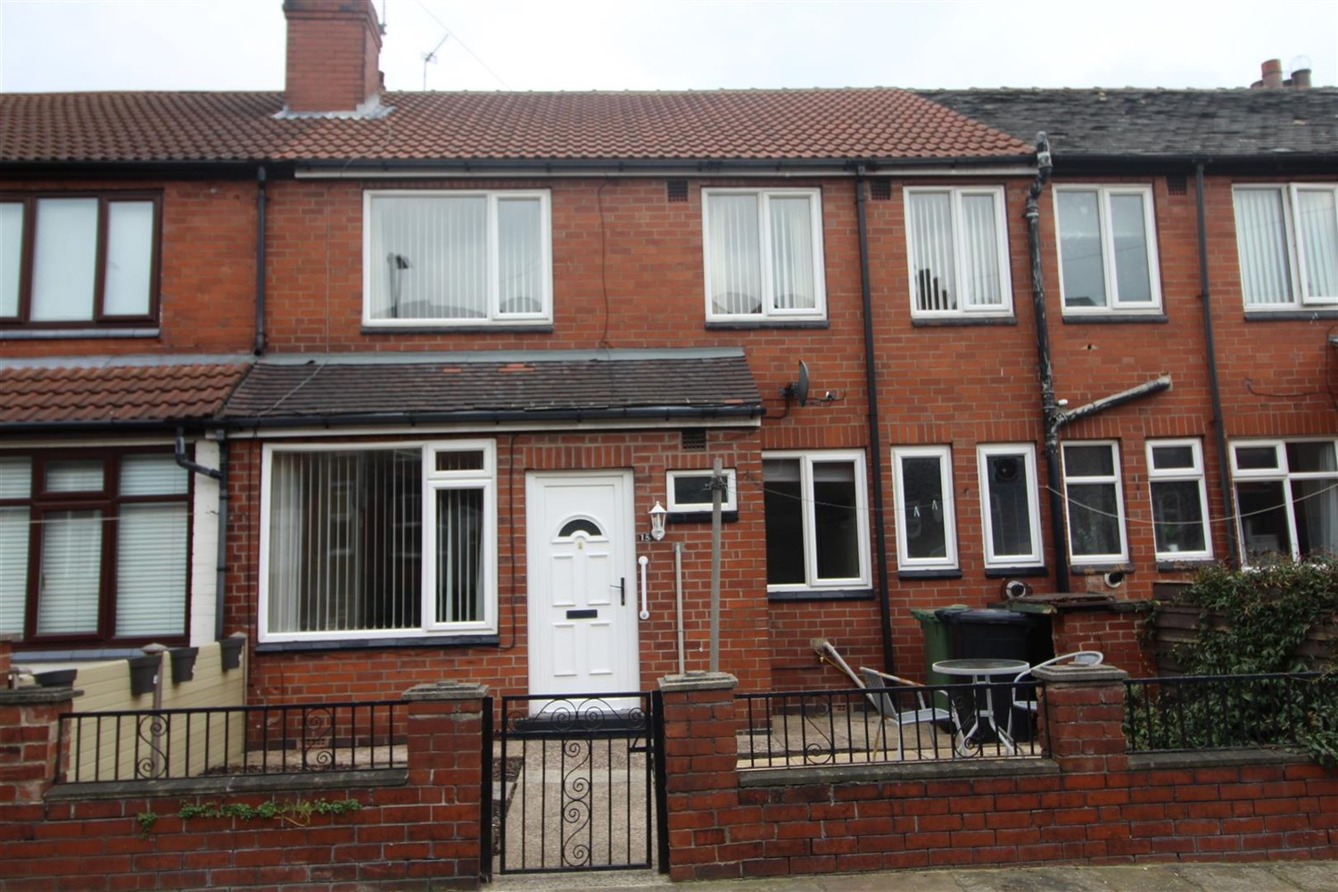



**Available to let £750.00pcm**

**Cross Flatts Street, LS11**

* Well presented two/three bedroom back to back mid terrace house available NOW. The property benefits from gas central heating and double glazing. Accommodation briefly comprises; spacious Lounge, modern fitted Kitchen with light ash units, downstairs bathroom with modern three piece suite and shower over bath, upstairs there are three Bedrooms, master Bedroom being a larger than average sized double with fitted wardrobes. To the front of the property is a forecourt garden. The property is situated close to all local amenities and has great transport links to Leeds City Centre. Council Tax Band A. Unfurnished. Available NOW. Deposit £865

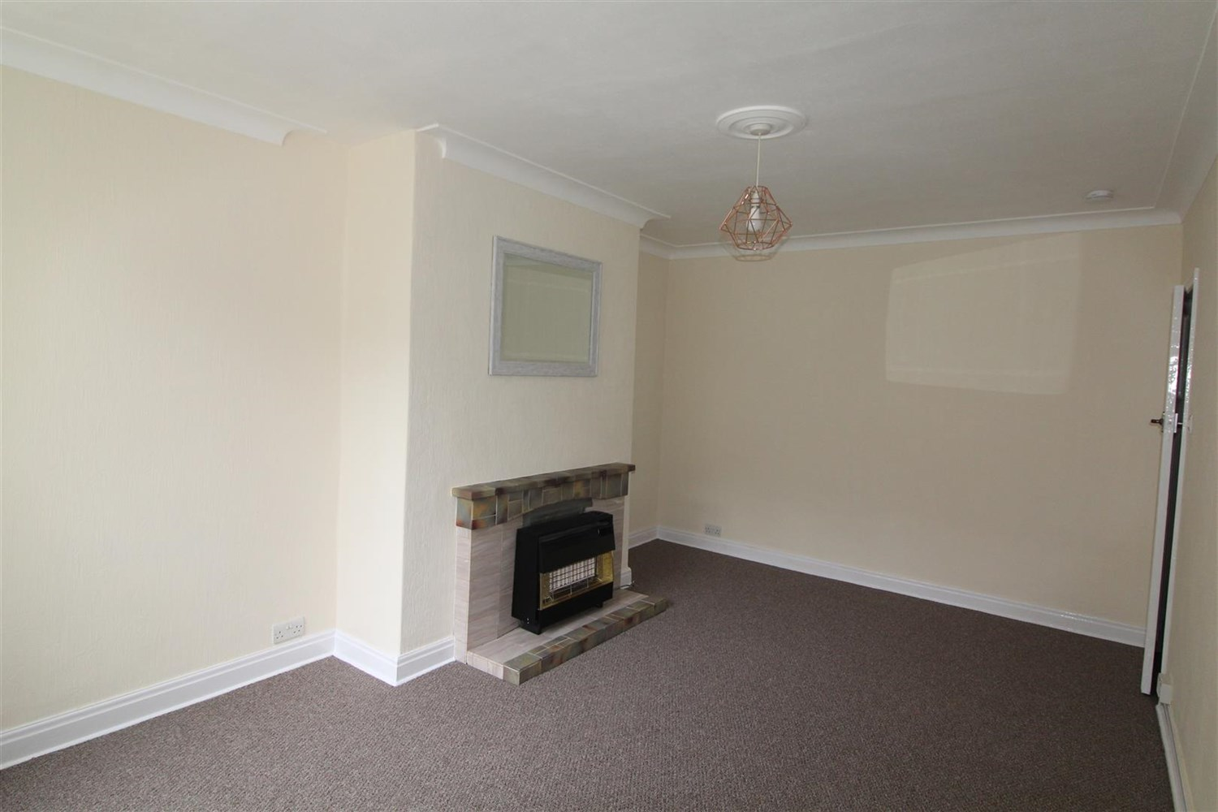

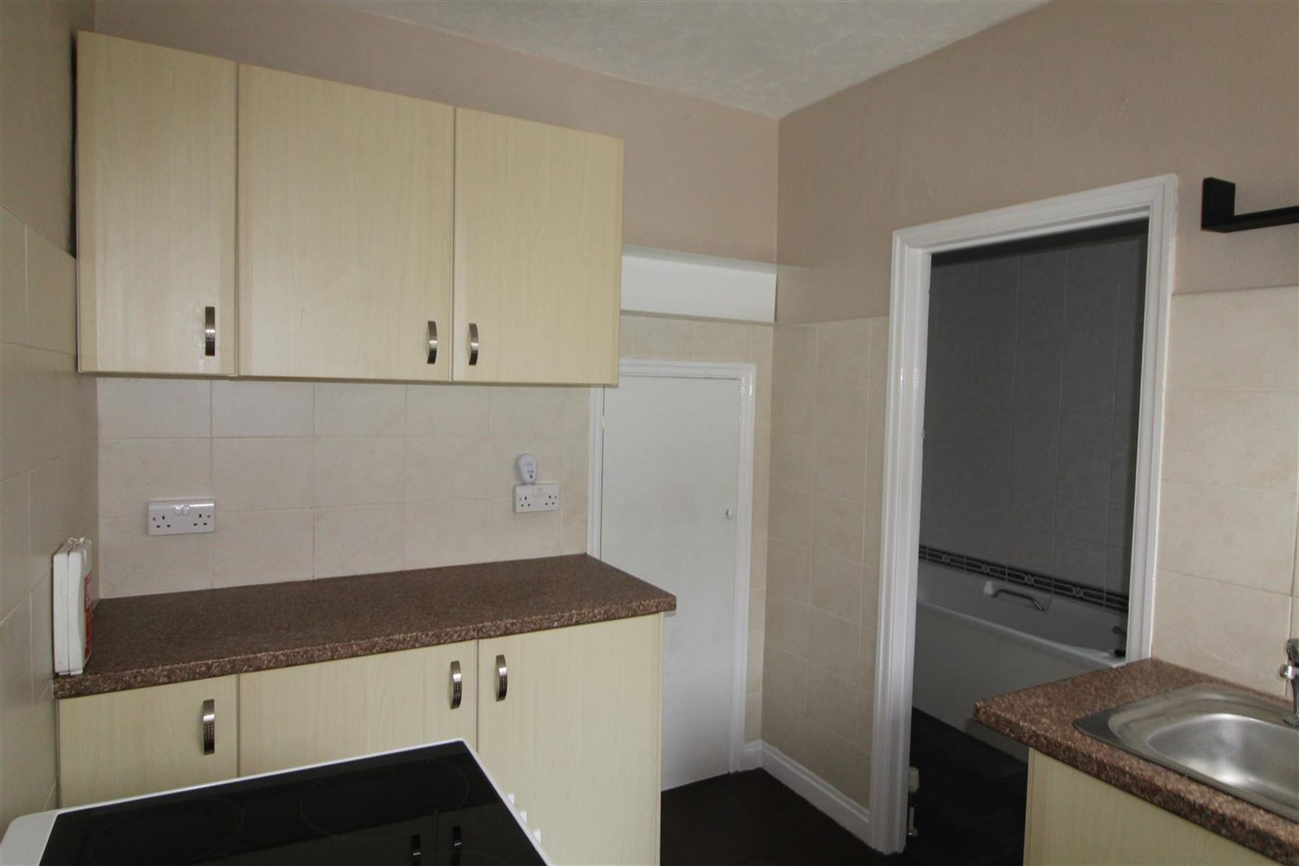



1 Bathroom(s)

1 Reception(s)

3 Bedroom(s)

00

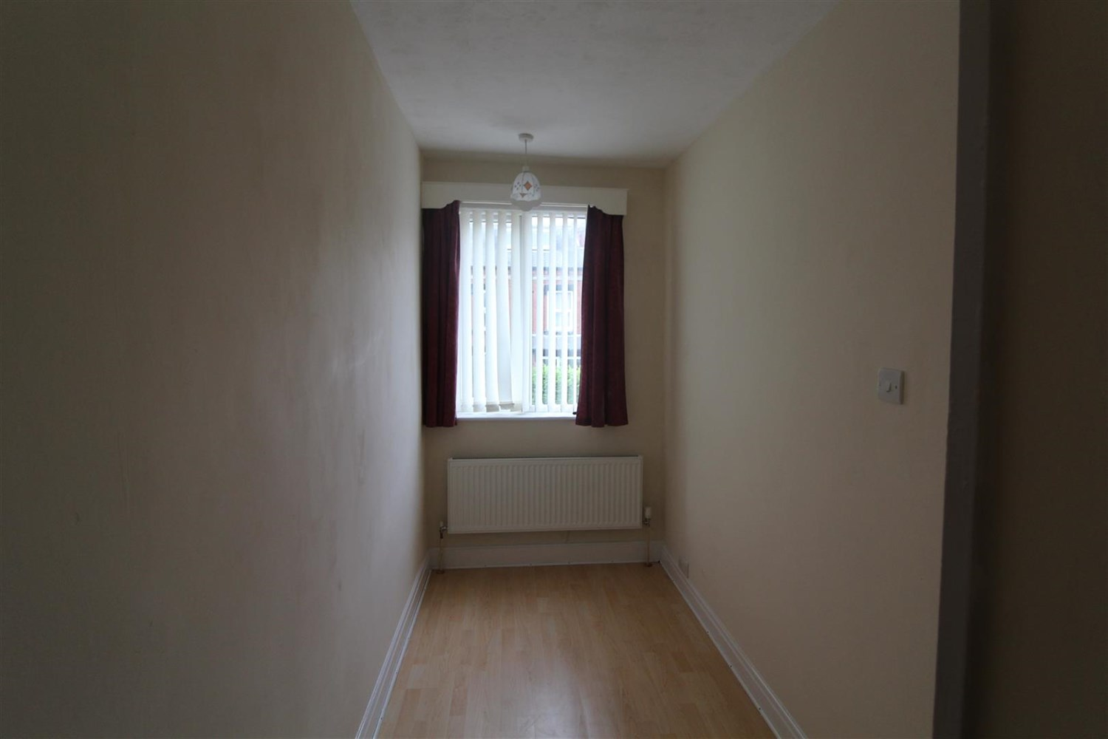

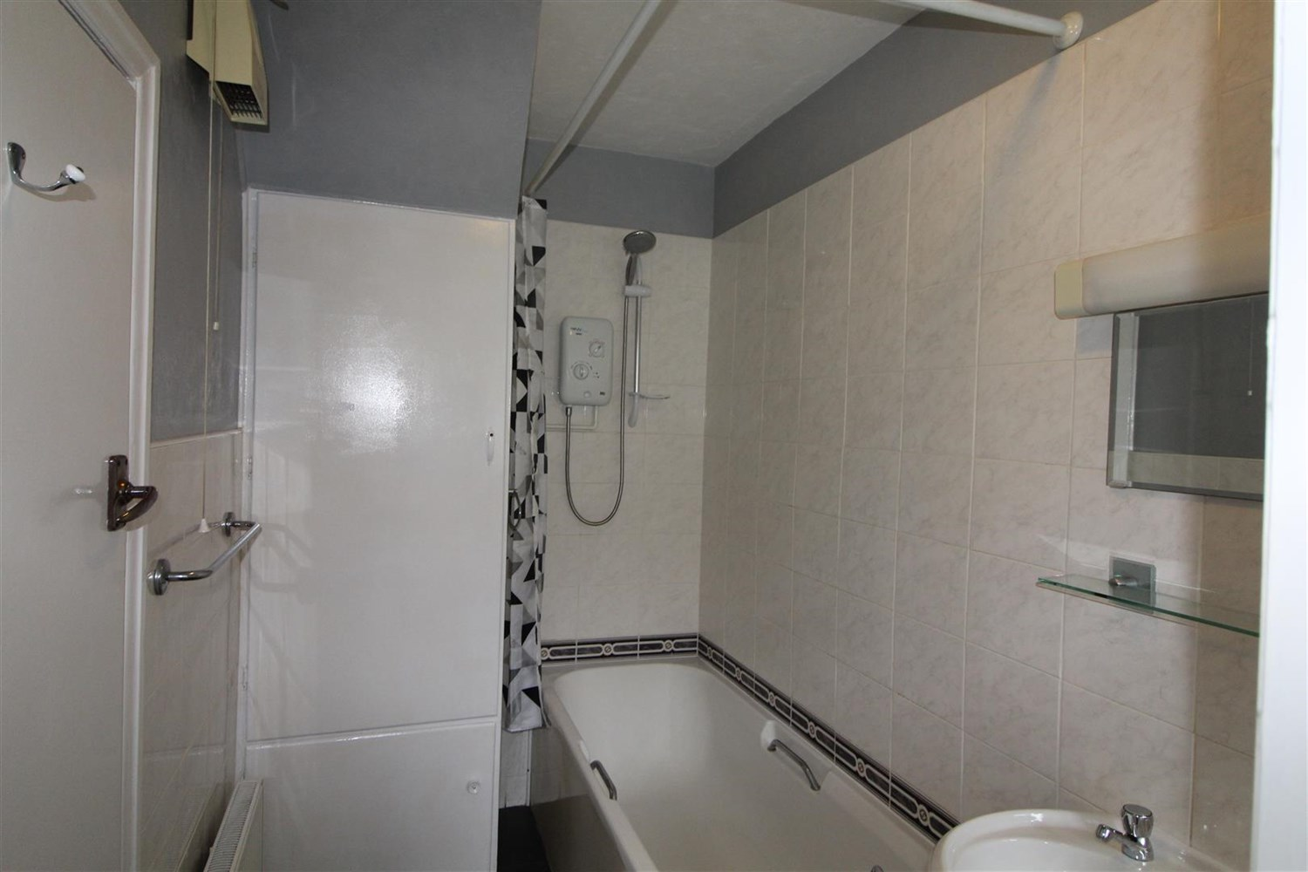

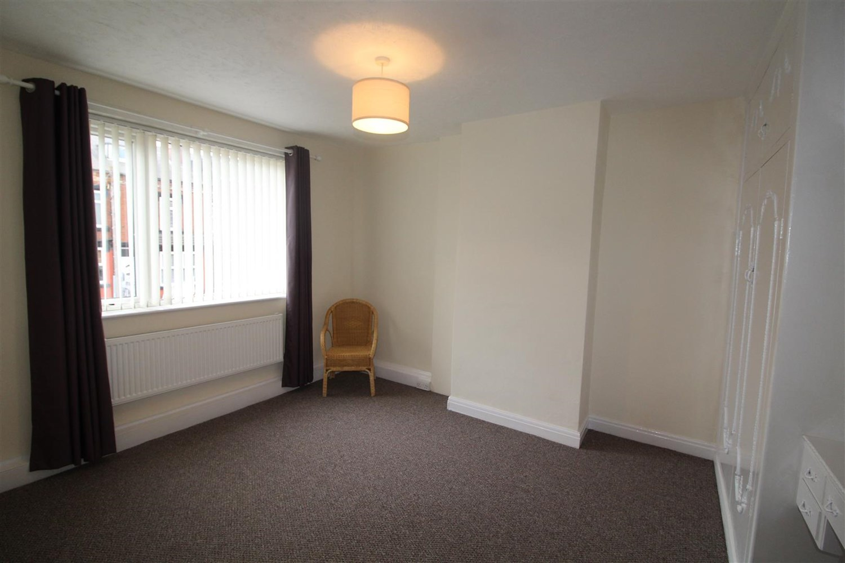

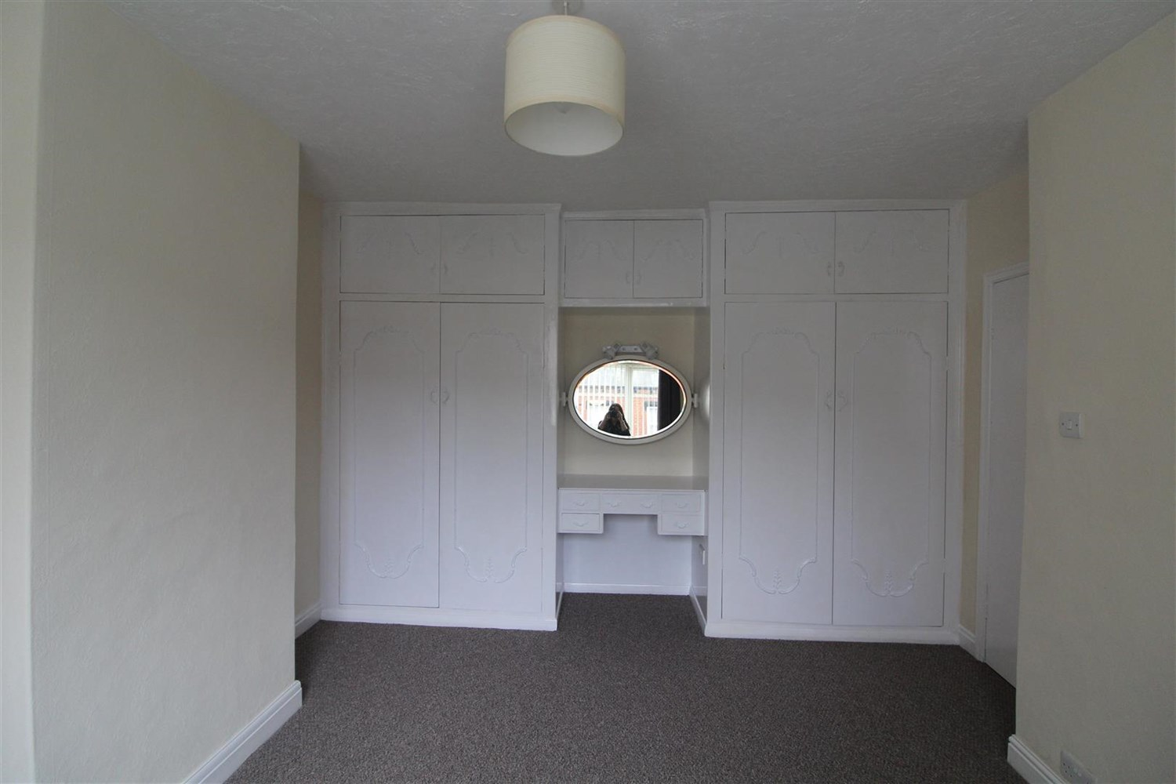

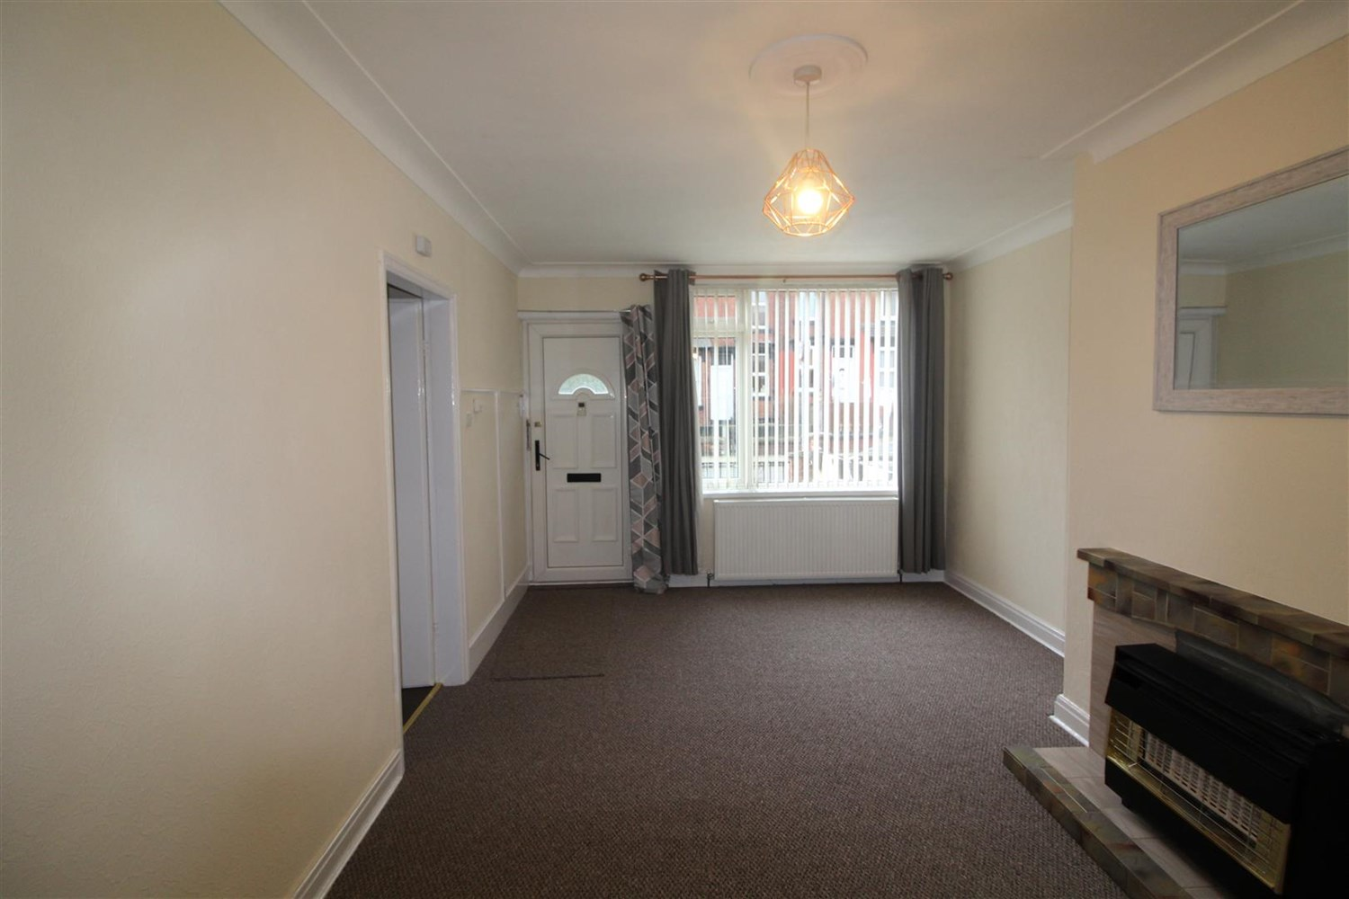

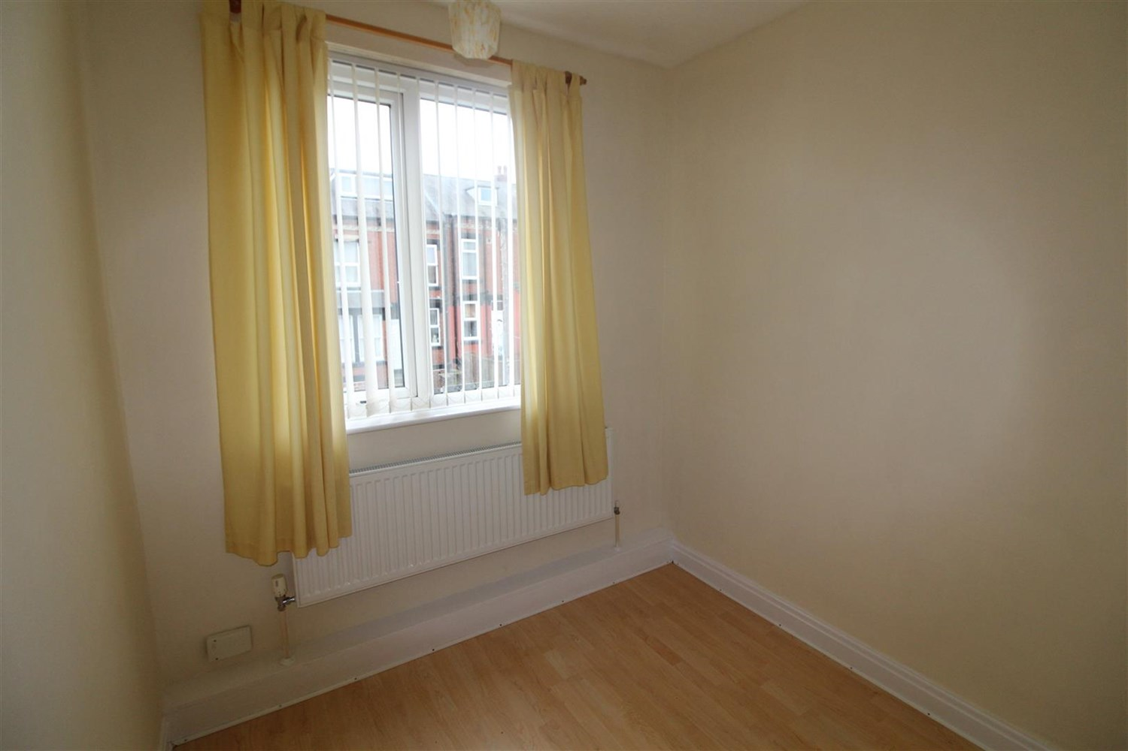

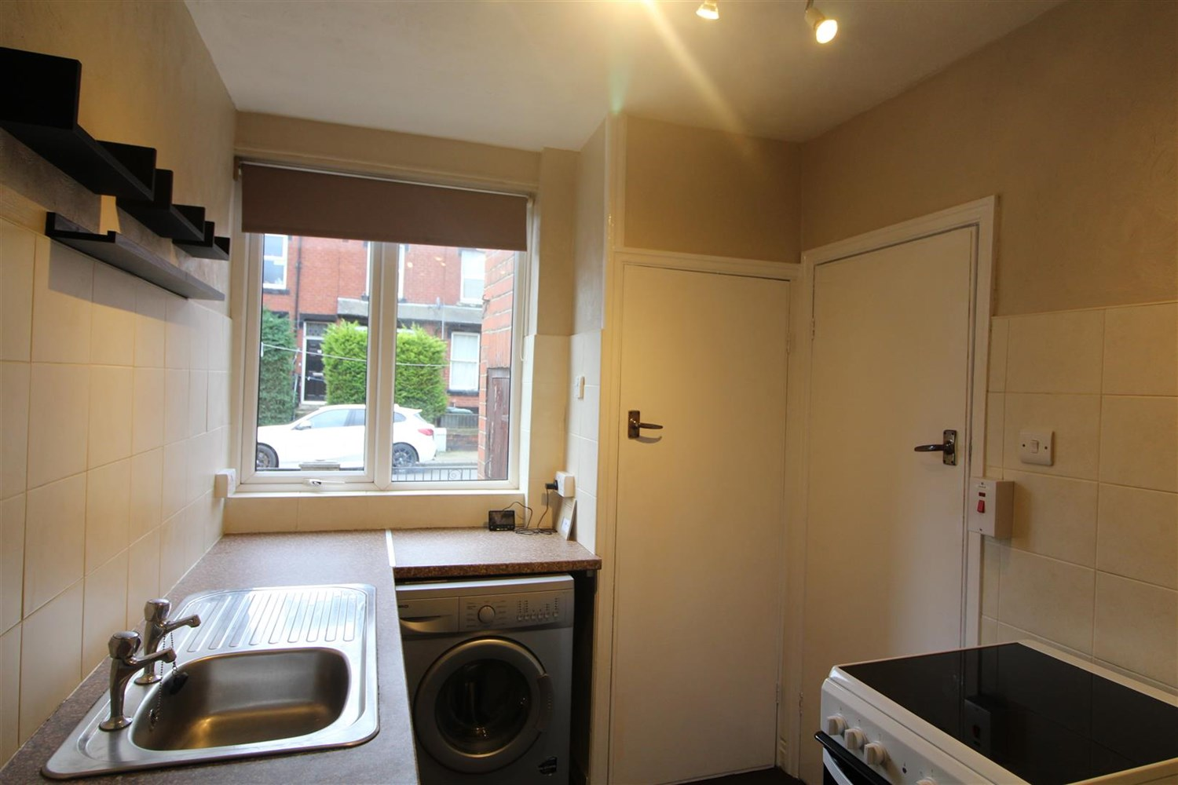

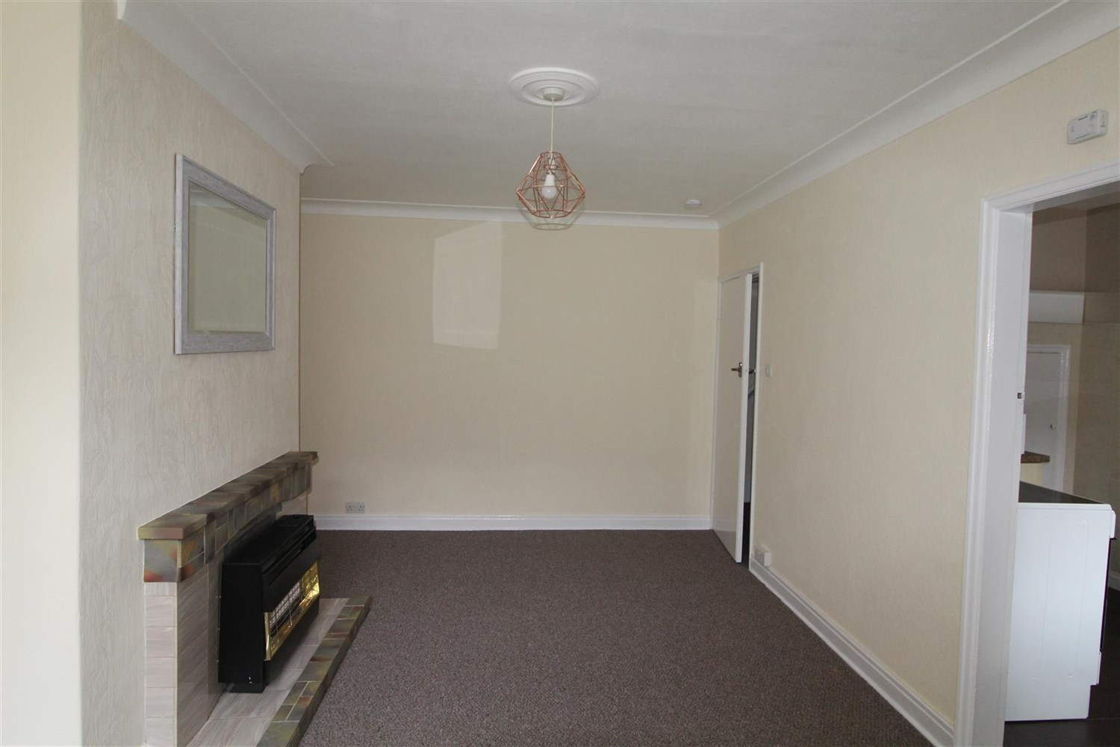

|  |
| --- |
| **Living Room**  Light and airy lounge with gas fire, window to front. |
| **Kitchen**  Fitted with a range of wall and base units with worktops over, stainless steel sink, window to front. |
| **Bedroom**  Double bedroom with fitted wardrobes, window to front, gas central heating radiator. |
| **Bedroom 2**  Bedroom two with window to rear, gas central heating. |
| **Bedroom 3**  Single bedroom with window to front. |
| **Bathroom**  Three piece bathroom suite with shower over bath, w/c and hand wash basin, part tiled walls. |
| **Home Information**  COUNCIL TAX BAND: A EPC Rating: D  Freehold property Street Parking  Broadband: Standard 15 Mbps 1 Mbps Good Superfast 80 Mbps 20 Mbps Good Ultrafast 1800 Mbps 220 Mbps Mobile availability: EE limited. Three Limited. O2 likely to have good coverage. Vodafone limited coverage.  Utilities: Water supplied on standard meters. Electric mains supplied on standard meters. Gas mains supplied on standard meters |

|  |  |
| --- | --- |
| These particulars are intended to give a fair description of the property, but their accuracy cannot be guaranteed, and they do not constitute an offer of contract. Intending purchasers must rely on their own inspection of the property. None of the above appliances/services have been tested by ourselves. We recommend purchasers arrange for a qualified person to check all appliances/services before legal commitment.  **Property Ref:** 5832  **For more information, please contact**  0113 258 1150 **|** [lettings@adairpaxton.co.uk](mailto:lettings@adairpaxton.co.uk) **|** www.adairpaxton.co.uk |  |