

**0113 258 1150**

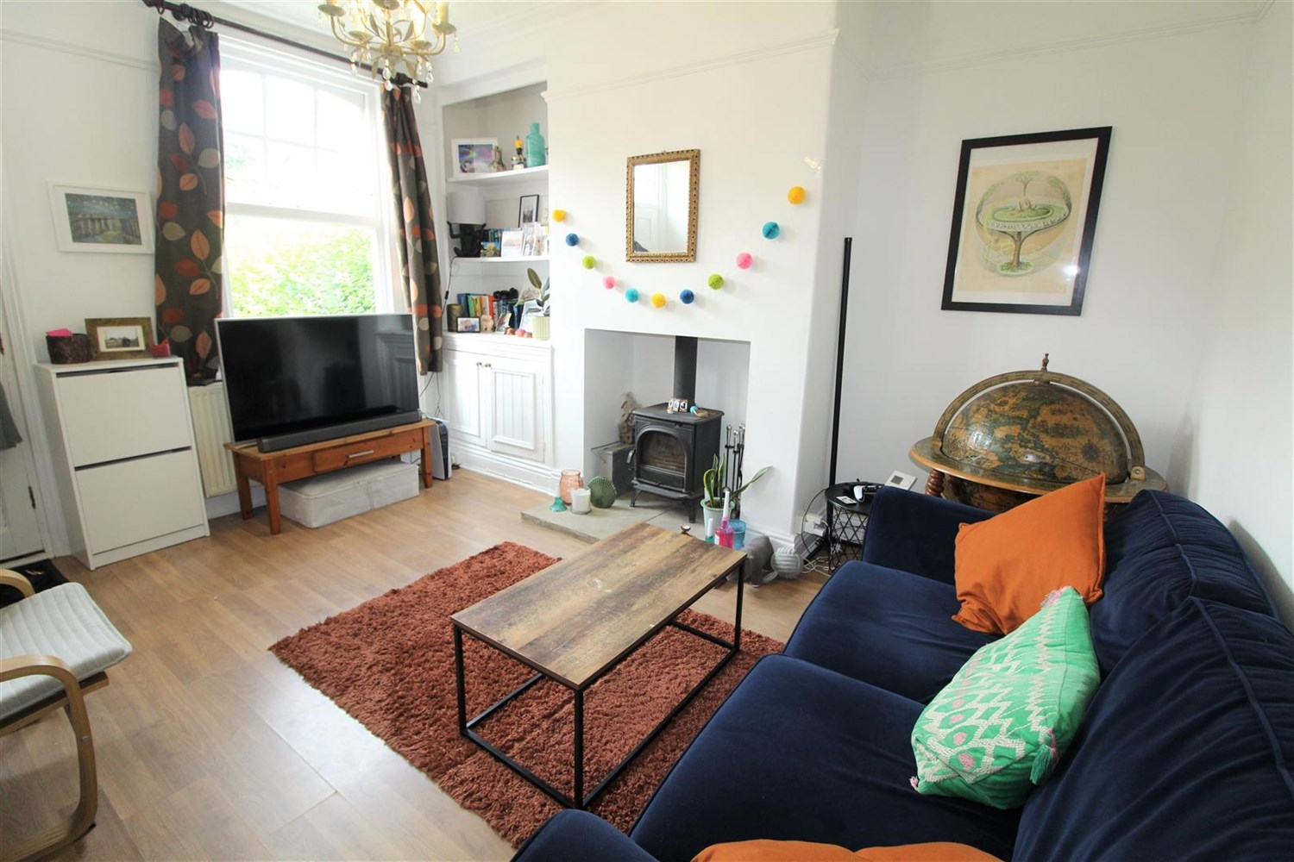



**Available to let £1,100.00pcm**

**Methley Place, LS7**

Two Bedroom terrace property with additional STUDY which has been sympathetically refurbished to retain much of the original character and integrity of the house. The accommodation has double glazed windows which have been specifically designed to replicate the originals and has combination gas fired central heating with instant hot water and tasteful décor throughout. Stylish kitchen and bathroom. Great garden perfect for those long summer evenings. The vibrant village of Chapel Allerton offers extensive local amenities including a range of cosmopolitan restaurants and café bars, supermarkets, banks and various other specialists shops. Local leisure facilities include a swimming pool, tennis and squash club. There are excellent public transport links to the surrounding areas and the City Centre, this being only a ten minute drive away. On street parking. Available Deposit £1265. Council tax band A, EPC rating D.

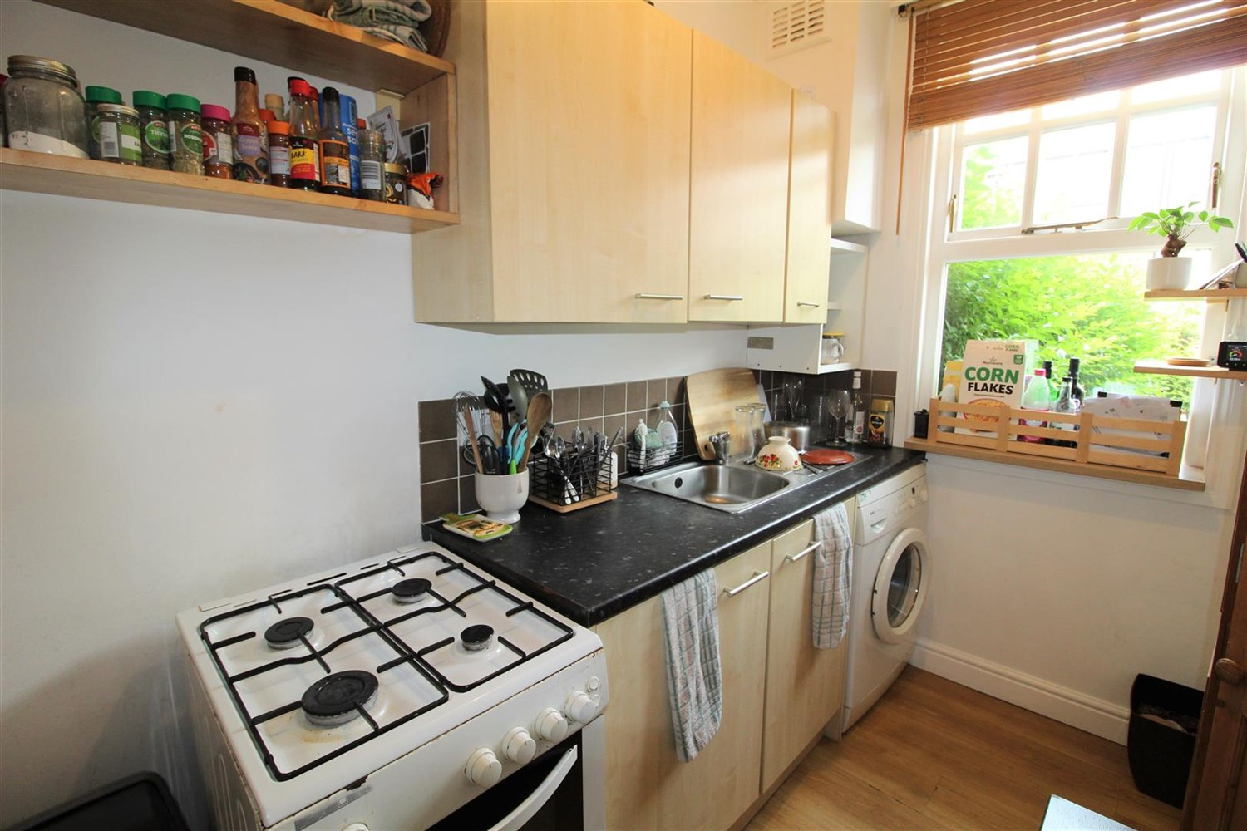

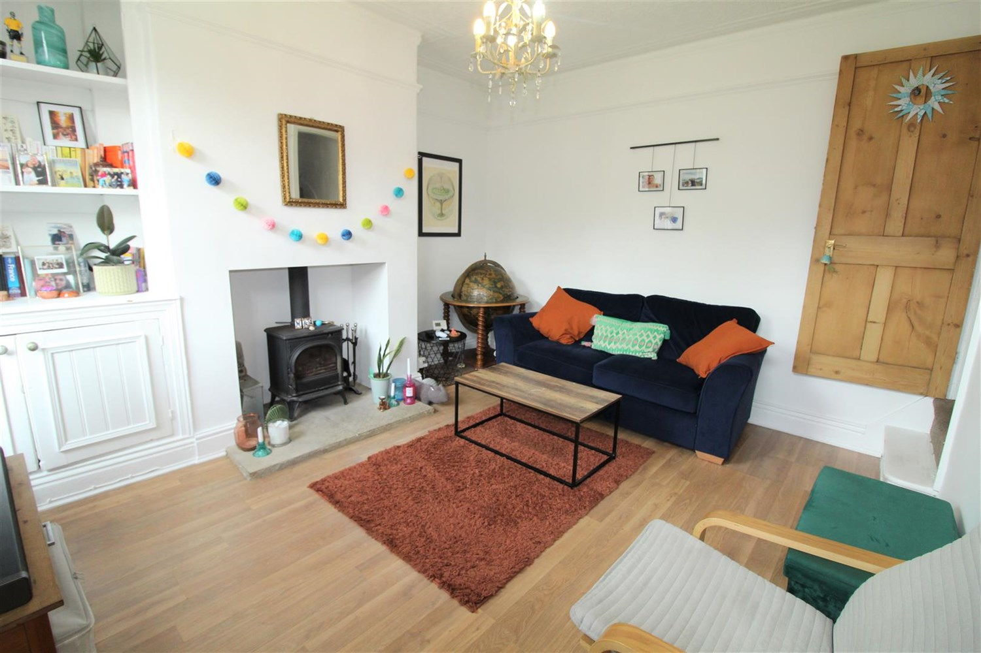

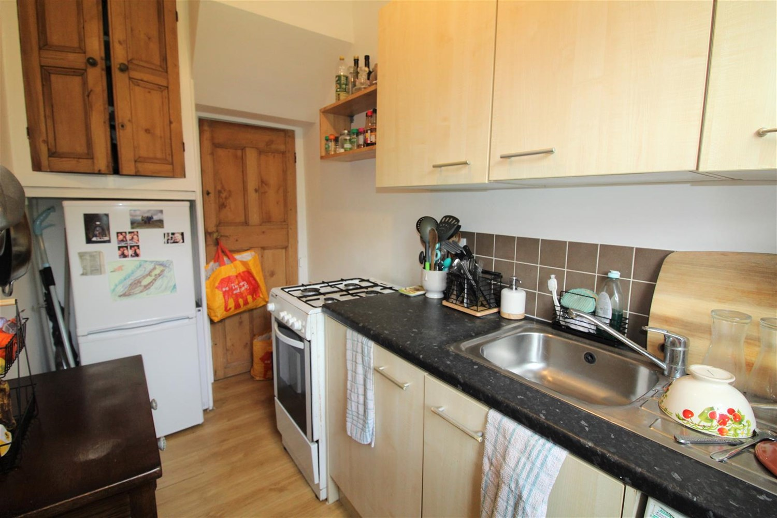

1 Bathroom(s)

1 Reception(s)

2 Bedroom(s)

00

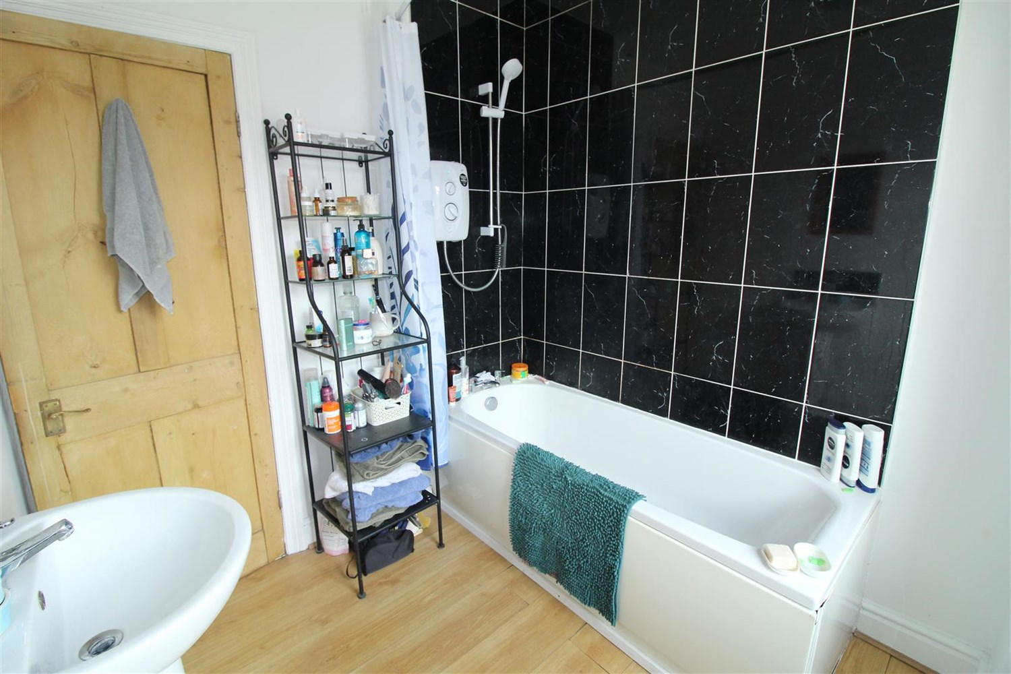

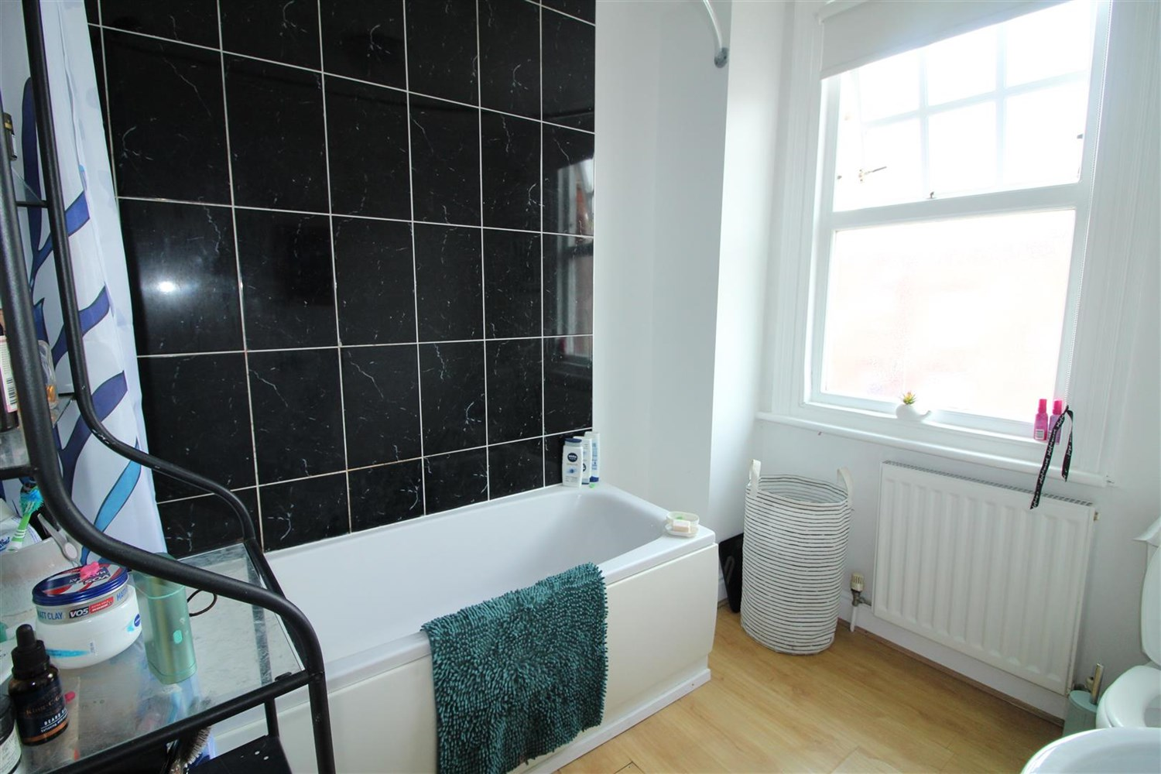

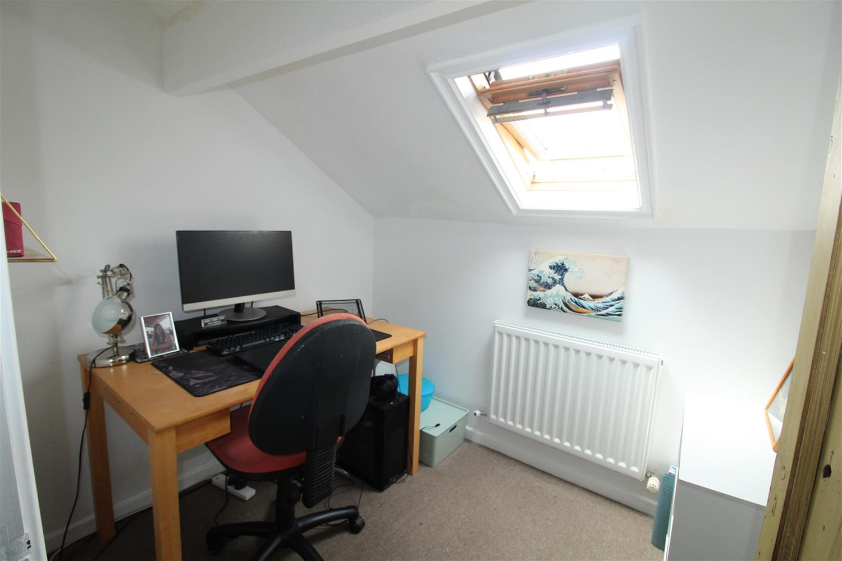

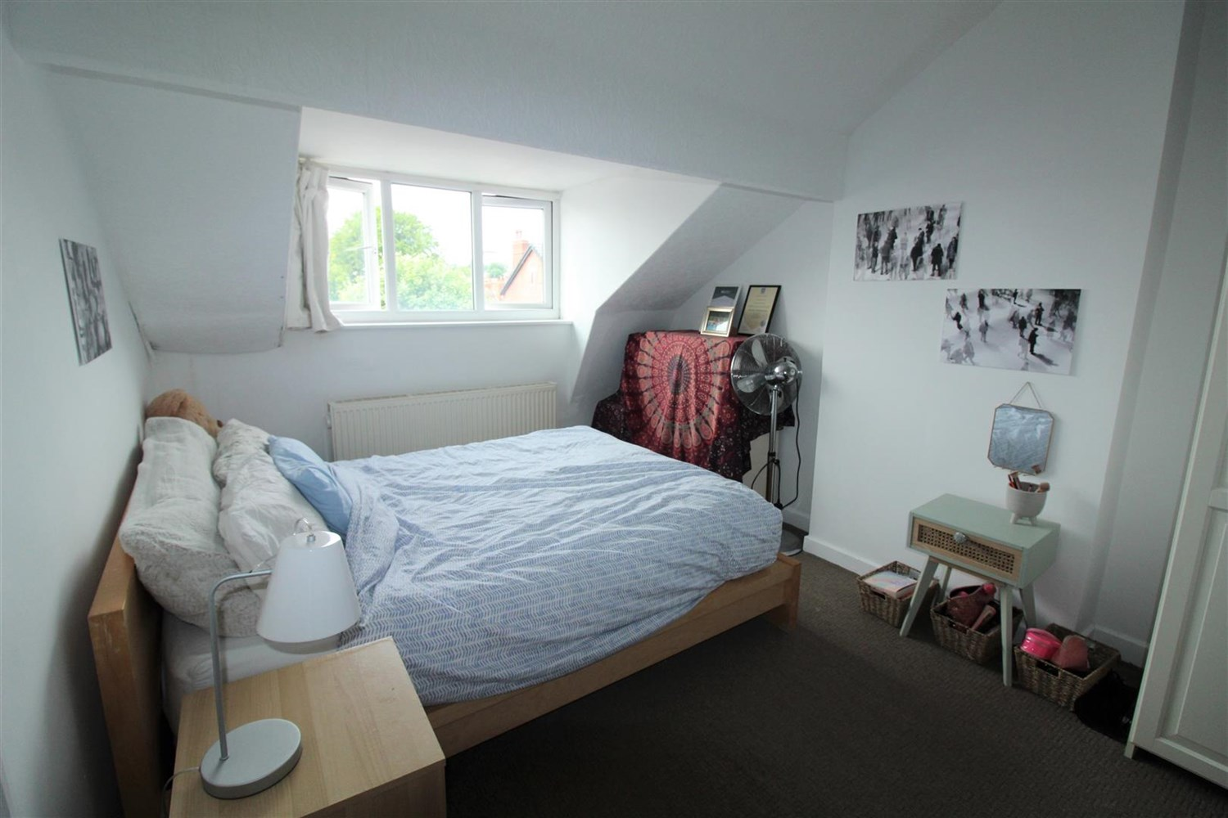

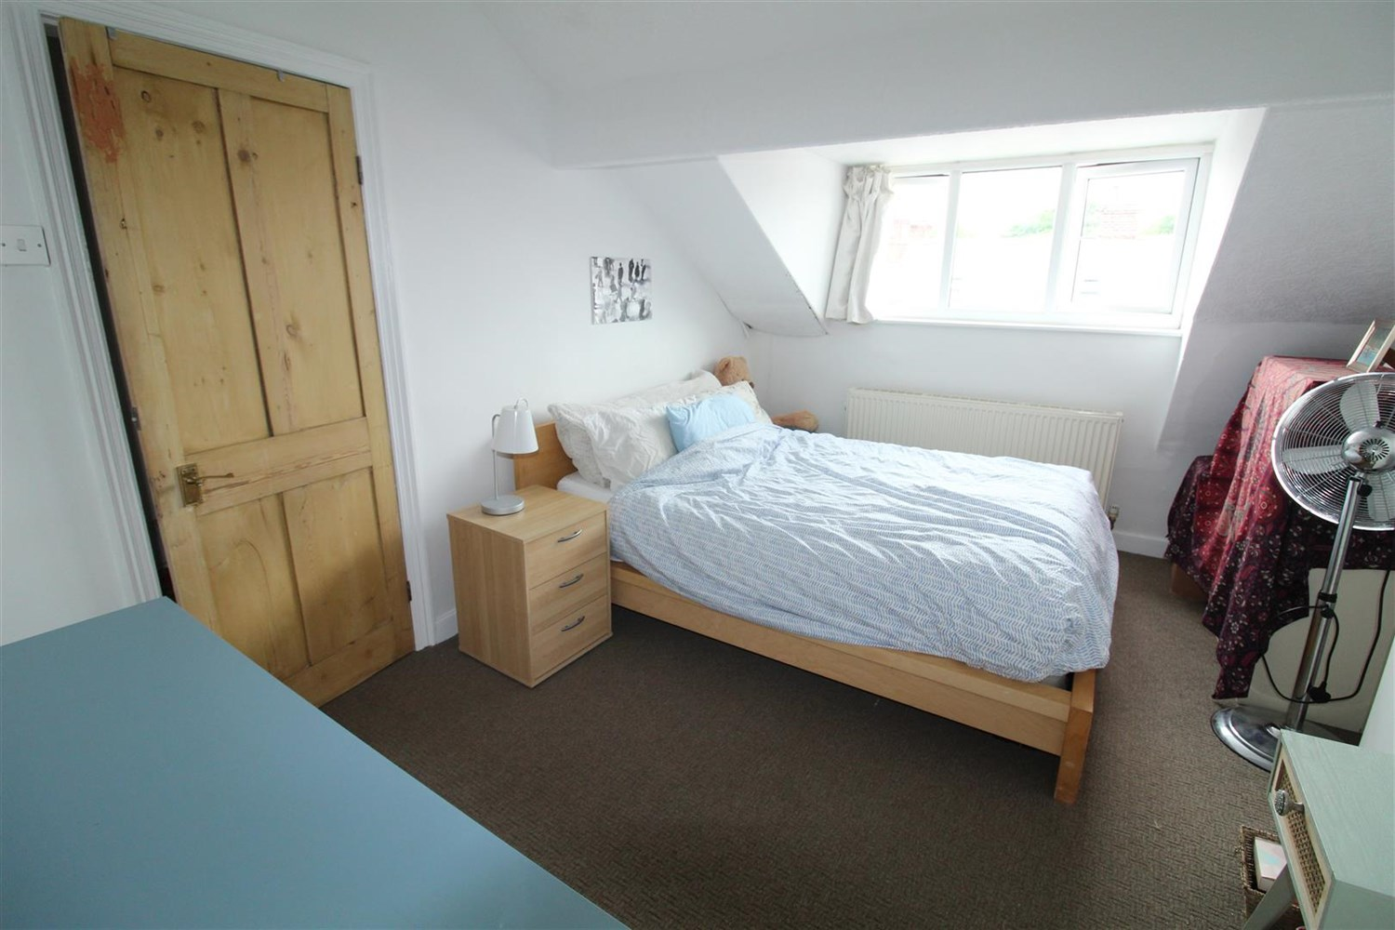

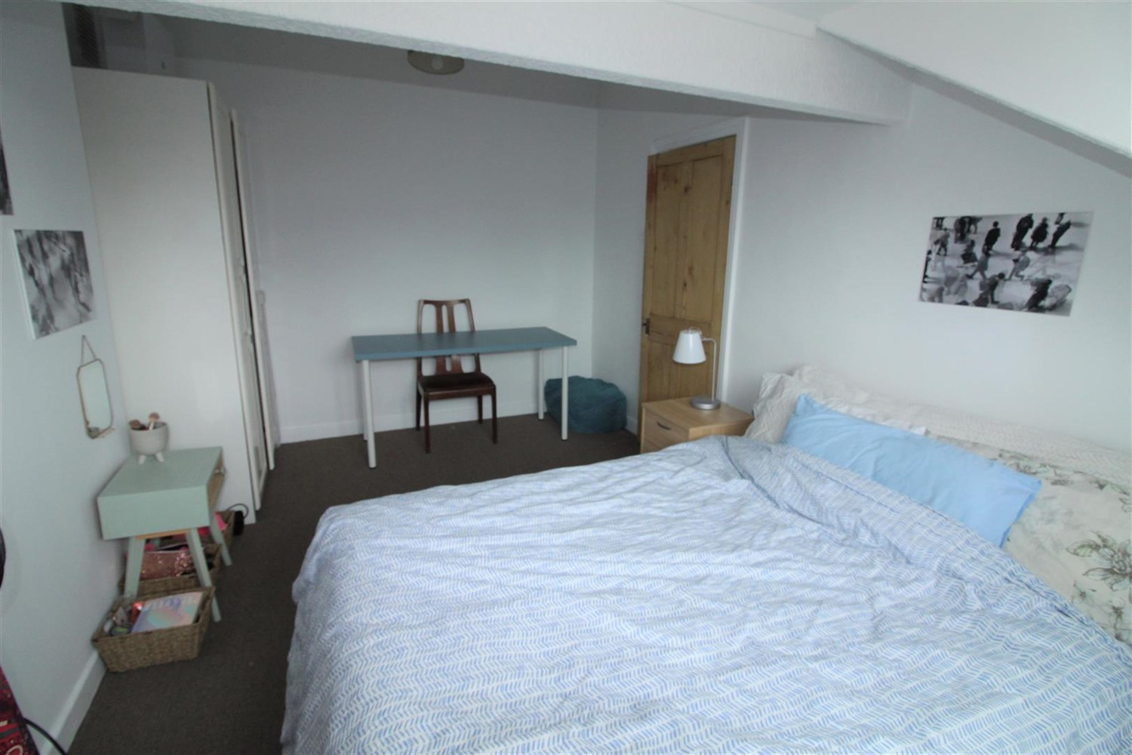

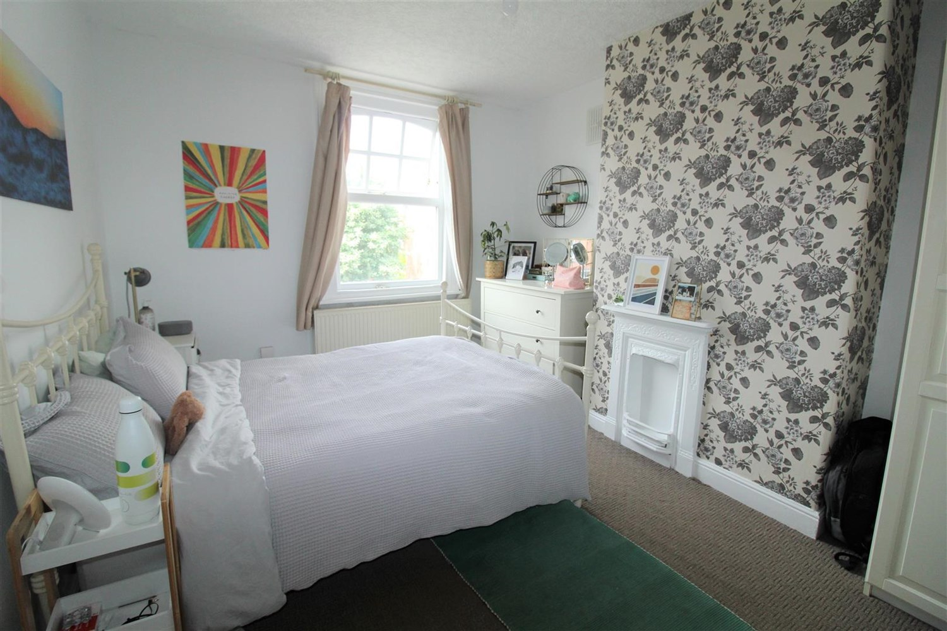

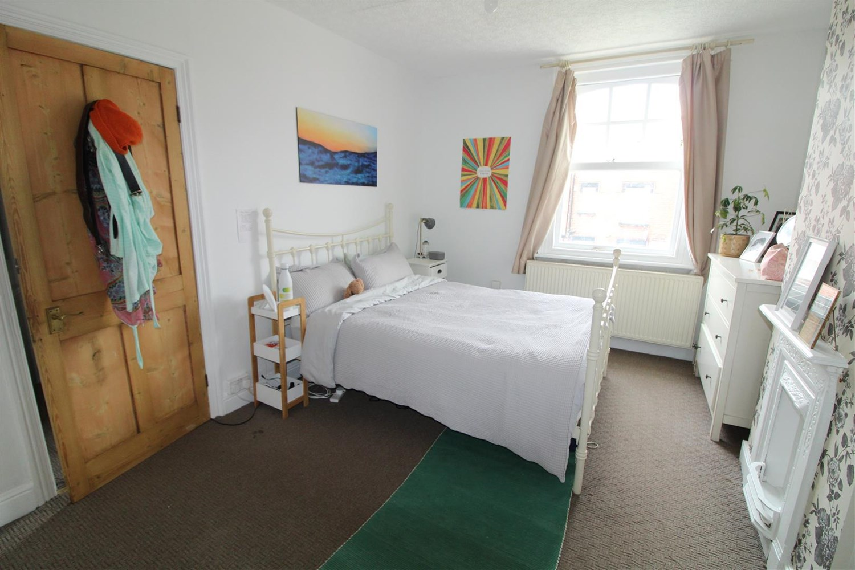

|  |
| --- |
| **Reception 1**  Spacious lounge with log fire, window to front, gas central heating radiator. |
| **Kitchen**  Fitted with a range of wall and base units with worktops over, stainless steel sink, window to front. Access to cellar. |
| **Bedroom 1**  Carpeted double bedroom with window to front, gas central heating radiator. |
| **Bedroom 2**  Carpeted double bedroom with window to front, gas central heating radiator. |
| **Bathroom**  Three piece bathroom suite with shower over bath, w/c and hand wash basin, part tiled walls. |
| **Courtyard Garden**  Small courtyard style garden to front. |
| **Parking**  On street parking. |
| **Central Heating**  Gas central heating throughout. |
| **Home Information**  COUNCIL TAX BAND: A EPC Rating: D  Freehold property Street Parking  Broadband: Standard 15 Mbps 1 Mbps Good Superfast 80 Mbps 20 Mbps Good Ultrafast 1800 Mbps 220 Mbps Mobile availability: EE limited. Three Limited. O2 likely to have good coverage. Vodafone limited coverage.  Utilities: Water supplied on standard meters. Electric mains supplied on standard meters. Gas mains supplied on standard meters |

|  |  |
| --- | --- |
| These particulars are intended to give a fair description of the property, but their accuracy cannot be guaranteed, and they do not constitute an offer of contract. Intending purchasers must rely on their own inspection of the property. None of the above appliances/services have been tested by ourselves. We recommend purchasers arrange for a qualified person to check all appliances/services before legal commitment.  **Property Ref:** 5828  **For more information, please contact**  0113 258 1150 **|** [lettings@adairpaxton.co.uk](mailto:lettings@adairpaxton.co.uk) **|** www.adairpaxton.co.uk |  |