

**0113 258 1150**

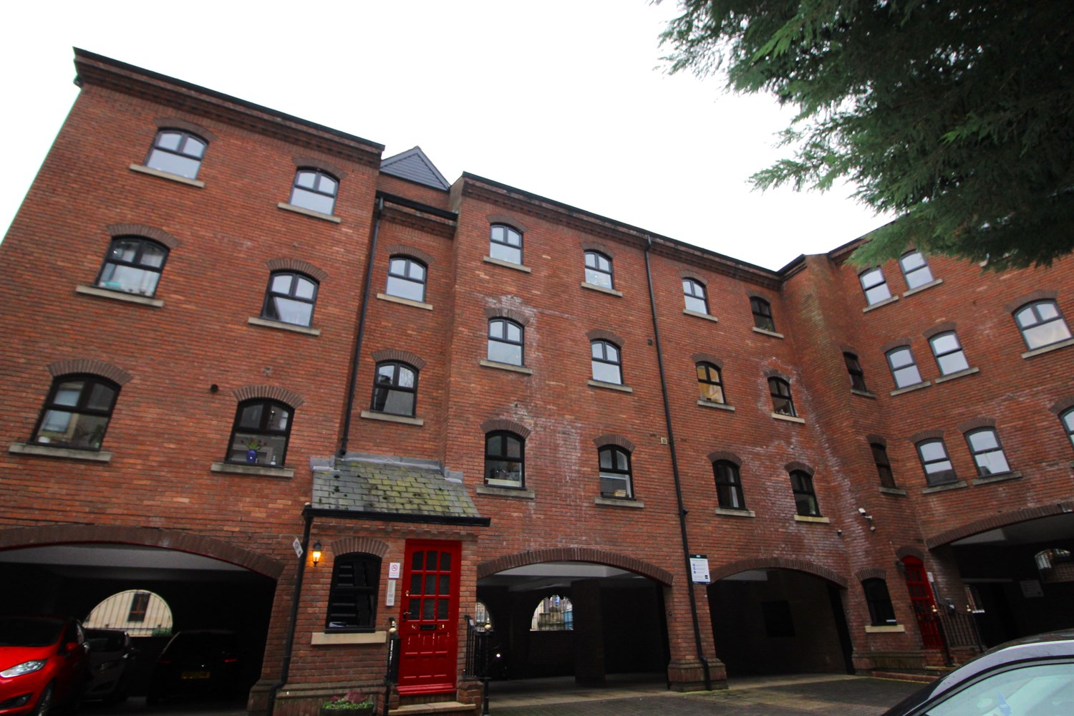



**Available to let £995.00pcm**

**Riverside Court, LS1**

****STUNNING NEWLY DECORATED TWO BED APARTMENT IN LEEDS CITY CENTRE WITH PARKING FOR TWO SMALL VEHICLES, WATER RATES INCLUDED****Situated in an excellent riverside location with views over Leeds Bridge and the River Aire. Second floor apartment briefly comprising; Communal entrance hall, stairs to second floor, private entrance hall, spacious lounge, kitchen with integrated appliances, house bathroom and two double bedrooms. Close to all of the City Centre amenities. Deposit £1145. Available Now. Due to the lease this property has a no pet policy. Council tax band D, EPC register D.

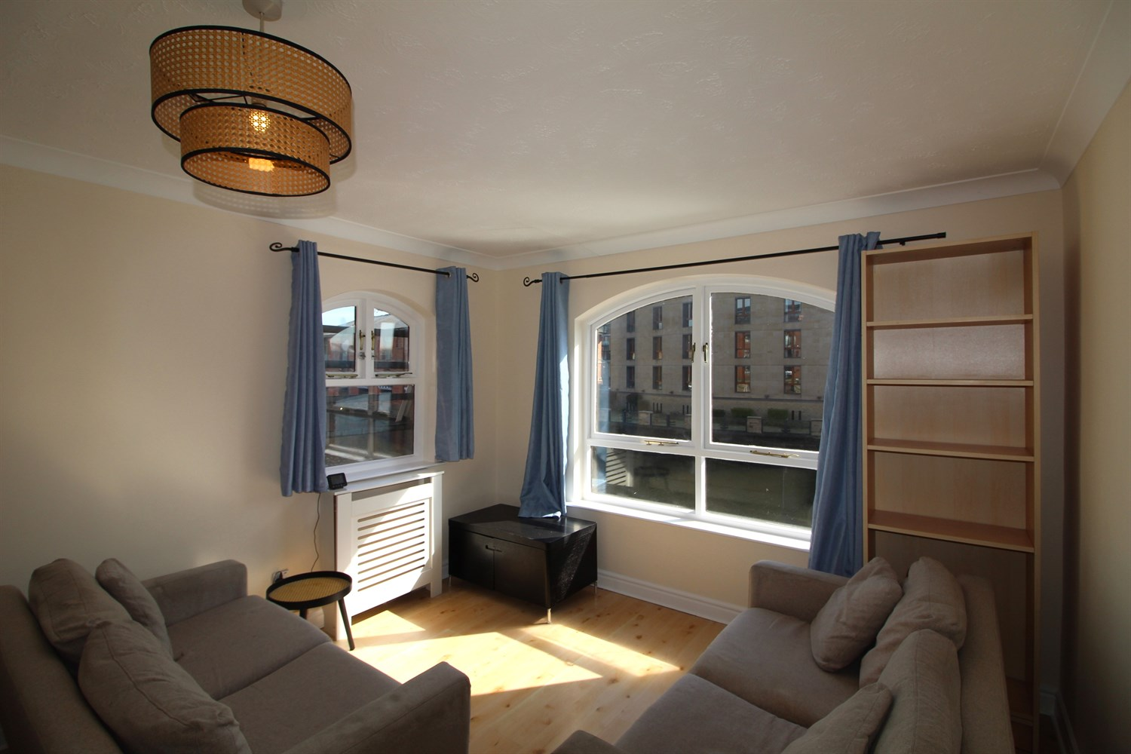

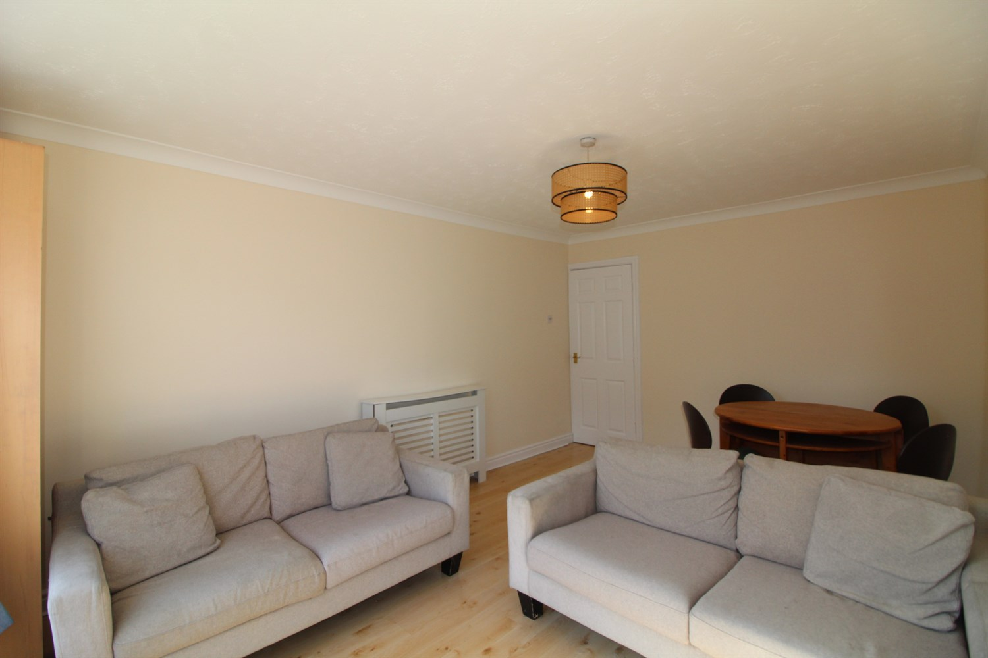

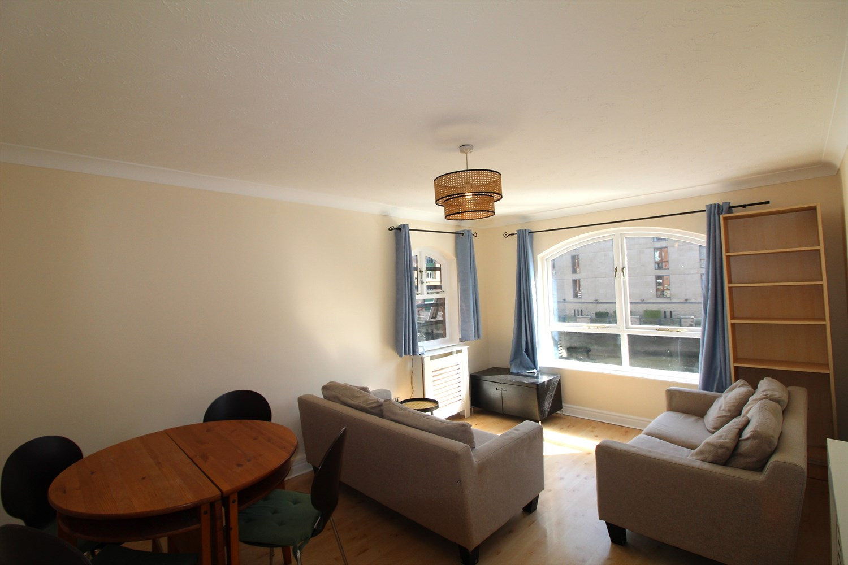

1 Bathroom(s)

1 Reception(s)

1 Bedroom(s)

00

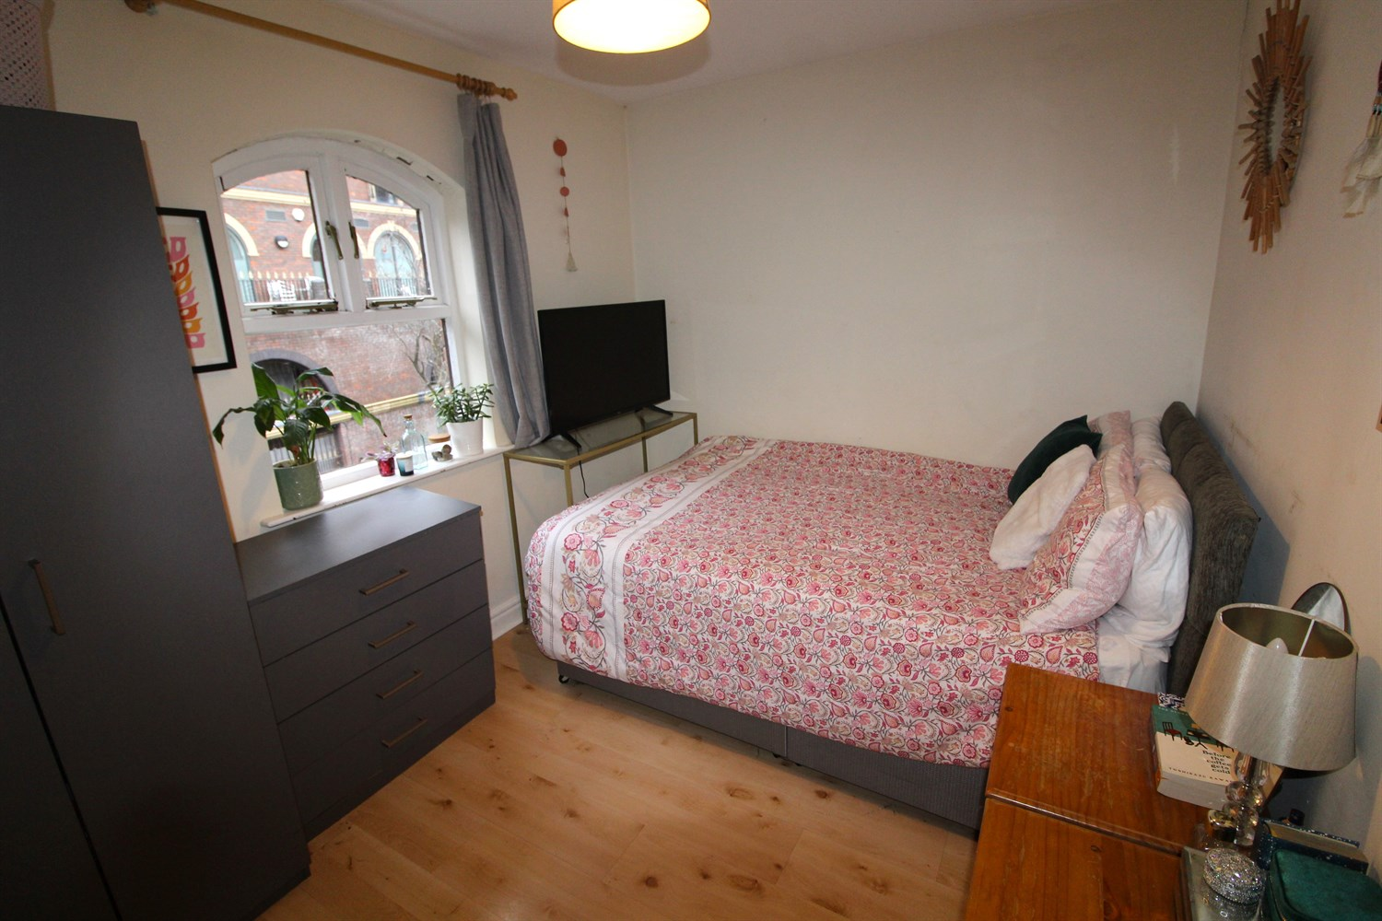

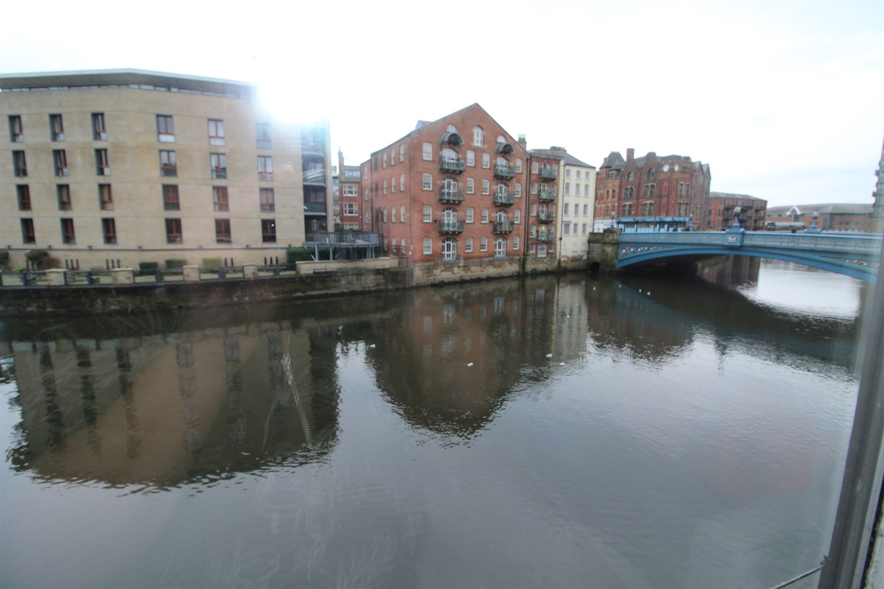

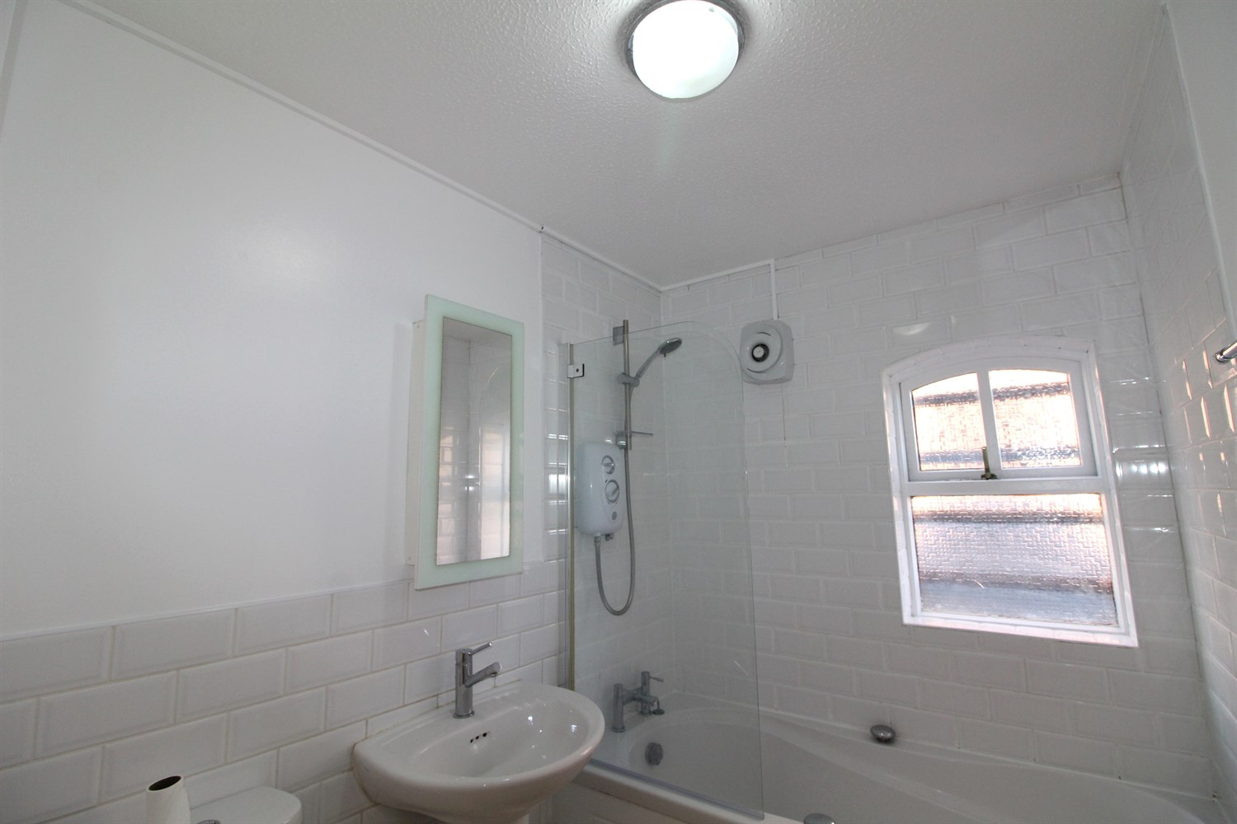

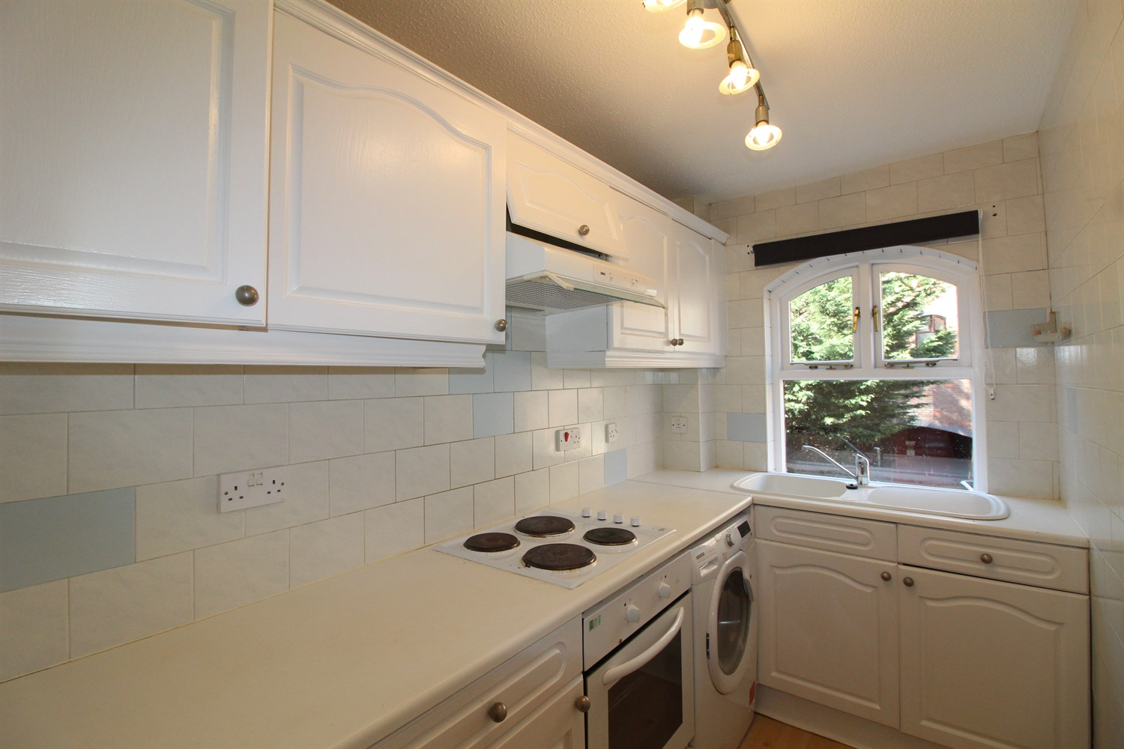

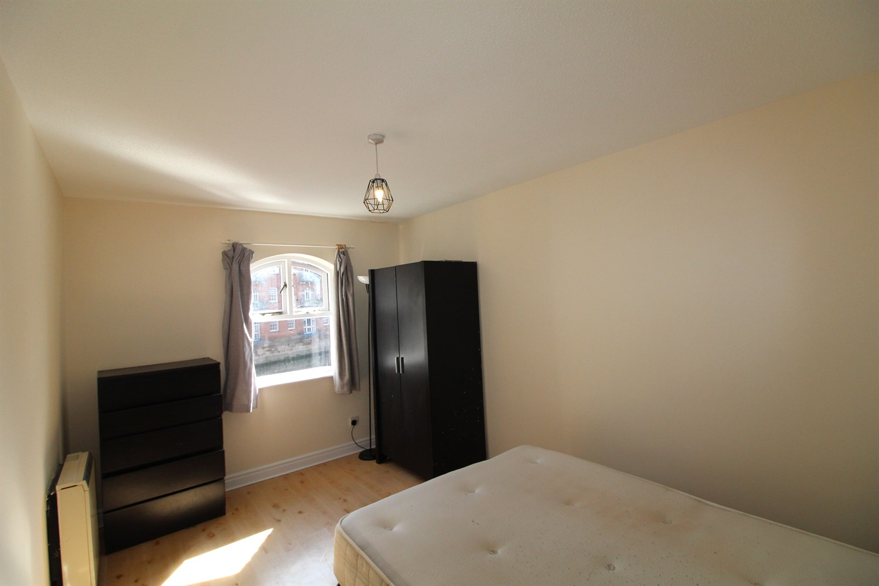

|  |
| --- |
| **Communal Entrance Hall**  Stairs leading to all floors. |
| **Private Entrance Hall**  Intercom |
| **Living Room**  Light and living room with windows over looking the canal, electric heater. |
| **Kitchen**  Fitted with a range of wall and base units with worktops over, electric oven and hob with extractor over, porcelain sink with mixer tap and drainer. Part tiled walls, |
| **Bedroom 1**  Double bedroom with window, views over canal, electric heater. |
| **Bedroom 2**  Double bedroom with window to rear, electric heater. |
| **Bathroom**  Three piece bathroom suite with shower over bath, shower screen, w/c, hand wash basin. Part tiled walls. |
| **Home Information**  COUNCIL TAX BAND: D EPC Rating: D  12 Month   Leasehold property Parking included for 2 small cars.  Broadband  Standard 16 Mbps 1 Mbps Good Superfast 80 Mbps 20 Mbps Good Ultrafast 900 Mbps 900 Mbps   Mobile availability: EE limited coverage. Three likely to have good coverage. O2 likely to have good coverage. Vodafone likely to have good coverage.  Utilities: Water supplied on standard meters. Electric mains supplied on standard meters. |

|  |  |
| --- | --- |
| These particulars are intended to give a fair description of the property, but their accuracy cannot be guaranteed, and they do not constitute an offer of contract. Intending purchasers must rely on their own inspection of the property. None of the above appliances/services have been tested by ourselves. We recommend purchasers arrange for a qualified person to check all appliances/services before legal commitment.  **Property Ref:** 4468  **For more information, please contact**  0113 258 1150 **|** [lettings@adairpaxton.co.uk](mailto:lettings@adairpaxton.co.uk) **|** www.adairpaxton.co.uk |  |