

**0113 258 1150**

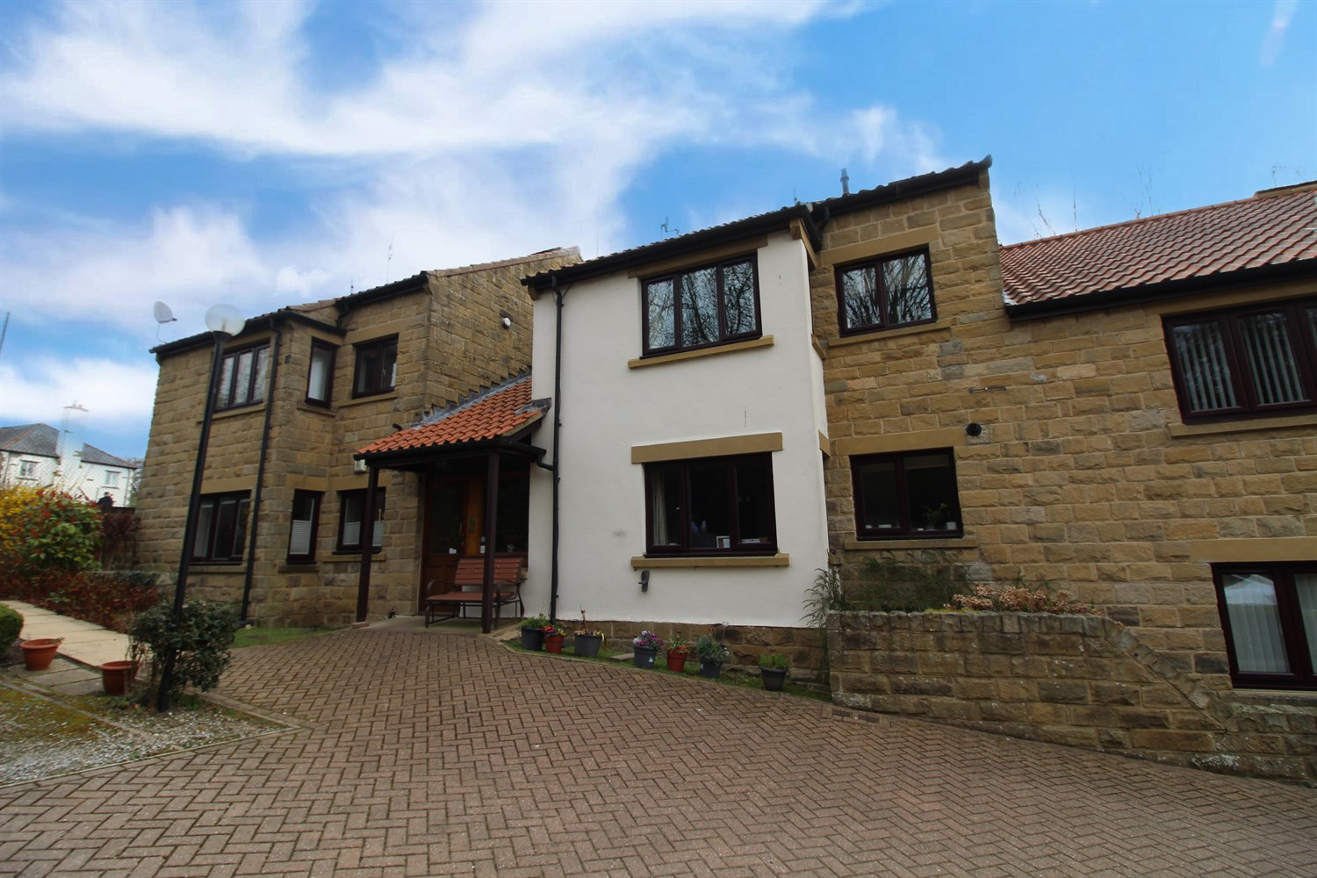



**Available to let £750.00pcm**

**Russell Court, Bardsey**

***OVER 55 DEVELOPMENT*** ONE BEDROOM GROUND FLOOR APARTMENT IN THE SOUGHT AFTER LOCATION OF BARDSEY VILLAGE*** Neutral decoration and carpets throughout and with the benefit of gas central heating, pleasant communal gardens and on-site parking. The accommodation briefly comprising; Private hallway with storage, spacious lounge, stylish shaker kitchen with oven/hob/extractor, one double bedrooms, bathroom with corner shower unit. FURNISHED or UNFURNISHED. Deposit £865. Parking for one vehicle. Available Now, council tax band B, EPC rating C.

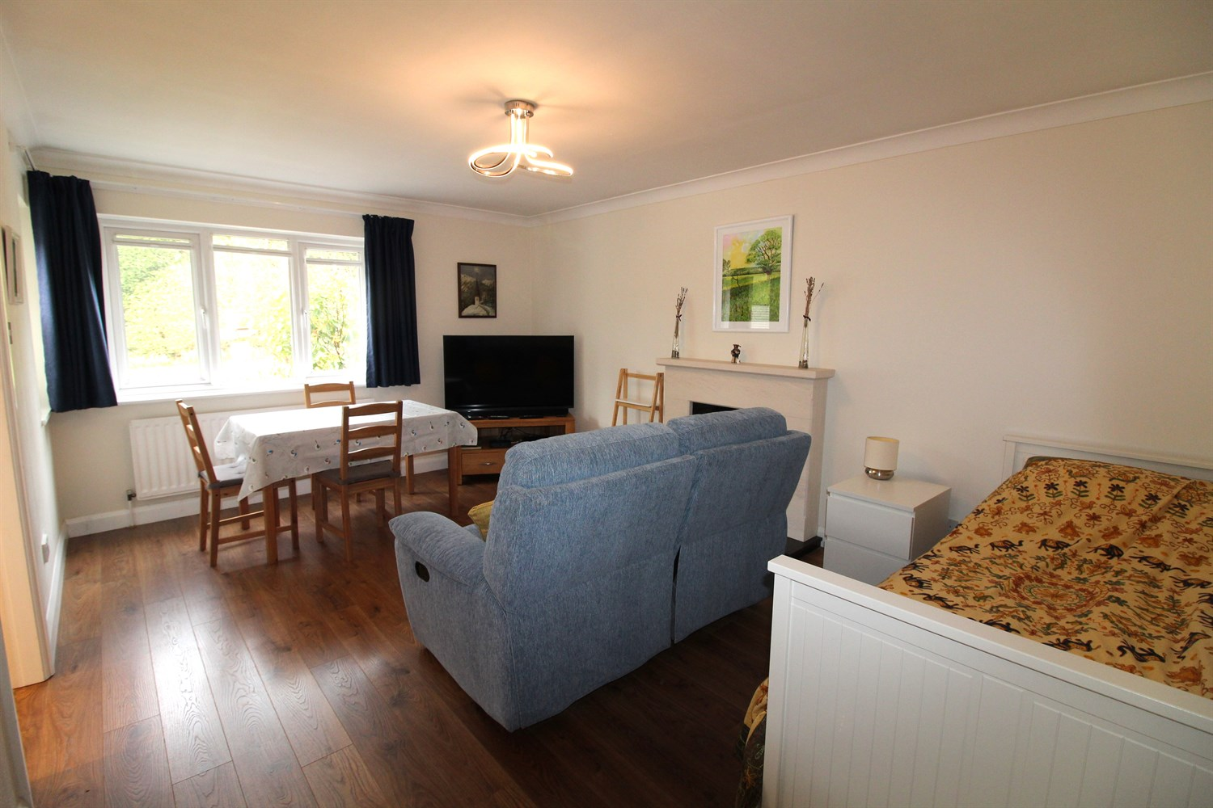

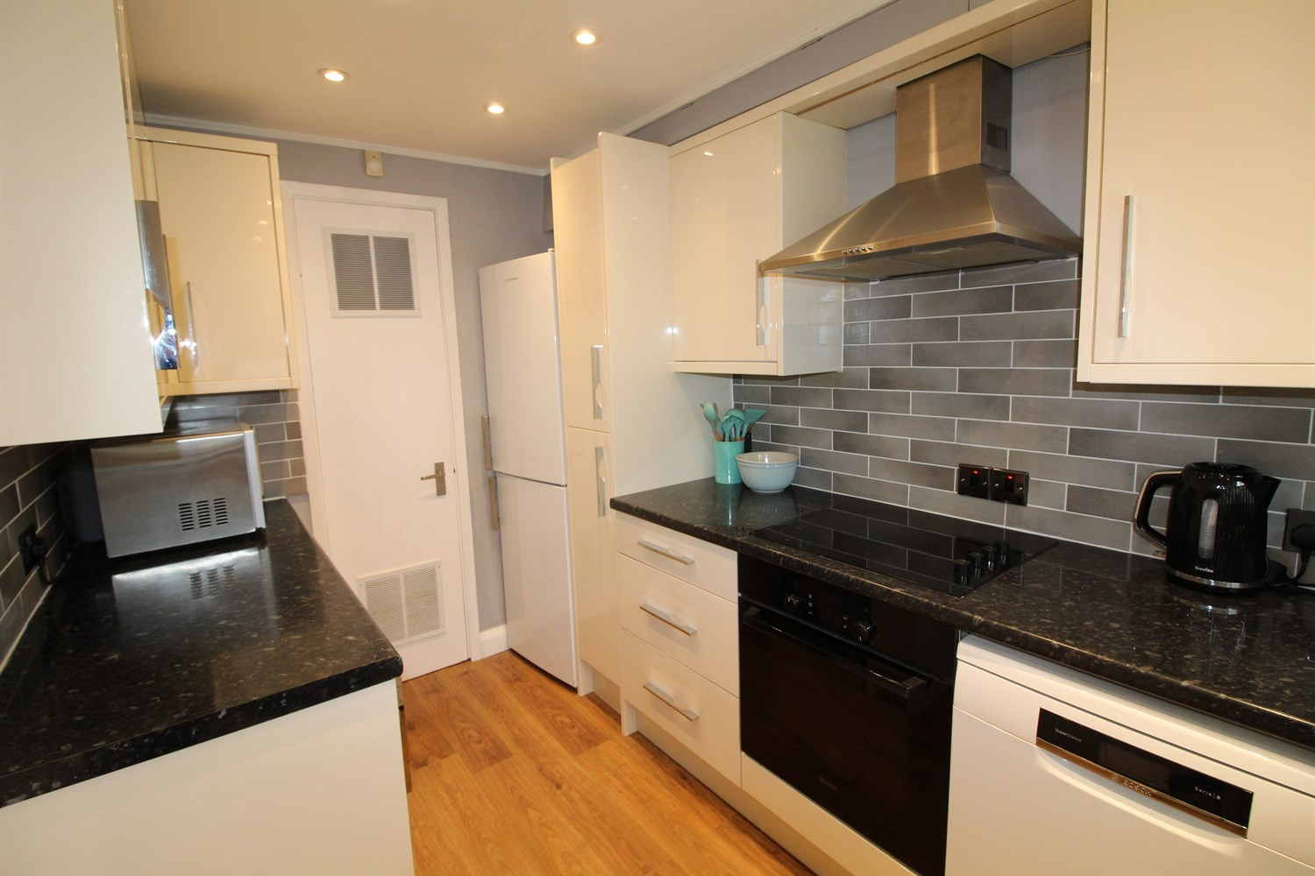

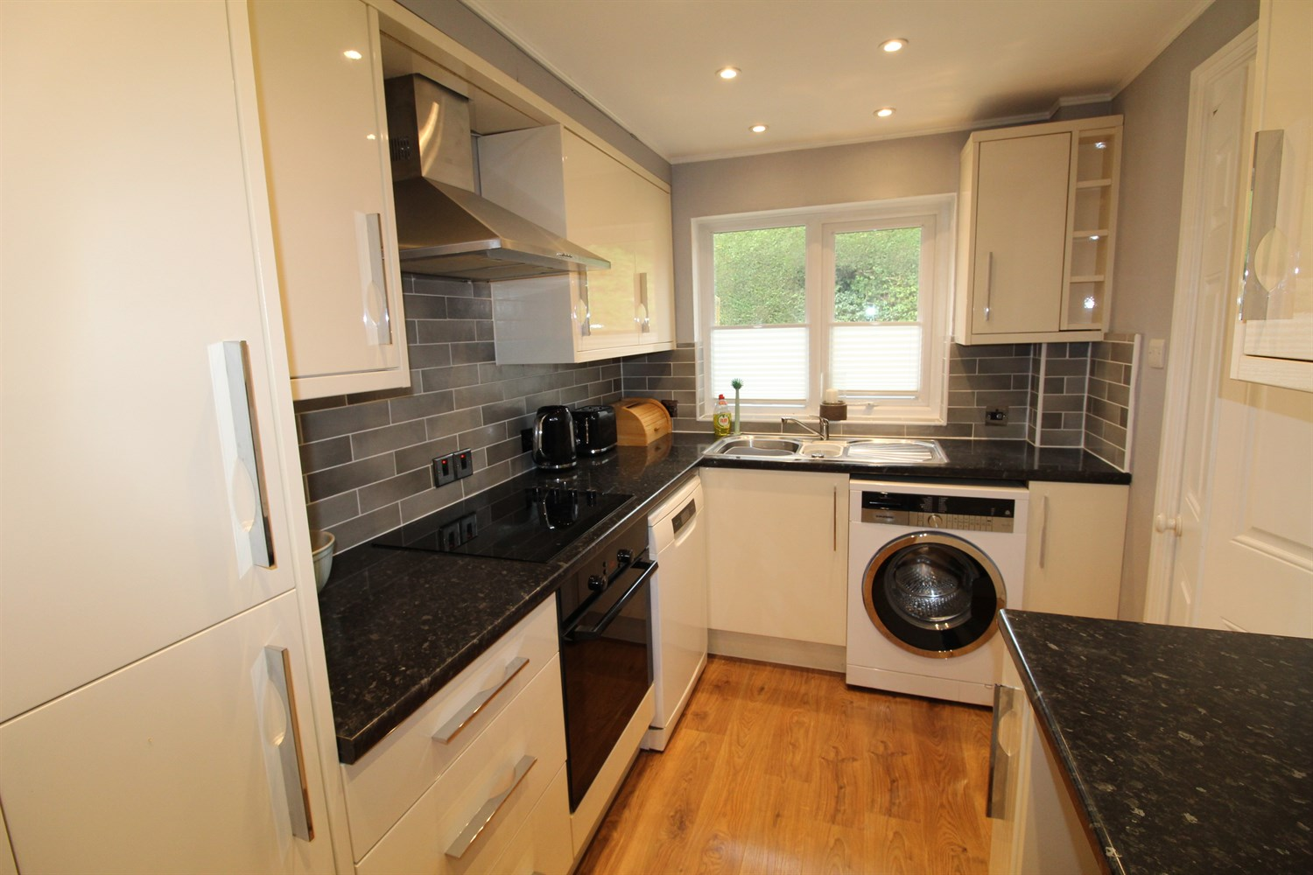

1 Bathroom(s)

1 Reception(s)

1 Bedroom(s)

00

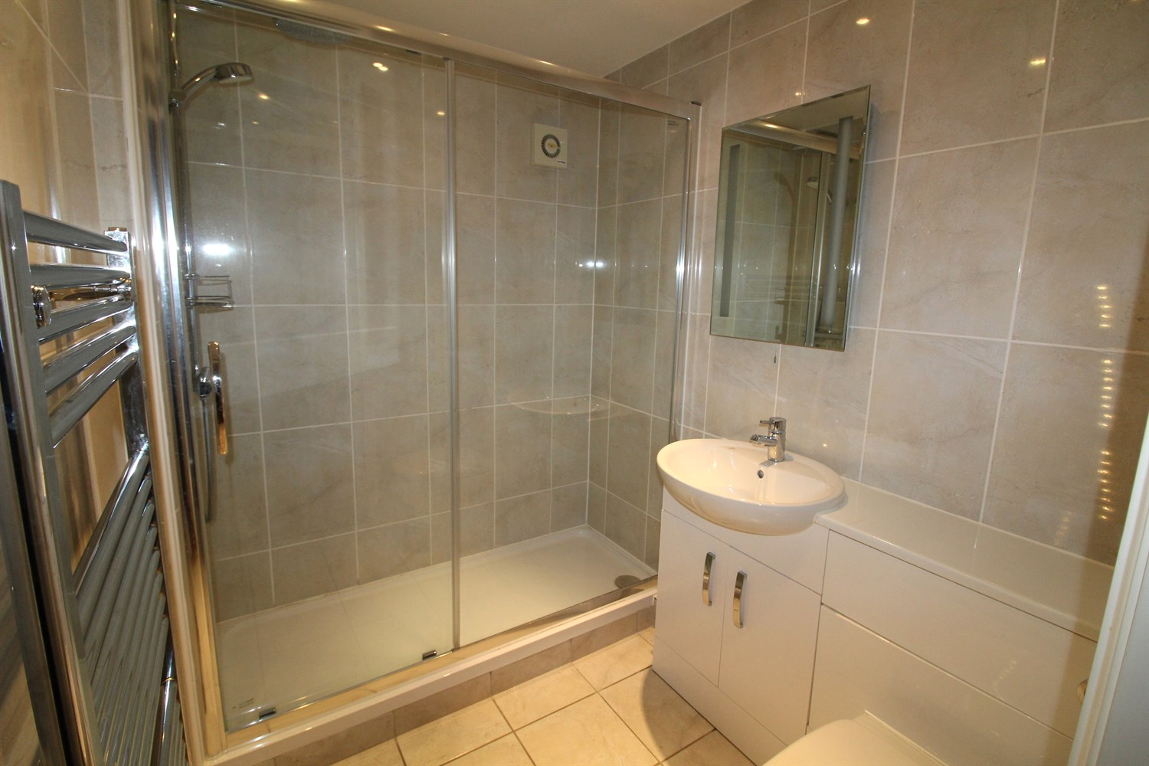

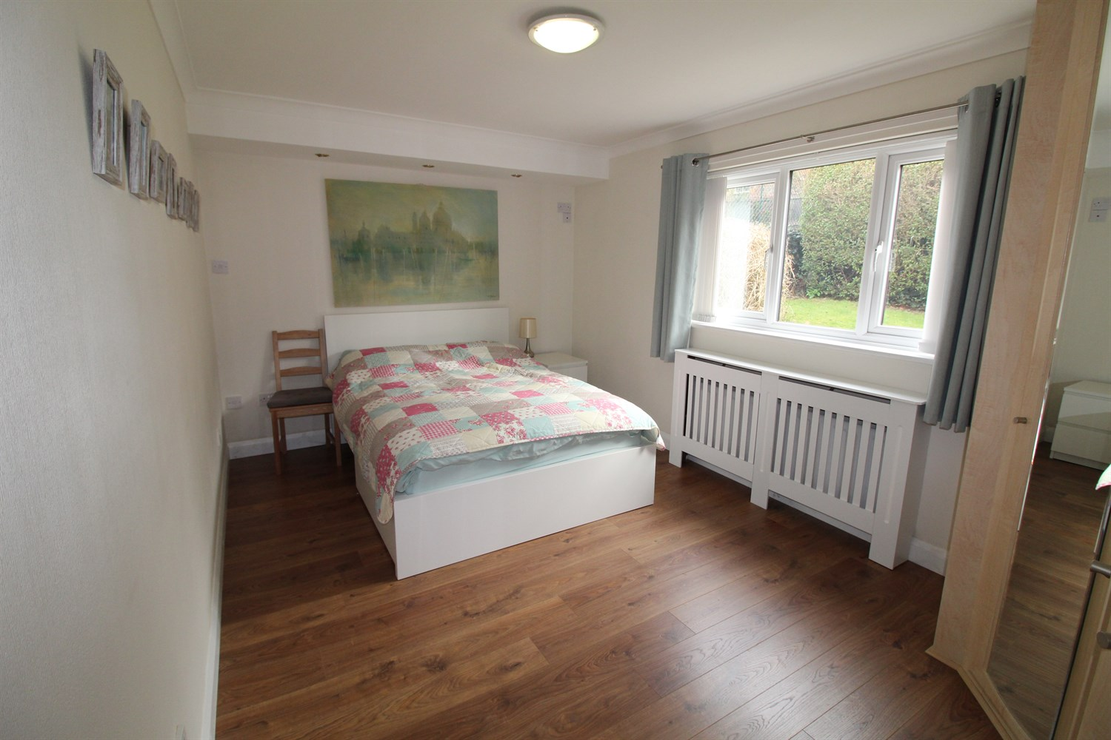

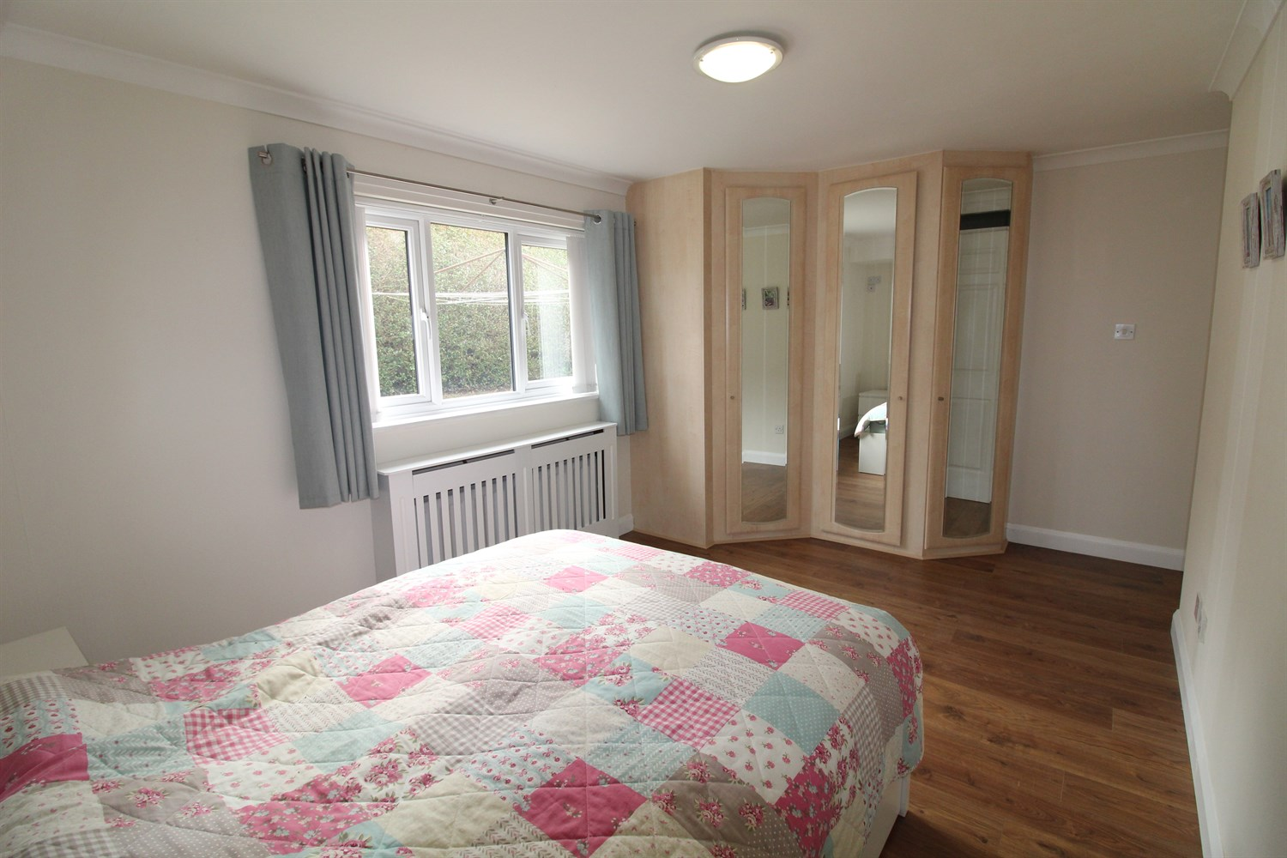

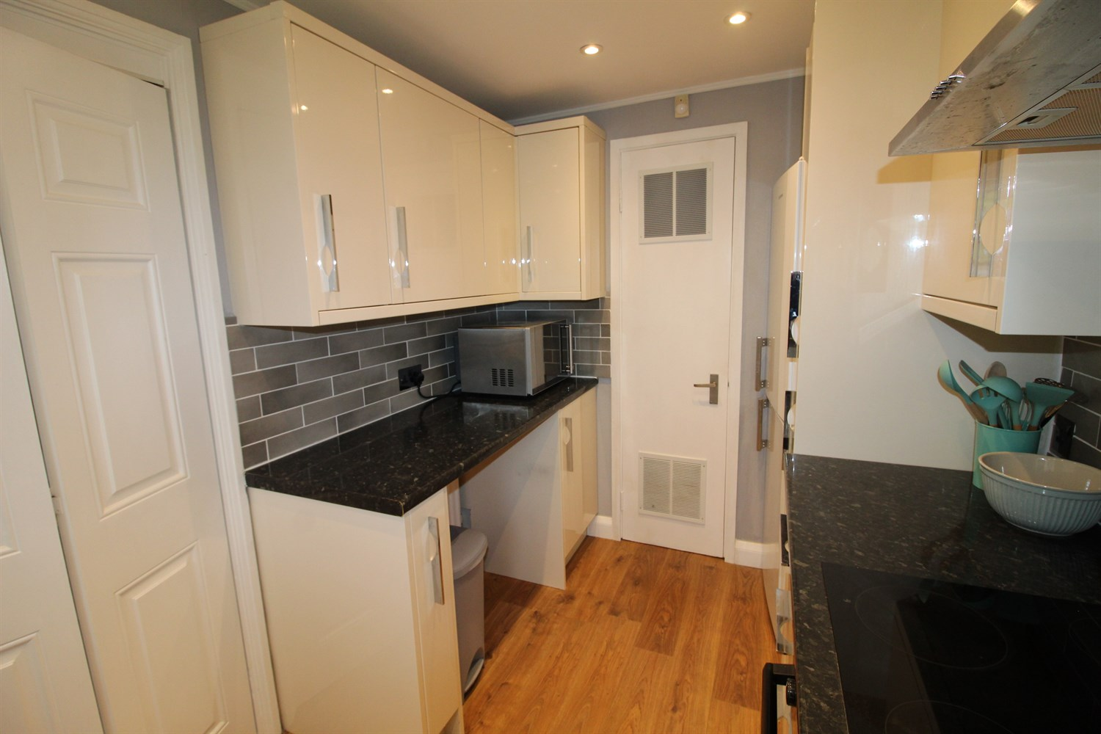

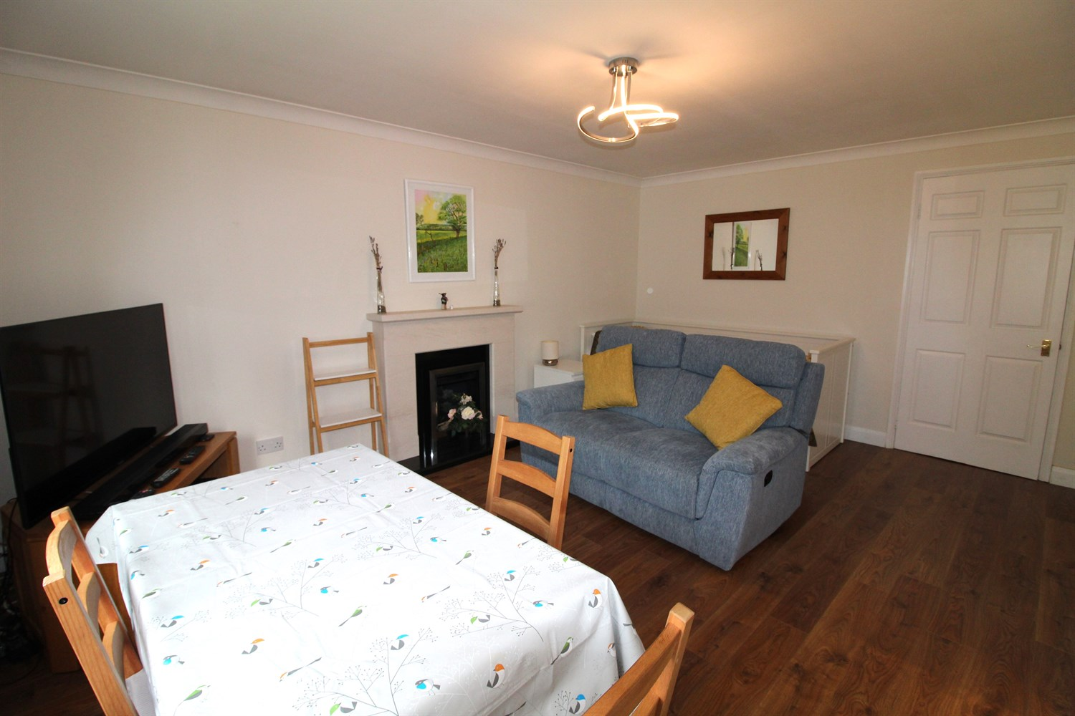

|  |
| --- |
| **Reception 1**  Large living room with space for a dining table, fire place and surround, double glazed window to front, gas central heating radiator. |
| **Kitchen**  Modern fitted kitchen with a range of wall and base units with worktops over, stainless steel sink with mixer tap, fridge freezer, washing machine. Double glazed window to front. |
| **Bedroom 1**  Large double bedroom with wardrobe, double glazed window to rear. |
| **Bathroom**  Bathroom suite with walk in shower, w/c and hand wash basin, tiled walls, radiator. |
| **Communal Garden**  Neatly kept communal gardens. |
| **Parking**  Allocated parking for one car. |
| **Home Information**  COUNCIL TAX BAND:B  EPC Rating: C   Leasehold property Allocated parking  Broadband : Standard 14 Mbps 1 Mbps Good Superfast 58 Mbps 12 Mbps Good Ultrafast 1800 Mbps 220 Mbps   Mobile availability: EE likely to have good coverage. Three likely to have good coverage. O2 limited coverage. Vodafone limited coverage.  Utilities: Water supplied on standard meters. Gas and Electric mains supplied on standard meters. |

|  |  |
| --- | --- |
| These particulars are intended to give a fair description of the property, but their accuracy cannot be guaranteed, and they do not constitute an offer of contract. Intending purchasers must rely on their own inspection of the property. None of the above appliances/services have been tested by ourselves. We recommend purchasers arrange for a qualified person to check all appliances/services before legal commitment.  **Property Ref:** 3832  **For more information, please contact**  0113 258 1150 **|** [lettings@adairpaxton.co.uk](mailto:lettings@adairpaxton.co.uk) **|** www.adairpaxton.co.uk |  |