

**0113 258 1150**

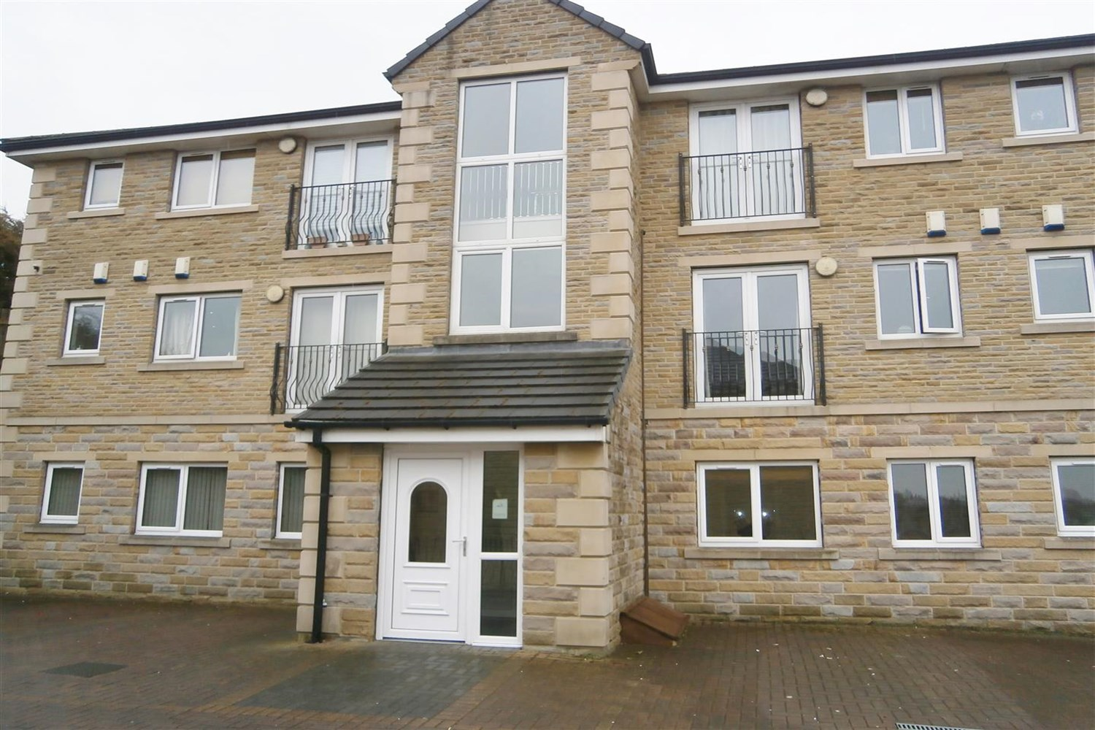



**Available to let £775.00pcm**

**Waterstone Court, Staincliffe, WF13**

Two bedroom ground floor apartment located in this popular development, just off Halifax Road with great links to the motorway network and handy for the main bus route. Comprising; Communal entrance hall, hallway, open plan lounge/dining/kitchen with oven/hob/extractor, integrated microwave and washing machine, two double bedrooms, one with fitted wardrobes and house bathroom with shower over bath, neutral décor throughout. On site parking.  
 Council tax band B. EPC rating C. Sorry, no pets. Deposit £890. Available 7th April.

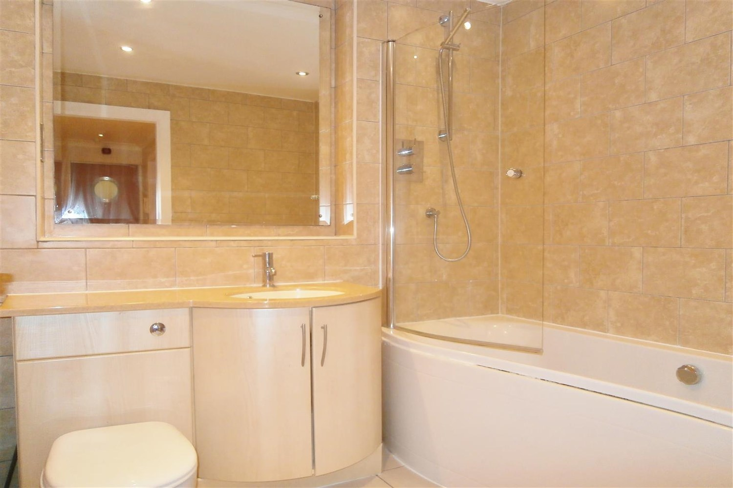

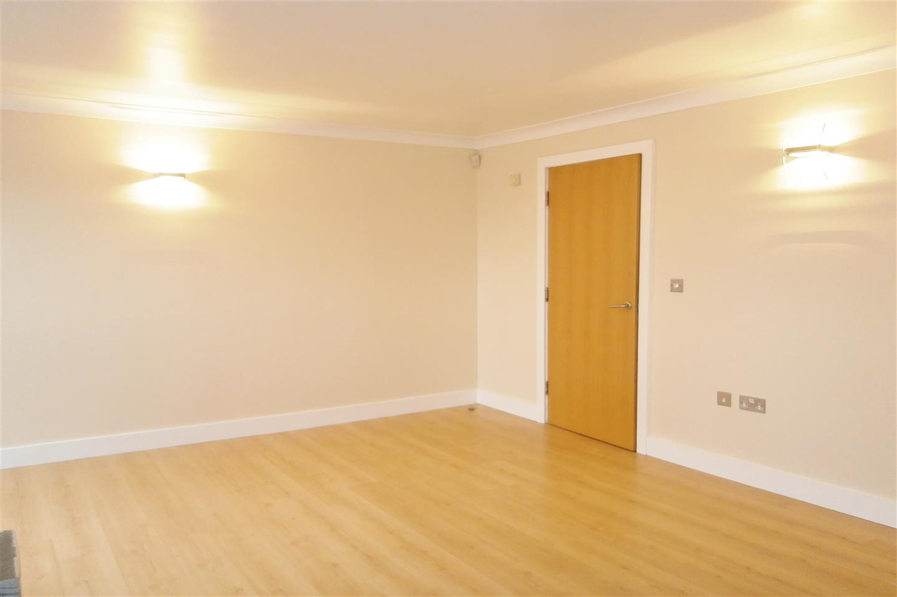

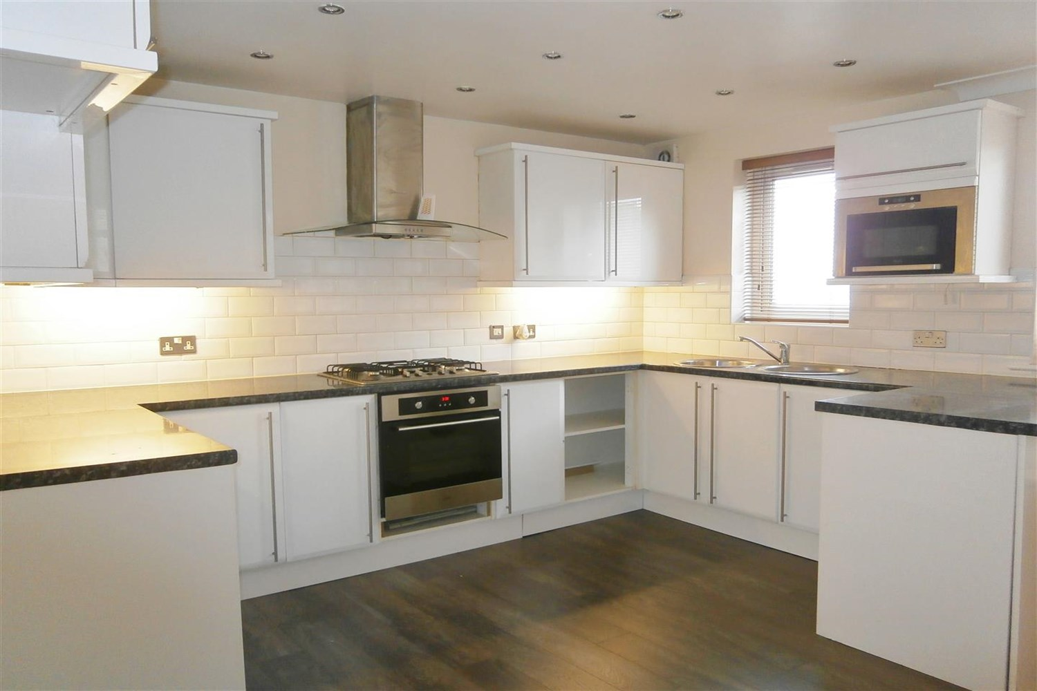

1 Bathroom(s)

1 Reception(s)

2 Bedroom(s)

00

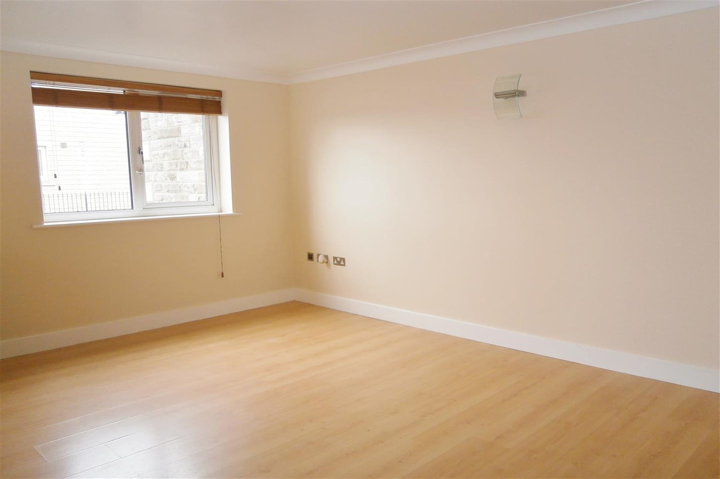

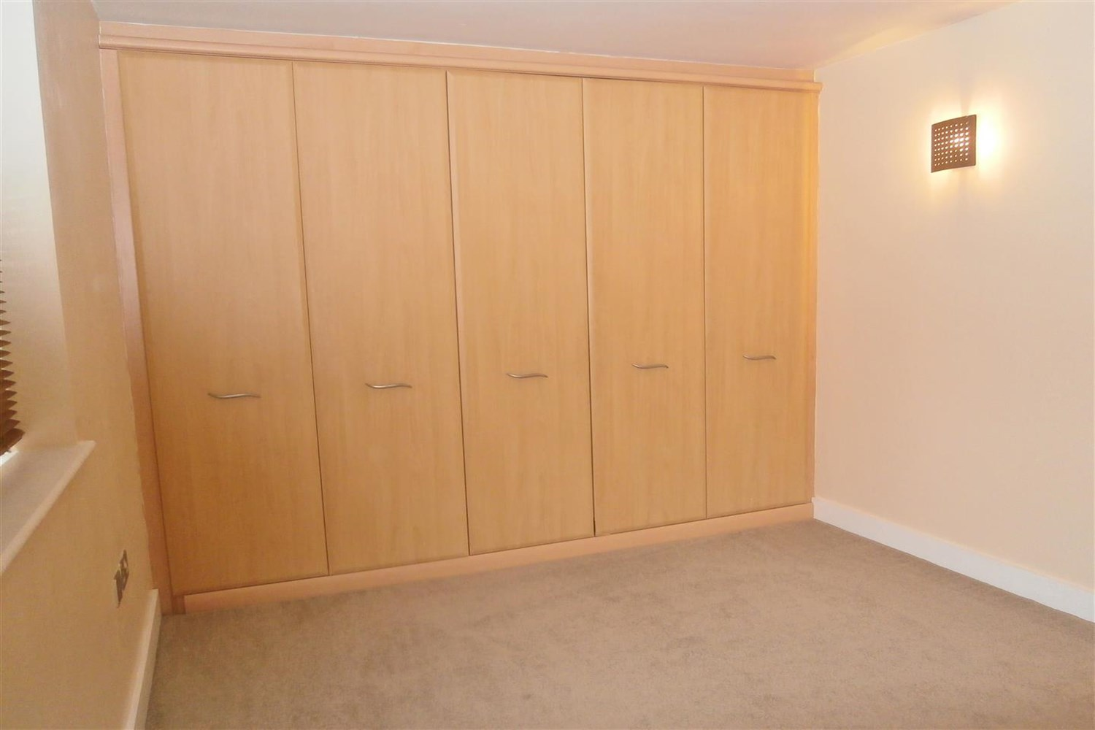

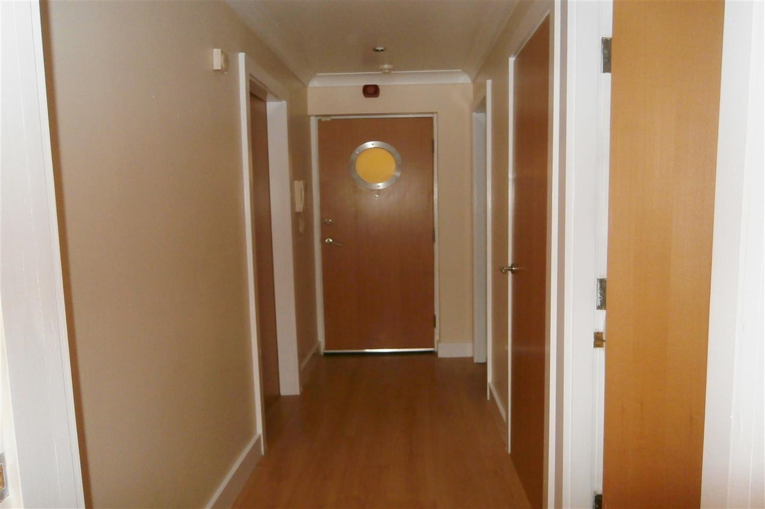

|  |
| --- |
| **Communal Entrance**  Communal entrance. |
| **Open Plan Living Room/Kitchen**  A light and airy reception room with laminate flooring   Fitted wall and base units having worksurfaces, integrated appliances. |
| **Bedroom 1**  Built in wardrobes, a central heating radiator and a window to the front elevation. |
| **Bedroom 2**  Central heating radiator and a window to the rear elevation. |
| **Bathroom**  Complemented by fully tiled walls the bathroom includes a bath with a shower and a screen over, a wash hand basin and a WC |
| **Home Information**  COUNCIL TAX BAND: B EPC Rating: C  Freehold property Driveway.  Broadband: Standard 15 Mbps 1 Mbps Good Superfast 80 Mbps 20 Mbps Good Ultrafast 1000 Mbps 1000 Mbps  Mobile availability: EE limited coverage. Three limited coverage. O2 likely to have good coverage. Vodafone likely to have good coverage.  Utilities: Water supplied on standard meters. Electric mains supplied on standard meters. Gas mains supplied on standard meters. |

|  |  |
| --- | --- |
| These particulars are intended to give a fair description of the property, but their accuracy cannot be guaranteed, and they do not constitute an offer of contract. Intending purchasers must rely on their own inspection of the property. None of the above appliances/services have been tested by ourselves. We recommend purchasers arrange for a qualified person to check all appliances/services before legal commitment.  **Property Ref:** 1498  **For more information, please contact**  0113 258 1150 **|** [lettings@adairpaxton.co.uk](mailto:lettings@adairpaxton.co.uk) **|** www.adairpaxton.co.uk |  |