

**0113 258 1150**

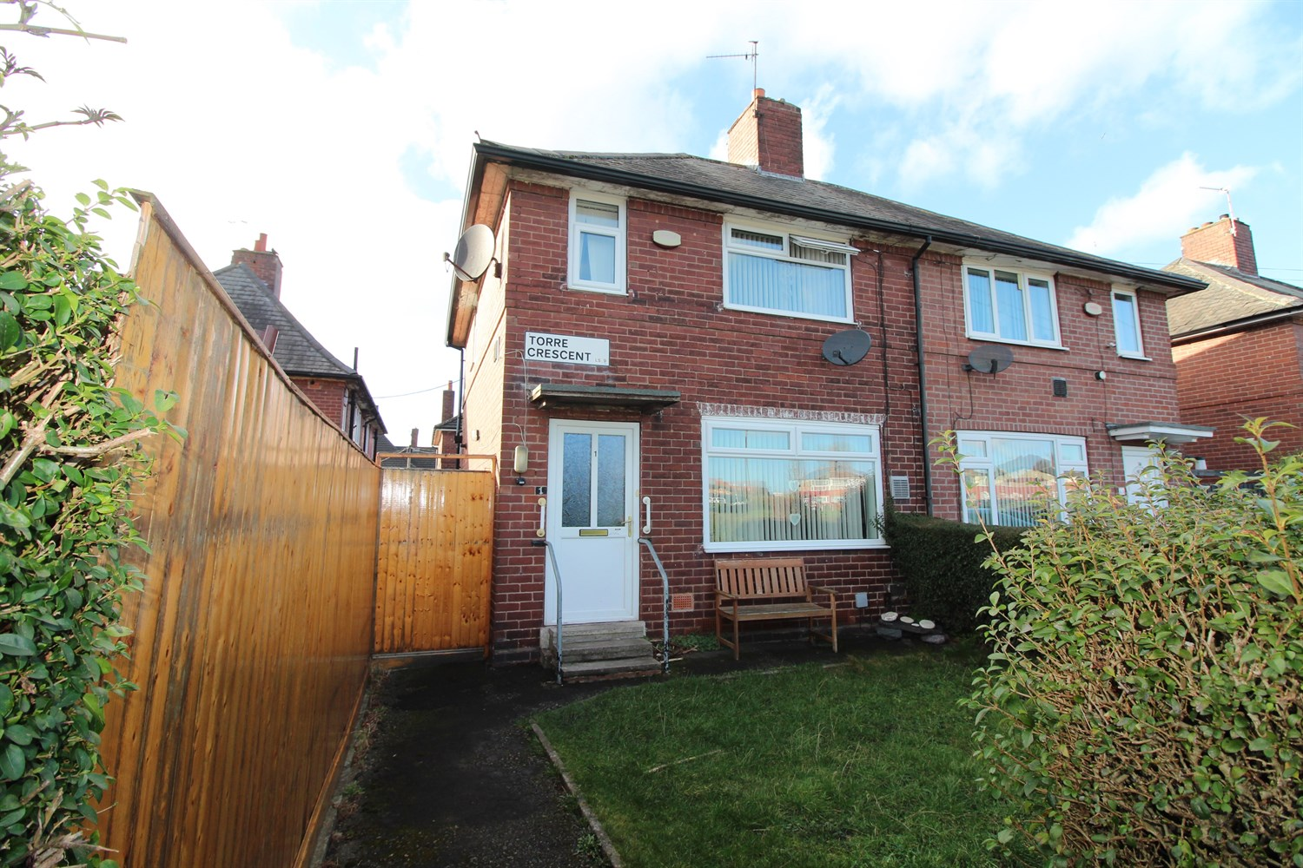



**For Sale £150,000.00**

**Torre Crescent, Leeds**

**TWO BEDROOM SEMI-DETACHED HOUSE - GARDENS TO REAR and SIDE** No onward chain. This semi-detached property is conveniently placed for Leeds city Centre and is sure to appeal to a variety of buyers, in particular the first-time buyer or investor. The property briefly comprises; Hallway, lounge and kitchen to the ground floor. To the first floor there are two double bedrooms and a house bathroom. Externally the property has a lawned garden to the side and rear. Currently tenanted on a periodic tenancy at £700pcm.

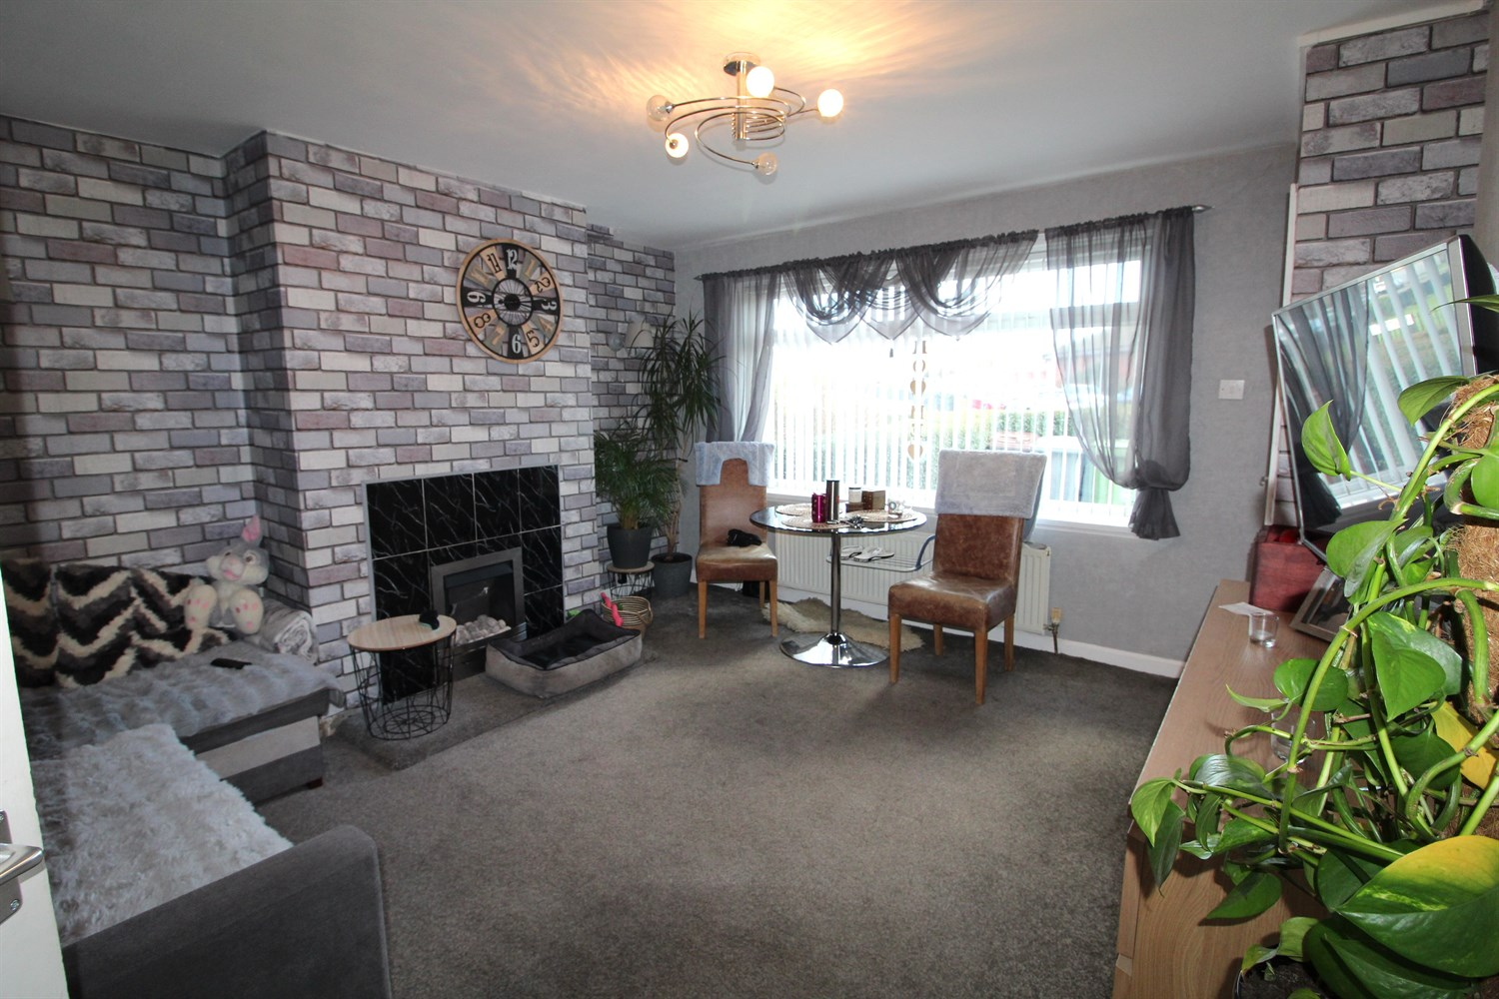

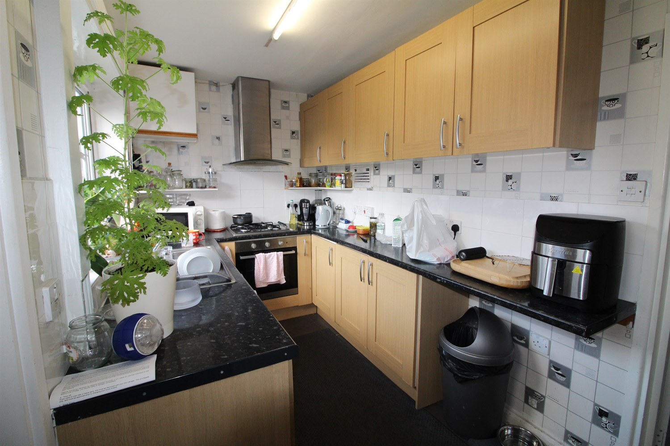

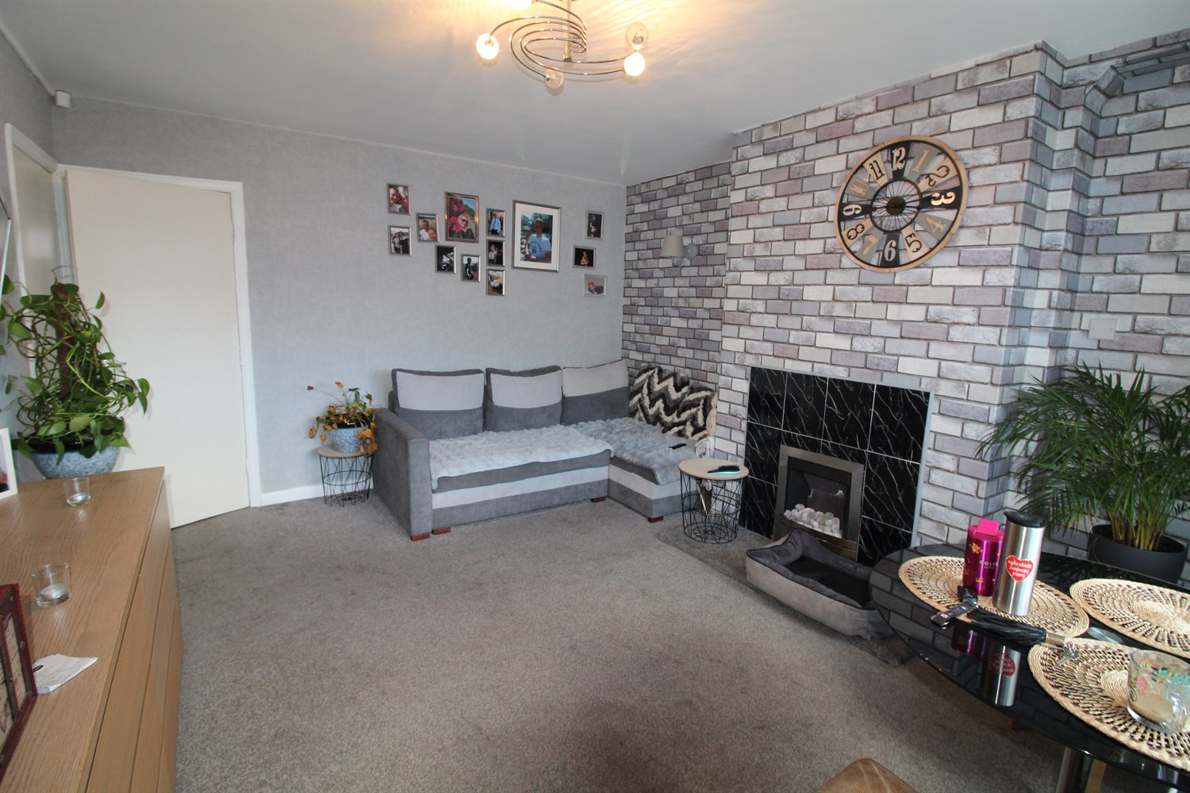

1 Bathroom(s)

1 Reception(s)

2 Bedroom(s)

00

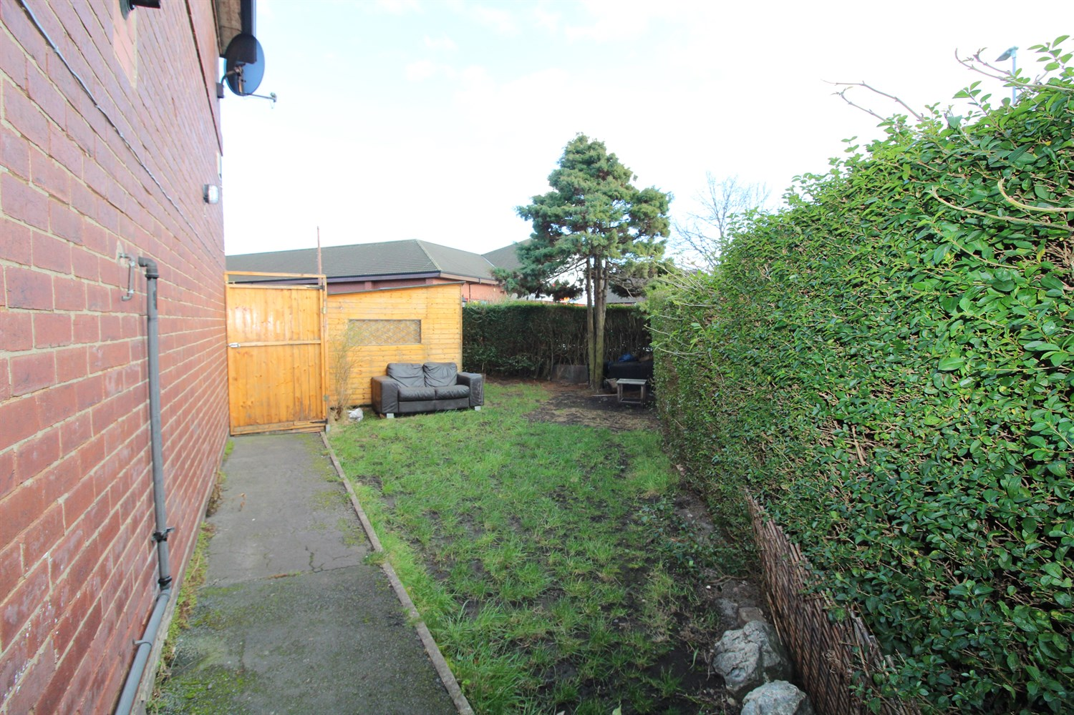

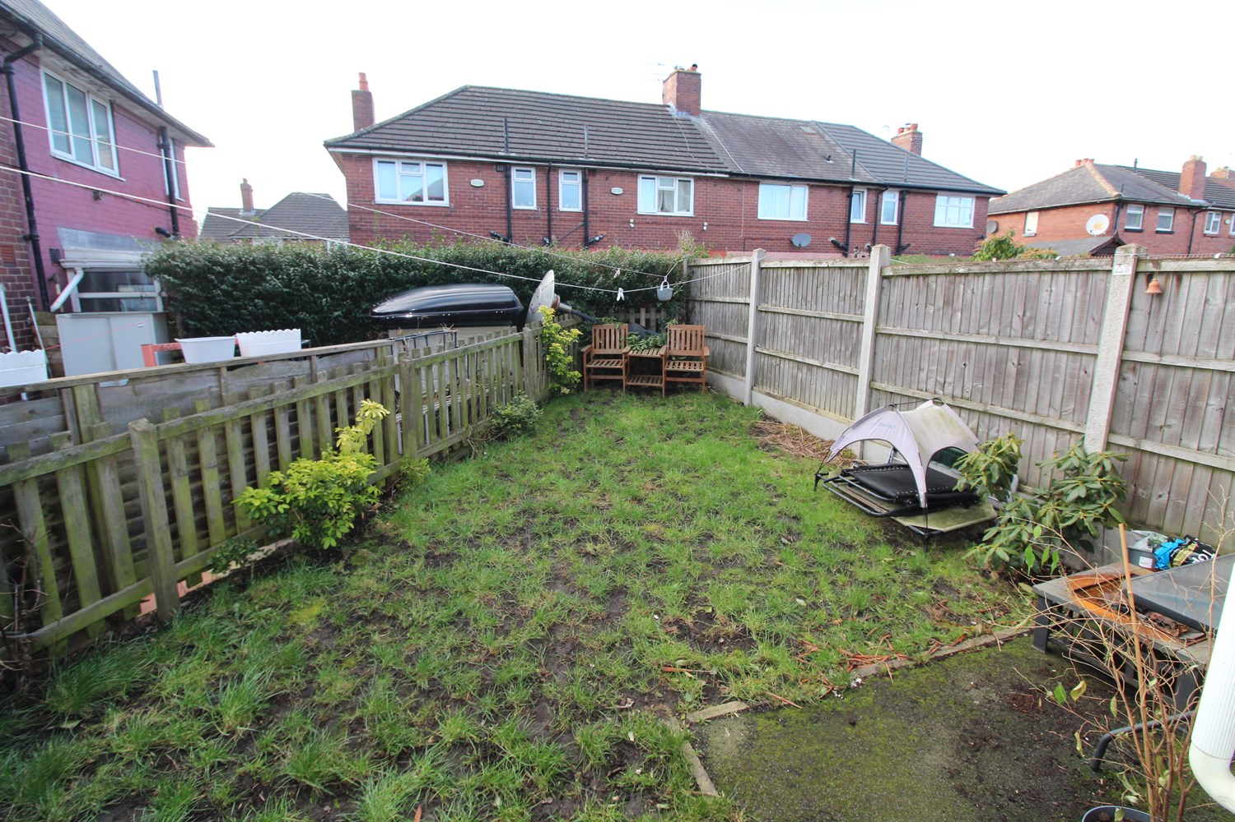

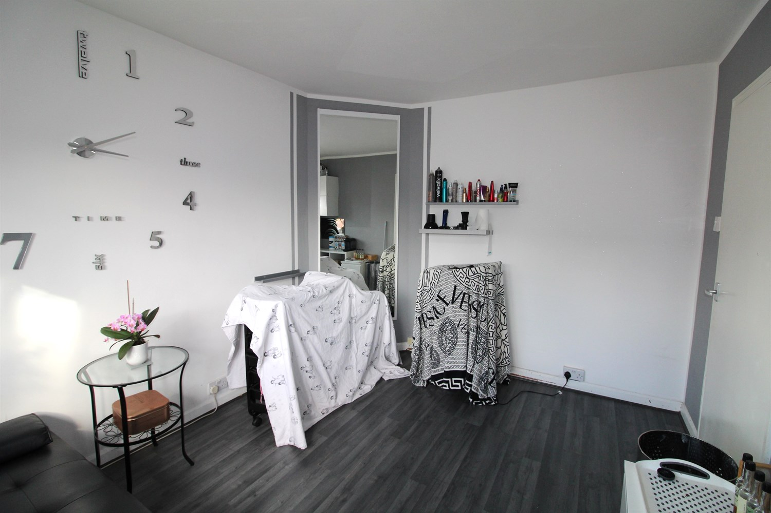

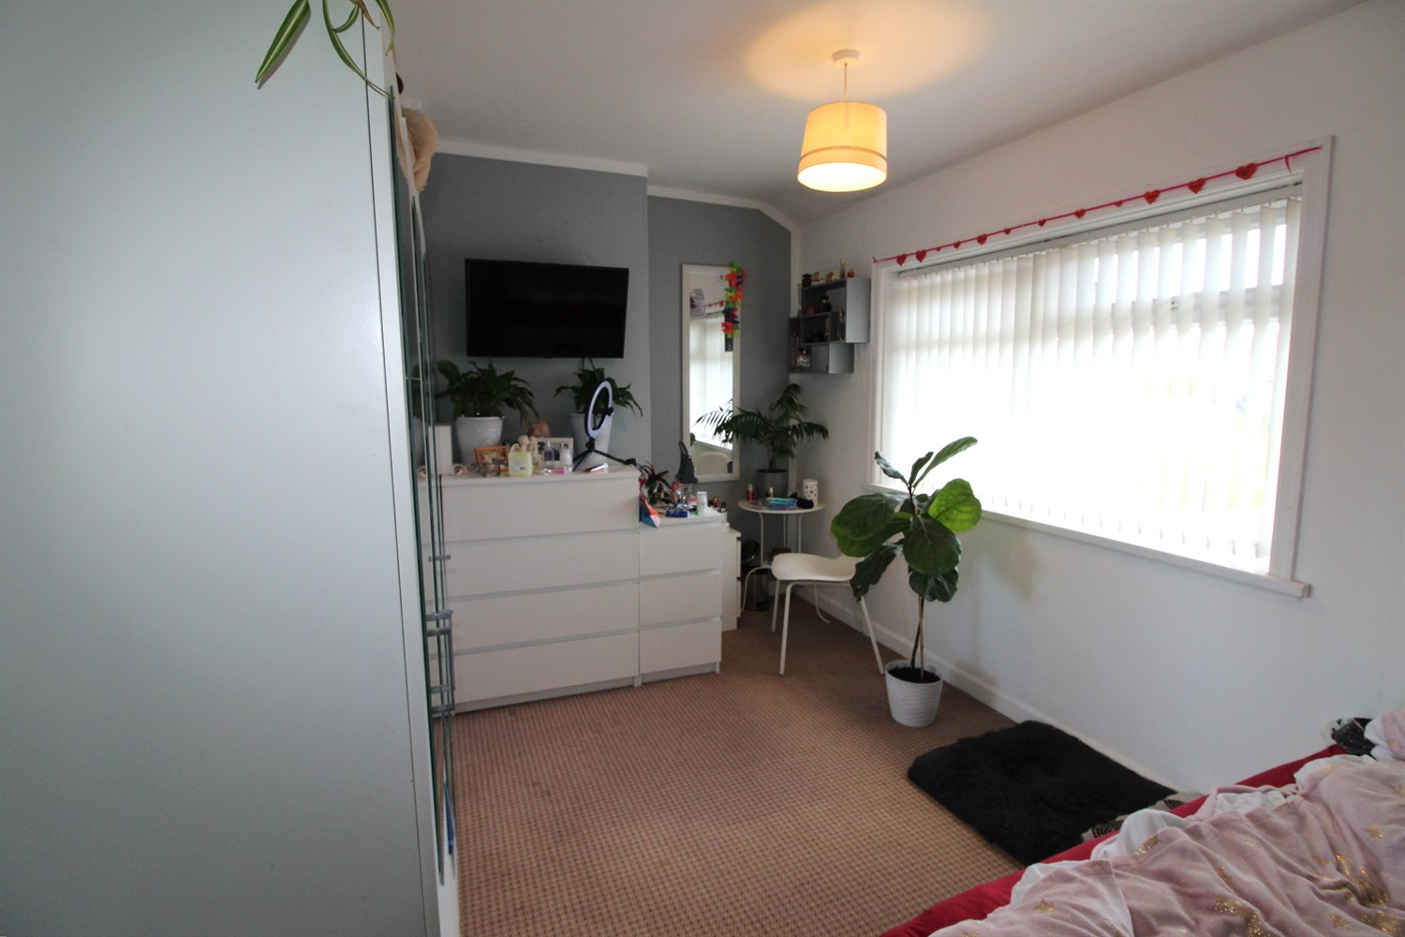

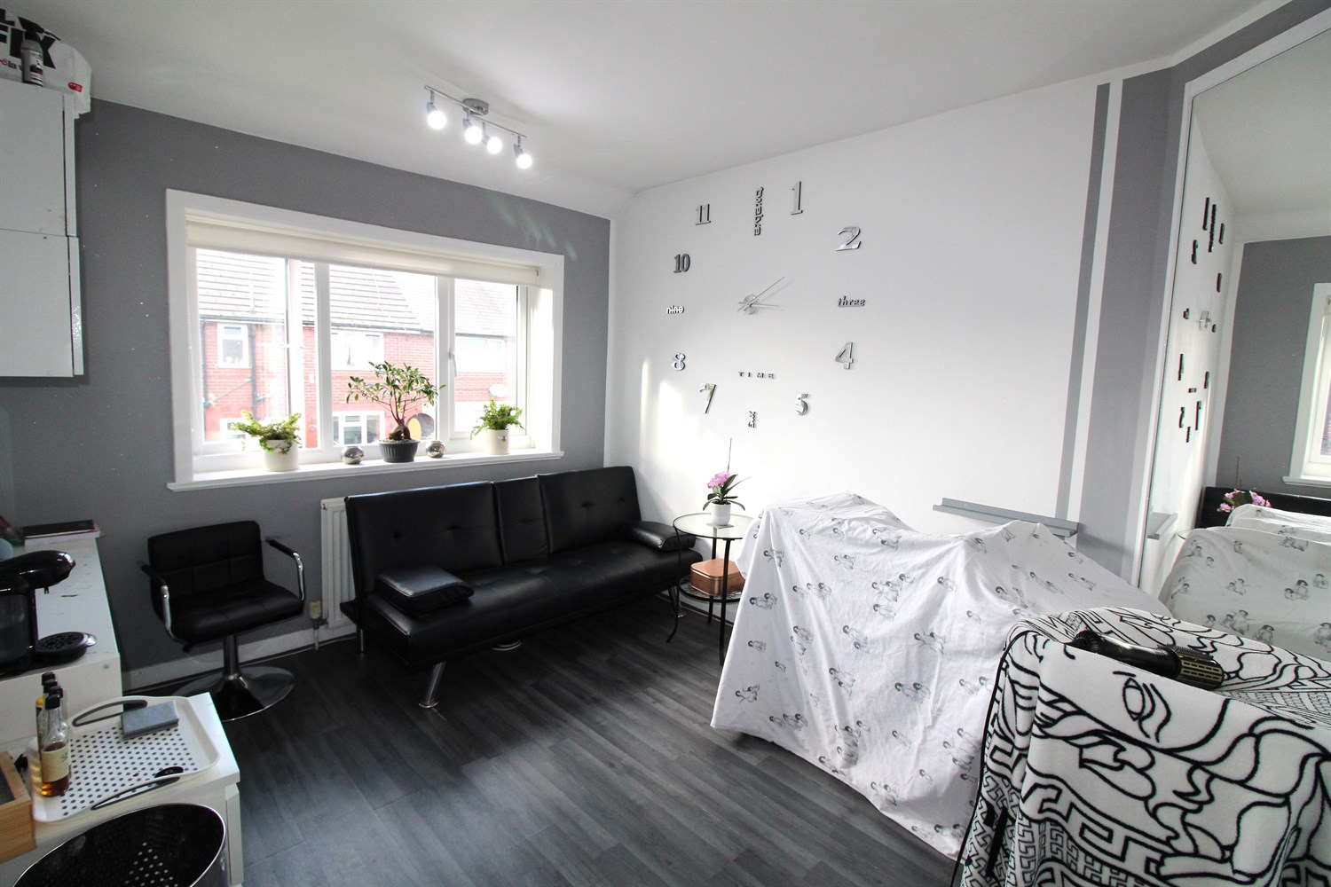



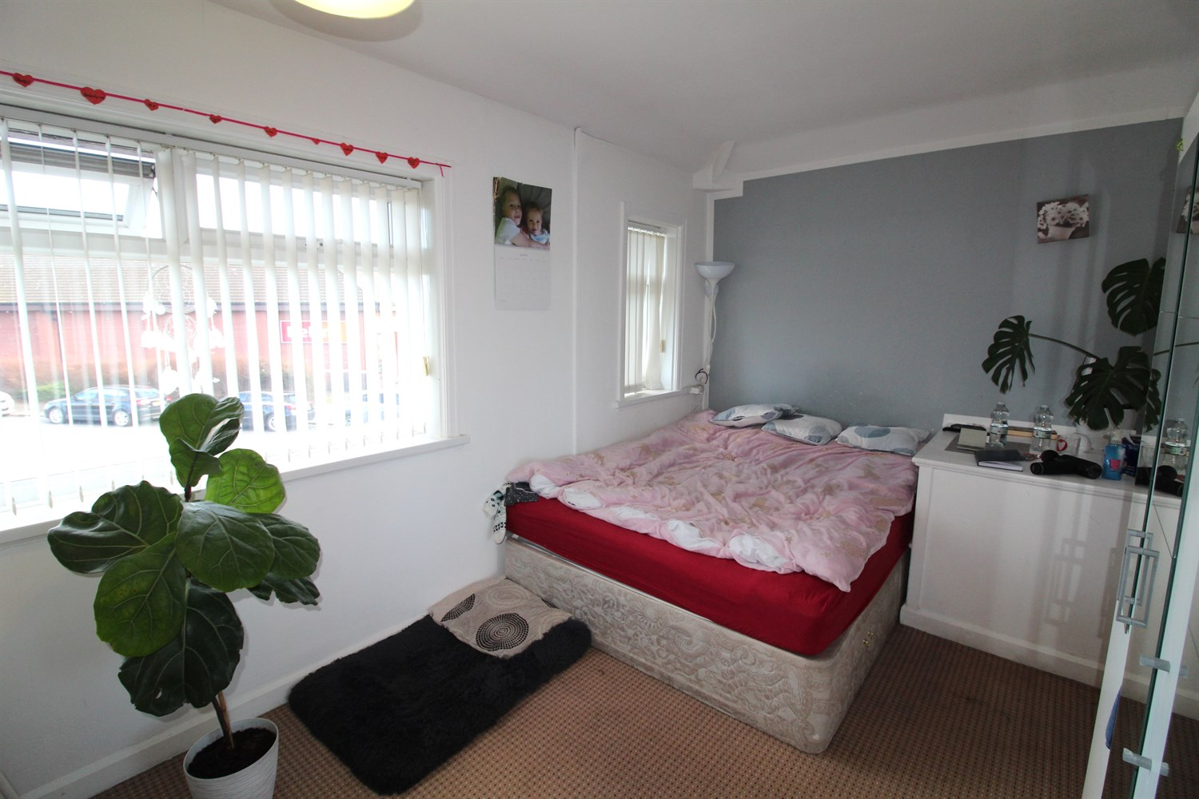

|  |
| --- |
| **Hallway**  Via front entrance door. Stairs to first floor. |
| **Lounge 3.78m (12'5) x 4.36m (14'4)**  Spacious living area with uPVC double glazed window to front. Gas central heating radiator. Storage cupboard. |
| **Kitchen 1.95m (6'5) x 3.79m (12'5)**  Fitted with a range of wall, base and drawer units with worktops over. Integrated electric oven with 4-ring gas hob and extractor hood over. Stainless steel sink with mixer tap and drainer. Space for washing machine. Store cupboard. uPVC double glazed window and door to rear. |
| **Landing**  Landing |
| **Bedroom 1 2.47m (8'1) x 4.82m (15'10) Max**  Double bedroom with two double glazed windows to front. Gas central heating radiator. Store cupboard. |
| **Bedroom 2 2.9m (9'6) x 3.47m (11'5)**  Second double bedroom with double glazed window to rear. Gas central heating radiator. |
| **House Bathroom**  Fitted with a three piece suite comprising; bath with shower over, WC and wash hand basin. uPVC double glazed window. |
| **Outside**  Enclosed gardens to the rear, side and front. |

|  |  |
| --- | --- |
| These particulars are intended to give a fair description of the property, but their accuracy cannot be guaranteed, and they do not constitute an offer of contract. Intending purchasers must rely on their own inspection of the property. None of the above appliances/services have been tested by ourselves. We recommend purchasers arrange for a qualified person to check all appliances/services before legal commitment.  **Property Ref:** 5313  **For more information, please contact**  0113 258 1150 **|** [sales@adairpaxton.co.uk](mailto:sales@adairpaxton.co.uk) **|** www.adairpaxton.co.uk |  |