

**0113 258 1150**

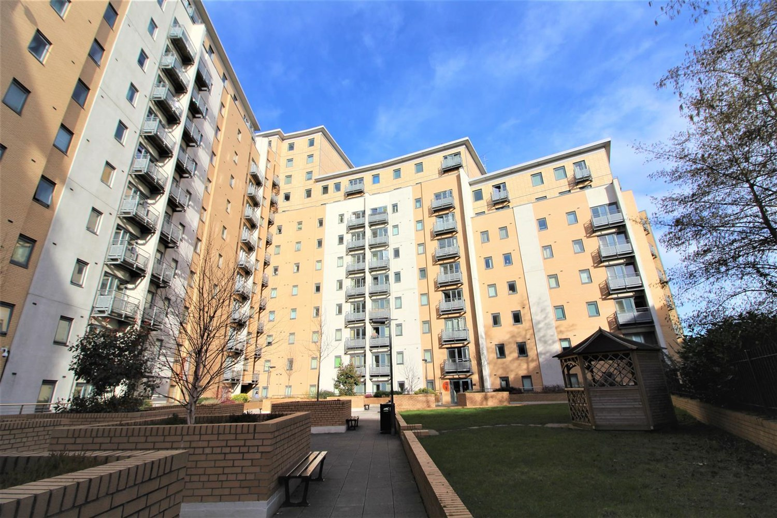



**Available to let £995.00pcm**

**Aspect 14, Leeds**

***TWO Double Bedroom apartment with PARKING, in the popular Aspect 14 Development*** Located in the City Centre, close to the Universities and handy for all amenities. Comprising; hallway, spacious open plan lounge/kitchen/diner, master bedroom with en-suite bathroom, house bathroom, second double bedroom. On-site caretaker and well maintained communal grounds. Furnished. Deposit £1145. Available Now. EPC rating B. Council Tax band D. Due to the lease this property has a no pet policy.

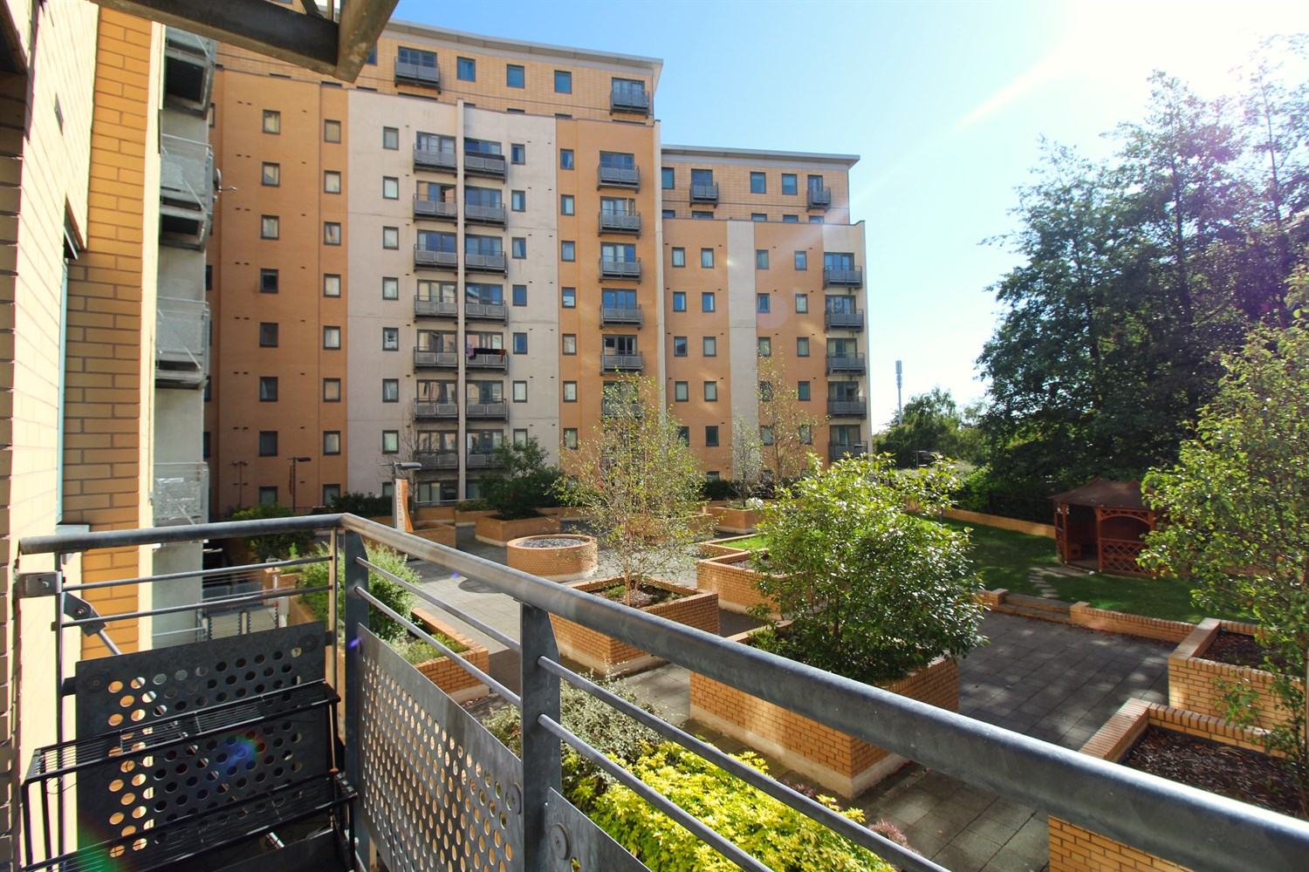

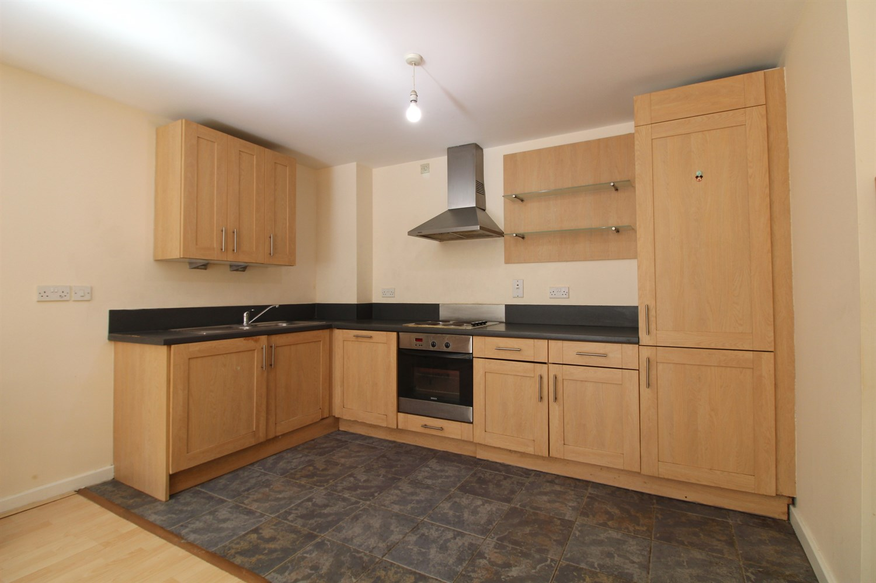

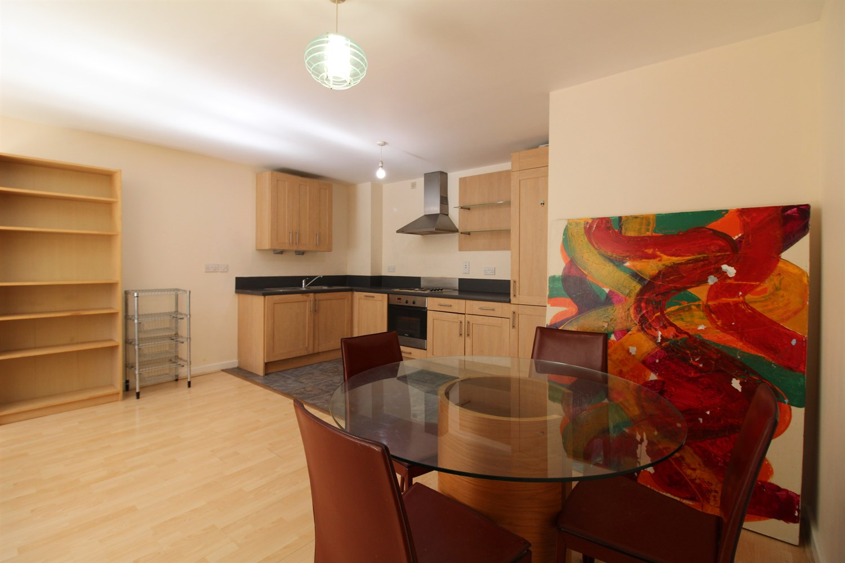

2 Bathroom(s)

1 Reception(s)

1 Bedroom(s)

00

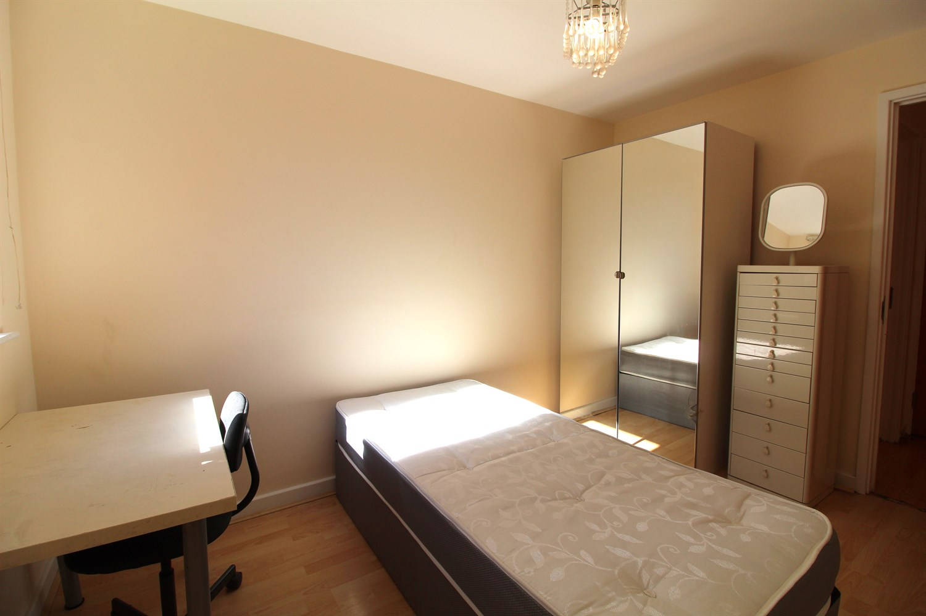

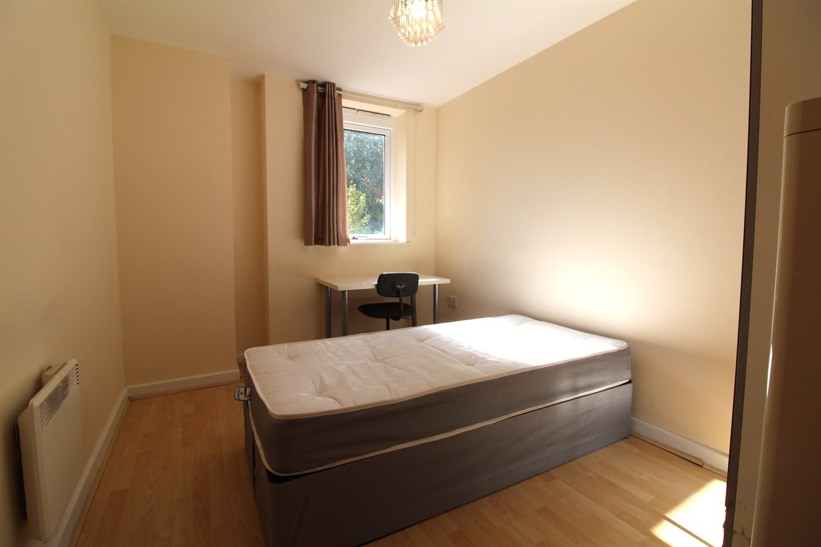

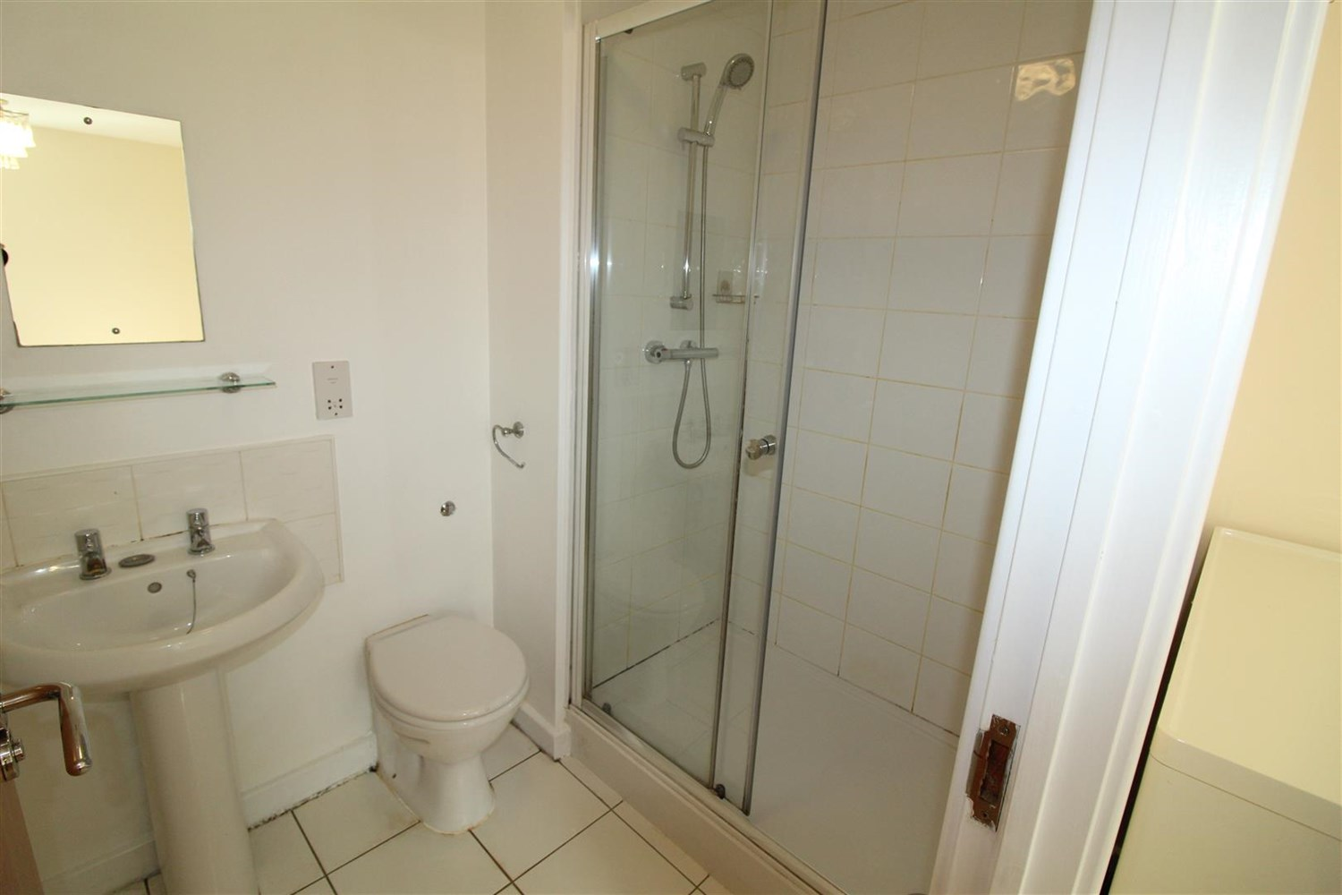

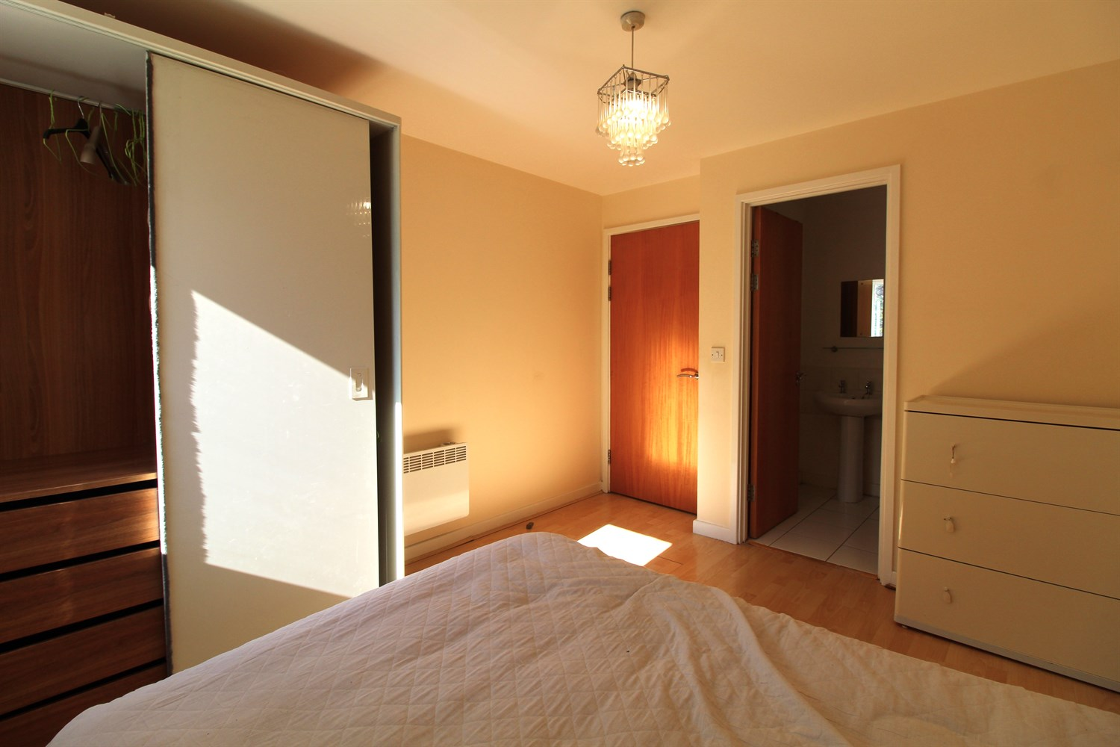

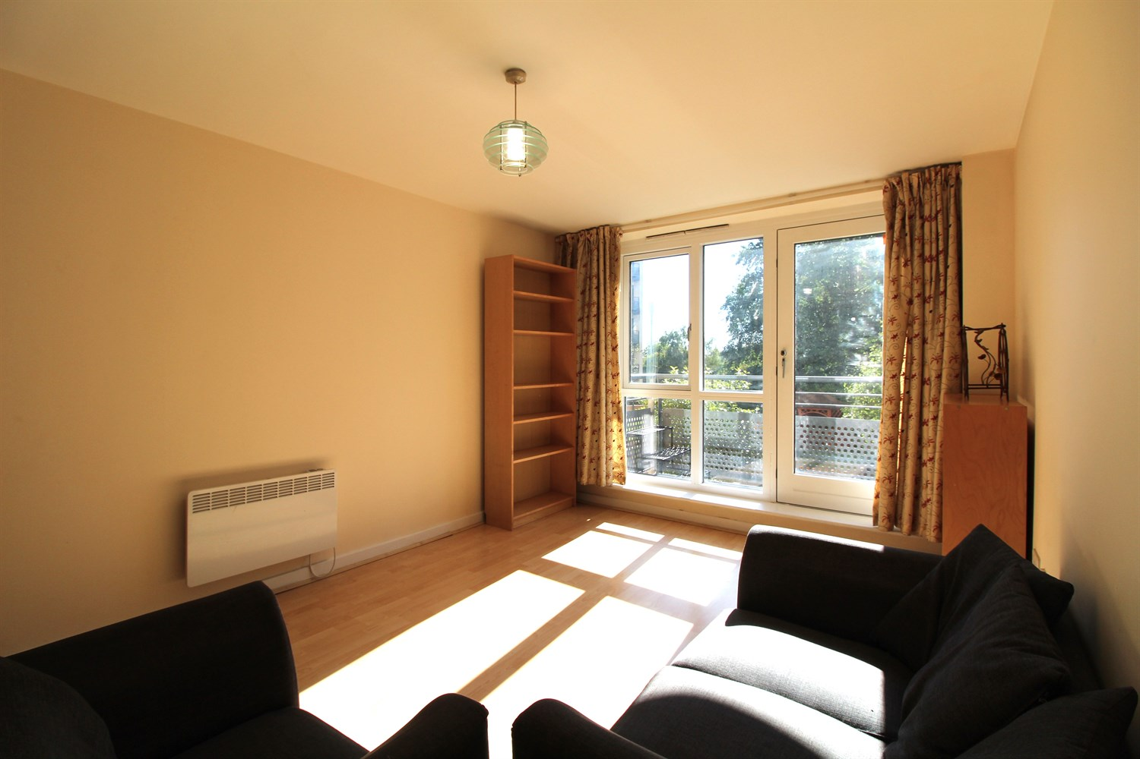

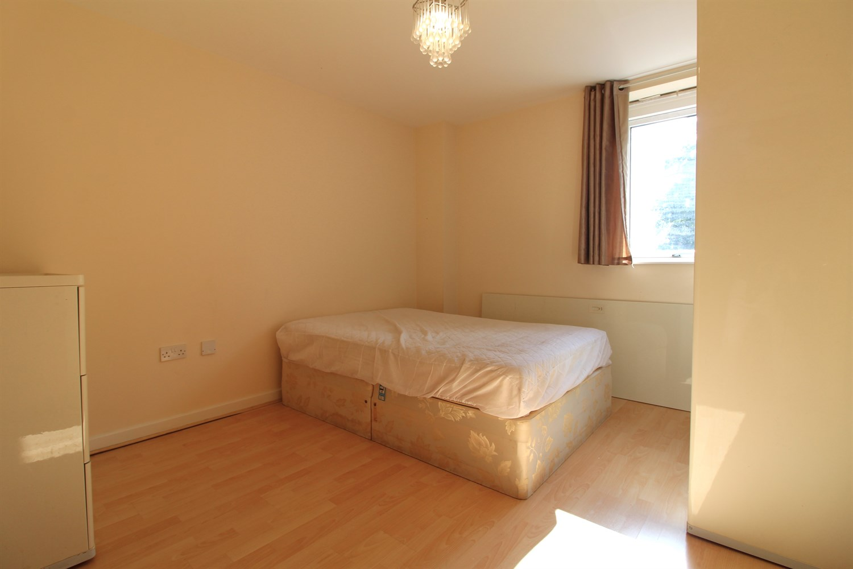

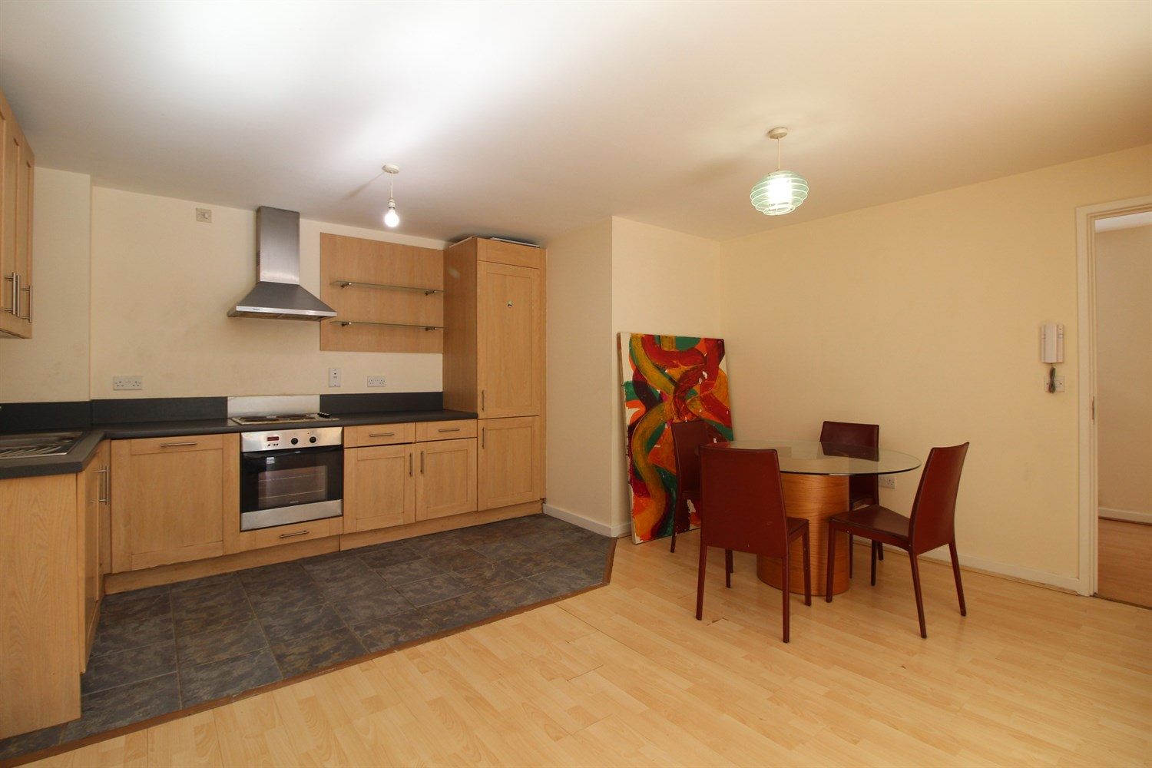

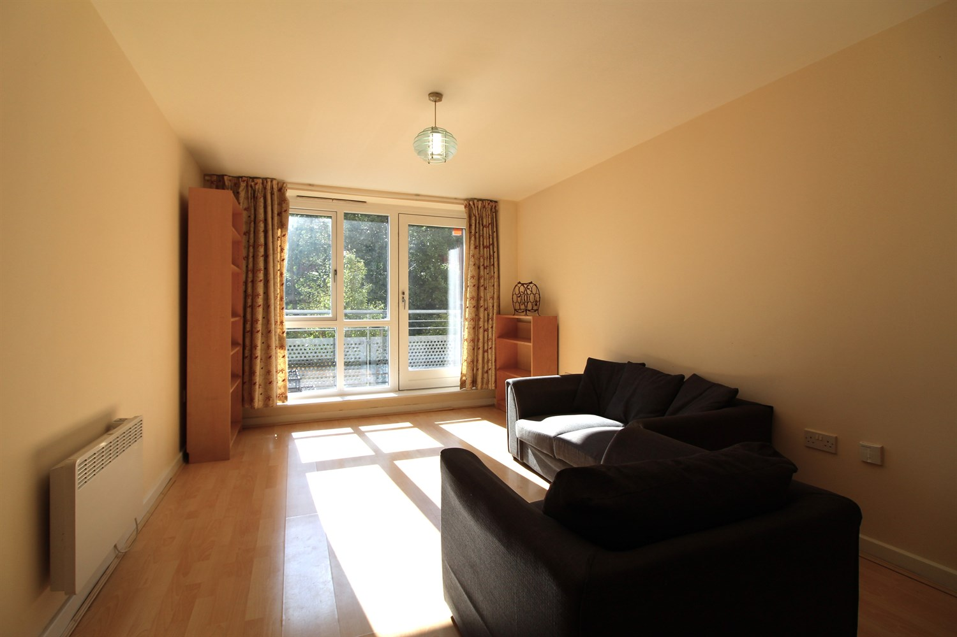

|  |
| --- |
| **Communal entrance**  Communal entrance with access to lifts and stairs to all floors and post boxes. |
| **Open Plan Kitchen/Living/Dining/ room**  Open plan living/dining room and kitchen access to the balcony. Kitchen is fitted with a range wall and base units with worktops over, electric oven and hob with extractor fan, integrated fridge freezer, stainless steel sink with mixer tap and drainer. |
| **Bedroom 1**  Large double bedroom with window to front, electric heater. |
| **En-suite**  Fitted with a white three piece suite compromising of a shower, W/C and hand wash basin. |
| **Bedroom 2**  Bedroom with window and wall mounted electric radiator. |
| **Bathroom**  Fitted with a white three piece suite compromising of bath with shower over head, shower screen, radiator, W/C and hand wash basin. |
| COUNCIL TAX BAND: B EPC Rating B  Leasehold property  Broadband: Standard 16 Mbps 1 Mbps Good Superfast 80 Mbps 20 Mbps Good Ultrafast 1000 Mbps 1000 Mbps Mobile availability: EE Likely. Three Likely. O2 Likely. Vodafone Likely.  Utilities: Water supplied on standard meters. Electric mains supplied on standard meters. |

|  |  |
| --- | --- |
| These particulars are intended to give a fair description of the property, but their accuracy cannot be guaranteed, and they do not constitute an offer of contract. Intending purchasers must rely on their own inspection of the property. None of the above appliances/services have been tested by ourselves. We recommend purchasers arrange for a qualified person to check all appliances/services before legal commitment.  **Property Ref:** 5563  **For more information, please contact**  0113 258 1150 **|** [lettings@adairpaxton.co.uk](mailto:lettings@adairpaxton.co.uk) **|** www.adairpaxton.co.uk |  |