

**Whitehall Waterfront, Whitehall Waterfront, Leeds, LS1**

**Available to let £1,200.00pcm**

**Apartment**

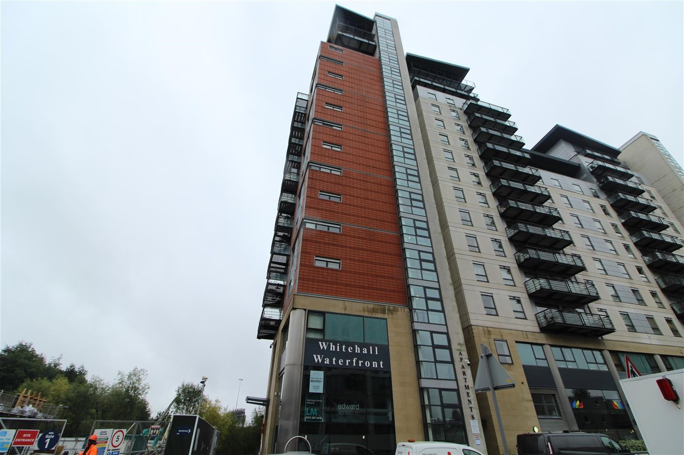

2 Bathroom(s)

1 Reception(s)

2 Bedroom(s)

***TWO BEDROOM APARTMENT WITH BALCONY AND SECURE PARKING IN THE SOUGHT AFTER CANAL SIDE DEVELOPMENT OF WHITEHALL WATERFRONT*** Close to all the amenities Leeds city centre has to offer. Handy for the train station and the motorway network. Spacious and well presented throughout. Comprising; hallway, open plan lounge/kitchen/diner with balcony with far reaching views across the canal and the city, gloss kitchen units to include oven/hob extractor, integrated fridge & slimline dishwasher. Utility cupboard with washer/dryer. Two double bedrooms, one with built in wardrobes and en-suite shower room, second bedroom/home study with Jack & Jill shower room. SECURE PARKING. FURNISHED. Council tax band D, EPC rating C Bond £1380. Available 1st November 2023 . Sorry No Pets.



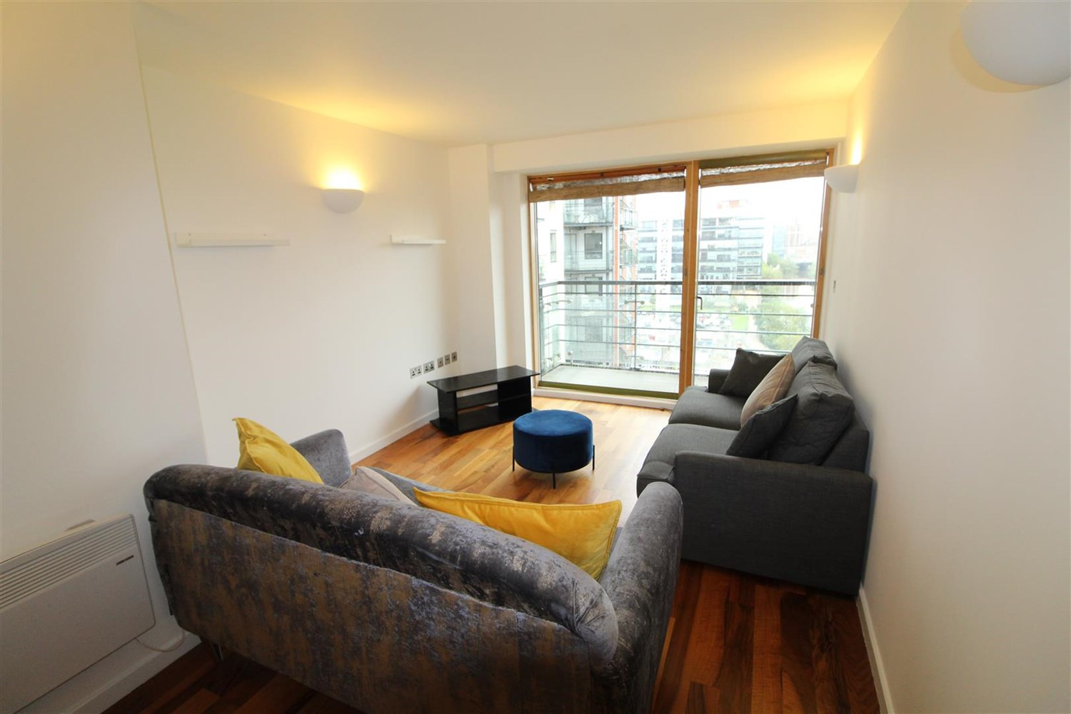

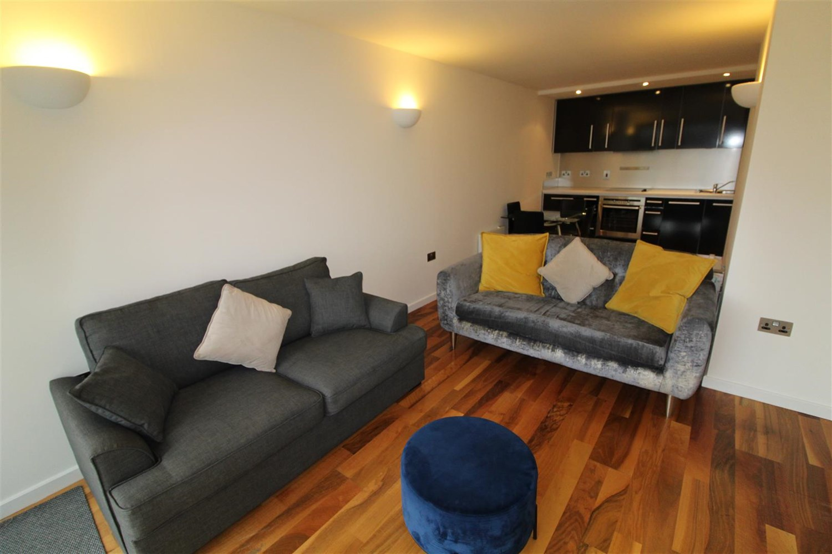

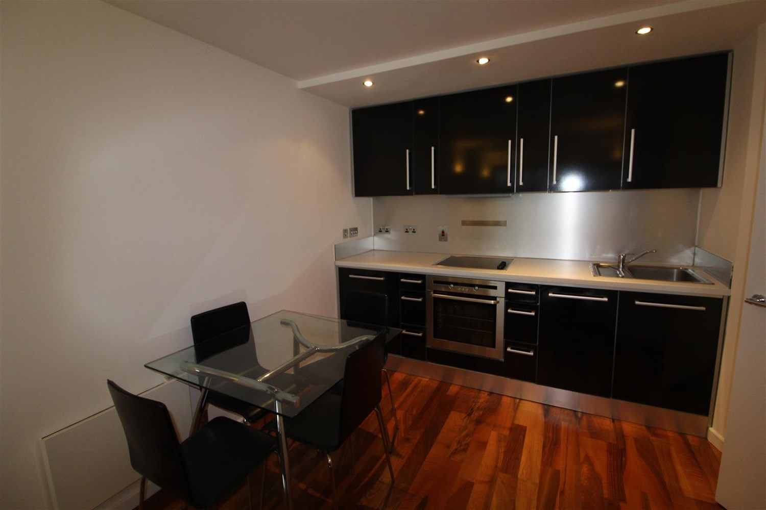

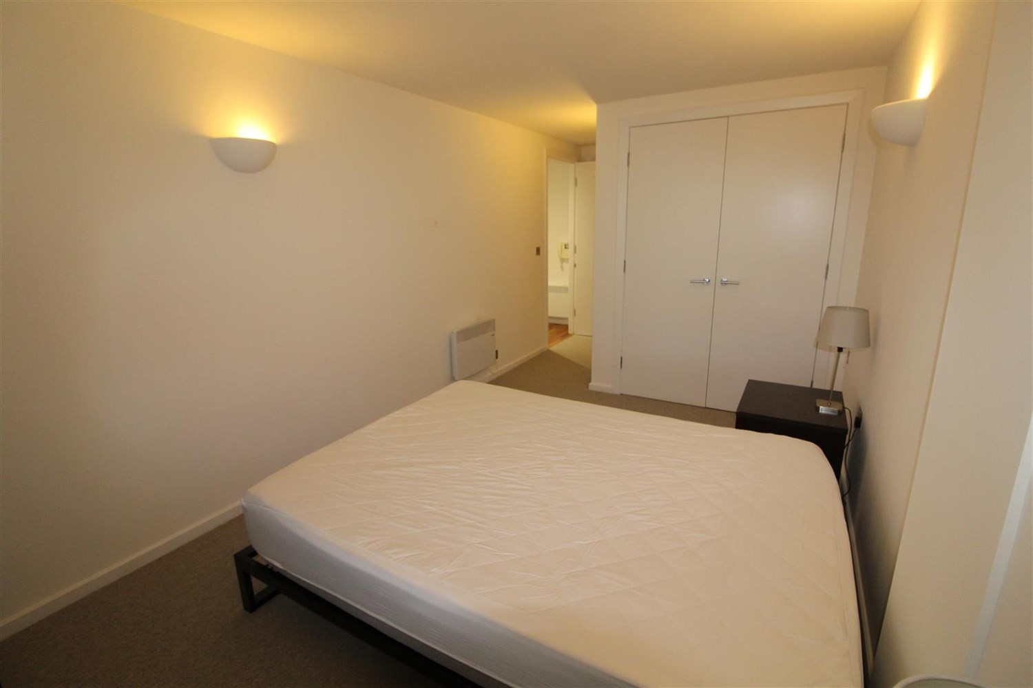

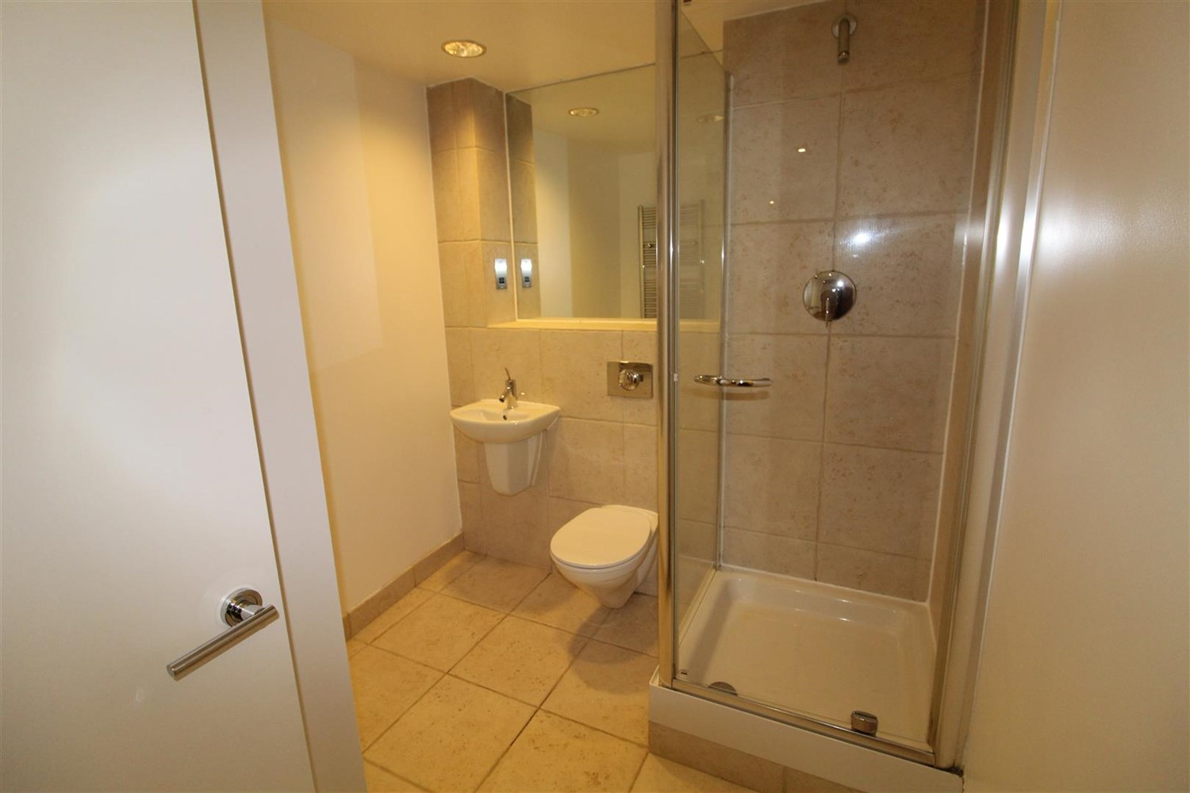

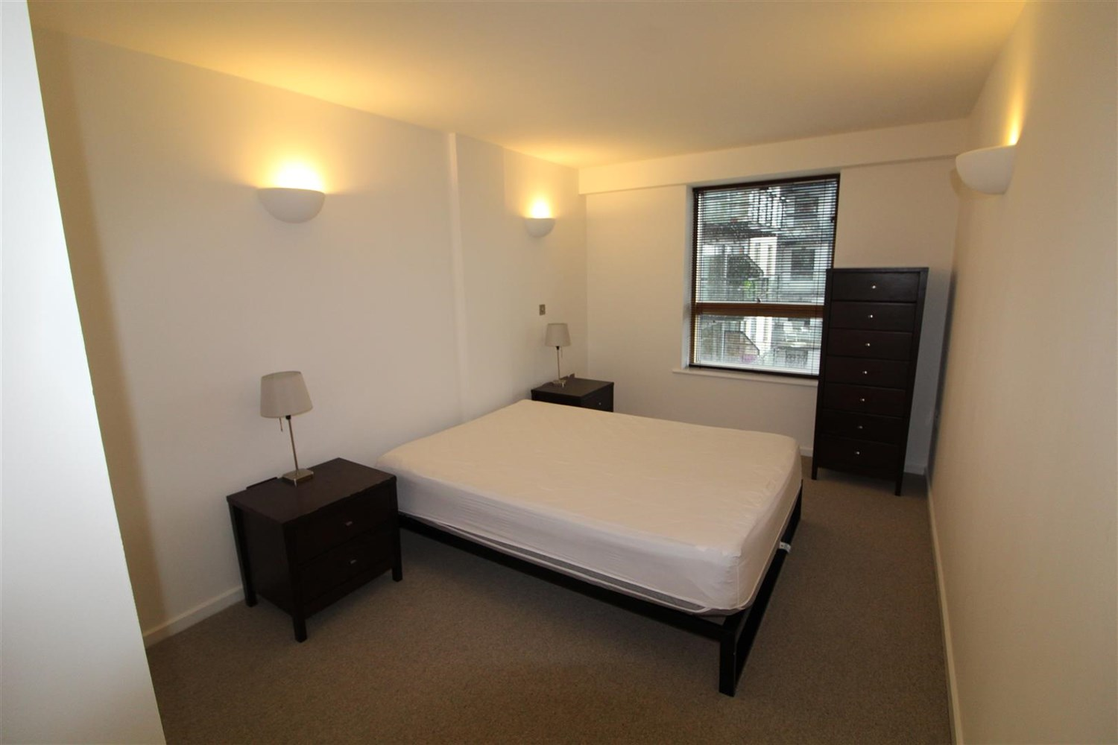



|  |
| --- |
| **Bathroom** |
| **Kitchen** |
| **Bedroom** |
| **Bedroom** |
| **Open Plan Kitchen and Living Room** |
| **En Suite** |

|  |
| --- |
|  |

These particulars are intended to give a fair description of the property, but their accuracy cannot be guaranteed, and they do not constitute an offer of contract. Intending purchasers must rely on their own inspection of the property. None of the above appliances/services have been tested by ourselves. We recommend purchasers arrange for a qualified person to check all appliances/services before legal commitment.

**Property Ref:** 144

**For more information, please contact**

0113 258 1150 **|** [lettings@adairpaxton.co.uk](mailto:lettings@adairpaxton.co.uk) **|** www.adairpaxton.co.uk