

**0113 258 1150**

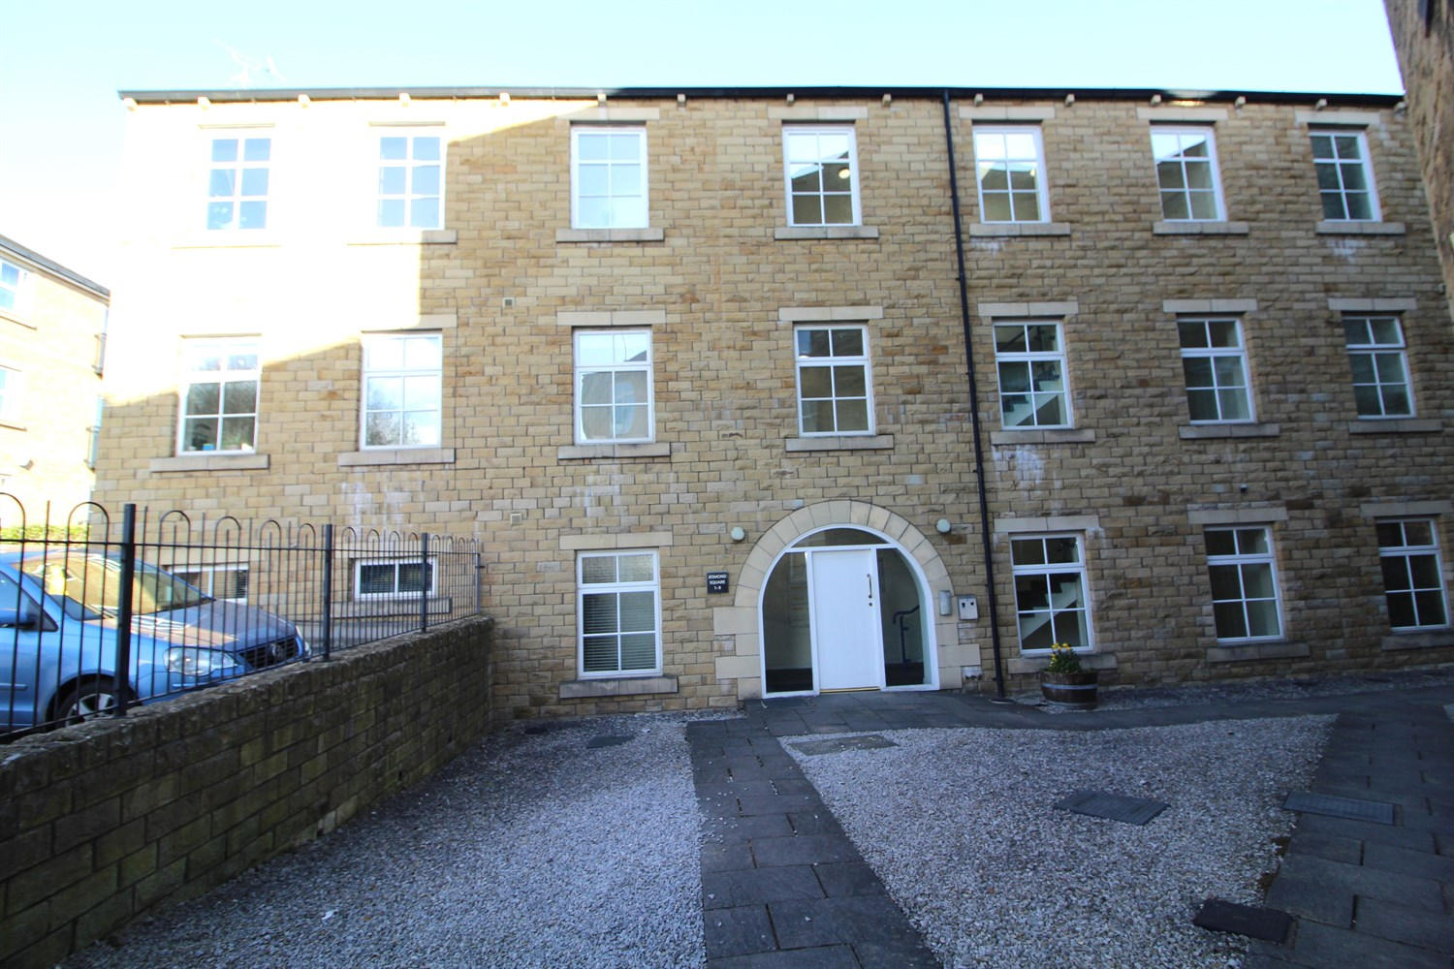



**Valuation £950.00pcm**

**Jesmond Square, LS28**

***SPACIOUS APARTMENT IN THE SOUGHT AFTER LOCATION OF FARSLEY*** This ground floor apartment is deceptively large. The property briefly compromises of open plan lounge and kitchen with space for a dining table, two double bedrooms one with a refurbished ensuite, . Allocated parking and visitor parking available. Stylish and modern décor, ready to move into. Close to all local amenities of Farsley and Rodley and with easy access to Leeds and Bradford. Available from the 1st April 2025, deposit £1095, EPC rating C, Council tax band B.

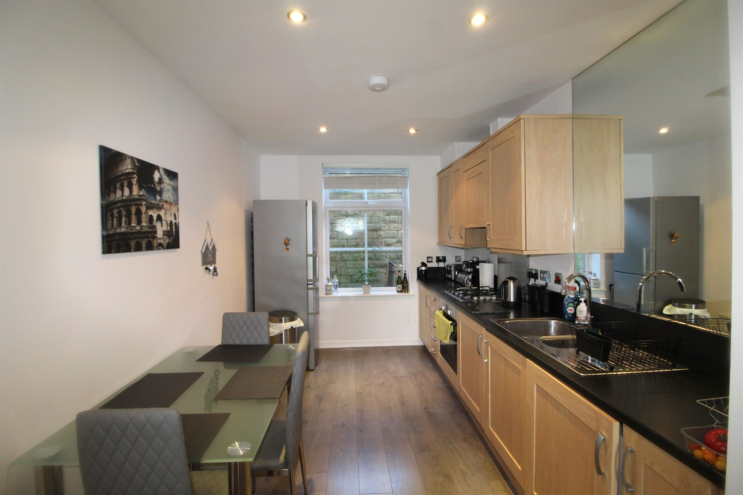

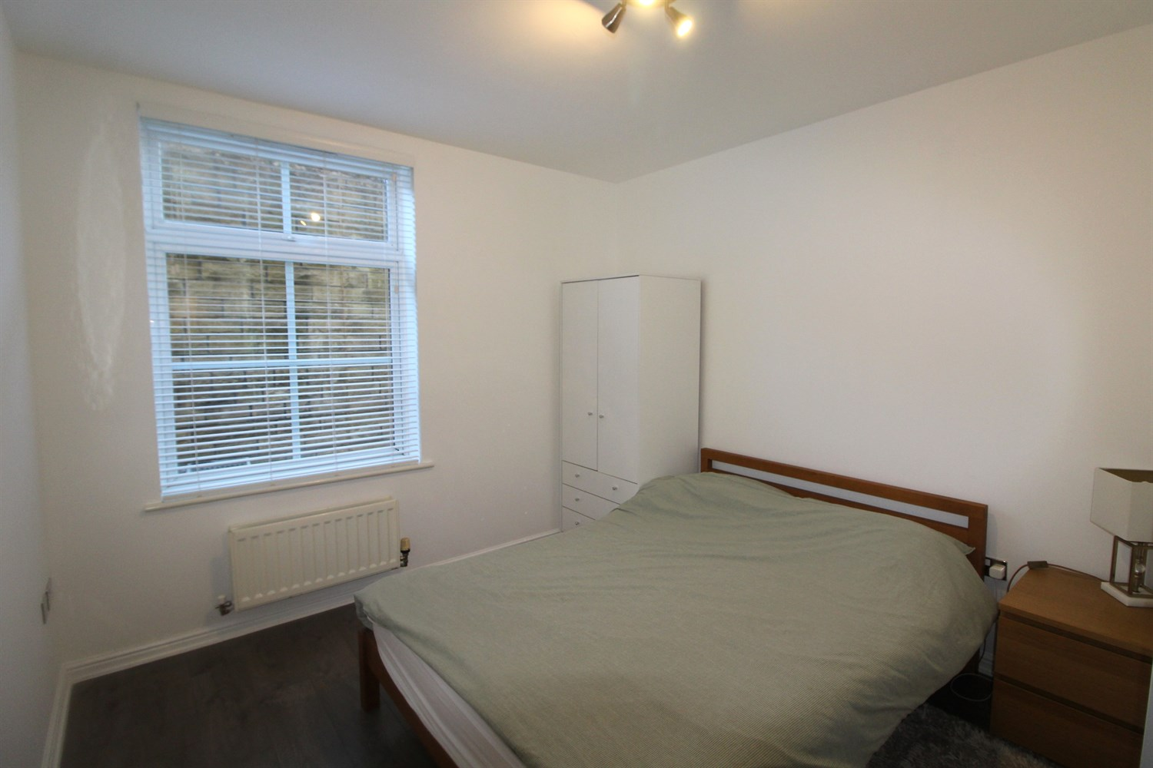

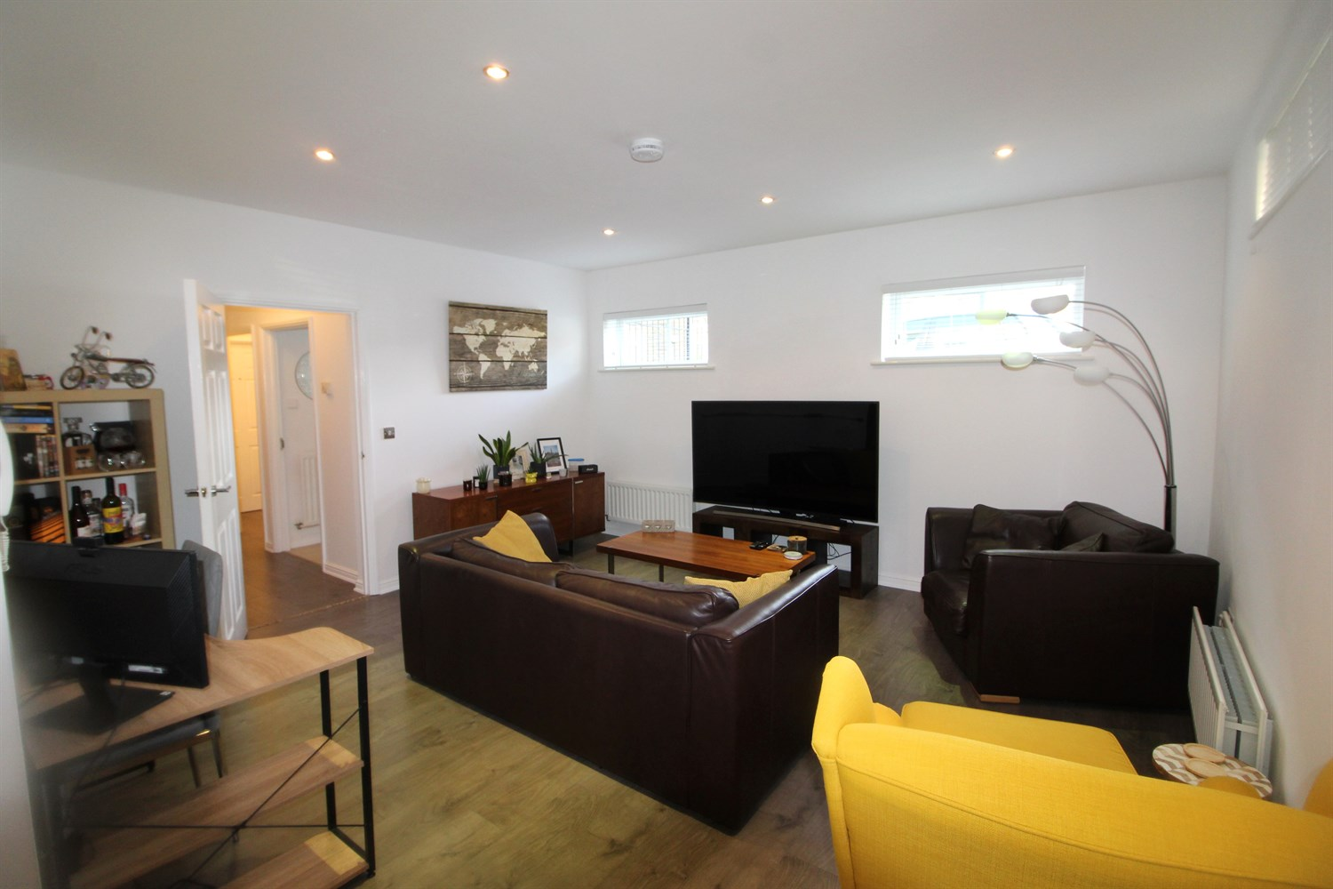

2 Bathroom(s)

1 Reception(s)

2 Bedroom(s)

00

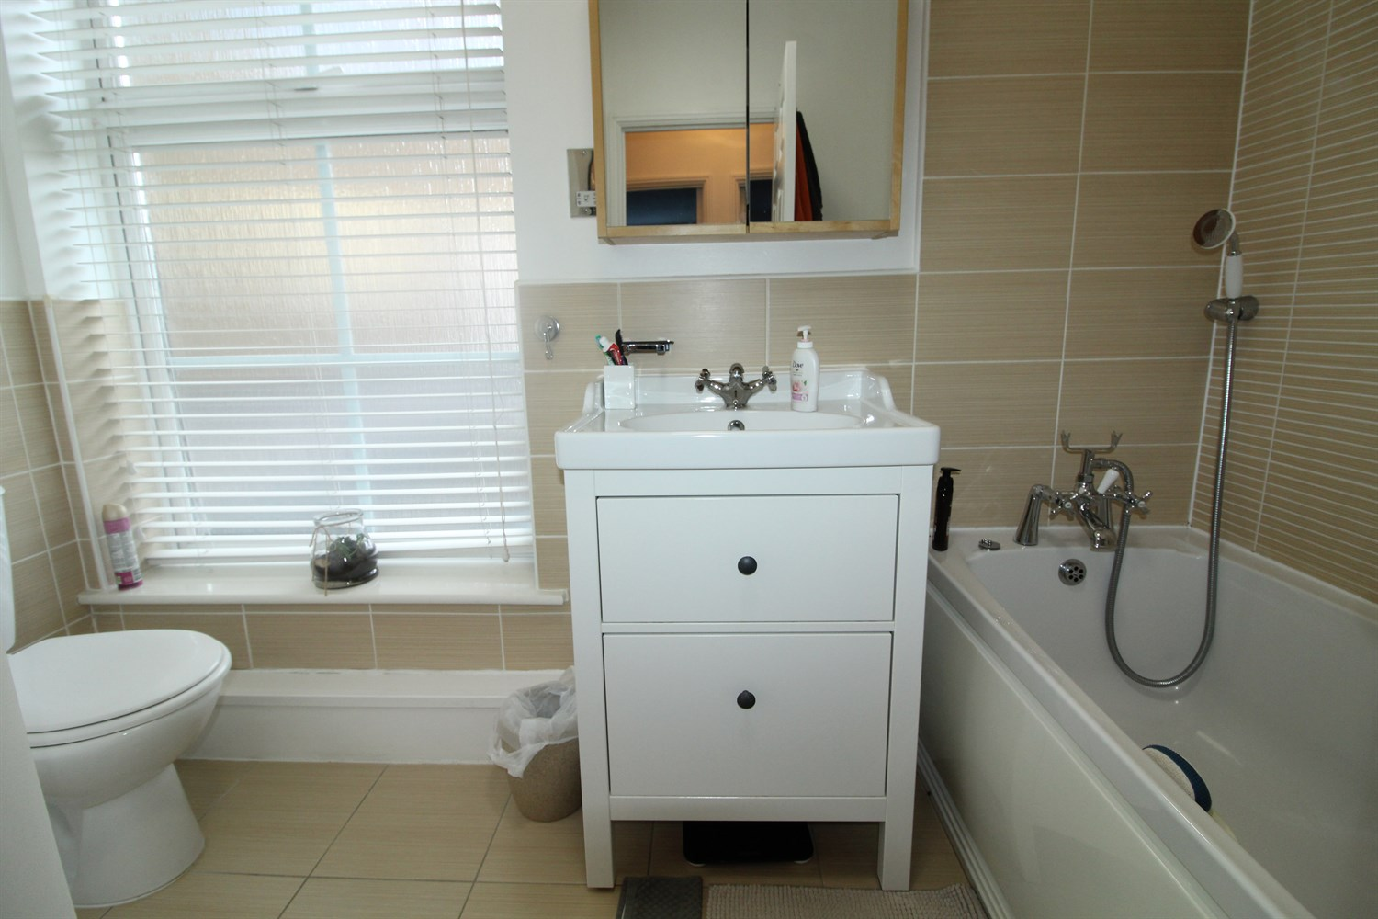

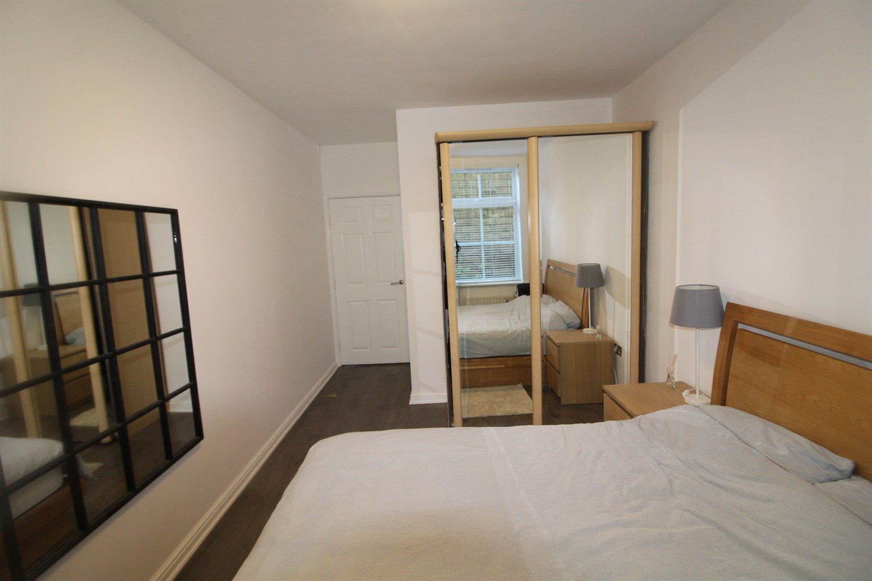

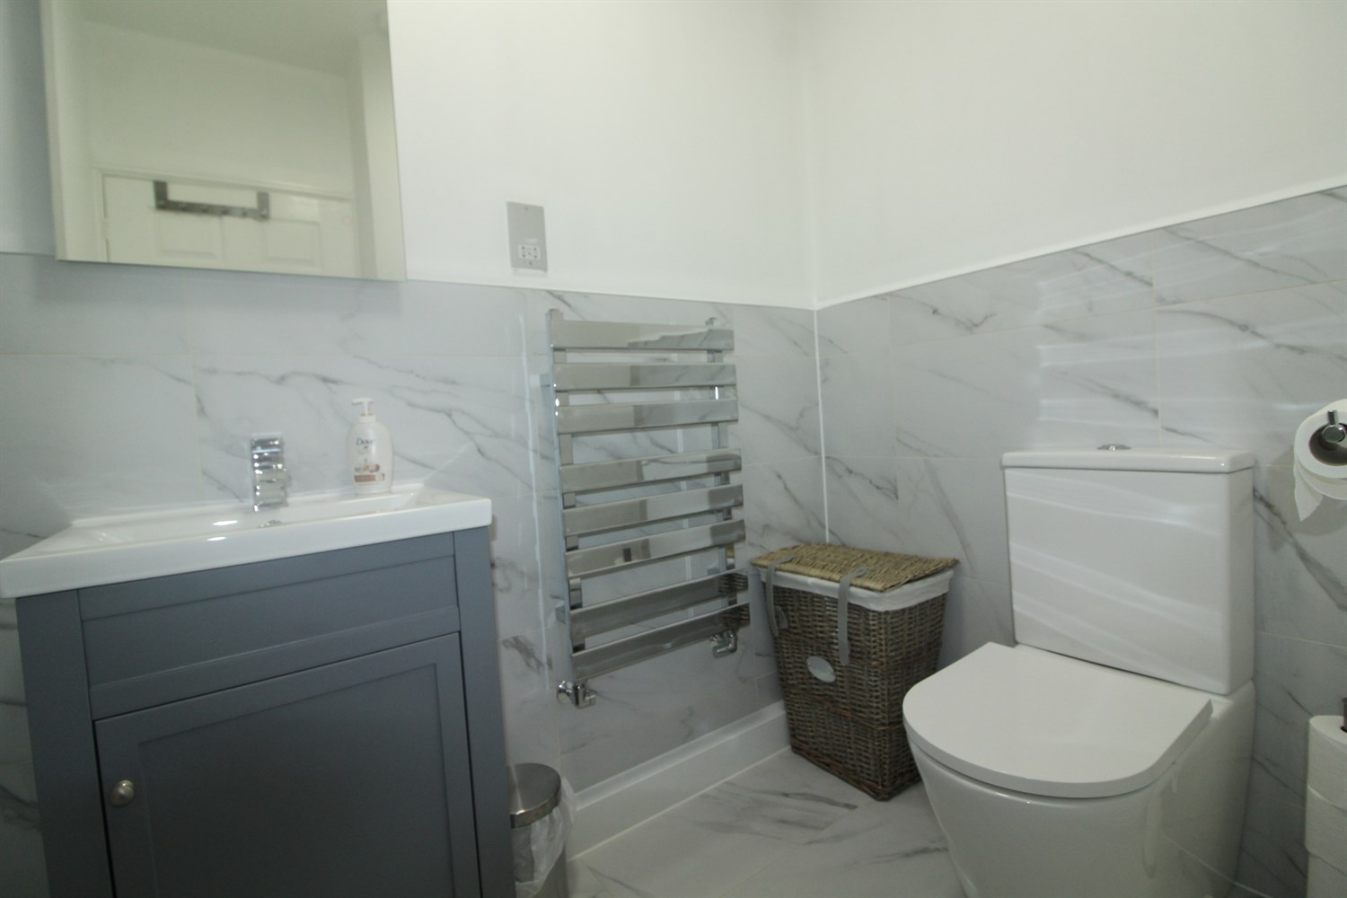

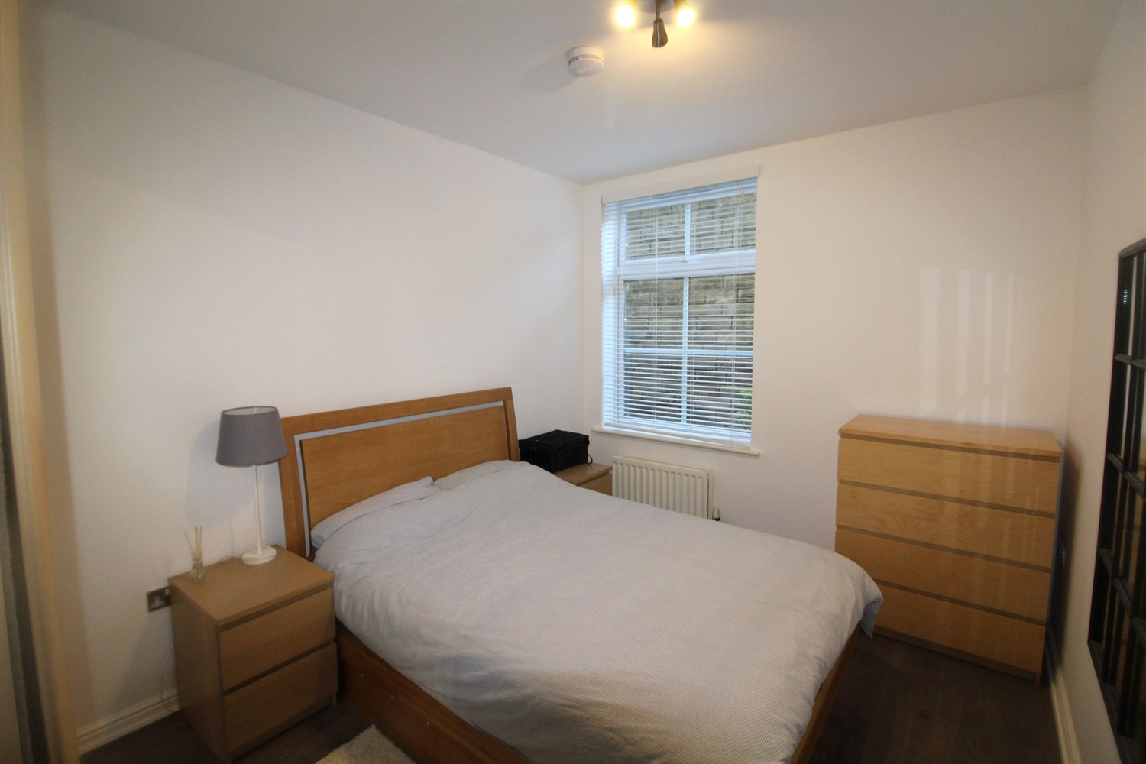

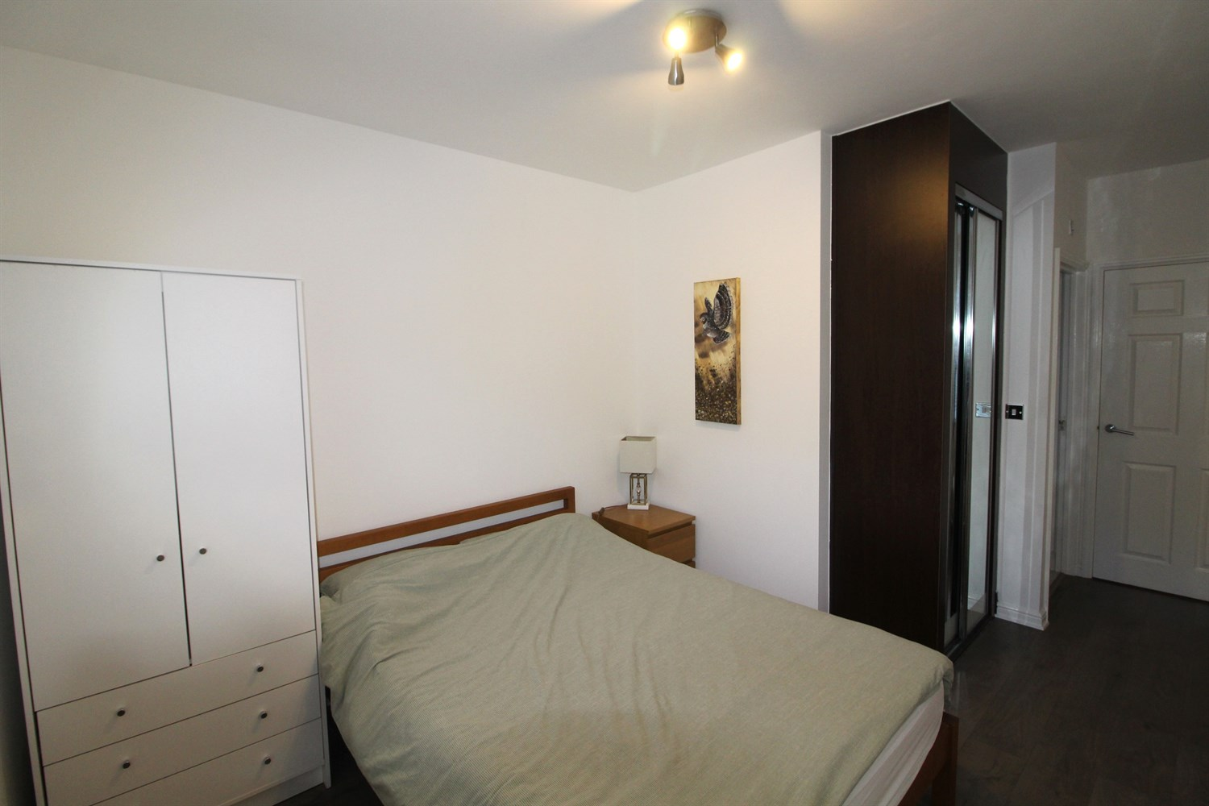

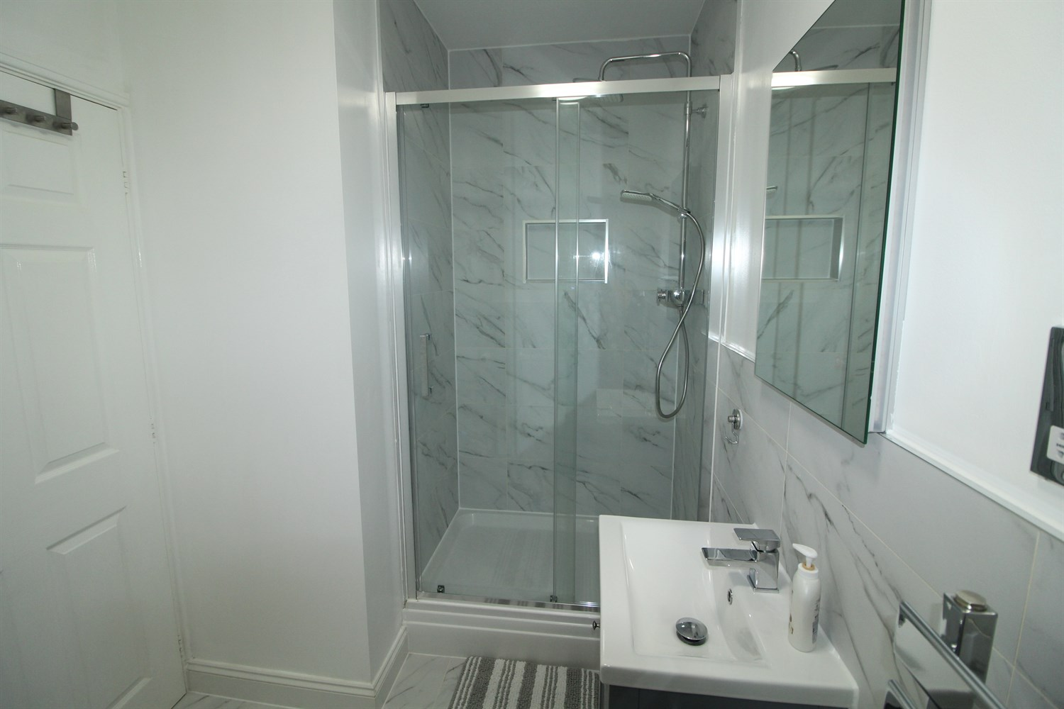

|  |
| --- |
| **Communal Entrance**  Intercom access, stairs leading to all floors. |
| **Private Entrance Hall**  Private entrance with storage cupboard, door leading to hallway. |
| **Reception 1 8.39m (27'6) x 4.51m (14'10)**  Spacious living room leading to the kitchen, three uPVC windows to front and side, window to rear from kitchen. Kitchen kitted with a range of wall and base units, gas hob and electric oven with extractor over, stainless steel sink with drainer and mixer tap, integrated washing machine. |
| **Bedroom 1 5.05m (16'7) x 2.97m (9'9)**  Double bedroom with fitted wardrobe and access to a refurbished en-suite. uPVC window to rear, gas central heating radiator. Wood effect flooring. |
| **Bedroom 2 5.01m (16'5) x 2.79m (9'2)**  Double bedroom with fitted wardrobe uPVC window to rear, gas central heating radiator. Wood effect flooring. |
| **En Suite 2.97m (9'9) x 5.05m (16'7)**  large en-suit with walk in shower, low flush w/c, hand wash basin, towel radiator. Part tiled walls. |
| **Bathroom 2 2.81m (9'3) x 2.05m (6'9)**  House bathroom fitted with bath, low flush w/c and hand wash basin, part tiled. Towel radiator |
| **Parking**  Allocated parking and visitor parking. |
| **Home Information**  COUNCIL TAX BAND: B EPC Rating C.  Leasehold property Allocated Parking  Broadband: Standard 8 Mbps 0.9 Mbps Good Superfast 80 Mbps 20 Mbps Good Ultrafast 1000 Mbps 1000 Mbps   Mobile availability: EE Likely to have good coverage. Three .Likely to have good coverage. O2 Likely to have good coverage. Vodafone Limited coverage.  Utilities: Water supplied on standard meters. Electric mains supplied on standard meters. Gas supplied on standard metres. |

|  |  |
| --- | --- |
| These particulars are intended to give a fair description of the property, but their accuracy cannot be guaranteed, and they do not constitute an offer of contract. Intending purchasers must rely on their own inspection of the property. None of the above appliances/services have been tested by ourselves. We recommend purchasers arrange for a qualified person to check all appliances/services before legal commitment.  **Property Ref:** 5484  **For more information, please contact**  0113 258 1150 **|** [lettings@adairpaxton.co.uk](mailto:lettings@adairpaxton.co.uk) **|** www.adairpaxton.co.uk |  |