

Calverley Lane, Horsforth
For Sale £330,000.00

***THREE BEDROOM VICTORIAN SEMI-DETACHED HOUSE - NO ONWARD CHAIN*** Located in a sought after location of Horsforth and within easy reach of local amenities, this characterful property is now in need of modernisation and briefly comprises; entrance hall, lounge, sitting room and kitchen to the ground floor. Cellar. To the first floor there are two double bedrooms, a single bedroom and the house bathroom. Externally the property has steps leading up to the front entrance door and a side gate leading to an enclosed the rear garden. An early internal viewing is highly recommended to appreciate the accommodation and potential on offer.
0113 258 1150
0800 000 000
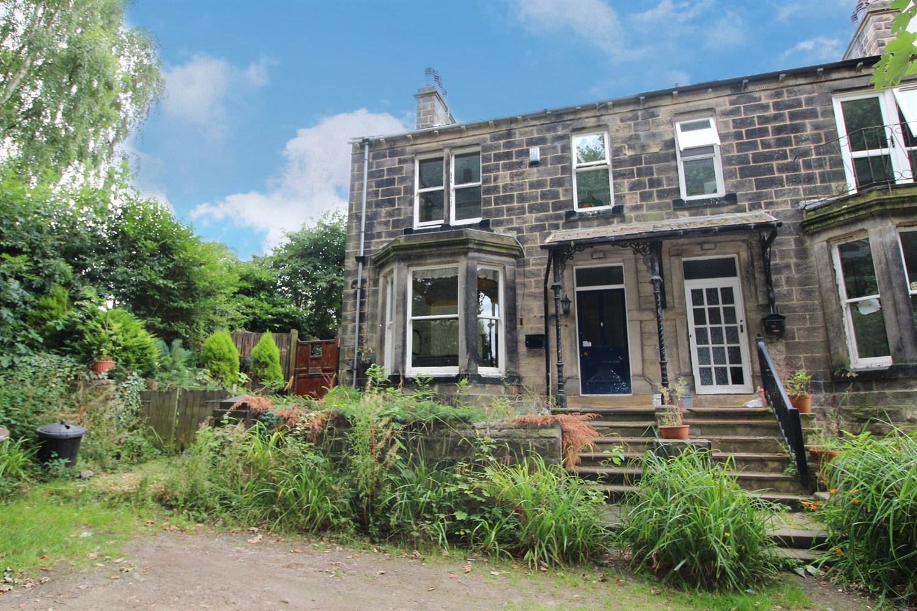



2 Reception
1 Bathroom
3 Bedroom
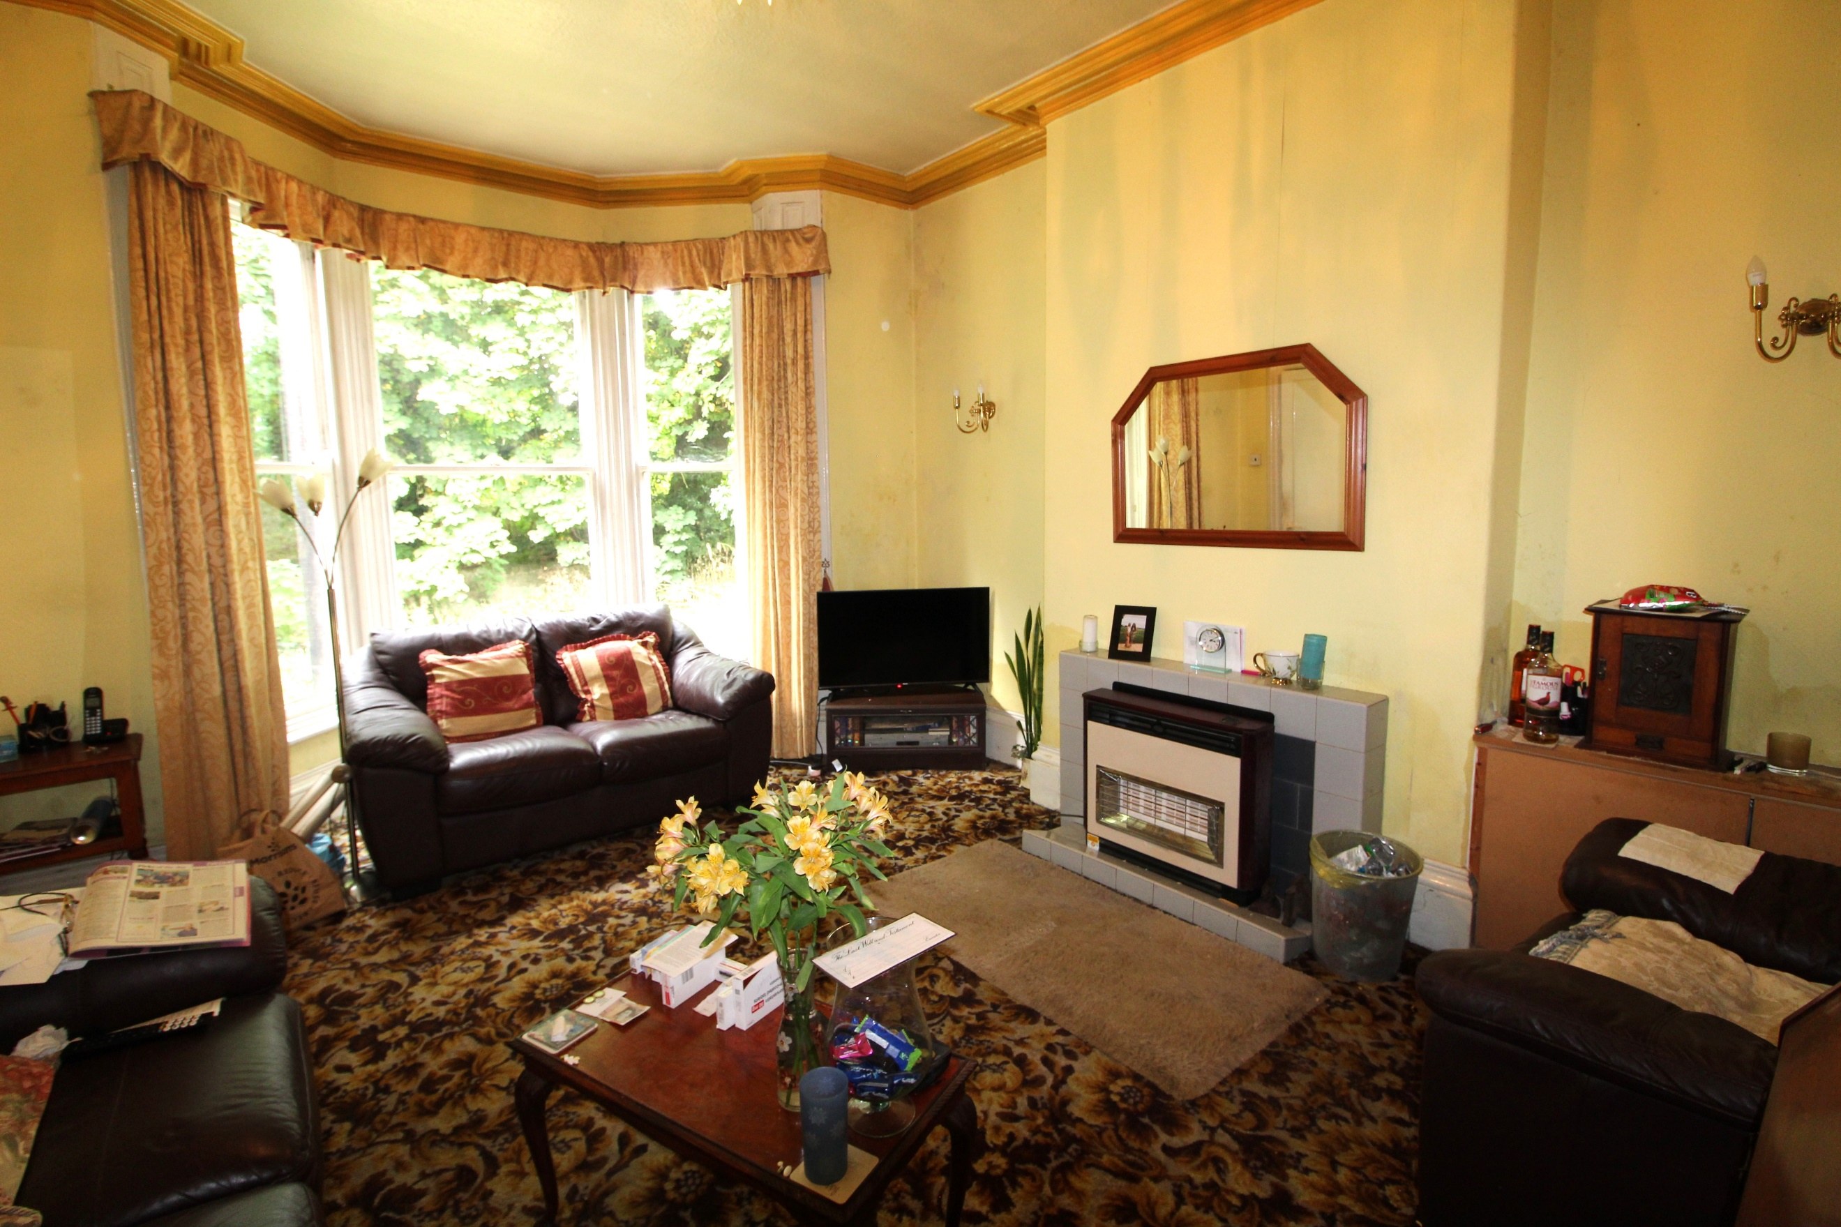
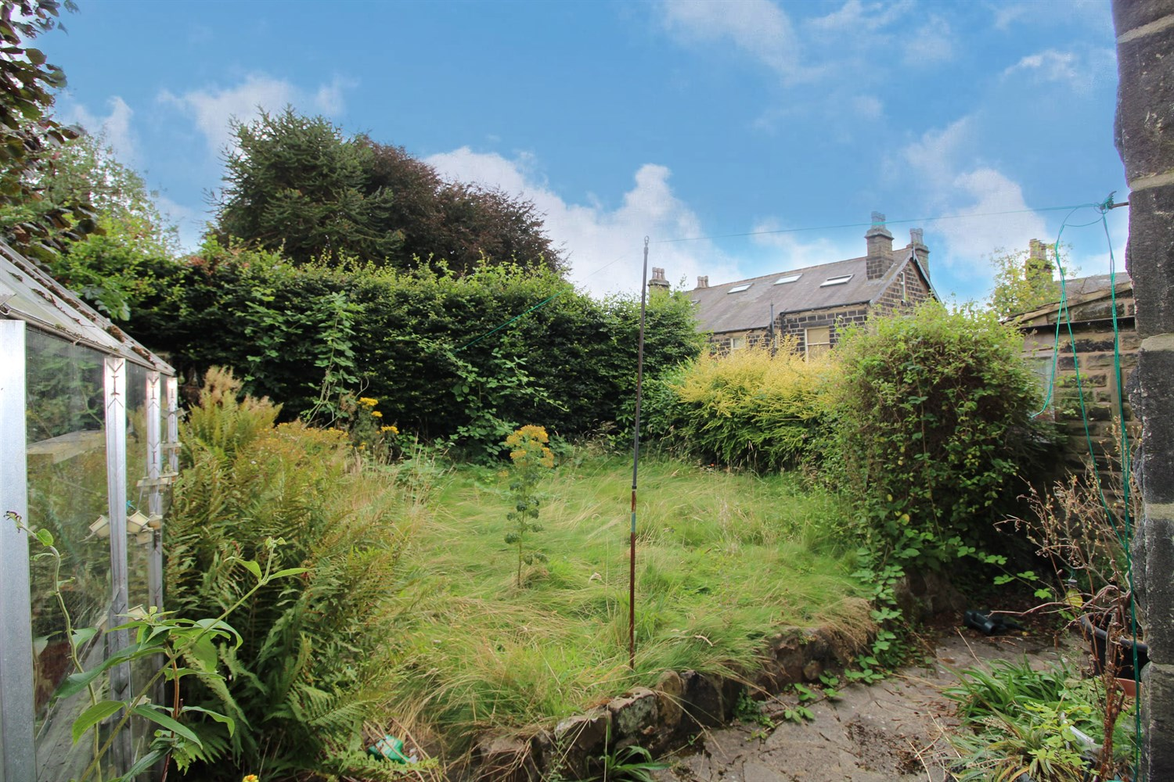
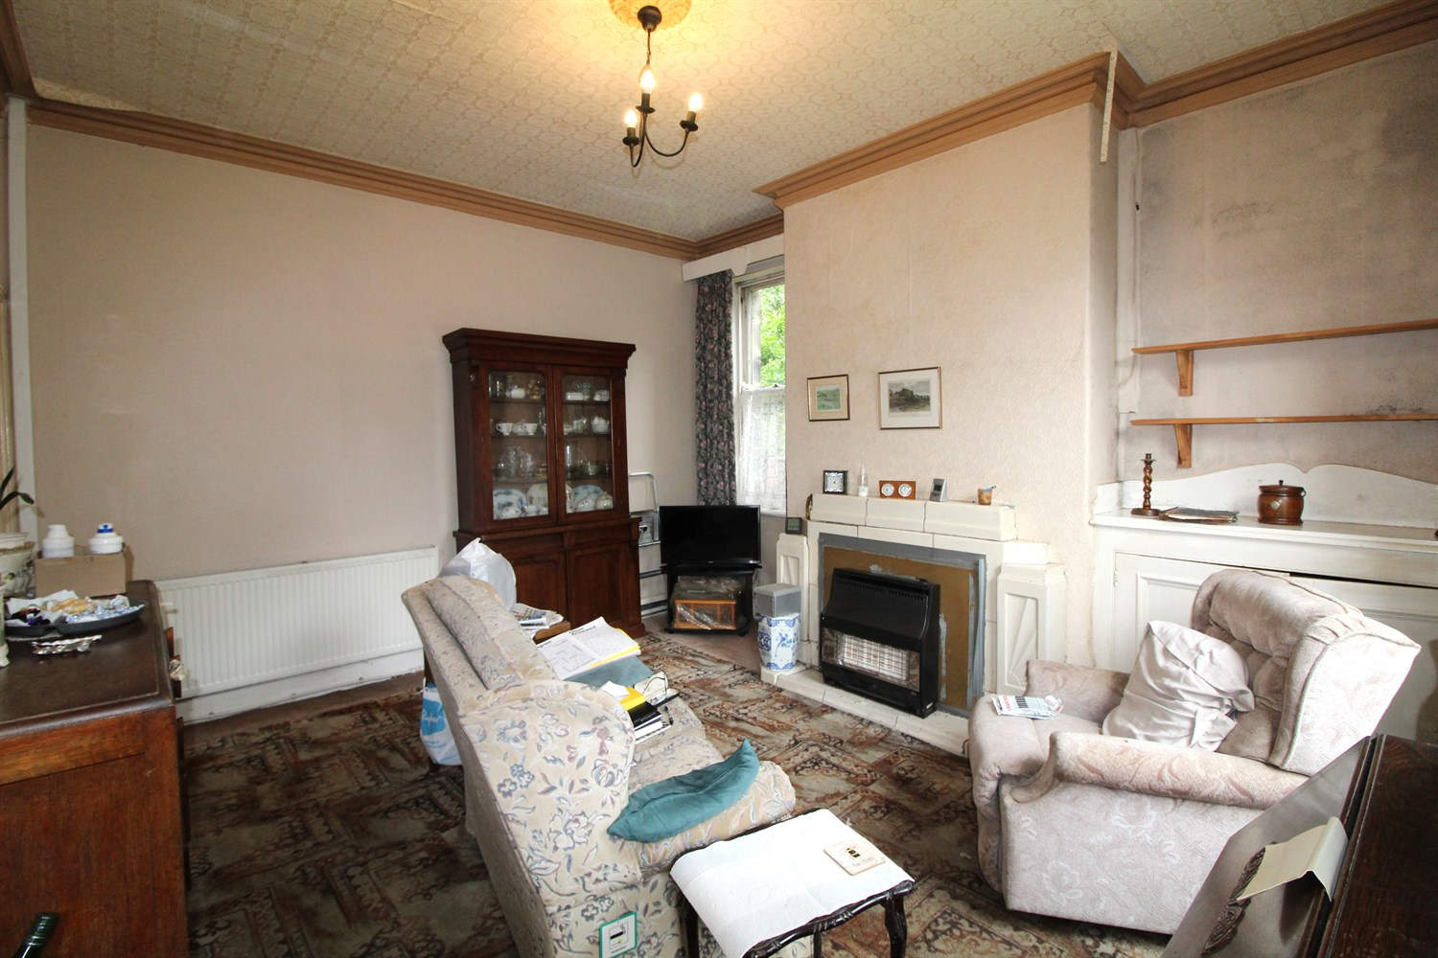
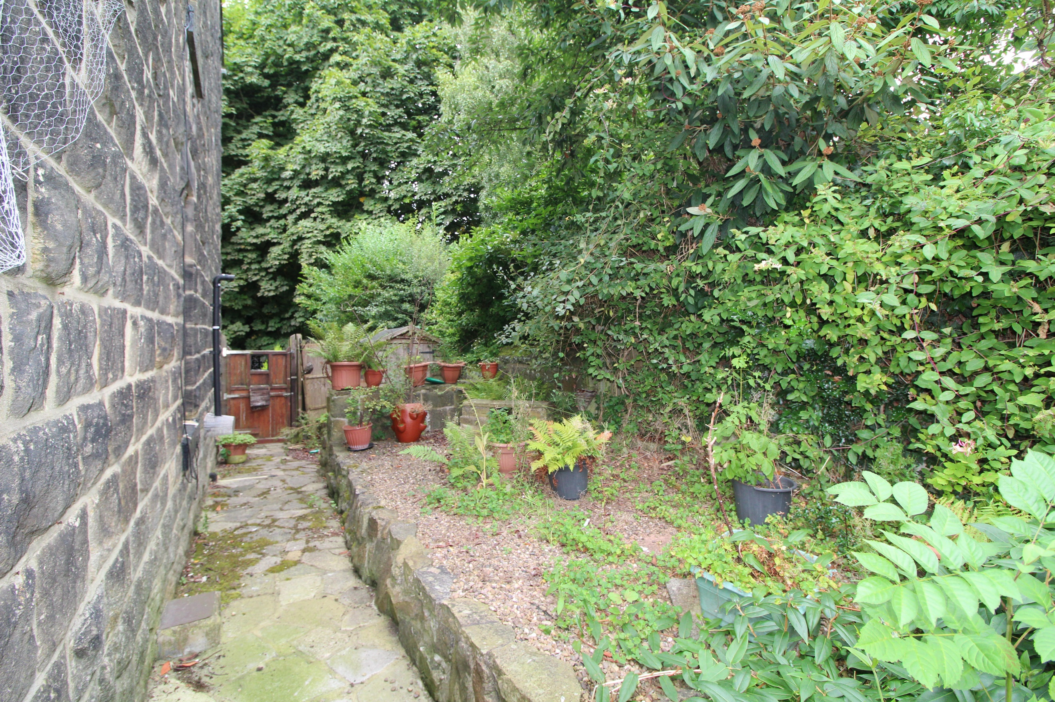
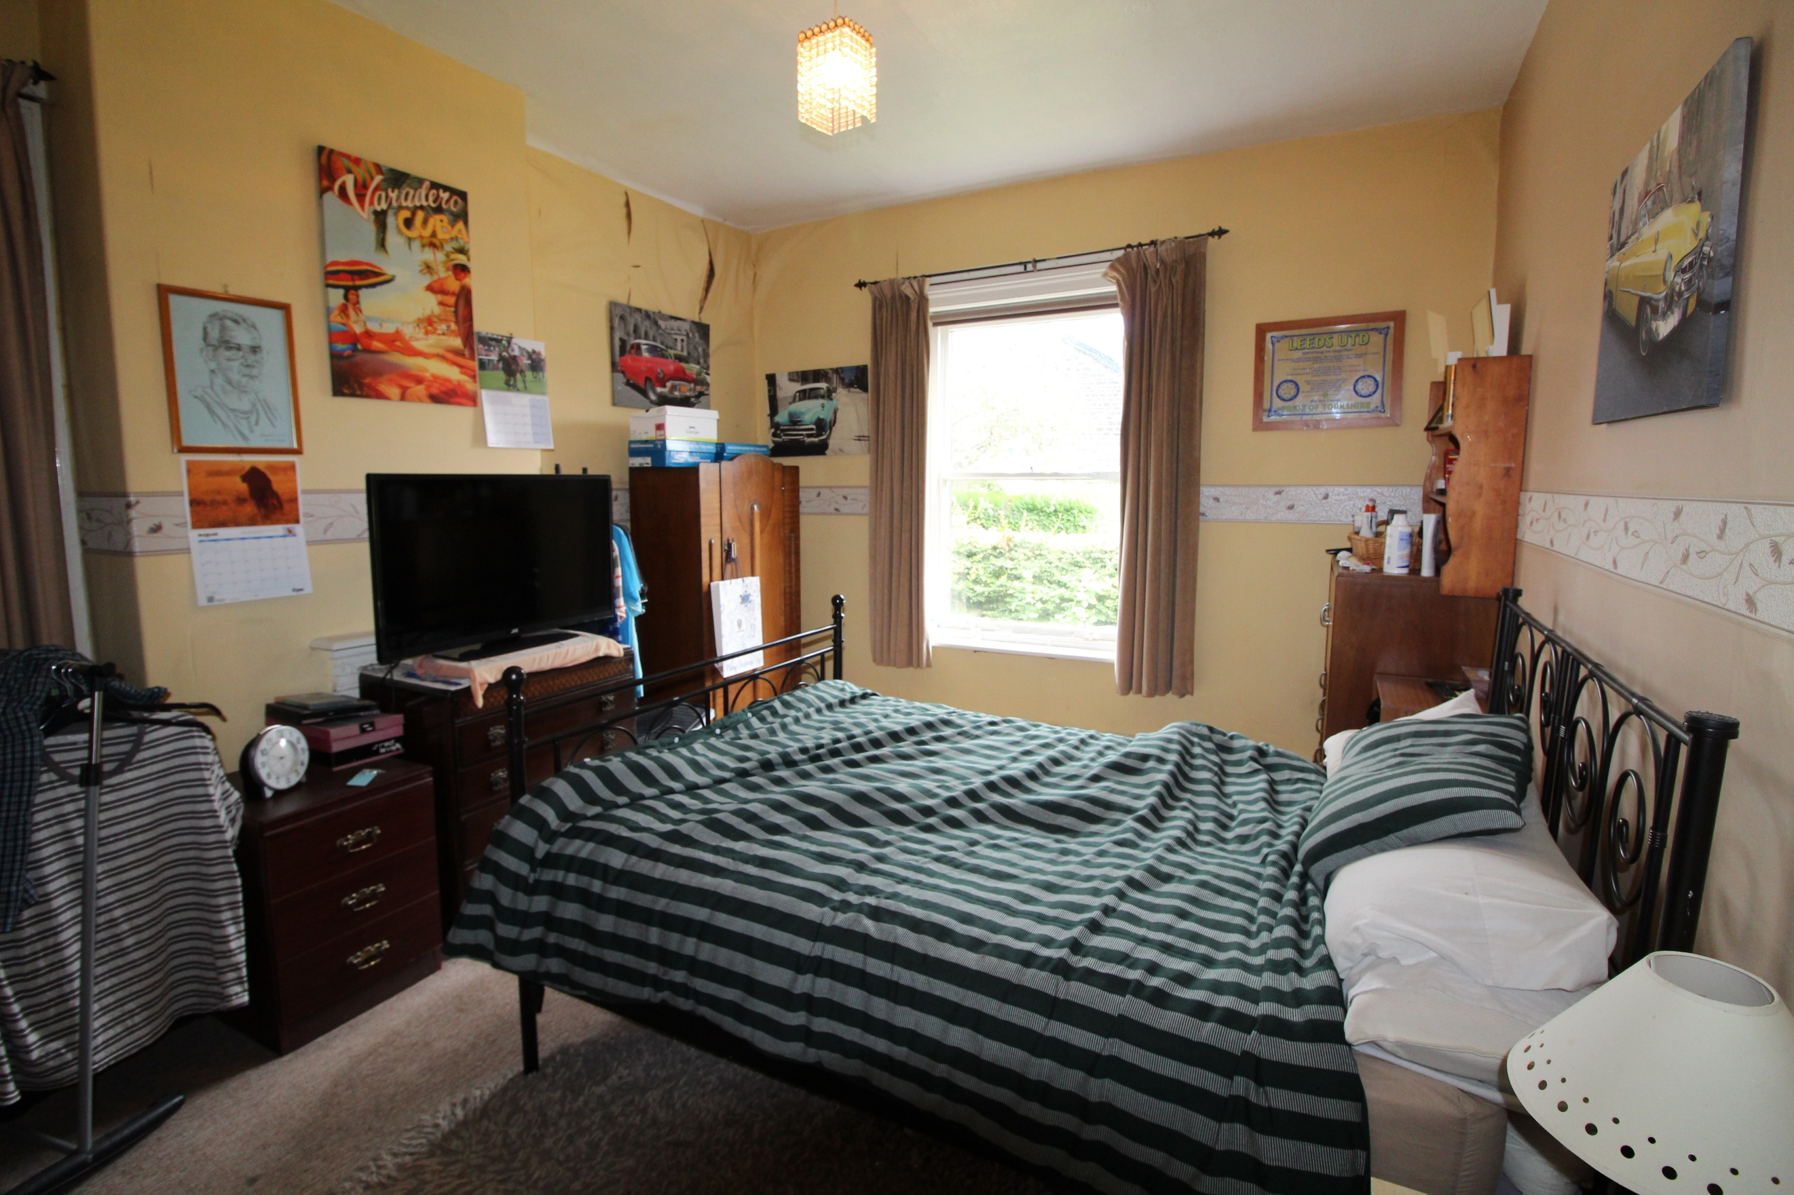
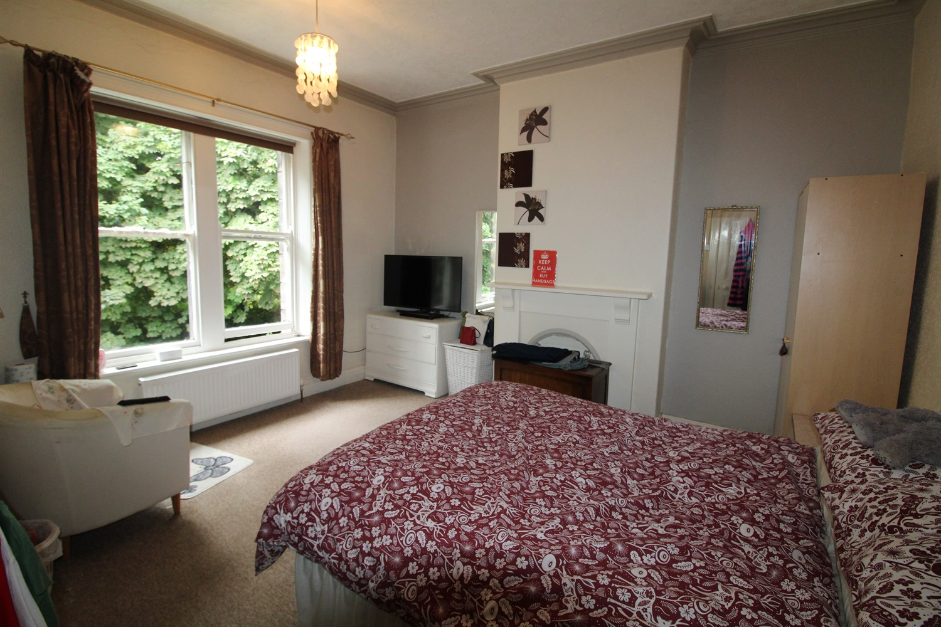
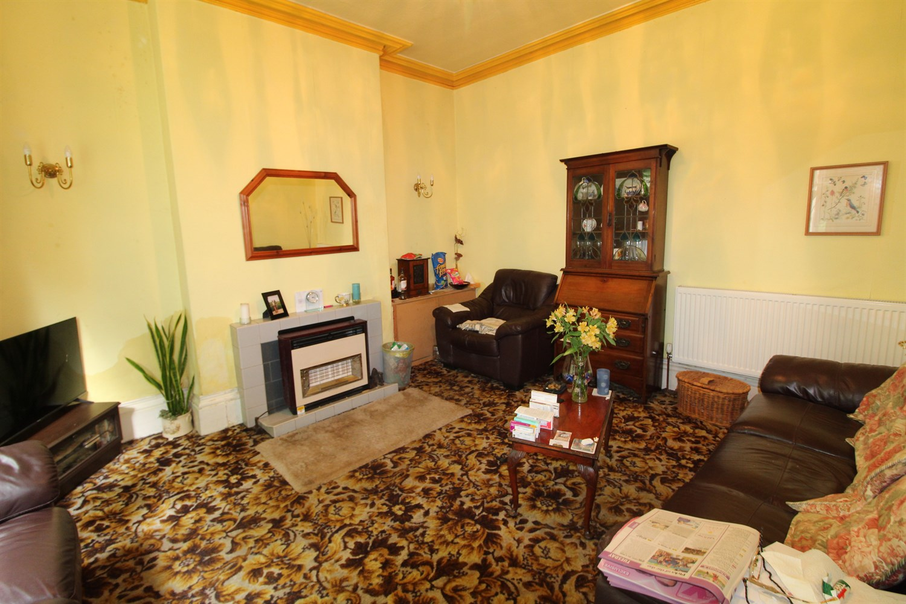
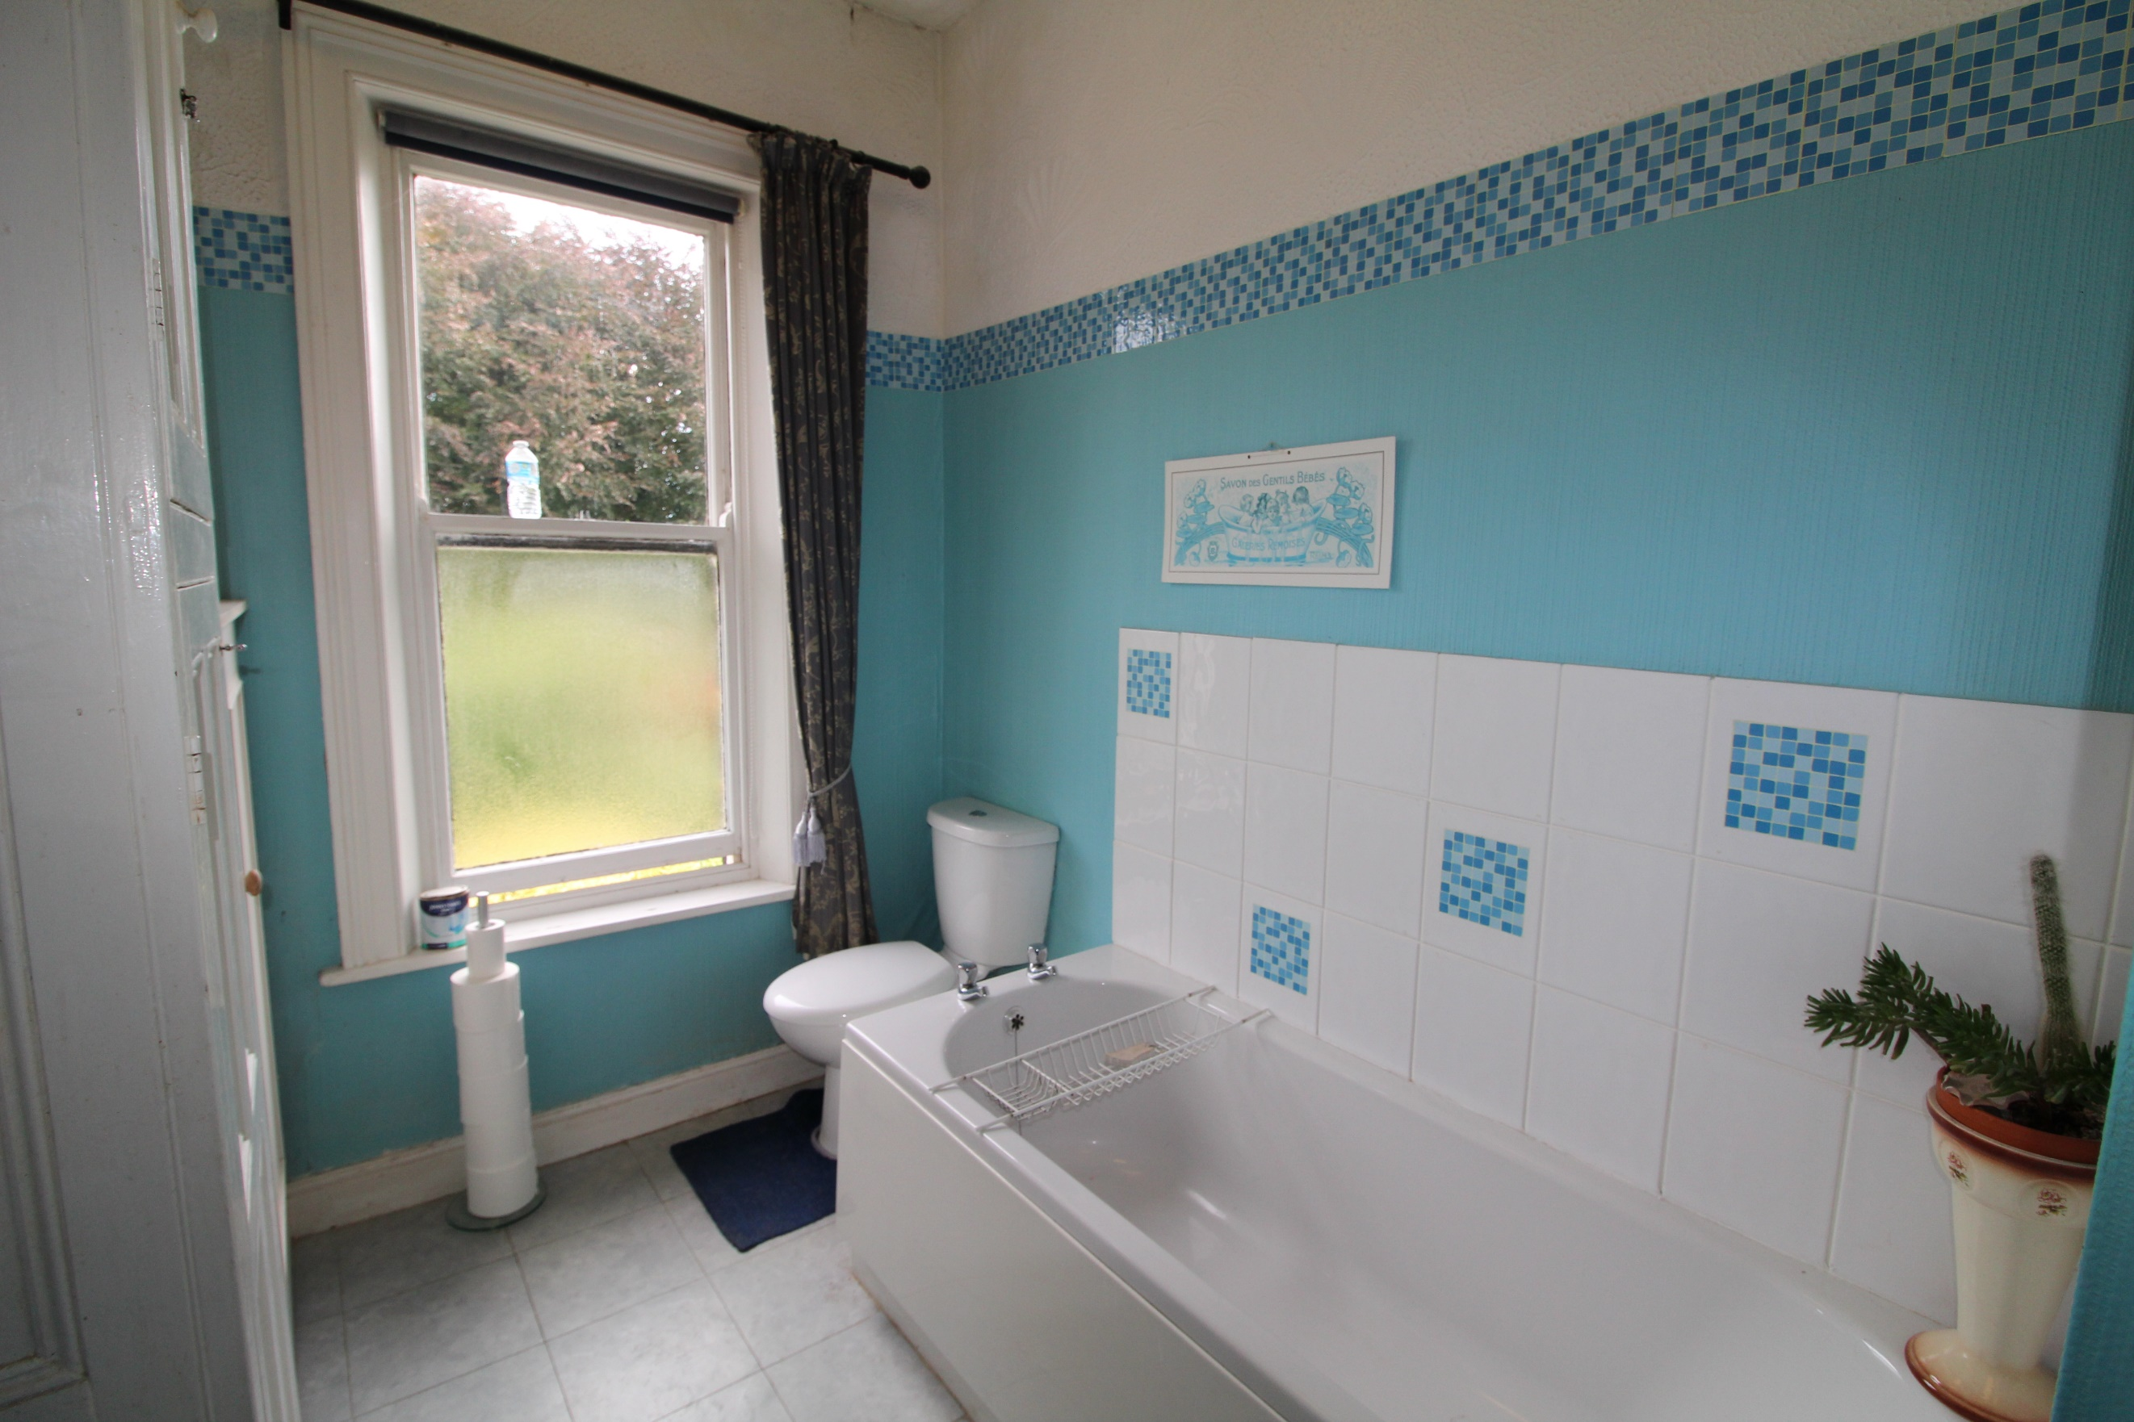

Entrance Hall
Via front entrance door. Stairs to first floor.

Lounge 4.16m (13'8) x 4.04m (13'3)
Good sized living room with bay window to the front. High ceilings and coving. Gas central heating radiator.

Sitting Room 4.56m (15') x 4.04m (13'3)
Second reception room with window looking out to the rear garden and window to side. Gas central heating radiator. Coving to ceiling. Door leading out to the rear garden.

Kitchen 3.47m (11'5) x 1.7m (5'7)
Fitted with a range of wall, base and drawer units with worktops over. Window to rear. Plumbed for washing machine and space for fridge/freezer. Door to cellar.

First Floor

Bedroom 1 4.16m (13'8) x 4.11m (13'6)
Double bedroom with window to the front. Gas central heating radiator. Coving to ceiling.

Bedroom 2 4.56m (15') x 3.58m (11'9)
Second double bedroom with window to side and rear. Gas central heating radiator.

Bedroom 3 2.57m (8'5) x 1.7m (5'7)
Third bedroom with window to front.

Bathroom
Fitted with a four piece white suite comprising; shower cubicle, bath, WC and wash hand basin. Tiled walls. window to rear.

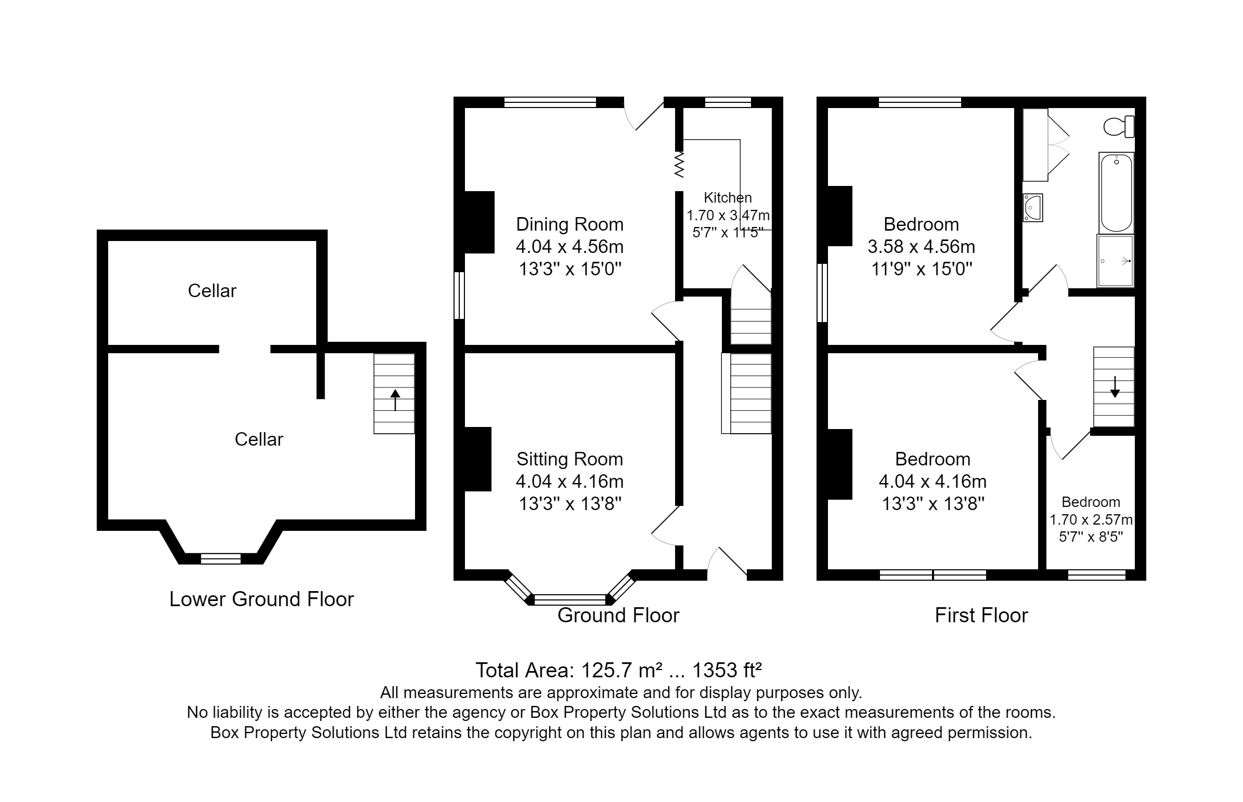

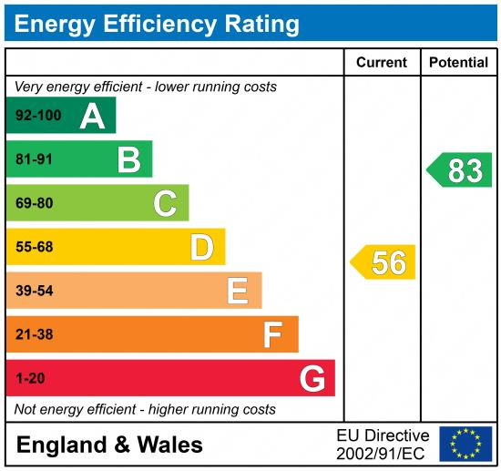

These particulars are intended to give a fair description of the property, but their accuracy cannot be guaranteed, and they do not constitute an offer of contract. Intending purchasers must rely on their own inspection of the property. None of the above appliances/services have been tested by ourselves. We recommend purchasers arrange for a qualified person to check all appliances/services before legal commitment.

Property Ref: 3459

For more information, please contact

0113 258 1150 | sales@adairpaxton.co.uk | www.adairpaxton.co.uk

