

**0113 258 1150**

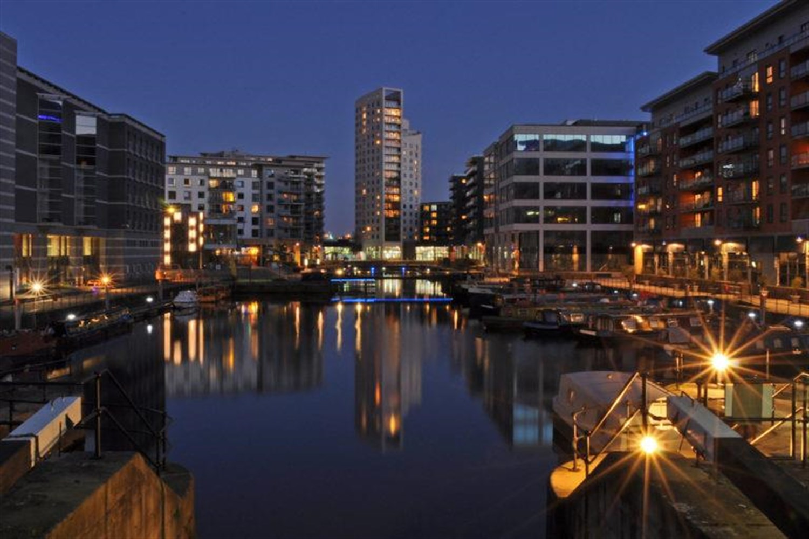



**Available to let £875.00pcm**

**Mackenzie House, Leeds**

***ONE BEDROOM SECOND FLOOR APARTMENT IN THE SOUGHT AFTER RIVERSIDE LOCATION AT CLARENCE DOCK***Close to all amenities at Leeds Dock including Tesco Express, Mumtaz Restaurant and Primal Gym. Briefly comprising; Open plan lounge/kitchen/diner, one double bedroom and bathroom. Furnished. Council tax band D, EPC rating C. Deposit £1005. Sorry, no pets. Available Now.

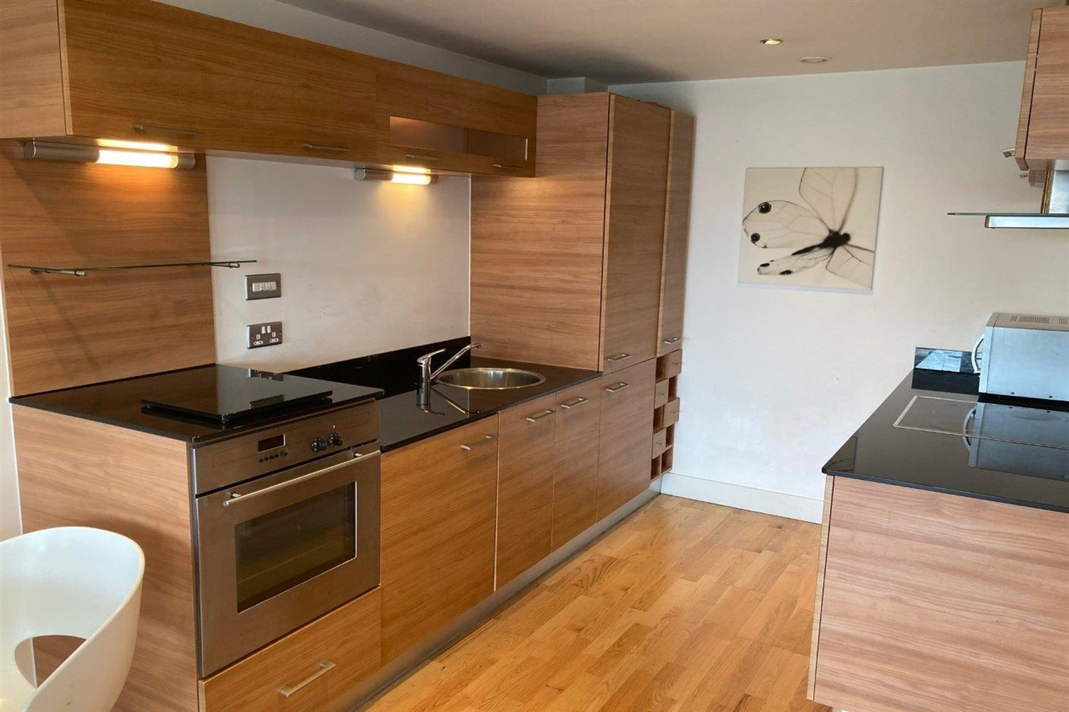

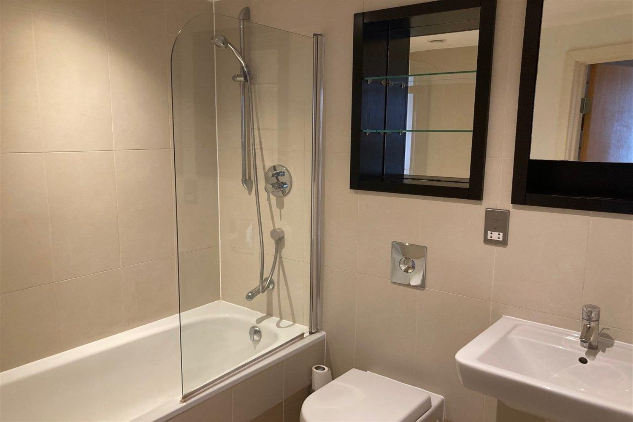

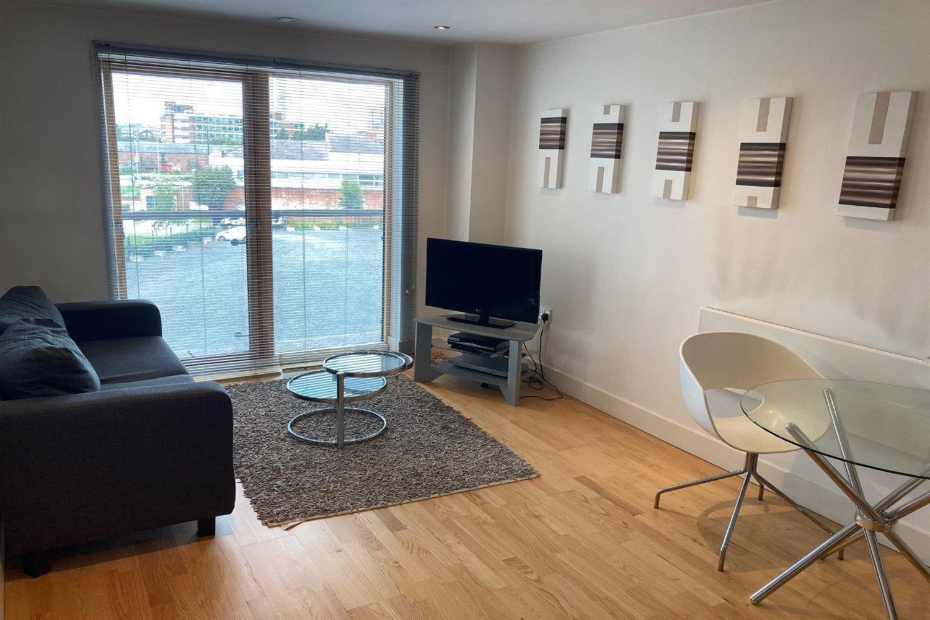

1 Bathroom(s)

1 Reception(s)

1 Bedroom(s)

00

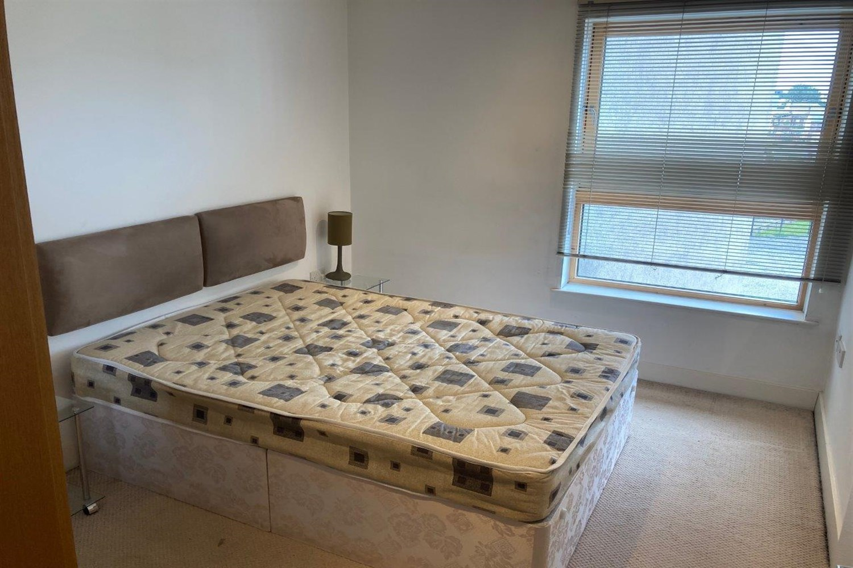

|  |
| --- |
| **Open Plan Kitchen and Living Room**  Spacious open plan living and kitchen. Living room is light and airy with sliding door to a Juliet balcony. Electric wall heater. Kitchen area is modern with integrated fridge-freezer, electric oven and hob with extractor over head. Round bowl with mixer tap. |
| **Bedroom 1**  Double bedroom with window to front, electric wall heater. |
| **Bathroom**  Three piece bathroom suite with shower over head, shower screen, w/c and hand wash basin. Tiled walls and floor and two mirrors one with shelves. Electric wall heater. |
| Tenancy. 12 months. COUNCIL TAX BAND: C EPC Rating B  Leasehold property Cladding work pending. Broadband:  Standard 16 Mbps 1 Mbps Good Superfast 80 Mbps 20 Mbps Good Ultrafast 330 Mbps 50 Mbps Mobile availability: EE Limited Limited Three Limited Limited O2 Likely Likely Vodafone Likely Likely  Utilities: Water supplied on standard meters. Electric mains supplied on standard meters. |

|  |  |
| --- | --- |
| These particulars are intended to give a fair description of the property, but their accuracy cannot be guaranteed, and they do not constitute an offer of contract. Intending purchasers must rely on their own inspection of the property. None of the above appliances/services have been tested by ourselves. We recommend purchasers arrange for a qualified person to check all appliances/services before legal commitment.  **Property Ref:** 3560  **For more information, please contact**  0113 258 1150 **|** [lettings@adairpaxton.co.uk](mailto:lettings@adairpaxton.co.uk) **|** www.adairpaxton.co.uk |  |