

**0113 258 1150**

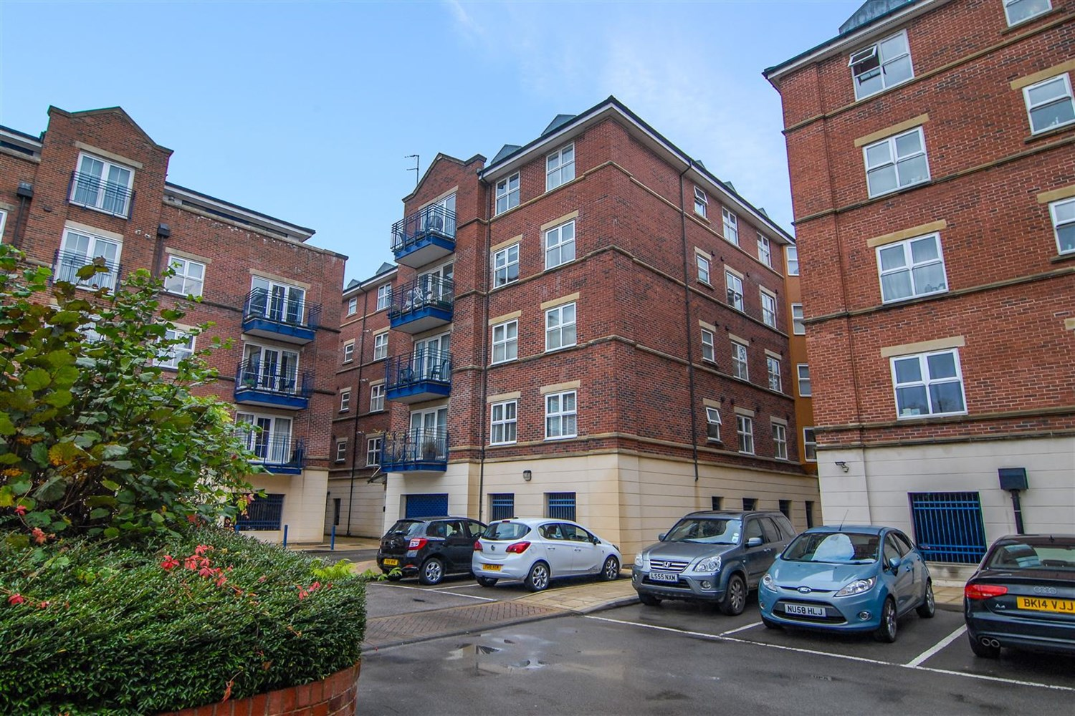



**For Sale £210,000.00**

**Carisbrooke Road, Far Headingley**

*** TWO DOUBLE BEDROOM, SECOND FLOOR APARTMENT WITH SECURE UNDERCROFT PARKING IN THIS SOUGHT AFTER DEVELOPMENT**** The apartment is located in the highly popular area of Weetwood and is within walking distance of the Village hotel, local shops, bars, restaurants and has great transport links. The property must be viewed to appreciate the accommodation on offer. Briefly comprising; spacious hallway with storage cupboard, good sized kitchen, spacious lounge, master bedroom with en-suite shower room, second double bedroom and house bathroom. SECURE PARKING. Deposit £1440.

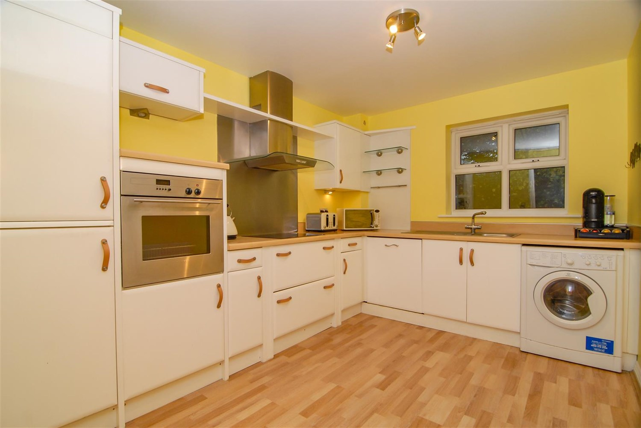

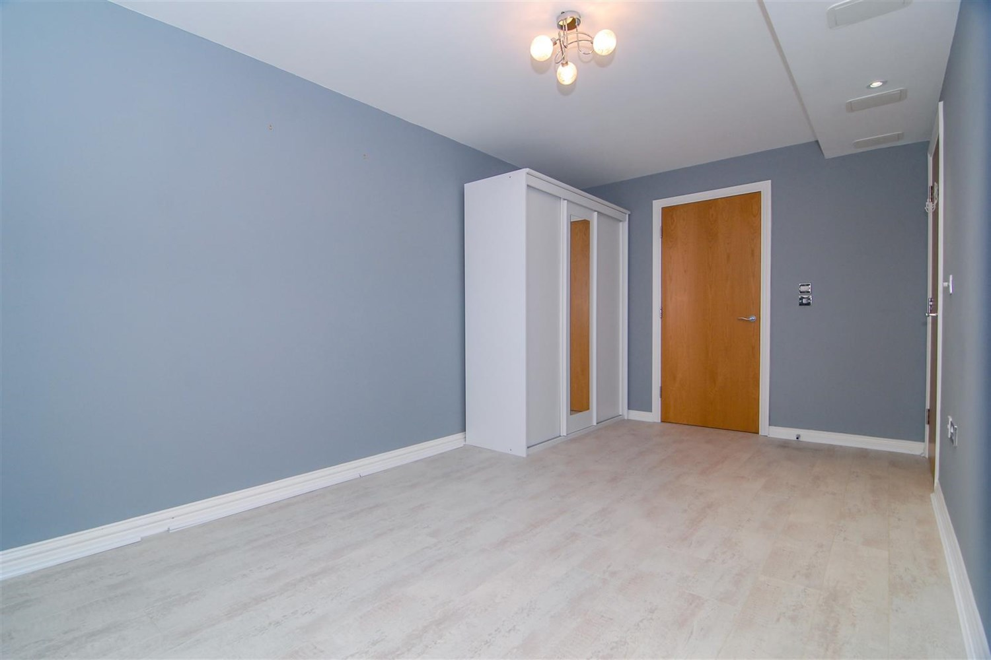

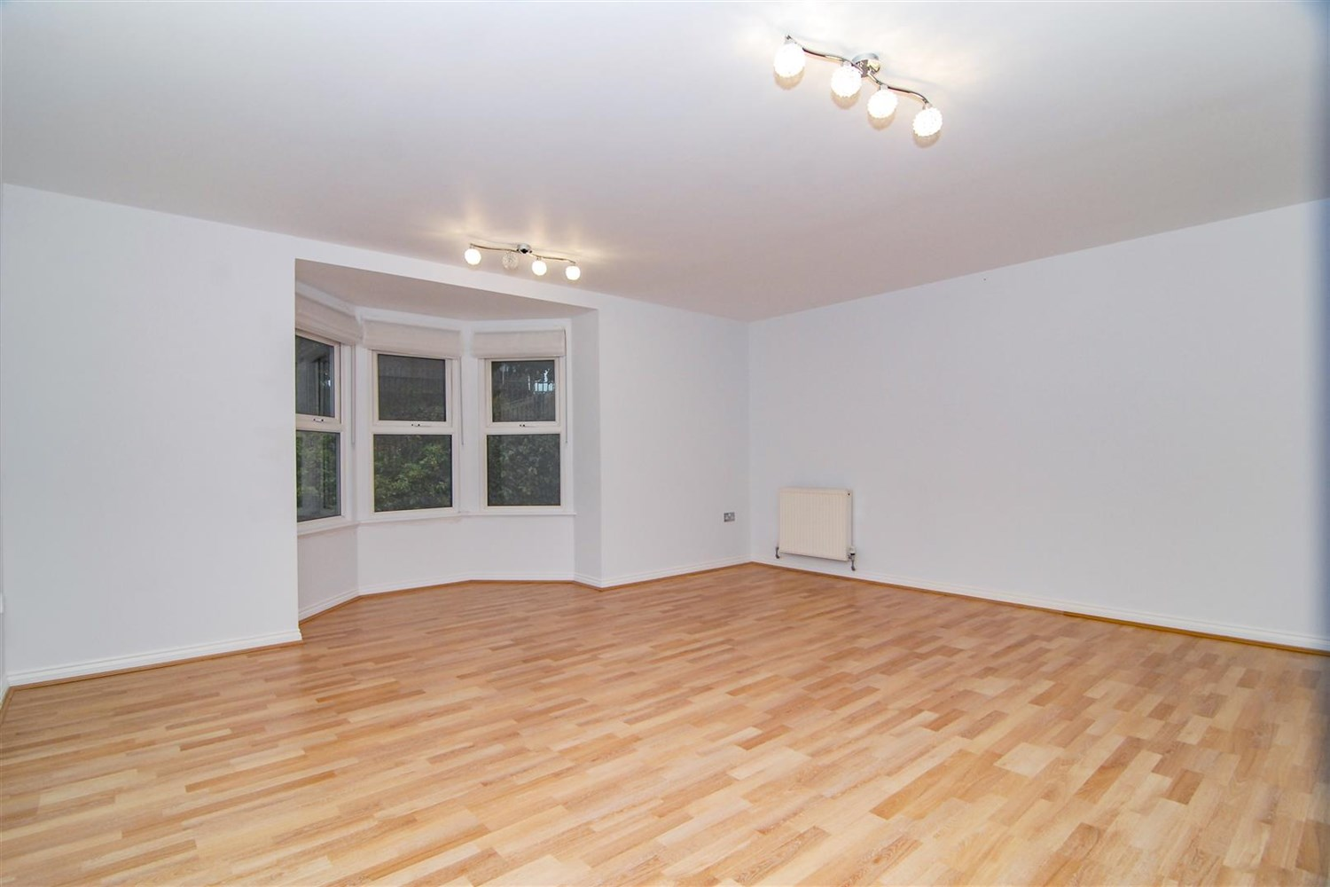

2 Bathroom(s)

1 Reception(s)

2 Bedroom(s)

00

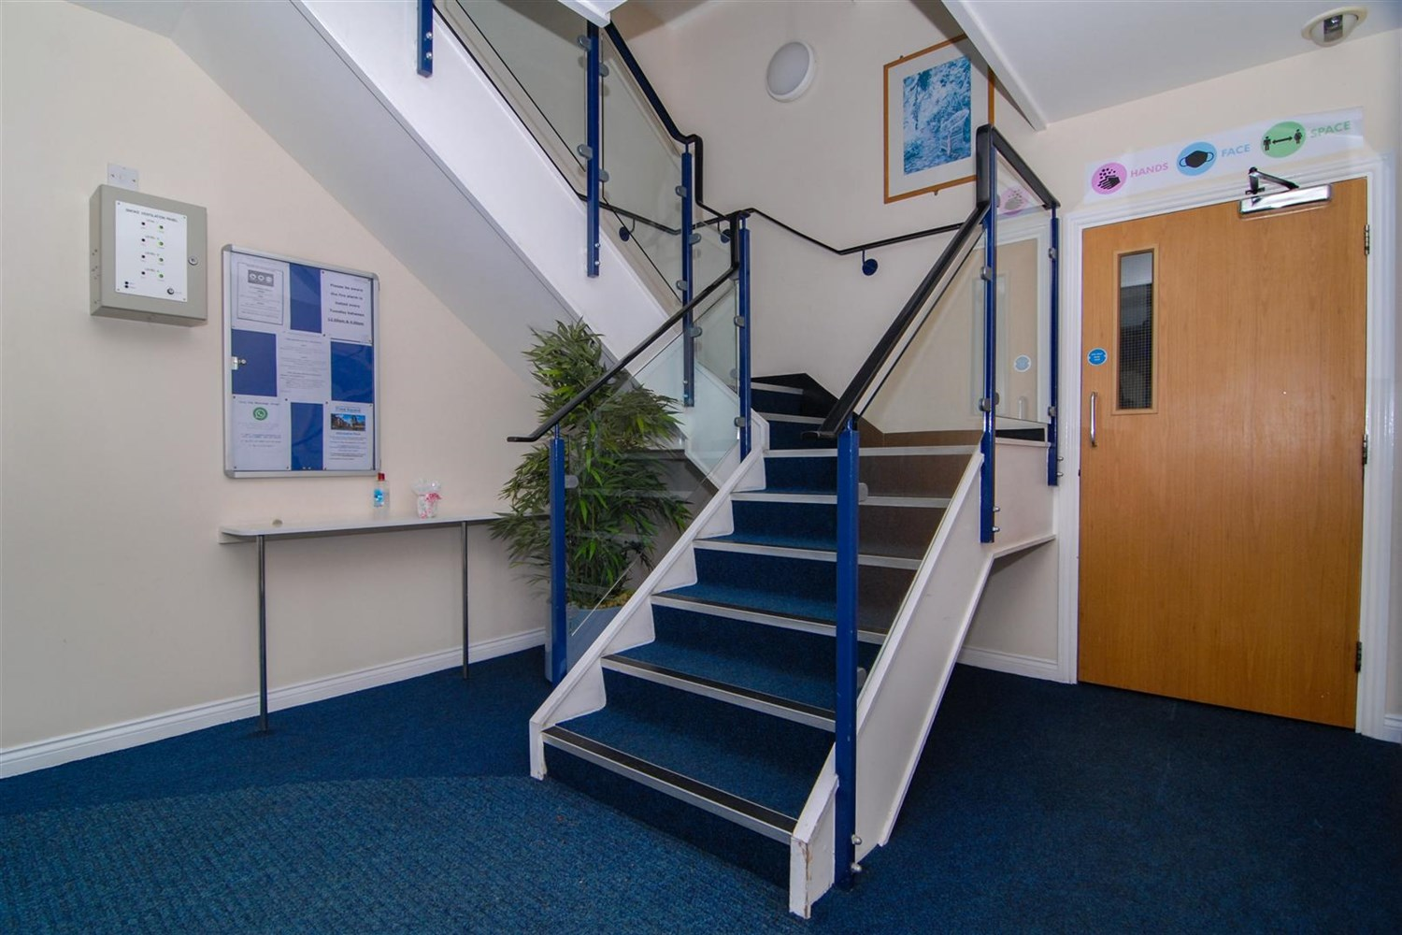

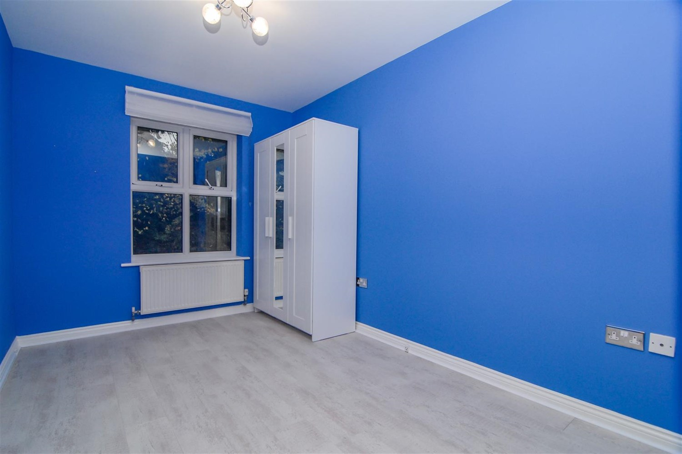

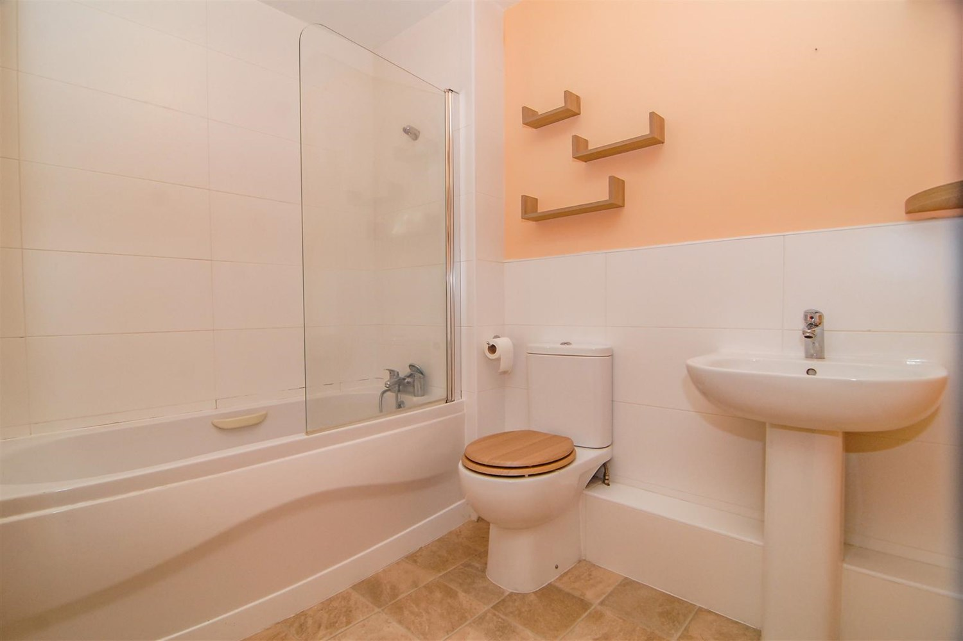

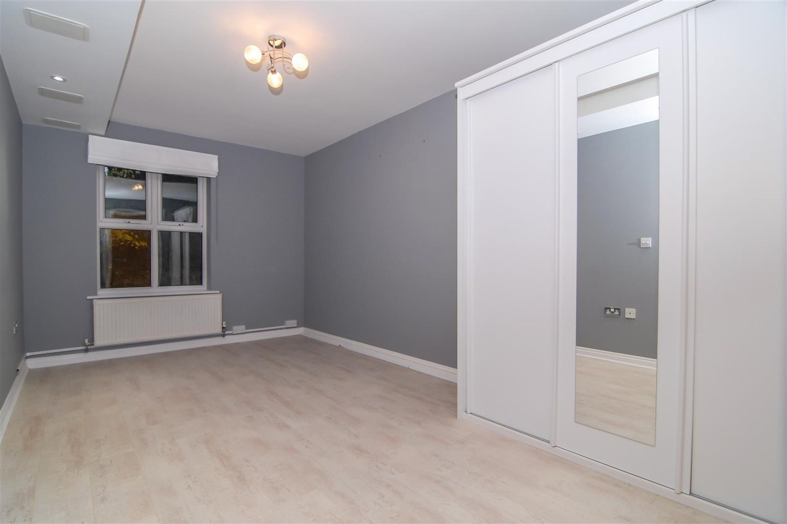

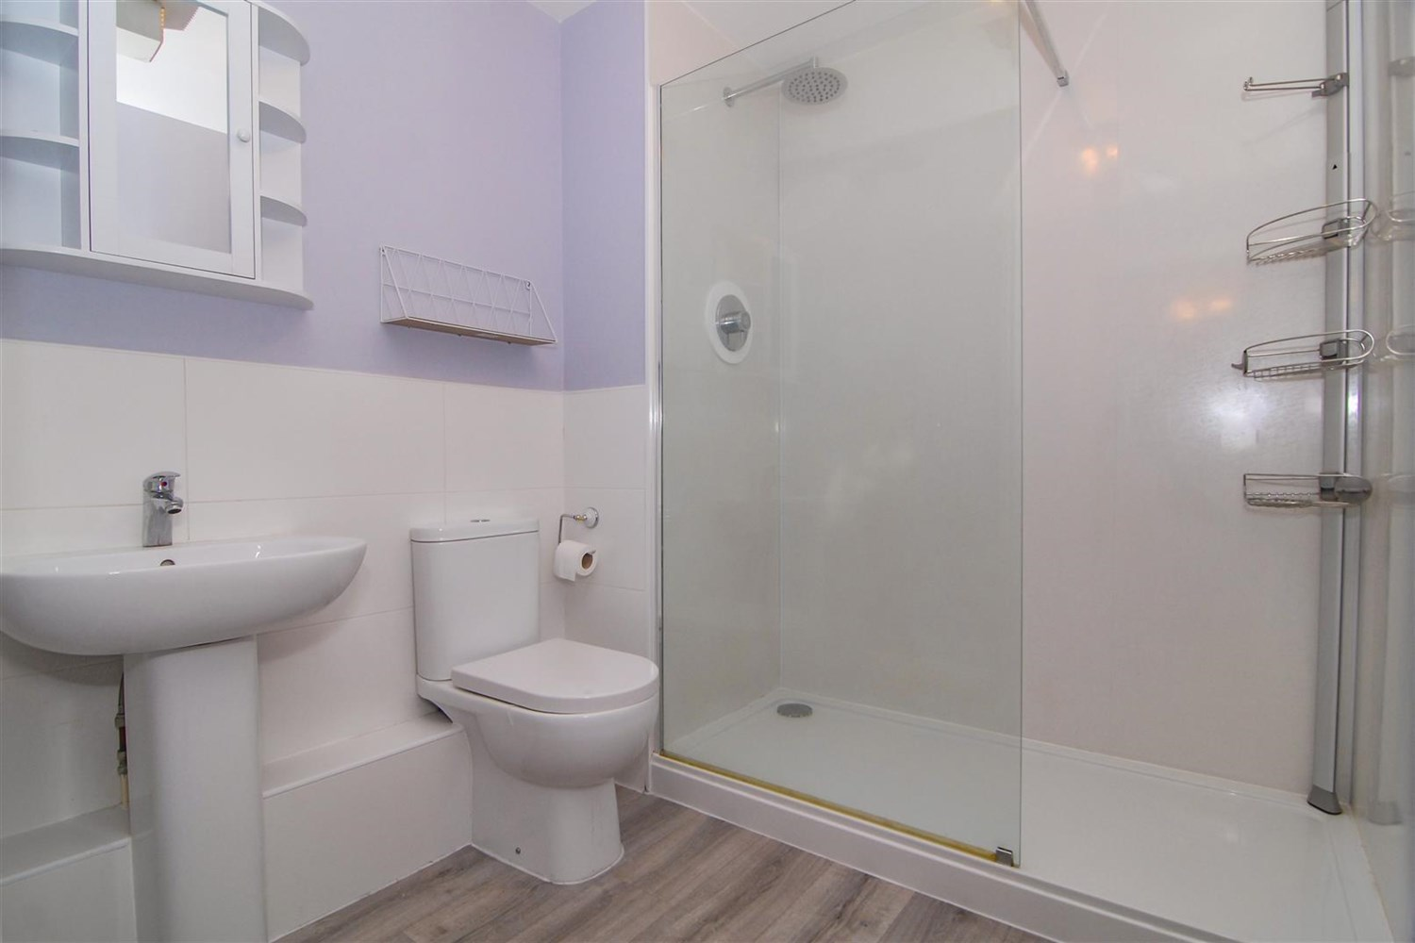

|  |
| --- |
| **Communal Hallway**  Attractive communal entrance with secure entry system. Lift and stairs to all floors. |
| **Entrance Hall**  A spacious private entrance with secure telephone entry system. Two useful storage cupboards, one housing the boiler. Laminate flooring. Central heating radiator. |
| **Living room 5.6m (18'4) x 4.3m (14'1)**  Spacious, light and airy living area with uPVC bay window. Two gas central heating radiators. |
| **Kitchen 3.7m (12'2) x 2.7m (8'10)**  Fitted with a range of modern wall, base and drawer units with worktops over. Integrated electric oven with gas hob and extractor hood above. Space for washing machine and fridge/freezer. Stainless steel sink with drainer and mixer tap. uPVC double glazed window. |
| **Bedroom 1 5m (16'5) x 2.8m (9'2)**  Double bedroom with uPVC double glazed window. Gas central heating radiator. |
| **En-suite**  Fitted with a three piece white suite comprising; shower cubicle, WC and wash hand basin. Tiled walls. |
| **Bedroom 2 3.7m (12'2) x 2.5m (8'2)**  Second double bedroom with uPVC double glazed window. Gas central heating radiator. |
| **Bathroom**  Fitted with a three piece white suite comprising; bath with shower over, WC and wash hand basin. Tiled walls. |
| COUNCIL TAX BAND: D EPC Rating B  6 Month tenancy only then onto rolling. Leasehold property Parking Broadband: Standard 15 Mbps 1 Mbps Good Superfast 80 Mbps 20 Mbps Good Ultrafast 1000 Mbps 1000 Mbps Mobile availability: EE likely to have good coverage . Three limited coverage. O2 limited. Vodafone limited coverage.  Utilities: Water supplied on standard meters. Gas and Electric mains supplied on standard meters. |
| **Tenure**  Leasehold - 125 years from 2003 |
| **Service Charge**  £143.99 (Annual) - Central Park (Grounds Only) £116.01 (Annual) - Headingly Otley Road  £2,451.47 (Annual) - Time Square |

|  |  |
| --- | --- |
| These particulars are intended to give a fair description of the property, but their accuracy cannot be guaranteed, and they do not constitute an offer of contract. Intending purchasers must rely on their own inspection of the property. None of the above appliances/services have been tested by ourselves. We recommend purchasers arrange for a qualified person to check all appliances/services before legal commitment.  **Property Ref:** 2029  **For more information, please contact**  0113 258 1150 **|** [sales@adairpaxton.co.uk](mailto:sales@adairpaxton.co.uk) **|** www.adairpaxton.co.uk |  |