

**0113 258 1150**

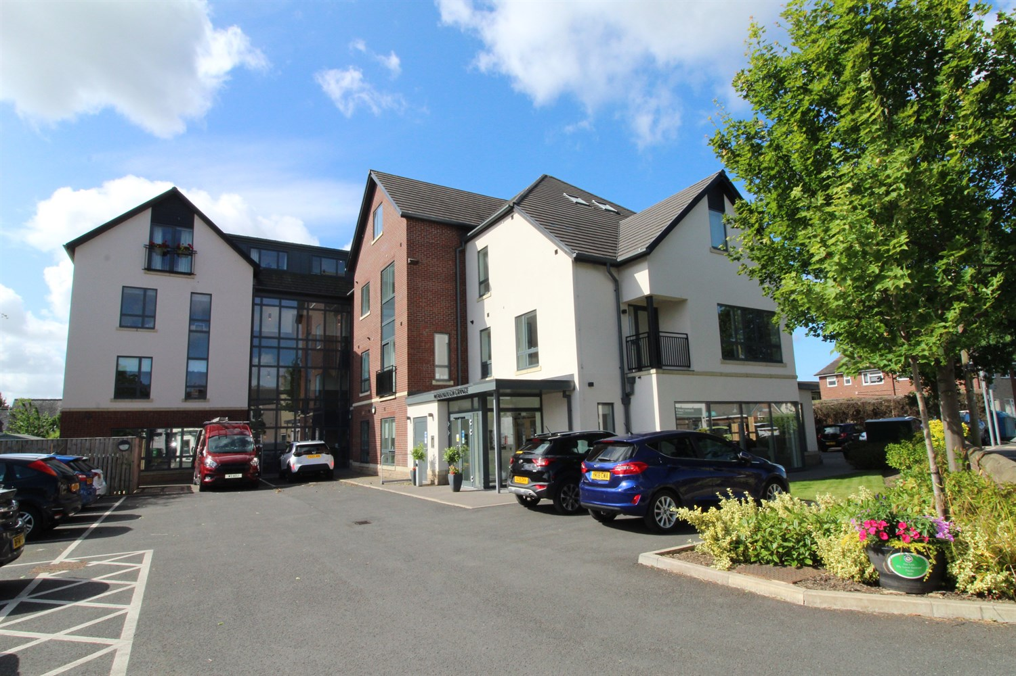



**For Sale £200,000.00**

**Mexborough Grange, Methley**

***BEAUTIFULLY PRESENTED TWO BEDROOM RETIREMENT APARTMENT AGE 55 PLUS WITH NO ONWARD CHAIN*** Situated in this sought after village of Methley, this newly built apartment has been finished to a high standard. The property briefly comprises: communal entrance hall, private entrance hall, spacious Kitchen/lounge leading to a Juliet balcony, two good sized bedrooms and house bathroom. Externally the property sits within well maintained communal grounds and residents parking is available. Mexborough Grange offers amenities including; Communal kitchen area and lounge, on-site hair salon and a programme of entertainment.

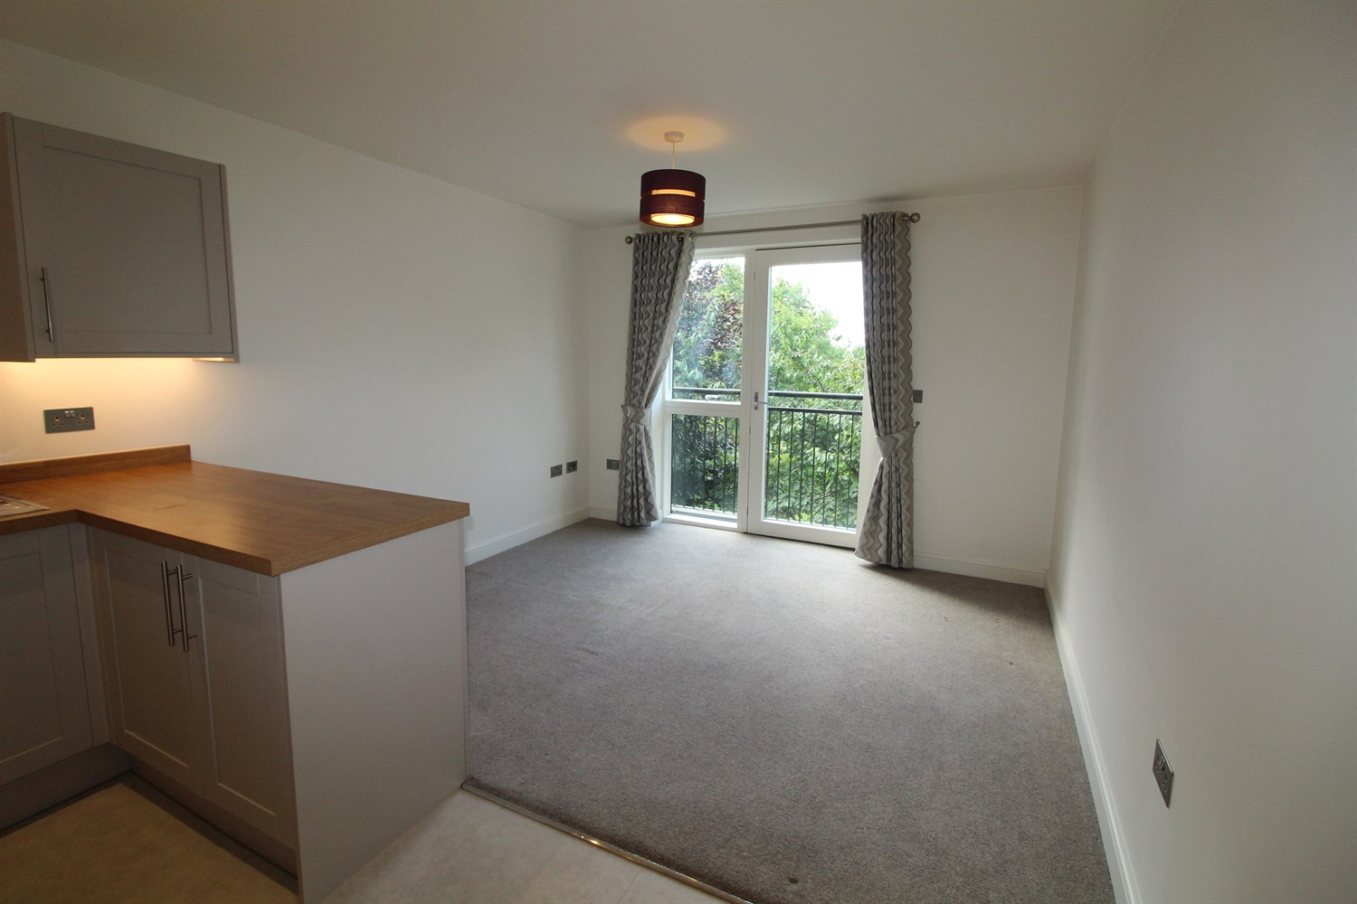

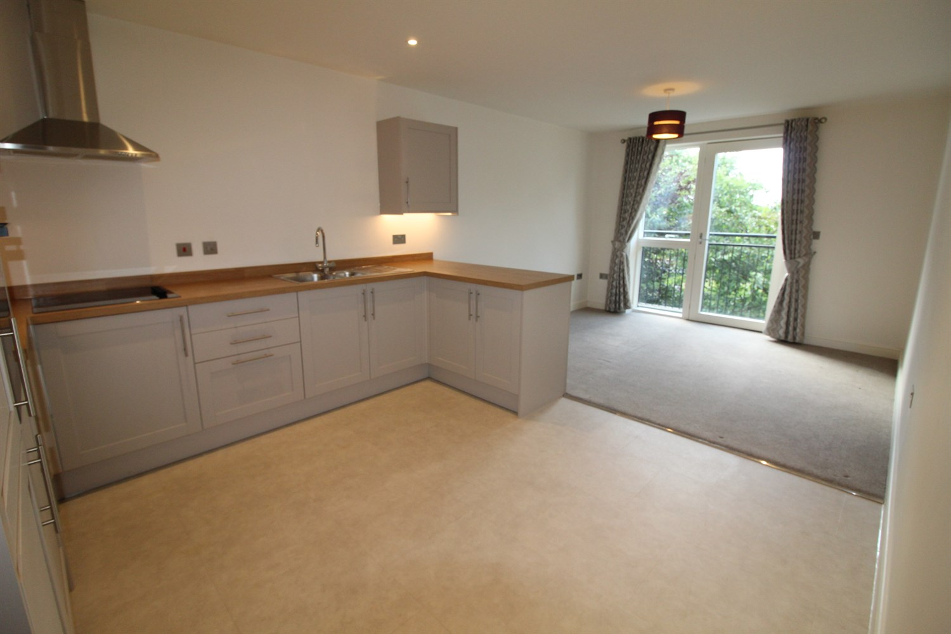

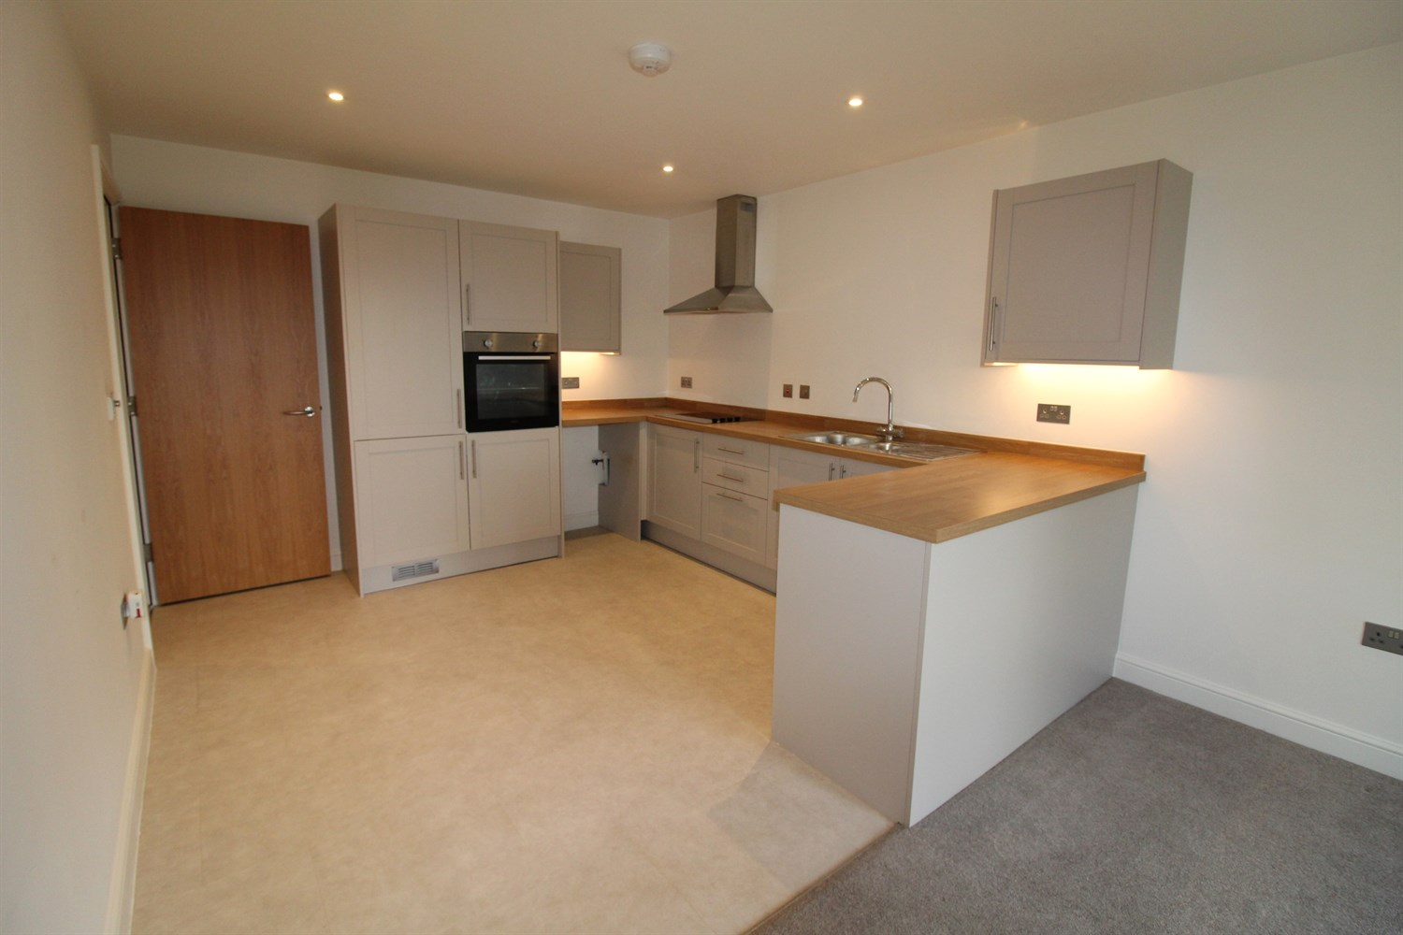

1 Bathroom(s)

1 Reception(s)

2 Bedroom(s)

00

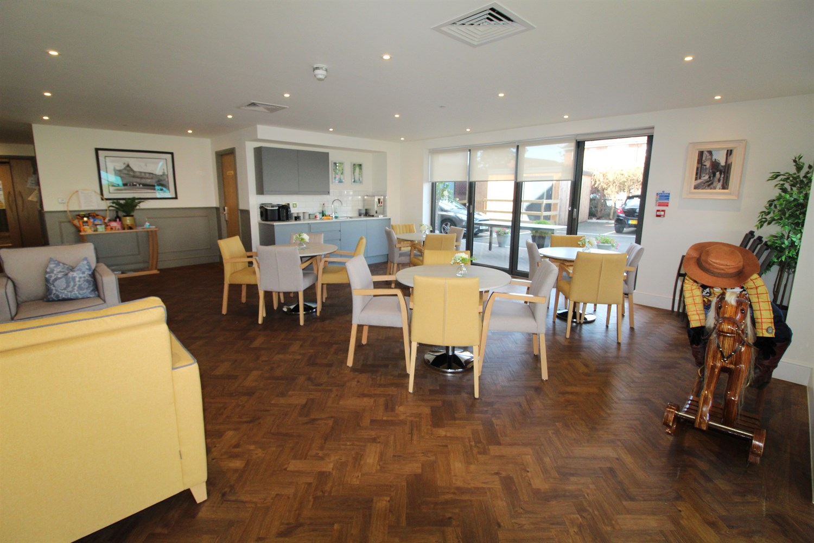

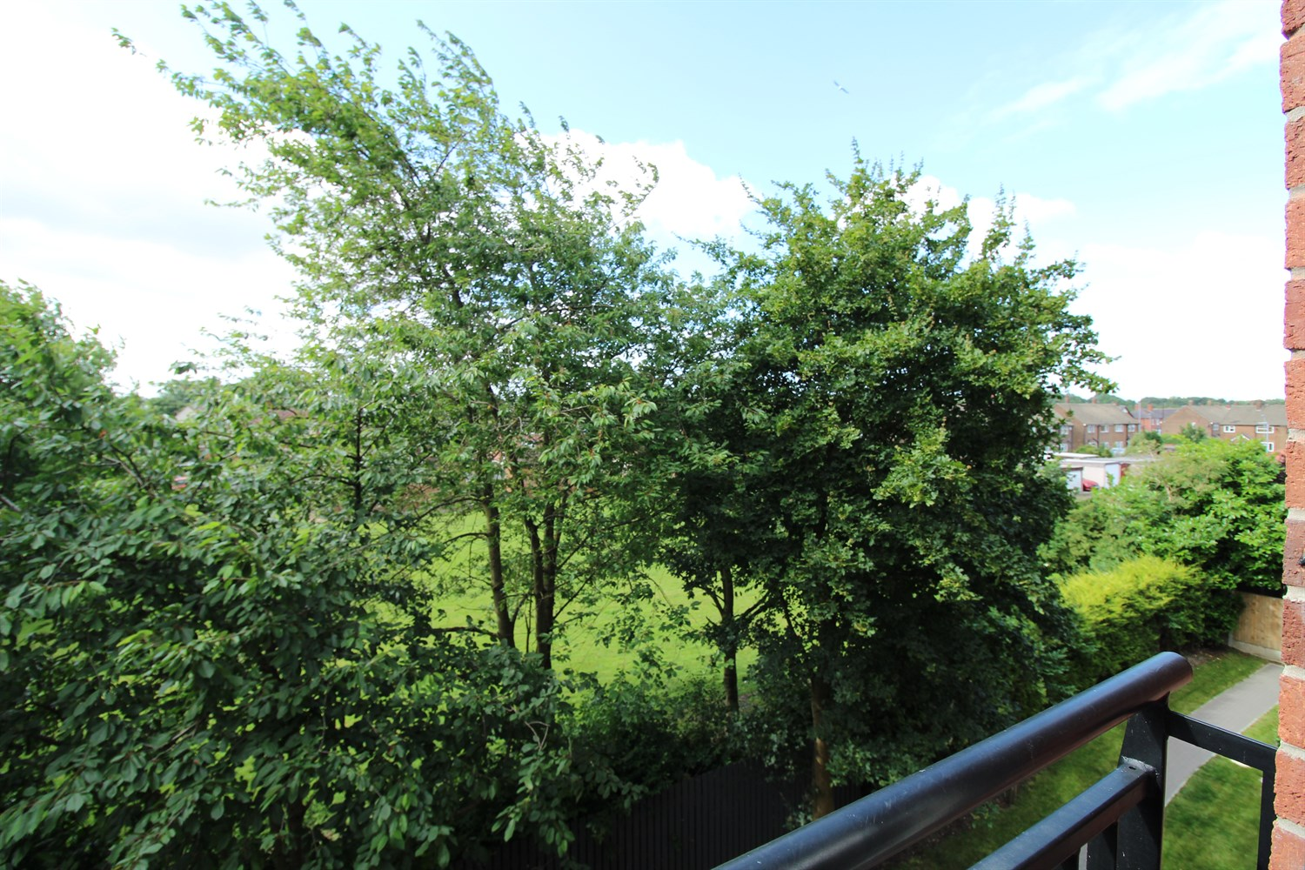

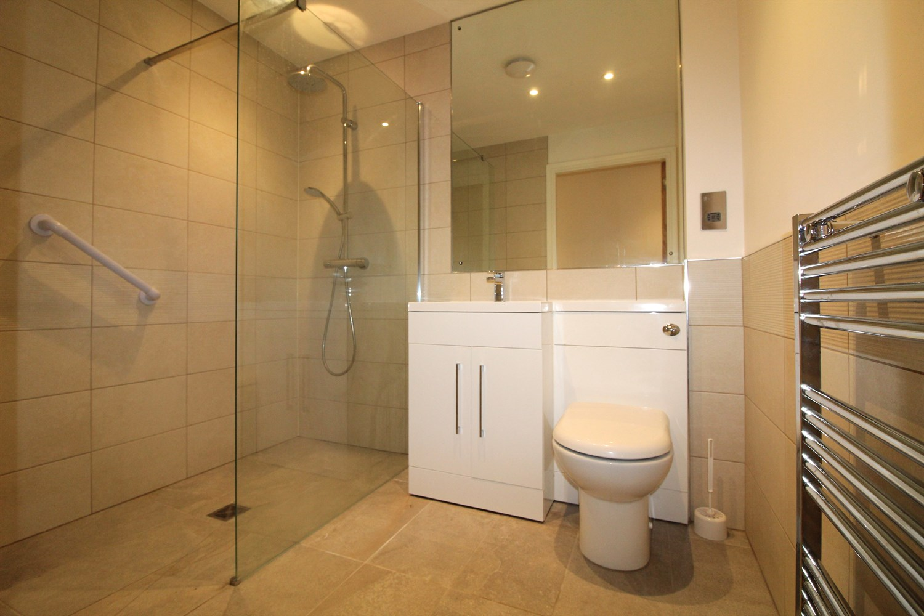

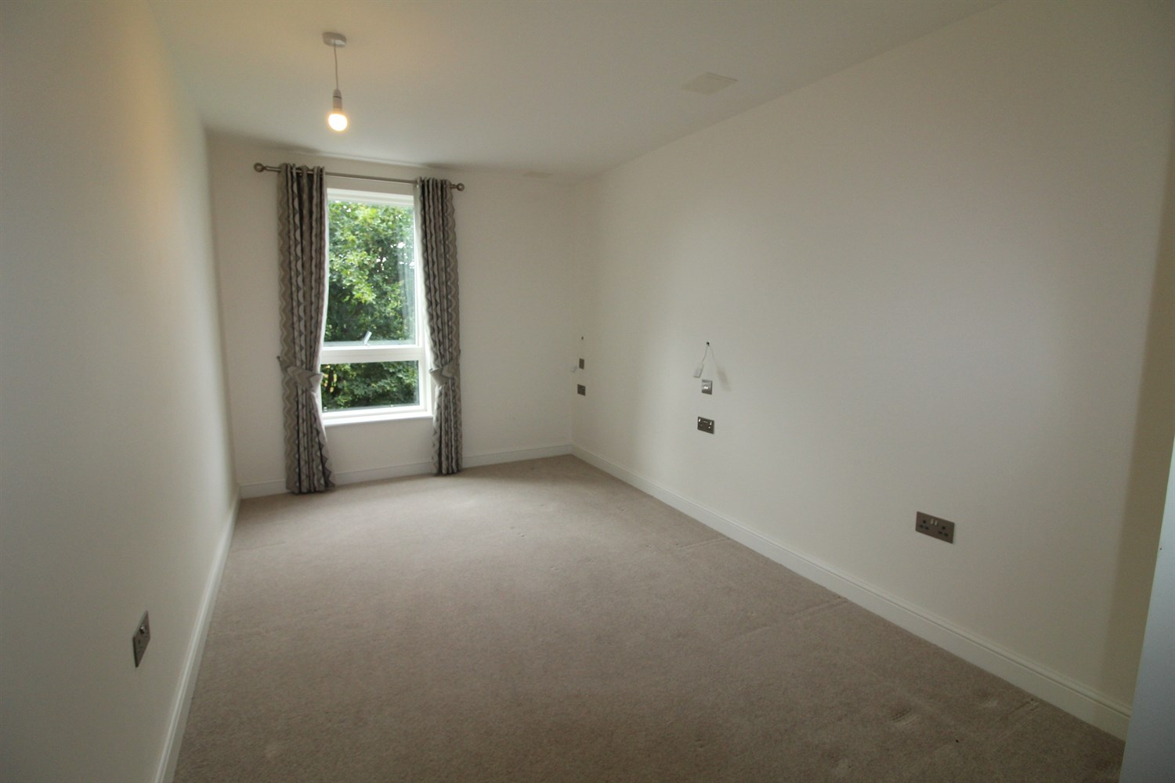

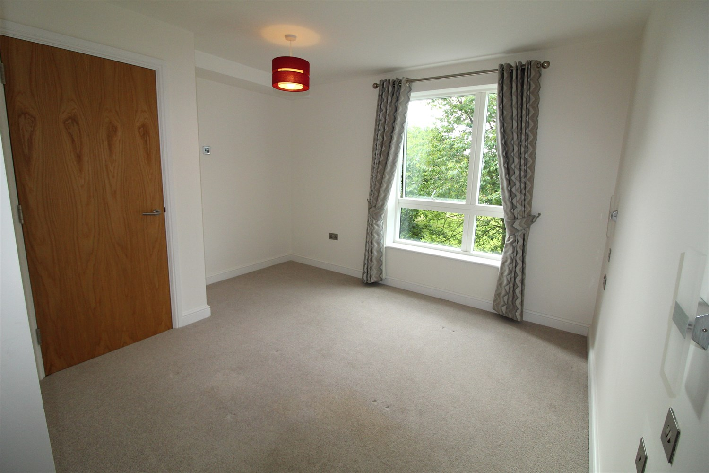

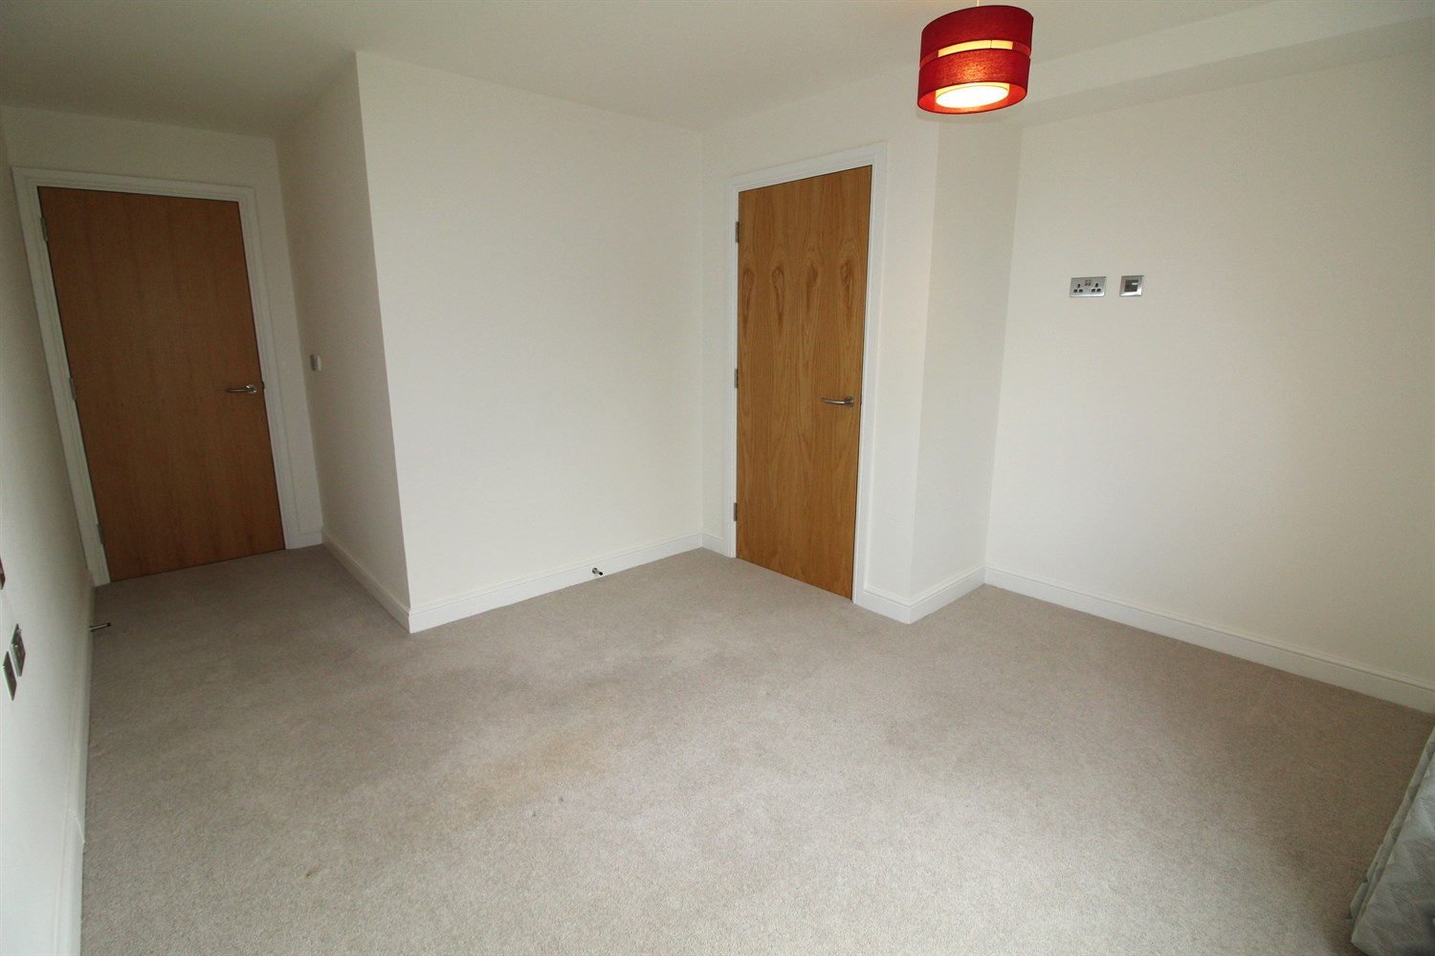

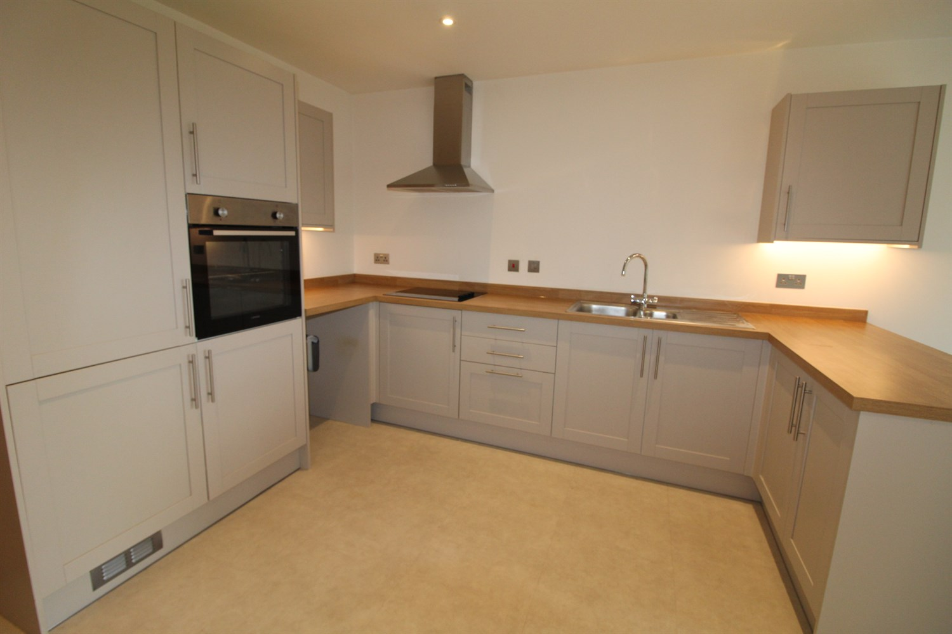

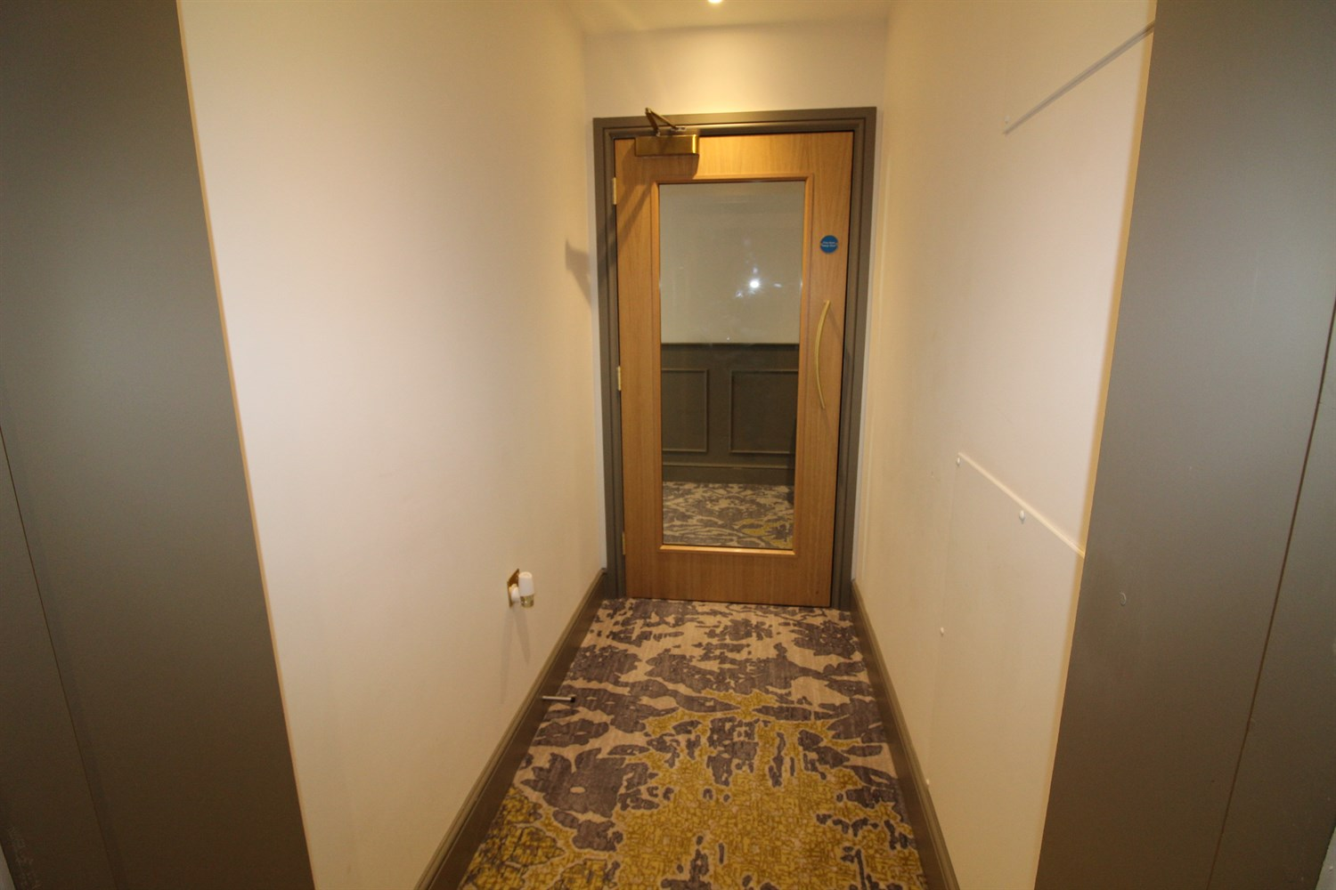

|  |
| --- |
| **Communal Entrance**  Via secure entry phone system. Communal lounge and lift/stairs to all floors. |
| **Private Hallway**  Flat 15 is accessed via a private entrance. The hallway is accessed via the front entrance door and benefits from a large storage cupboard housing the boiler. |
| **Fitted Kitchen**  Modern fitted kitchen opening to the living area. Fitted with a range of wall, base and drawer units with worktops over. Integrated oven and fridge/freezer. 4-ring electric hob with extractor hood over. Space for washing machine. 1.5 bowl stainless steel sink with mixer tap and drainer. Breakfast bar. |
| **Living Area**  Light and Airy living area with uPVC double glazed doors opening to Juliet balcony. |
| **Bedroom One**  Double bedroom with uPVC double glazed window. Large storage cupboard. |
| **Bedroom Two**  Second double bedroom with uPVC double glazed window. |
| **Shower Room**  Modern shower room with large walk in shower cubicle, Vanity wash basin and WC. Tiled walls and floor. Inset ceiling spotlights. Wall mounted heated towel rail. |
| **Tenure**  Leasehold - 999 years from 2021 |
| **Service Charge**  Service Charge £401.50 per month, plus £183.21 per month for on-site manager and out of hours emergency call monitoring. |

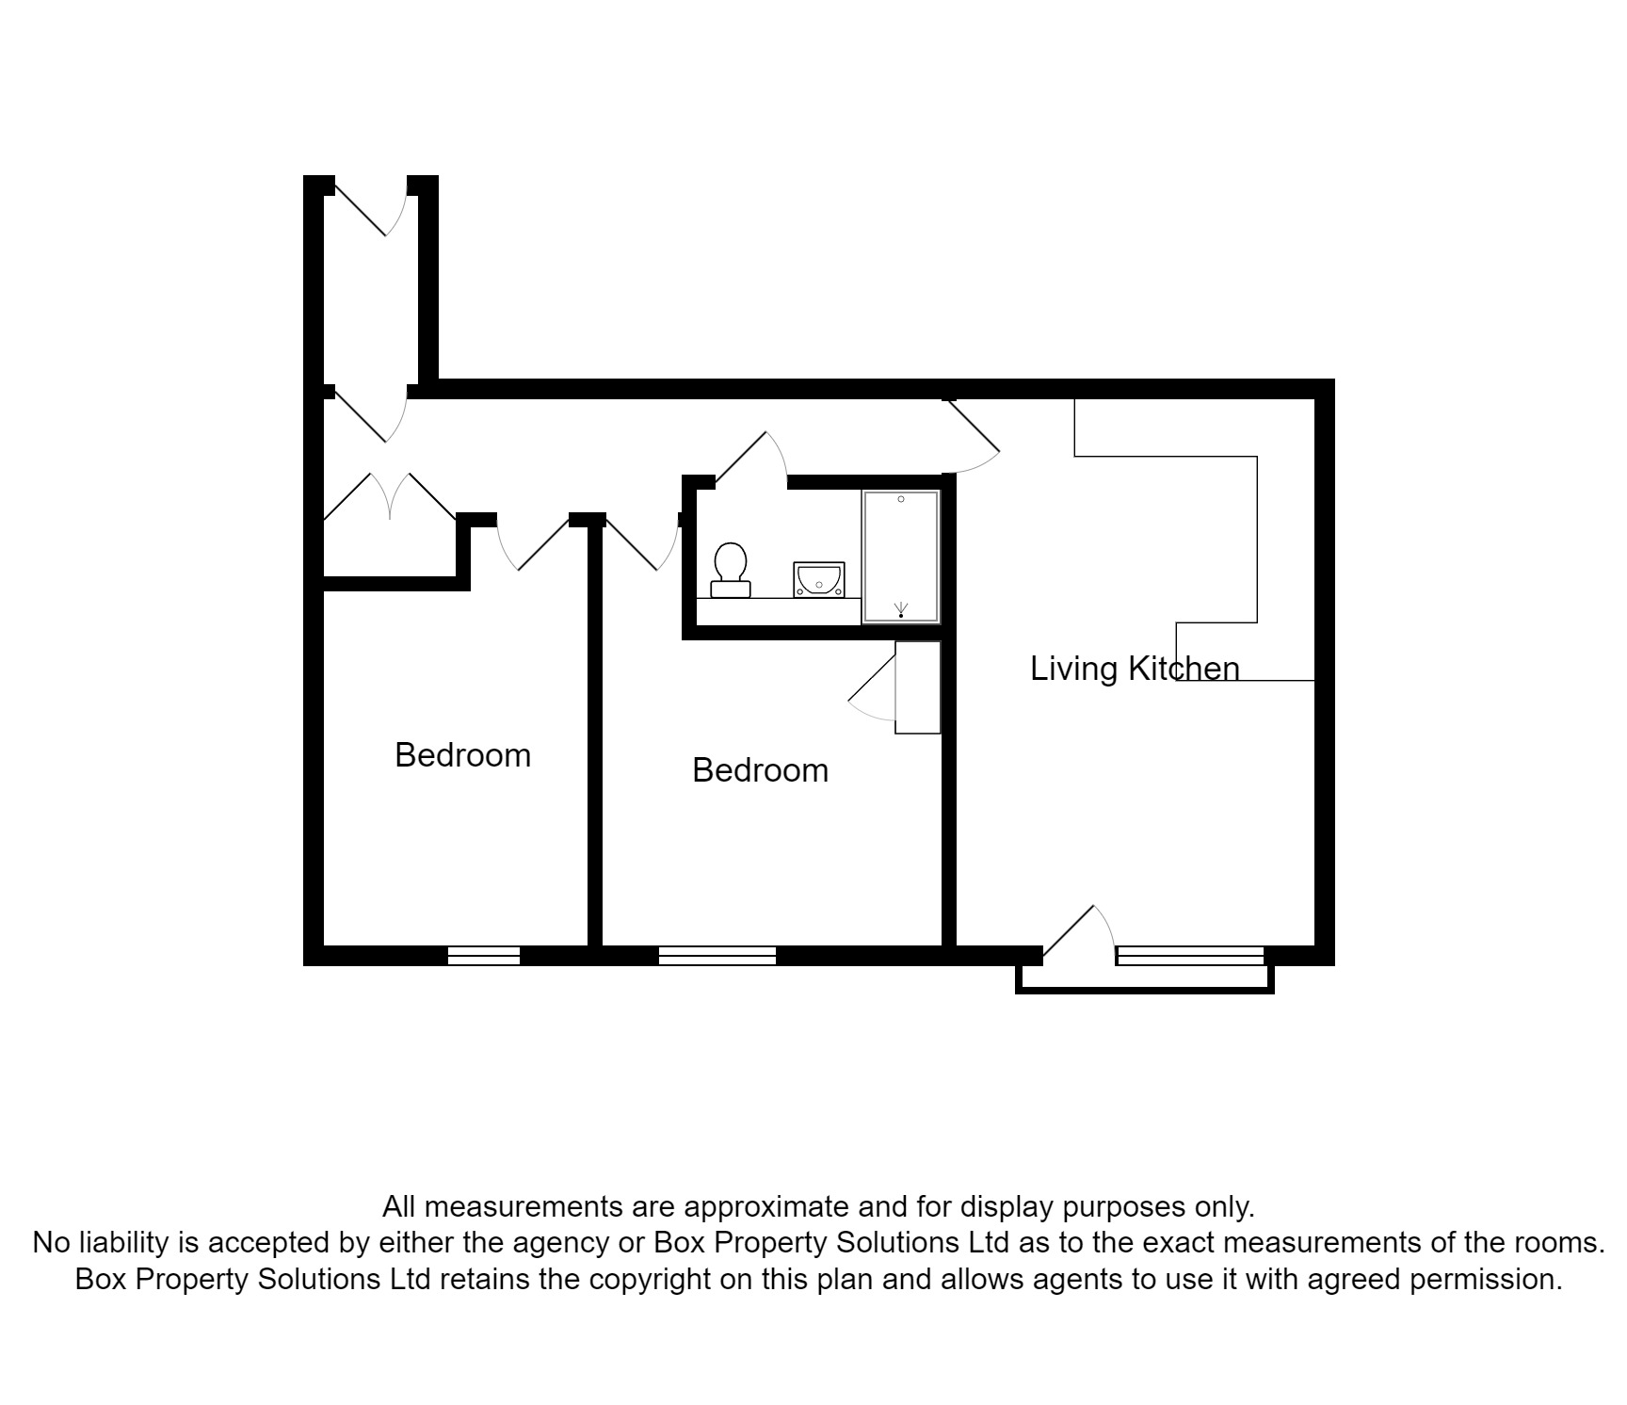

|  |  |
| --- | --- |
| These particulars are intended to give a fair description of the property, but their accuracy cannot be guaranteed, and they do not constitute an offer of contract. Intending purchasers must rely on their own inspection of the property. None of the above appliances/services have been tested by ourselves. We recommend purchasers arrange for a qualified person to check all appliances/services before legal commitment.  **Property Ref:** 2331  **For more information, please contact**  0113 258 1150 **|** [sales@adairpaxton.co.uk](mailto:sales@adairpaxton.co.uk) **|** www.adairpaxton.co.uk |  |