

**0113 258 1150**

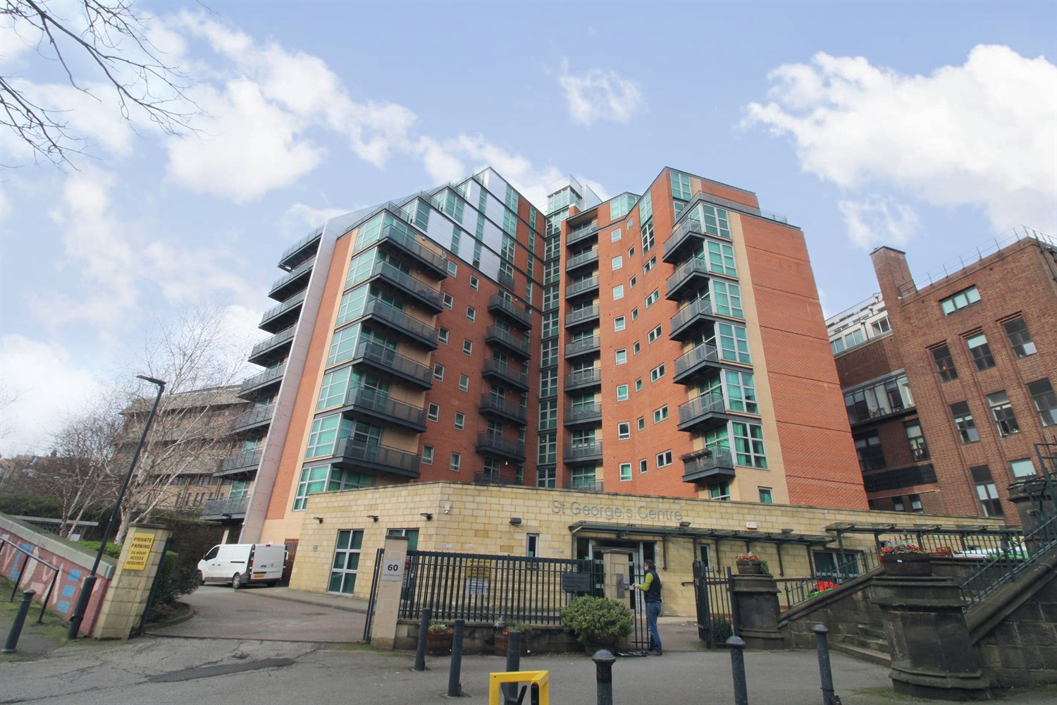



**For Sale £165,000.00**

**St. George Building, Great George Street, Leeds**

***SPACIOUS TWO BEDROOM APARTMENT WITH BALCONY OFFERED WITH NO ONWARD CHAIN*** Ideally located for Leeds General Infirmary, Leeds Universities, the business and shopping districts, is this delightful two bedroom apartment. The property briefly comprises: Communal entrance with stairs and lift access to all floors, private entrance hall, open plan living room/kitchen/diner, two double bedrooms and house bathroom. Close to Nuffield Private Hospital, close to Leeds General Infirmary, Universities and other amenities including shops, bars and restaurants. Good transport links and easy access to motorway network. Offered for sale with NO ONWARD CHAIN, early internal viewing is highly recommended.

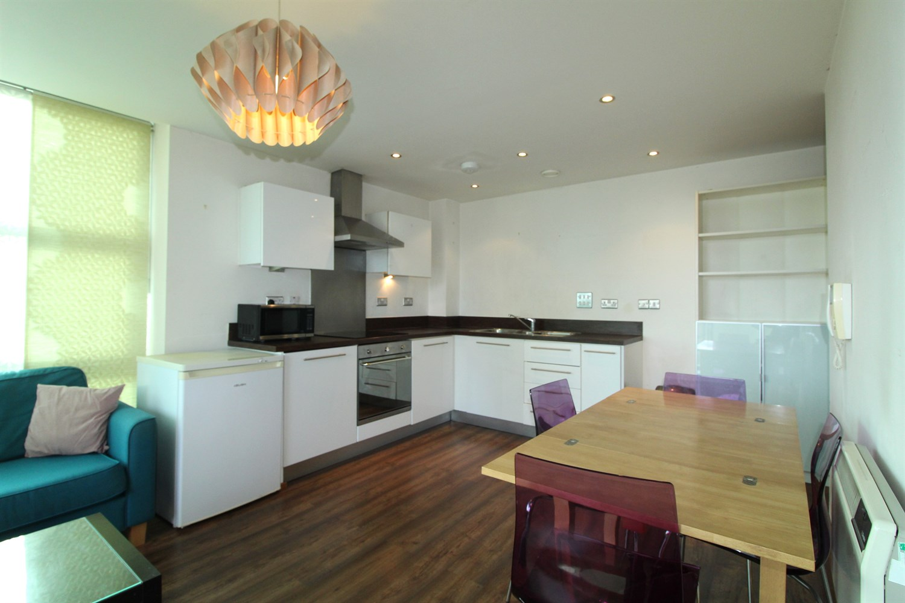

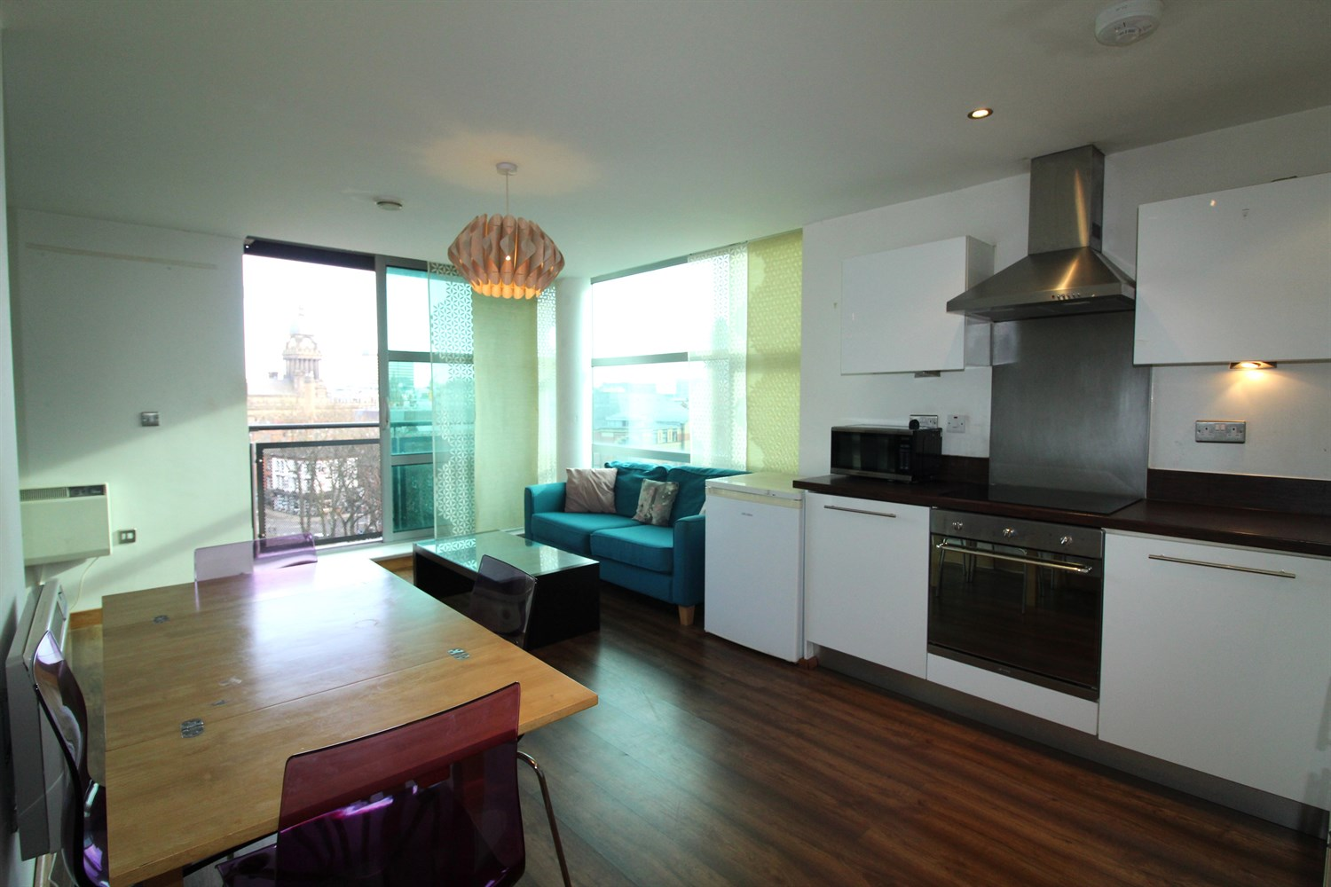

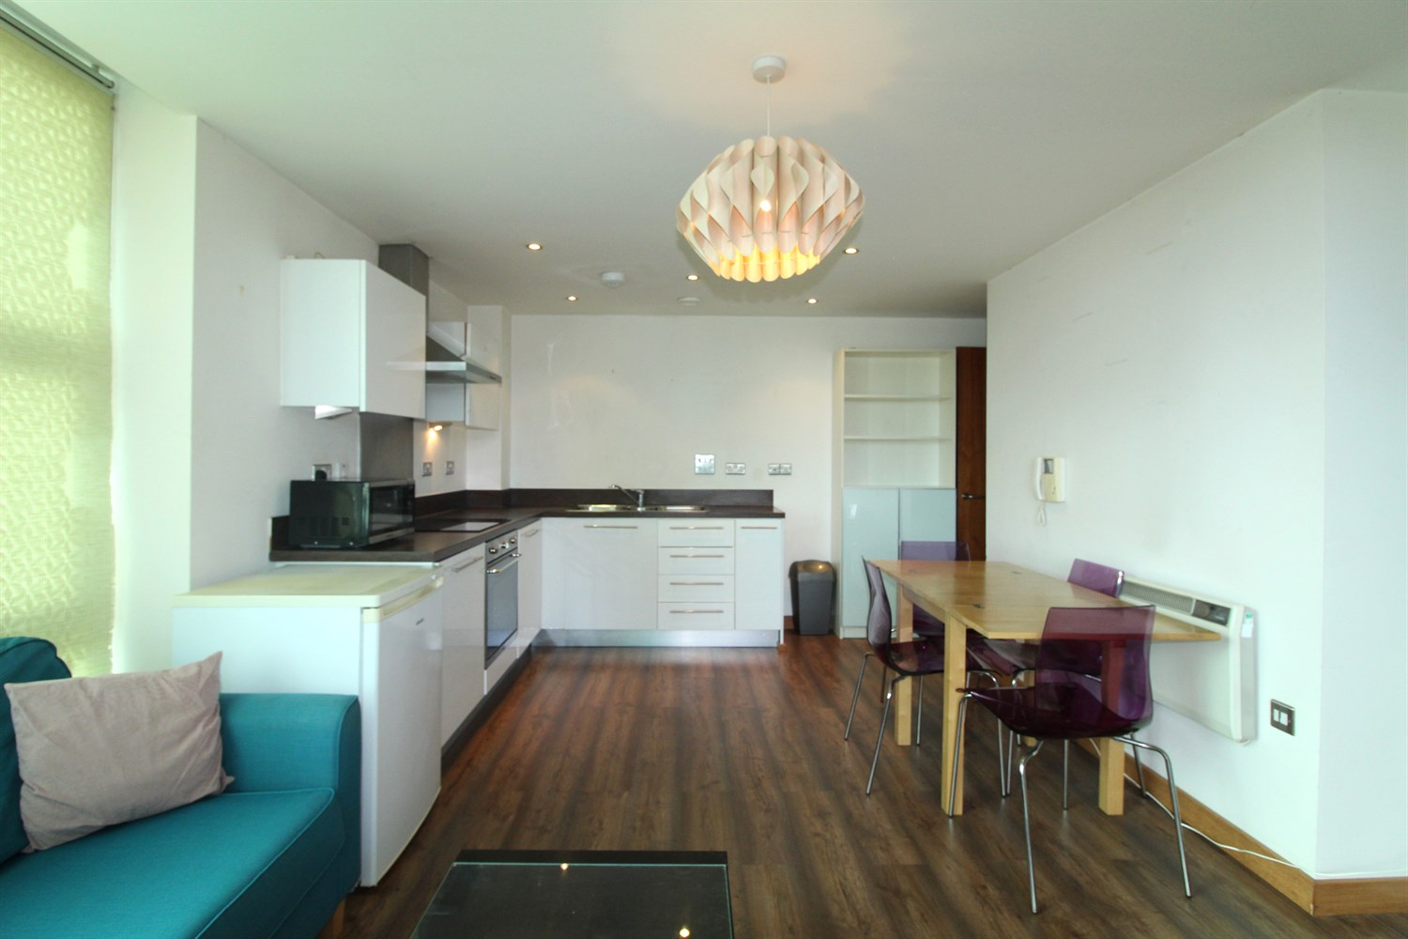

1 Bathroom(s)

1 Reception(s)

2 Bedroom(s)

00

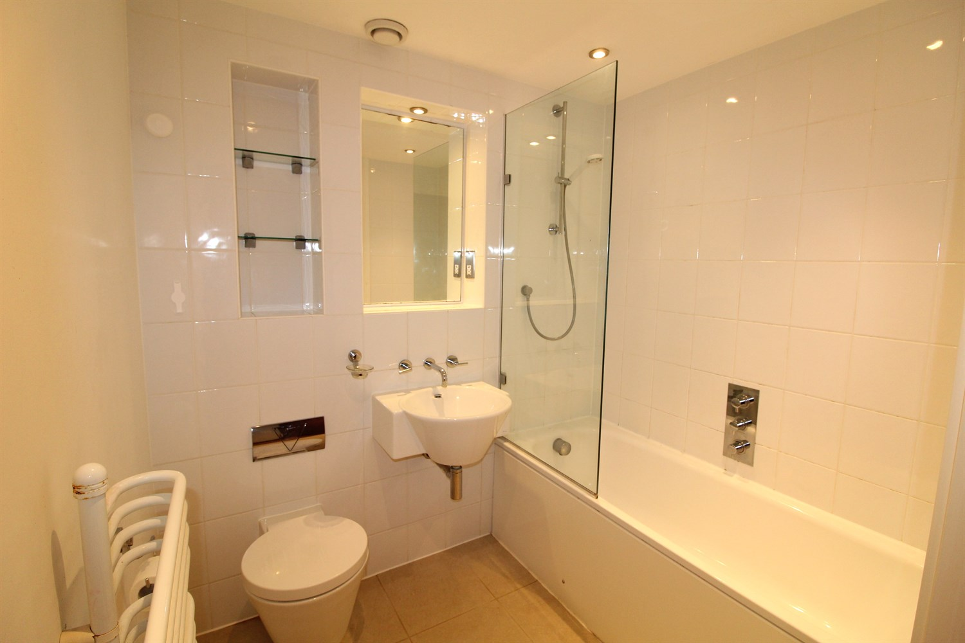

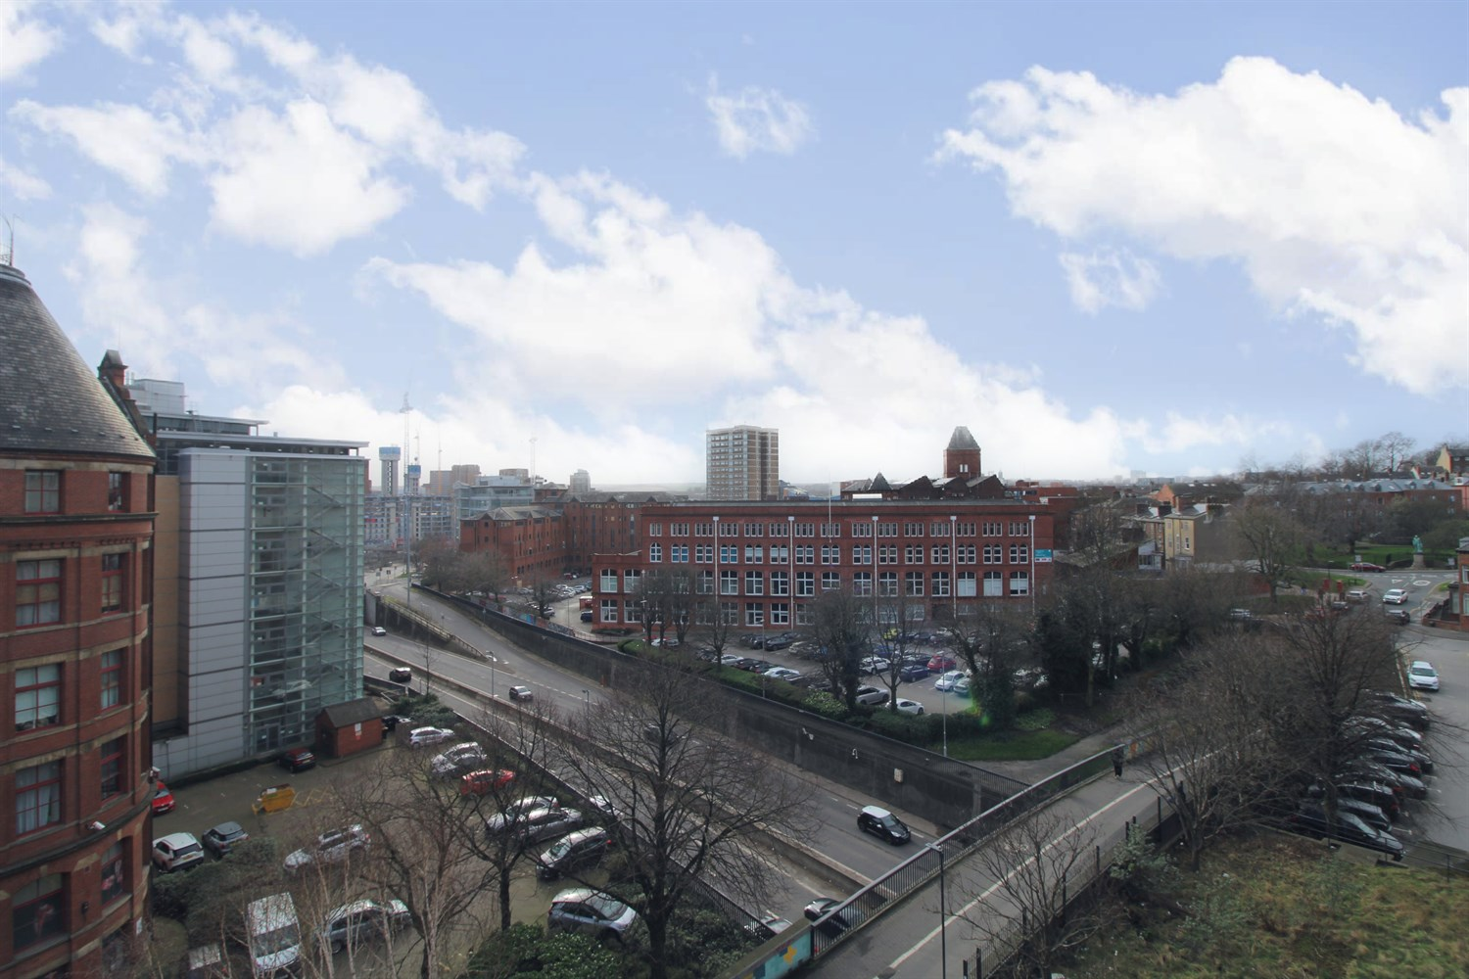

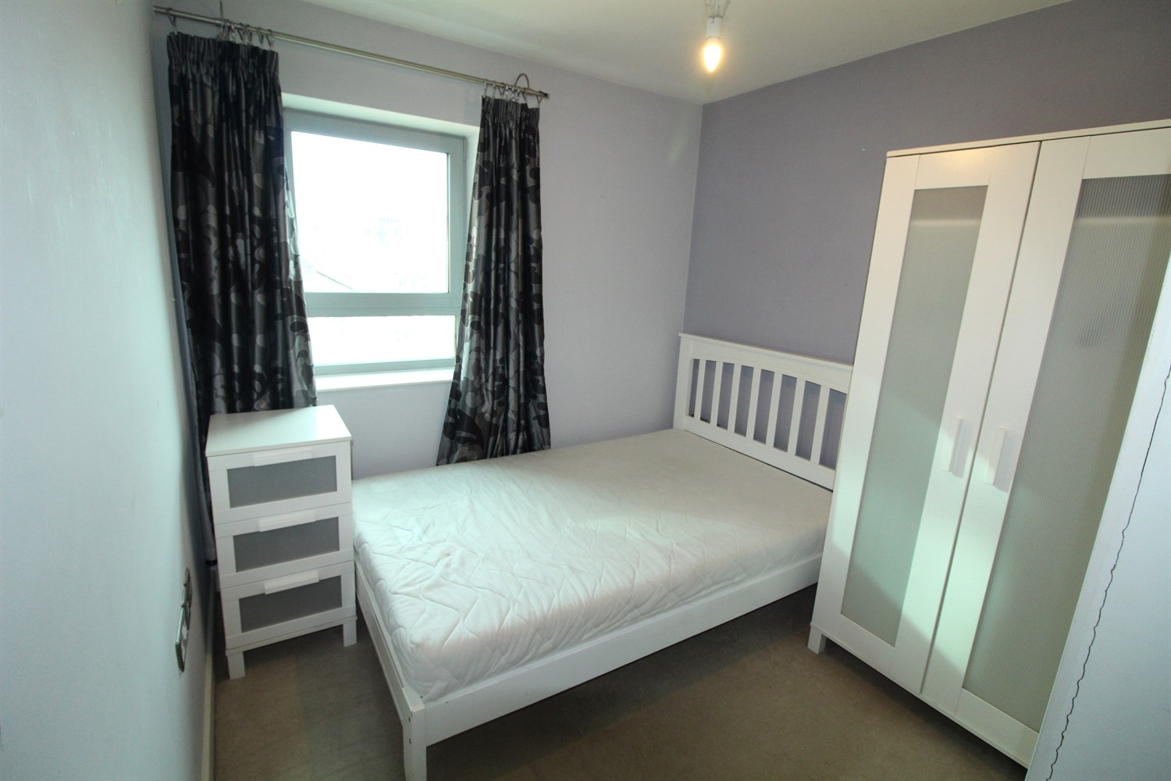

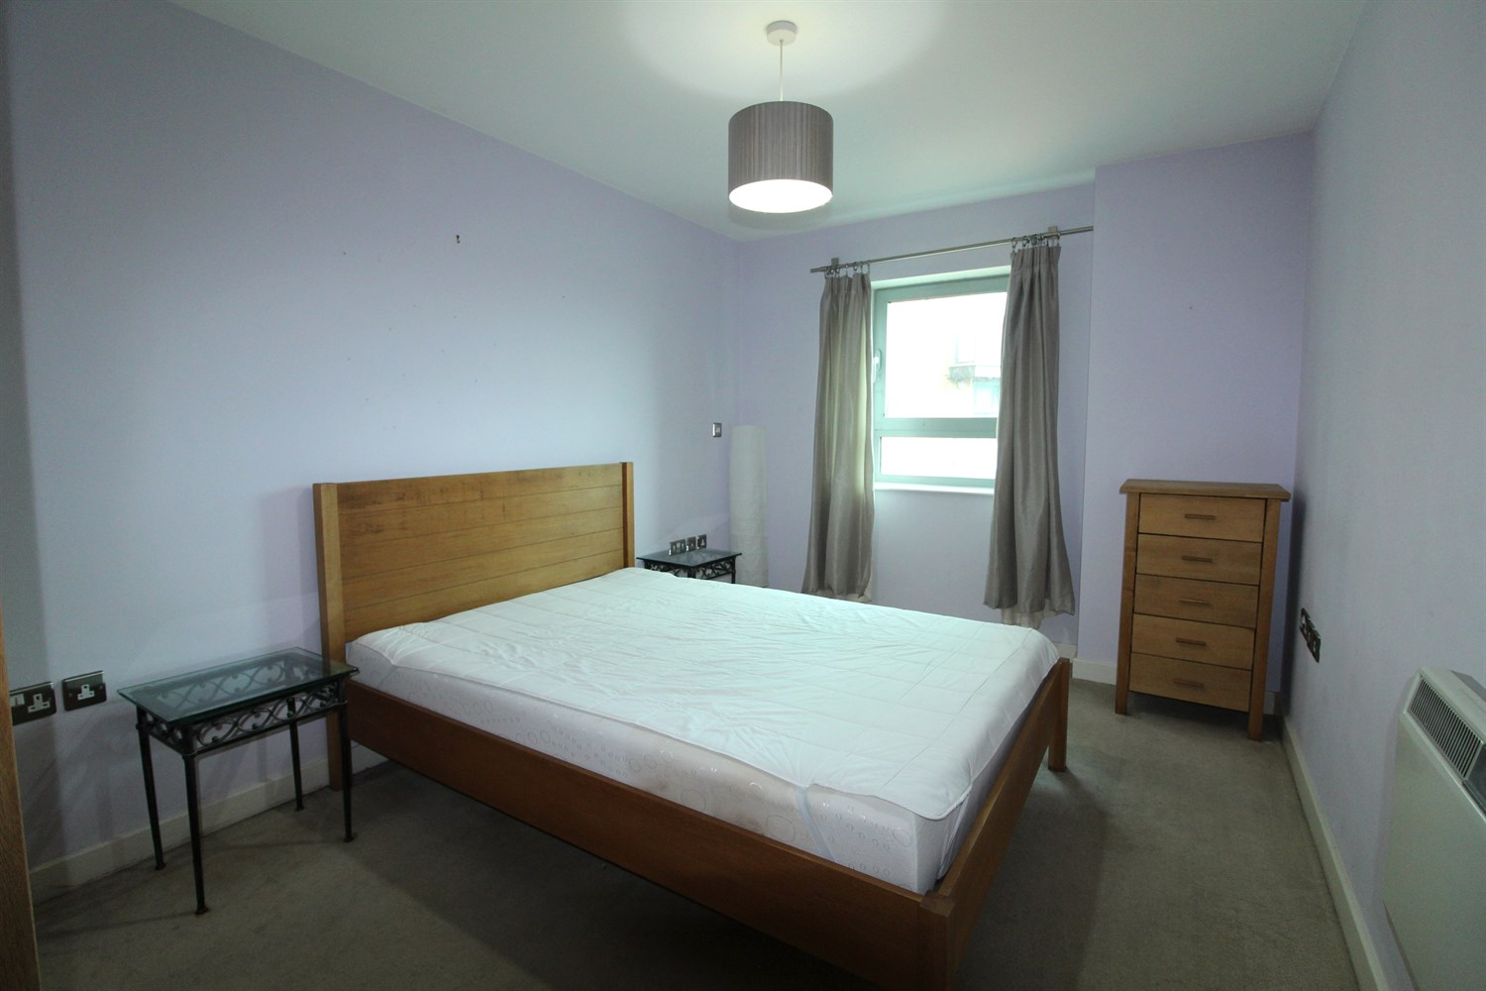

|  |
| --- |
| **Communal Entrance**  Entrance door with secure entry phone system. Stairs and lifts to all floors. |
| **Private Entrance**  Spacious Entrance hall with secure entry phone system. |
| **Open Plan Living/Kitchen**  Fitted with a range of wall, base and drawer units with worktops over. Integrated oven, hob and extractor. 1.5 bowl stainless steel sink with mixer tap and drainer. Inset ceiling spotlights. double glazed window. Light and Airy living area with two double glazed windows. wall mounted electric radiator. Door to Balcony. |
| **Bedroom 1 2.7m (8'10) x 4.17m (13'8)**  Double bedroom with double glazed window. Wall mounted electric heater. |
| **Bedroom 2 4.33m (14'2) x 2.49m (8'2)**  Double bedroom with double glazed window. Wall mounted electric heater. |
| **Bathroom**  Fitted with a three piece white suite comprising bath with shower above, wash basin and WC. Tiled walls and floor. Wall mounted heated towel rail. Inset ceiling spotlights. |
| **Tenure**  Leasehold - 150 years from 2004  Ground rent - £150 per annum |
| **Service Charge**  Service charge - £598.14 per quarter |

|  |  |
| --- | --- |
| These particulars are intended to give a fair description of the property, but their accuracy cannot be guaranteed, and they do not constitute an offer of contract. Intending purchasers must rely on their own inspection of the property. None of the above appliances/services have been tested by ourselves. We recommend purchasers arrange for a qualified person to check all appliances/services before legal commitment.  **Property Ref:** 265  **For more information, please contact**  0113 258 1150 **|** [sales@adairpaxton.co.uk](mailto:sales@adairpaxton.co.uk) **|** www.adairpaxton.co.uk |  |