0113 258 1150
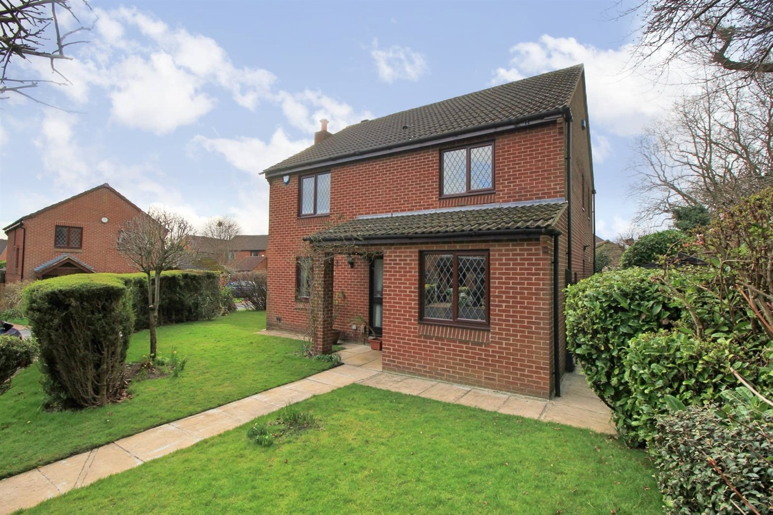
For Sale £475,000.00

3 Gypsy Wood Crest, Colton, LS15 9DZ

***SPACIOUS FOUR BEDROOM, TWO BATHROOM DETACHED HOUSE IN THE HEART OF COLTON*** Situated in a superb location in the heart of Colton, this delightful four bedroom detached house simply must be viewed to be appreciated. The property is set in a delightful cul-de-sac location and briefly comprises: entrance hall, lounge, dining room, kitchen/diner and guest WC to the ground floor. To the first floor there is a good sized master bedroom with en-suite shower room, three further double bedrooms and a house bathroom. Externally, the property sits on a great sized corner plot with generous gardens and a driveway leading to a detached double garage. Colton is a highly convenient and popular village location with excellent commuter links including ease of access to the A1/M1 Link Road, A64 York Road and good transportation links into the commercial heart of Leeds City Centre. A wide range of local amenities can be found at the Sainsbury's Retail Park at Colton with further shopping facilities to be found at Crossgates which also has a local railway station.
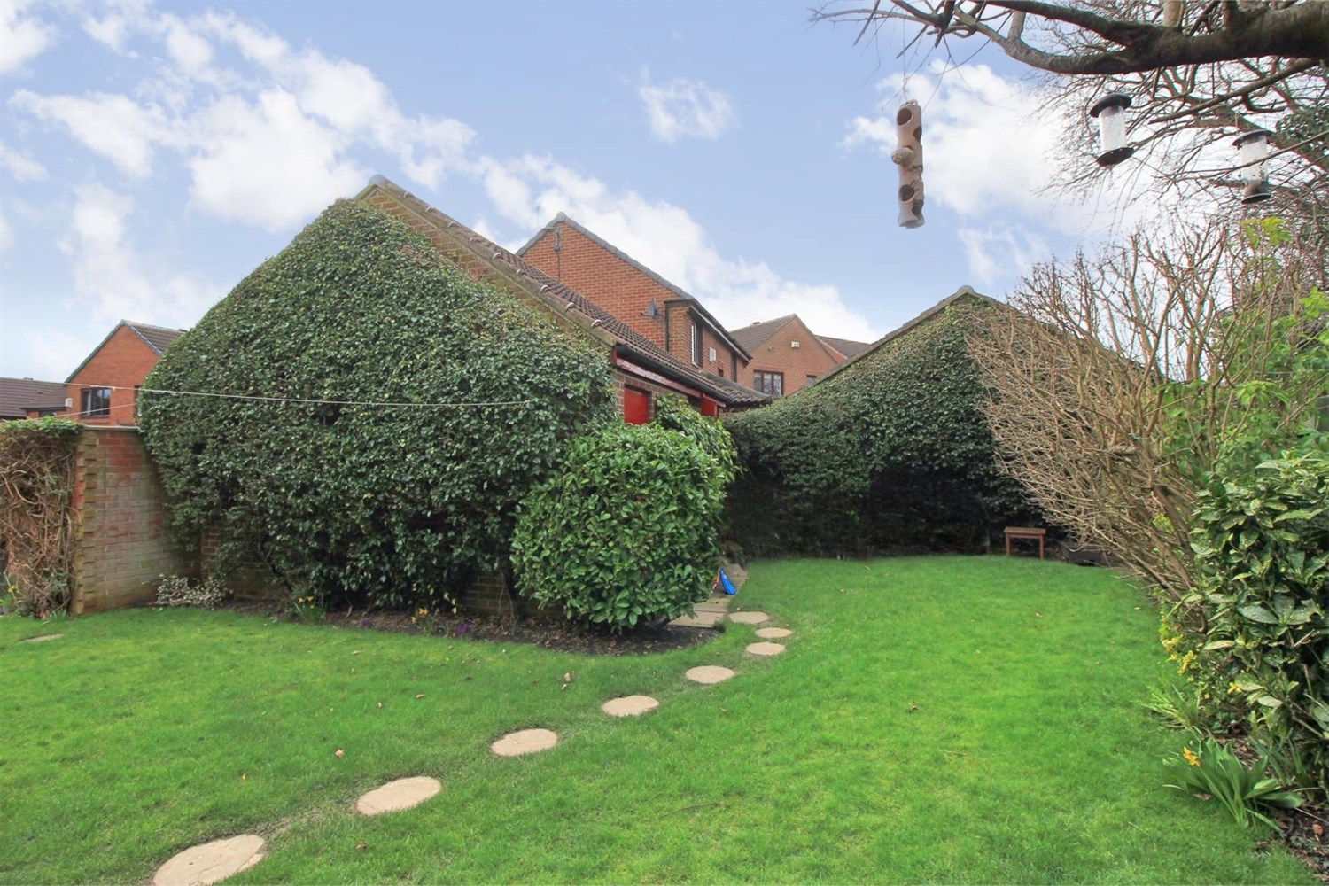
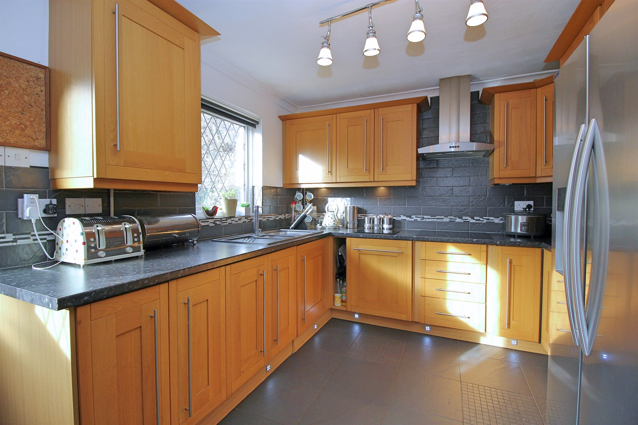
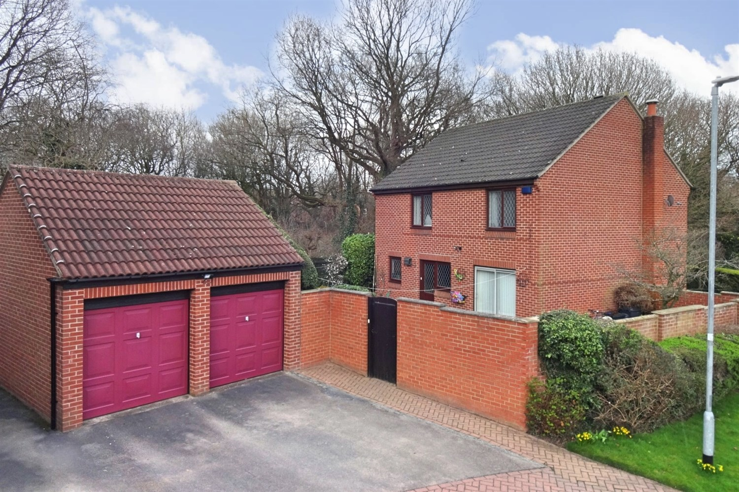
3 Bathroom(s)
2 Reception(s)
4 Bedroom(s)
00
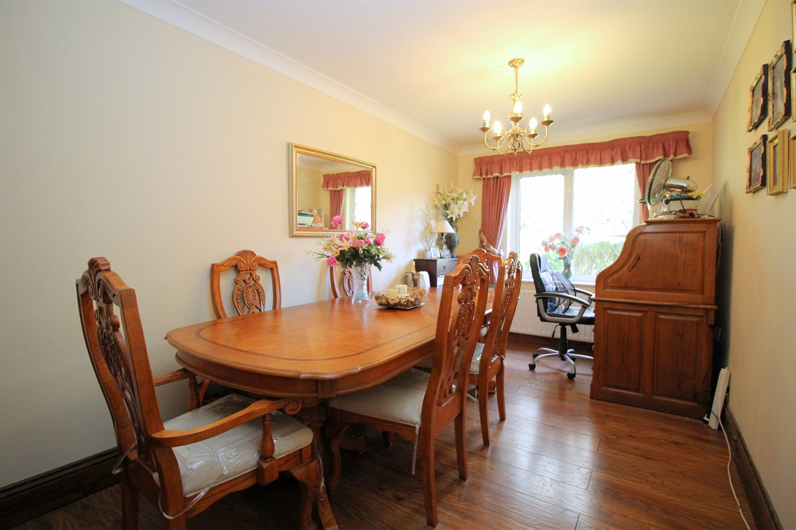
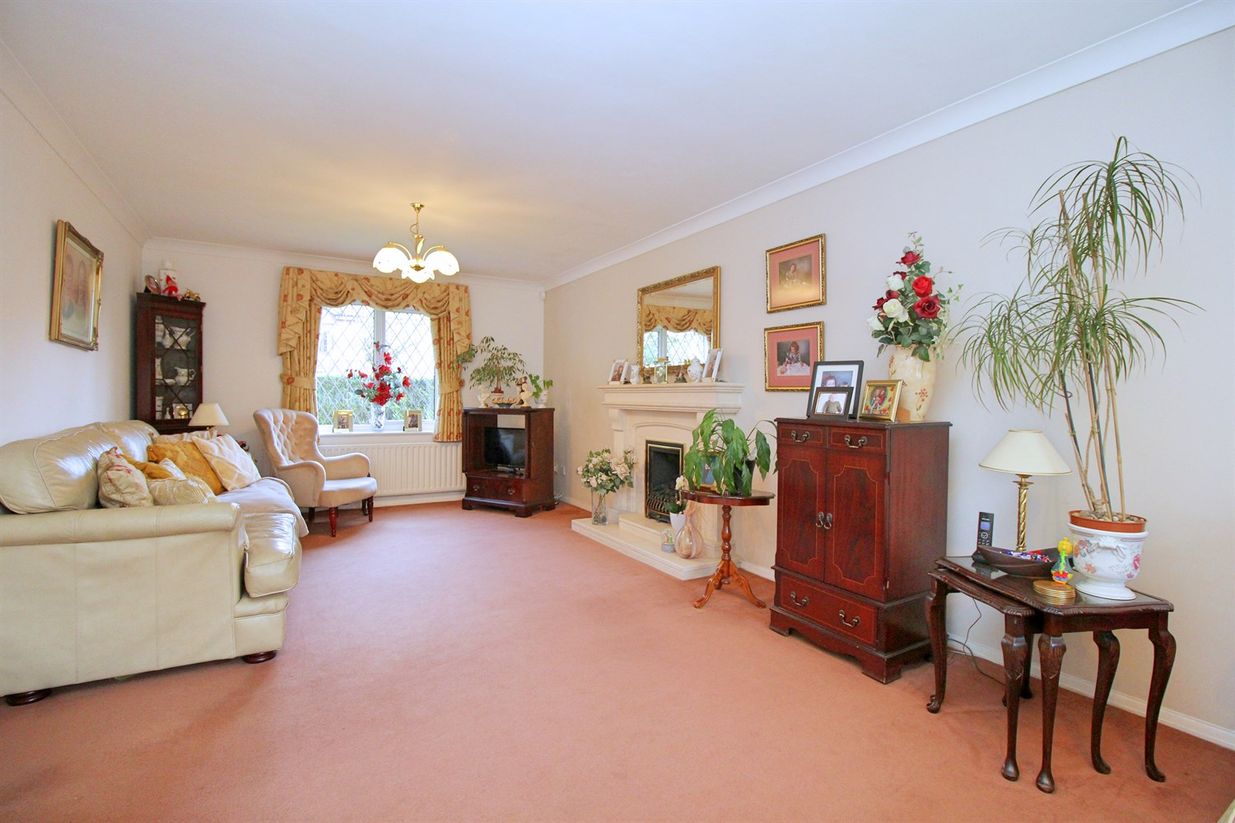
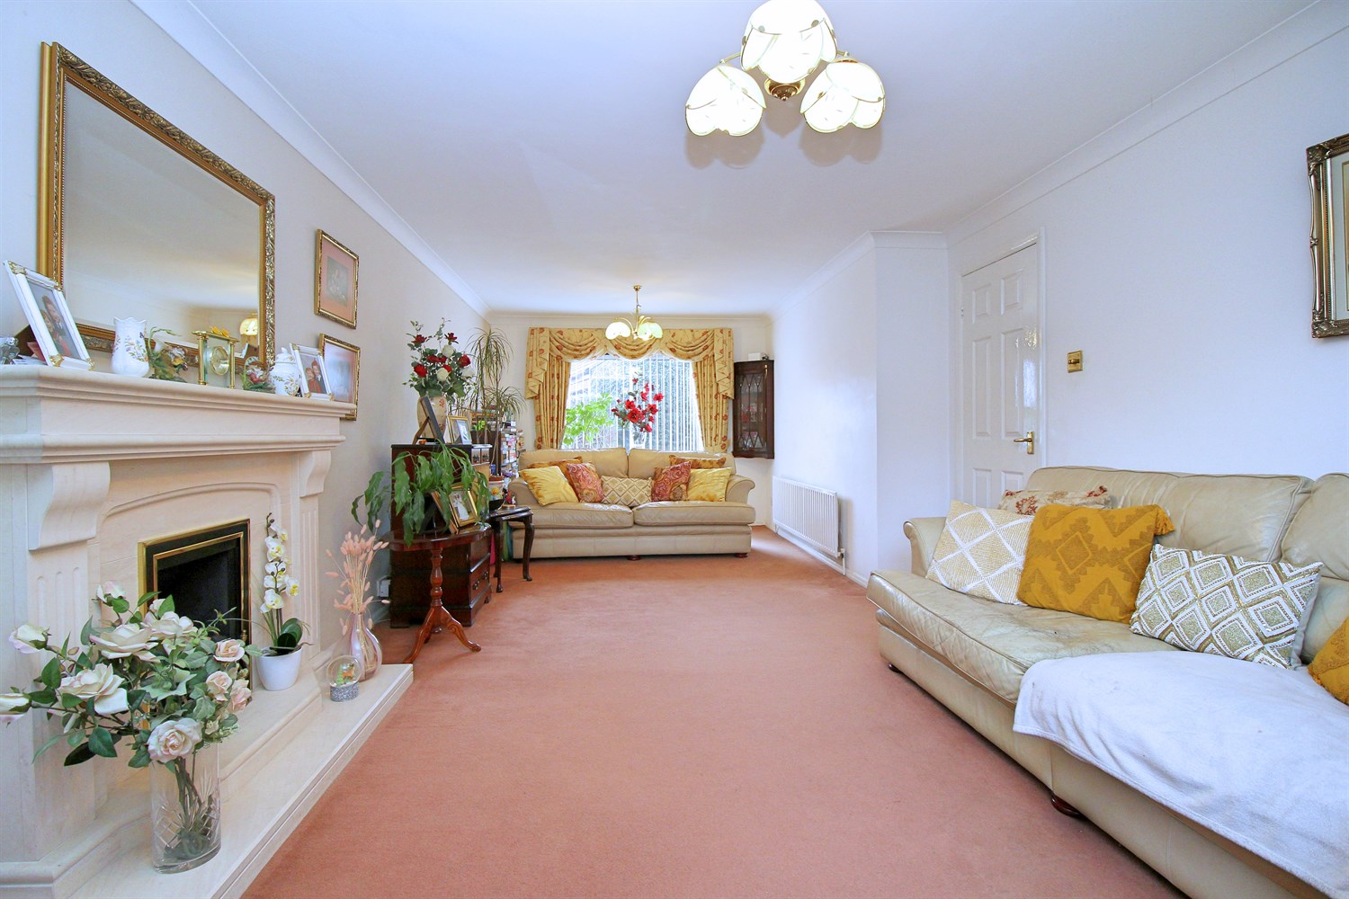
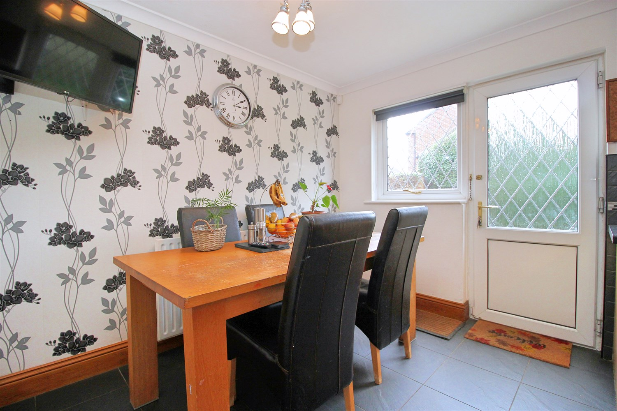
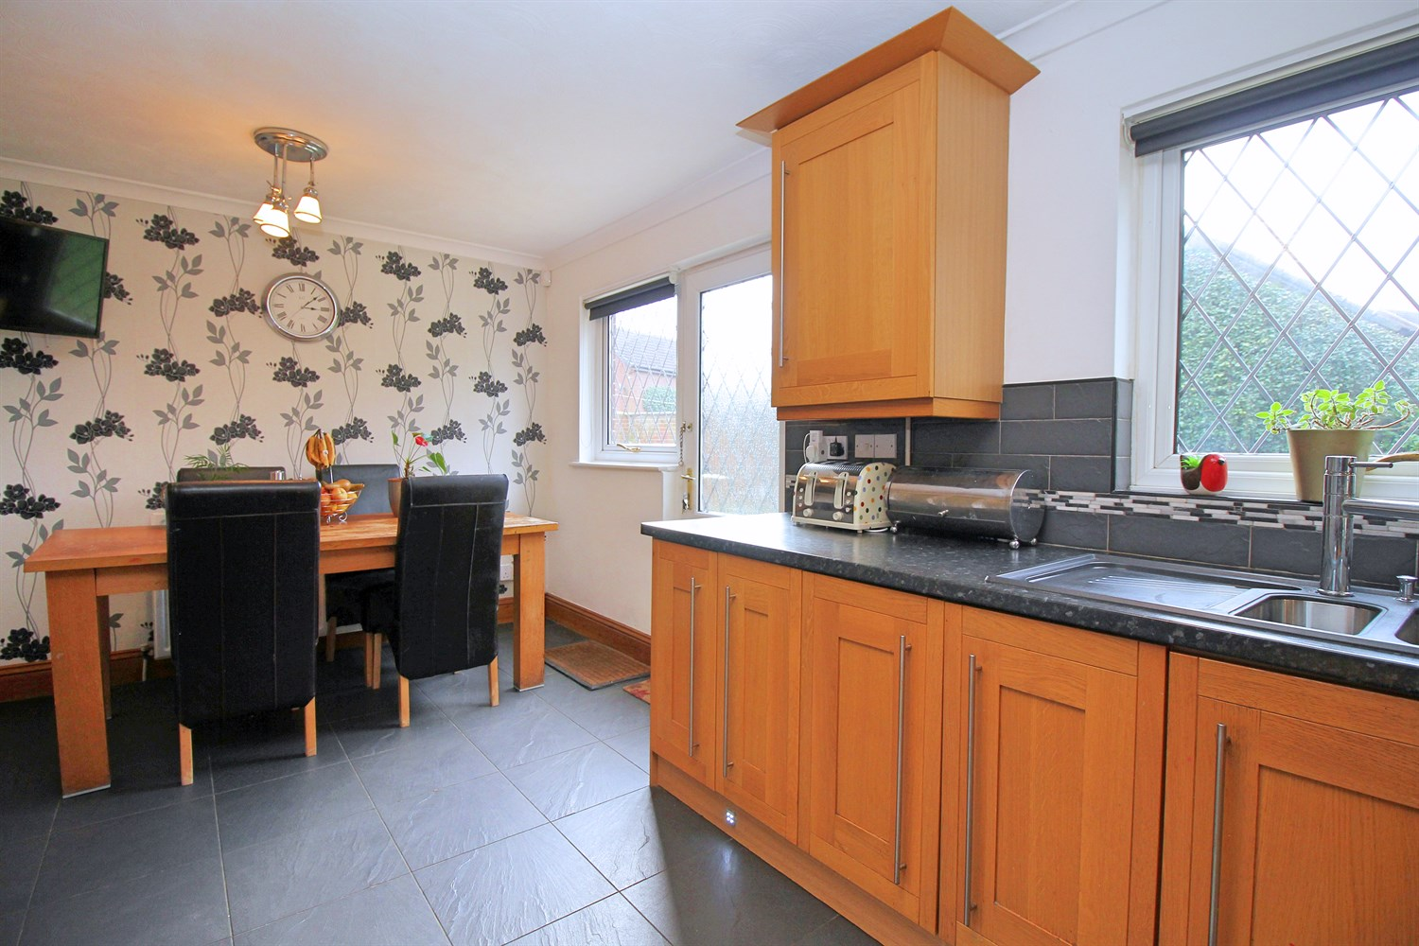
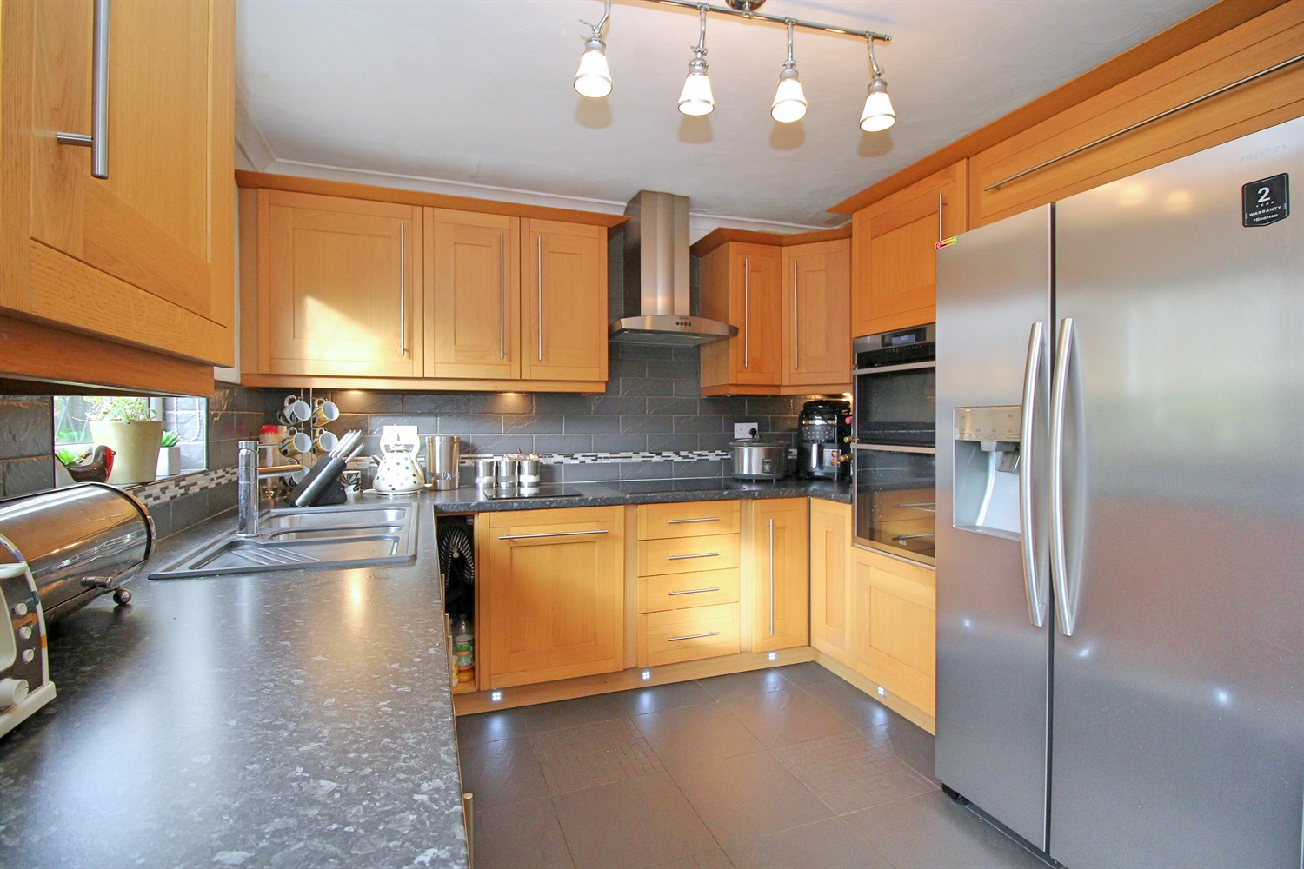
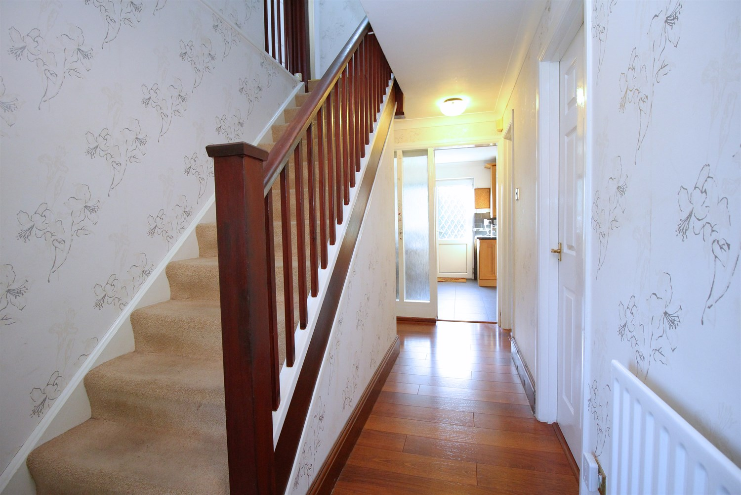
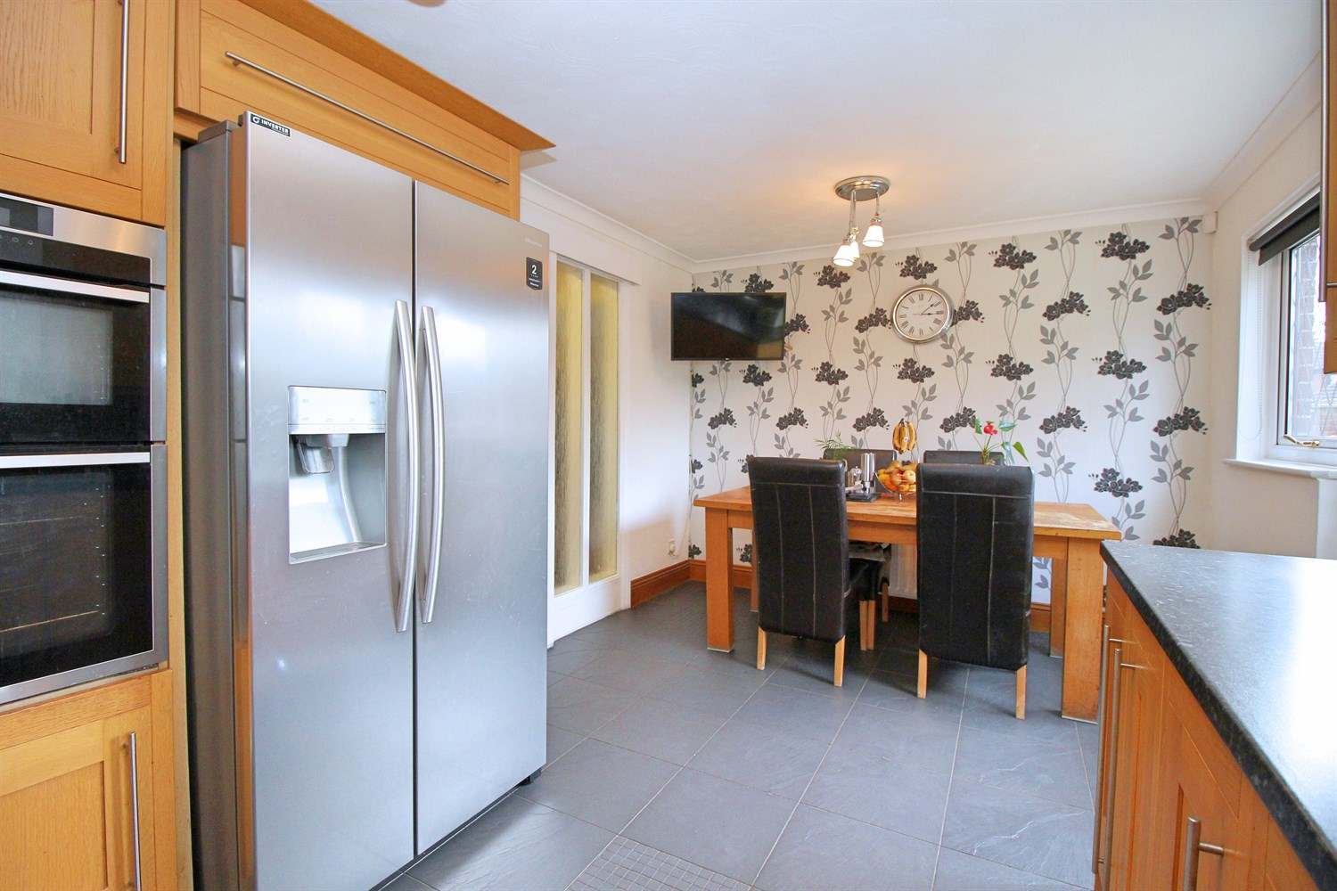

Entrance Hall
Via front entrance door. Gas central heating radiator. Stairs to first floor. Under stairs storage cupboard.

Guest WC
Fitted with a two piece suite comprising; WC and wash hand basin. Double glazed window. Tiled walls and floor. Wall mounted heated towel rail.

Lounge 3.55m (11'8) x 7.75m (25'5)
Light and Airy living area with uPVC double glazed window to front. Sliding Patio doors leading out to the rear garden. Two gas central heating radiator.

Kitchen/Diner 5.04m (16'6) x 3.01m (9'11)
Fitted with a range of wall, base and drawer units with worktops over. Integrated dishwasher and washing machine. Space for double fridge/freezer. Integrated double oven, 4-ring hob with extractor hood over. 1.5 bowl sink with mixer tap and drainer. Part tiled walls and floor. uPVC double glazed window to rear. uPVC double glazed window and door leading out to the rear garden.

Dining Room 2.51m (8'3) x 4.98m (16'4)
Dining room with uPVC double glazed window to front. Gas central heating radiator.

First Floor
Access to boarded loft with pull down ladder.

Master Bedroom 3.99m (13'1) x 3.06m (10'0)
Master bedroom with uPVC double glazed window to front. Gas central heating radiator. Built in wardrobes and dressing table.

En-Suite Shower Room
Fitted with a three piece suite comprising; shower cubicle, WC and wash hand basin. Tiled walls and floor. Gas central heating radiator. Double glazed window.

Bedroom 2 3.62m (11'11) x 3.48m (11'5)
Second double bedroom with uPVC double glazed window to front. Built in wardrobes and drawers. Gas central heating radiator.

Bedroom 3 2.62m (8'7) x 4.11m (13'6)
Third bedroom with uPVC double glazed window to rear. Built in wardrobes. Gas central heating radiator.

Bedroom 4 3.57m (11'9) x 2.55m (8'4)
Double bedroom with uPVC double glazed window to front. Store cupboard. Gas central heating radiator.

House Bathroom
Fitted with a four piece suite comprising; Bath with hand shower over, shower cubicle, WC and wash hand basin. Tiled walls. uPVC double glazed window.

Outside
The property sits on a great sized plot and benefits from lawned gardens to three sides with borders of hedges and shrubs. The rear garden is mainly laid to lawn and offers a good deal of privacy. There is a driveway to the rear, leading to a detached double garage with two up and over doors.
Double Garage
Double garage with two up and over doors. Light and Power. Additional storage in the loft space.

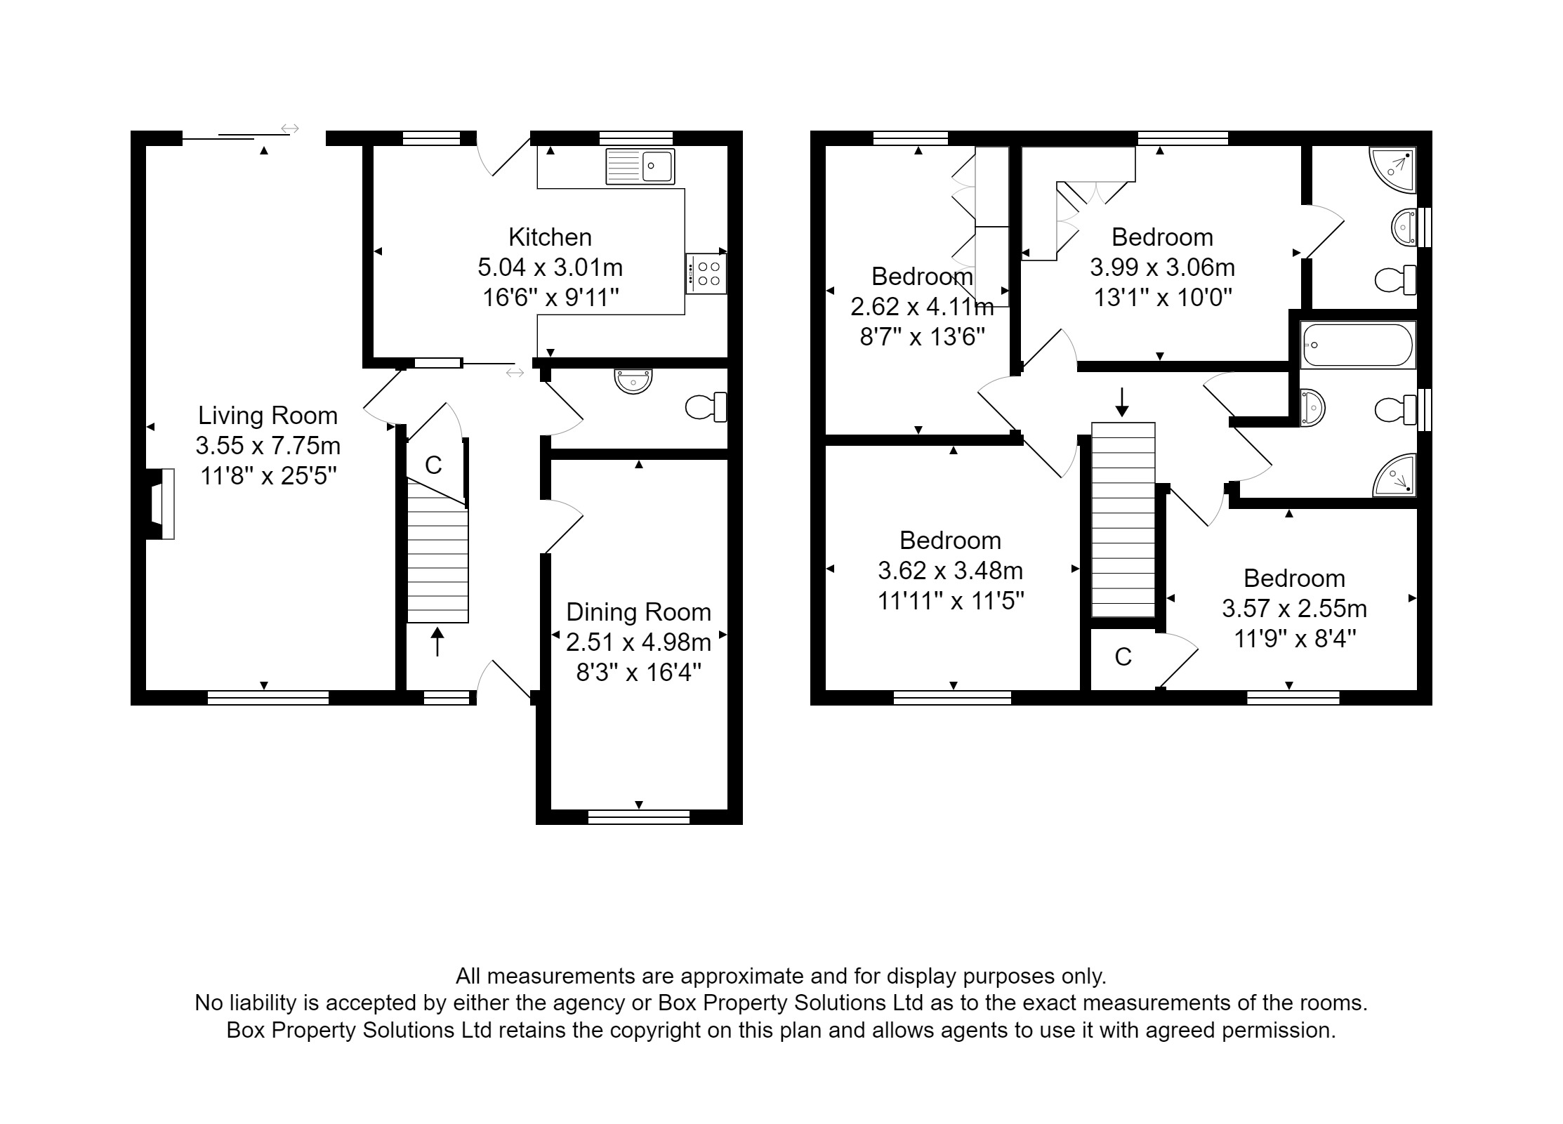

These particulars are intended to give a fair description of the property, but their accuracy cannot be guaranteed, and they do not constitute an offer of contract. Intending purchasers must rely on their own inspection of the property. None of the above appliances/services have been tested by ourselves. We recommend purchasers arrange for a qualified person to check all appliances/services before legal commitment.  Property Ref: 1393  For more information, please contact  0113 258 1150 | sales@adairpaxton.co.uk | www.adairpaxton.co.uk | 