0113 258 1150
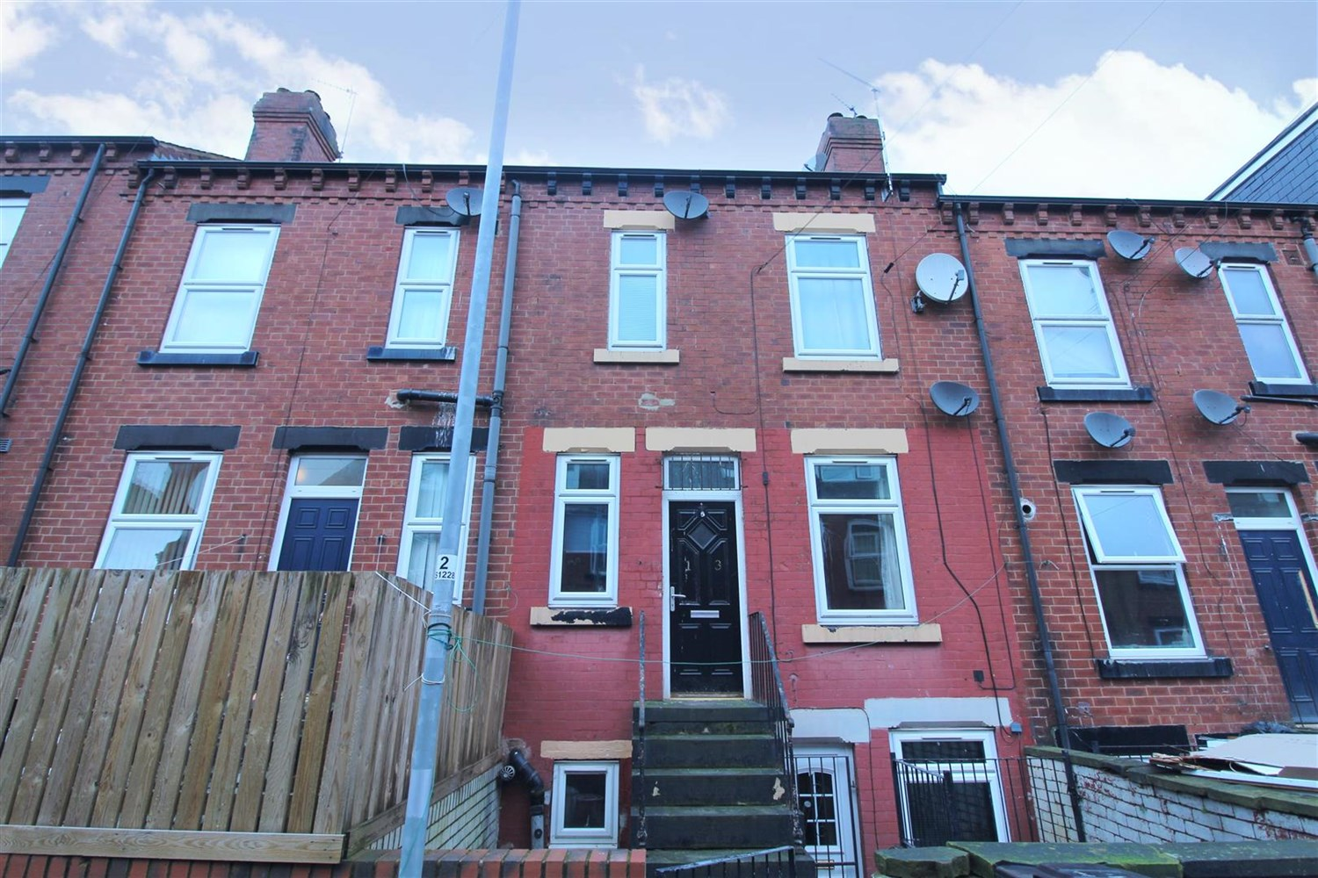
For Sale £275,000.00

Stratford Avenue, LS11

***INVESTMENT OPPORTUNITY - 10.65% YIELD***FIVE SELF CONTAINED APARTMENTS***
The property has been converted in to 5 apartments. To the front of the property there is access to 3 apartments via a communal hallway. To the rear, 2 apartments are accessed via a private entrance. The annual gross income is currently £33,247.56.
Situated in a favourable residential area of Beeston with an excellent choice of local schools, good public transport links, easy access to Leeds city centre and the motorway network.

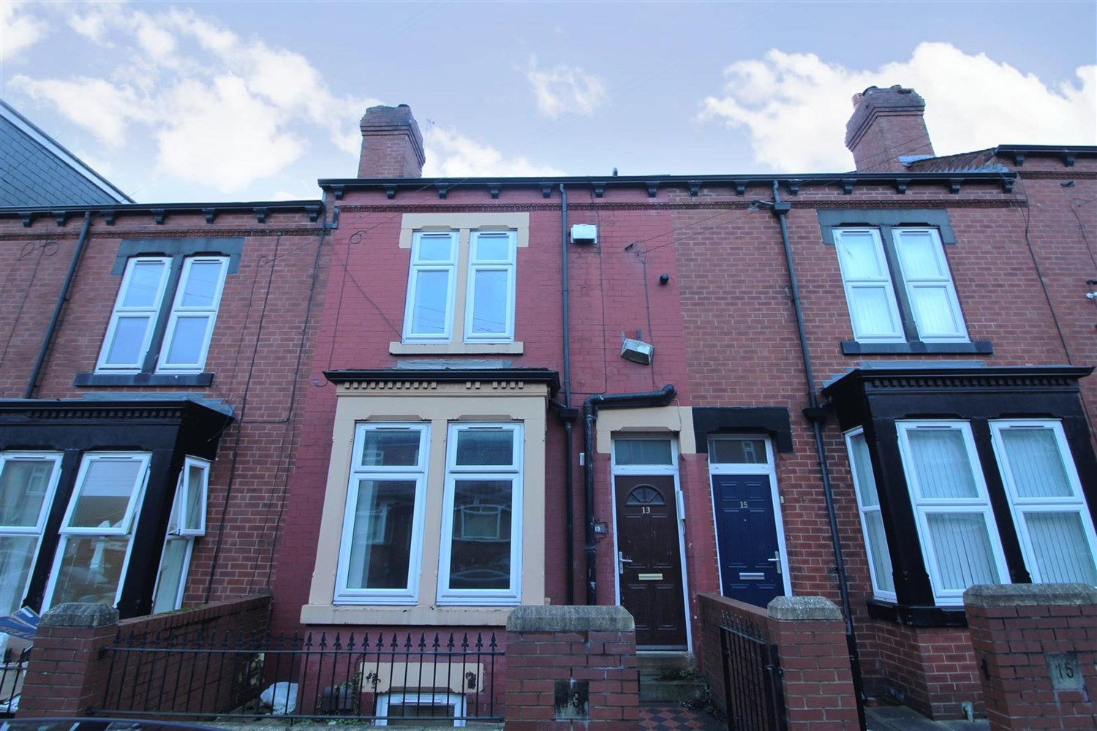
5 Bathroom(s)
4 Reception(s)
5 Bedroom(s)
00

Price
The property is offered on a freehold basis subject to the existing tenancies at a guide price of £275,000.

Investment Opportunity
A gross income of £33,247.56. per annum.

EPCs
All available on request.

Flat 1
Ground floor. Split level one bedroom apartment currently rented at £523.55, as it has recently been refurbished. Council Tax Band A.

Flat 2
First Floor - One Bedroom. Currently tenanted at £524.99 pcm. Council Tax Band A.

Flat 4
Top Floor. One bedroom. Currently tenanted at £523.55 pcm. Council Tax Band A.

Flat 5
Basement flat to the rear. One Bedroom. Currently tenanted at £674.99 pcm. Council Tax Band A.

Flat 6
First floor to the rear. One bedroom. Currently tenanted at £523.55 pcm. Council Tax Band A.

Reception 2

Reception 3

Reception 4

Reception 5

Kitchen 1

Kitchen 2

Kitchen 3

Kitchen 4

Kitchen 5

Bedroom 1

Bedroom 2

Bedroom 3

Bedroom 4

Bedroom 5

Bathroom 1

Bathroom 2

Bathroom 3

Bathroom 4

Bathroom 5

These particulars are intended to give a fair description of the property, but their accuracy cannot be guaranteed, and they do not constitute an offer of contract. Intending purchasers must rely on their own inspection of the property. None of the above appliances/services have been tested by ourselves. We recommend purchasers arrange for a qualified person to check all appliances/services before legal commitment.

Property Ref: 781

For more information, please contact

0113 258 1150 | sales@adairpaxton.co.uk | www.adairpaxton.co.uk

