0113 258 1150
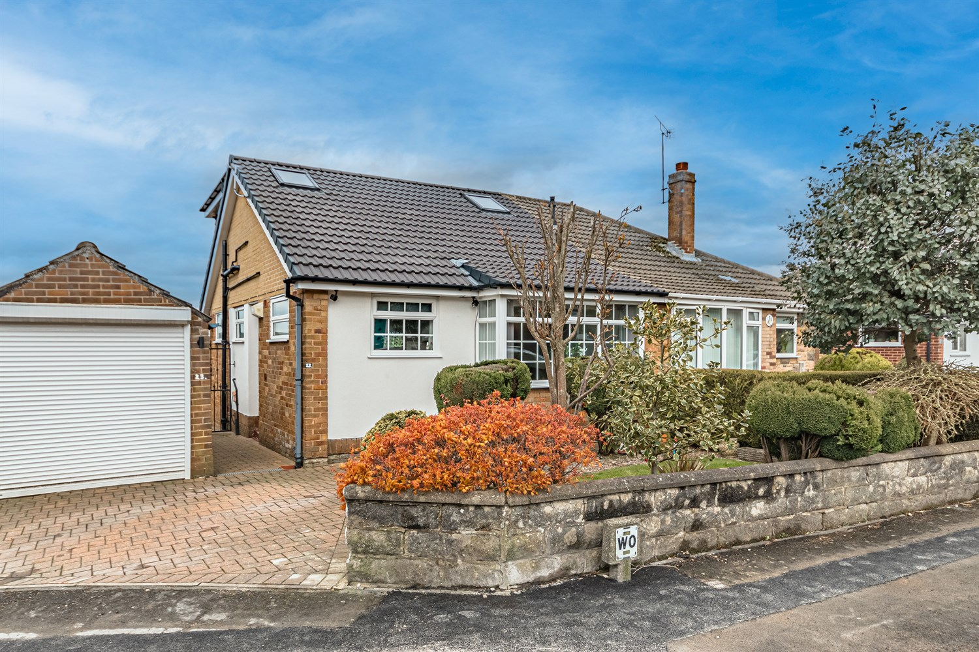
For Sale £350,000.00

Kirkwood Avenue, Cookridge

***SUPERB THREE BEDROOM, SEMI-DETACHED BUNAGLOW*** Set in this much sought after quiet location and having far reaching views, this property offers ready to move into accommodation. The property briefly comprises: Modern kitchen, a double bedroom, light and airy living room and a shower room to the ground floor. To the first floor there is a superb master bedroom, bathroom and a third bedroom. Externally there is a driveway to the front and a detached garage, with an enclosed rear garden benefitting from a decked area offering amazing views. This bungalow is ideally situated for access to Otley Road and the Ring Road. The Holt Park shopping centre is only a short drive away offering the amenities of a swimming pool, Asda supermarket and a health centre. Public transport facilities are good by bus or rail from the Horsforth Train Station located on the Horsforth/Cookridge border.
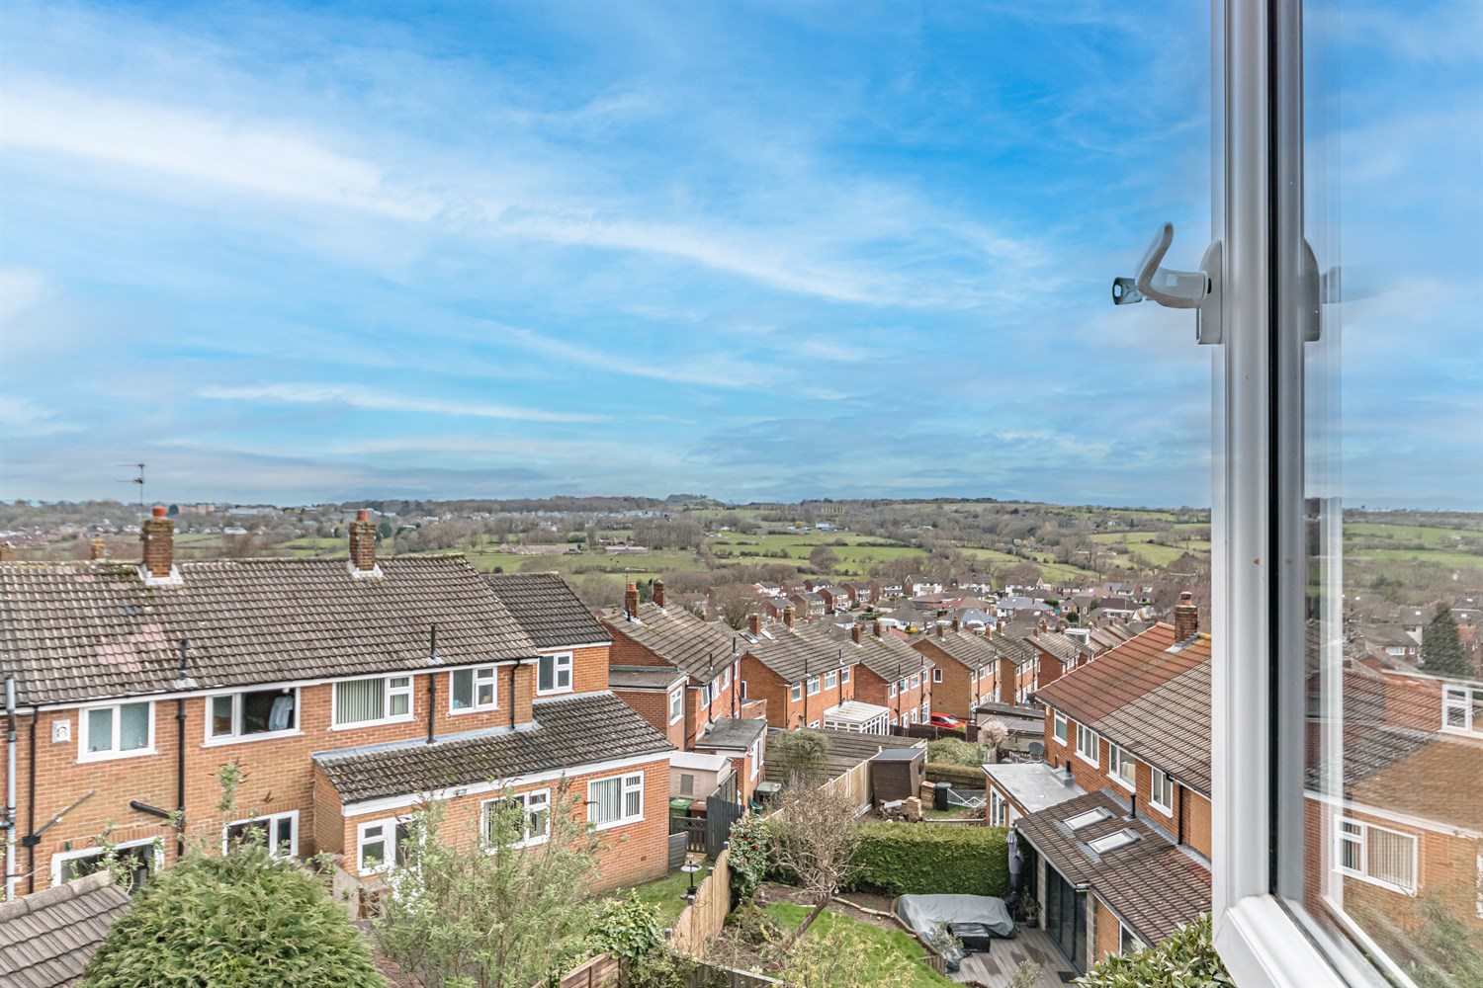
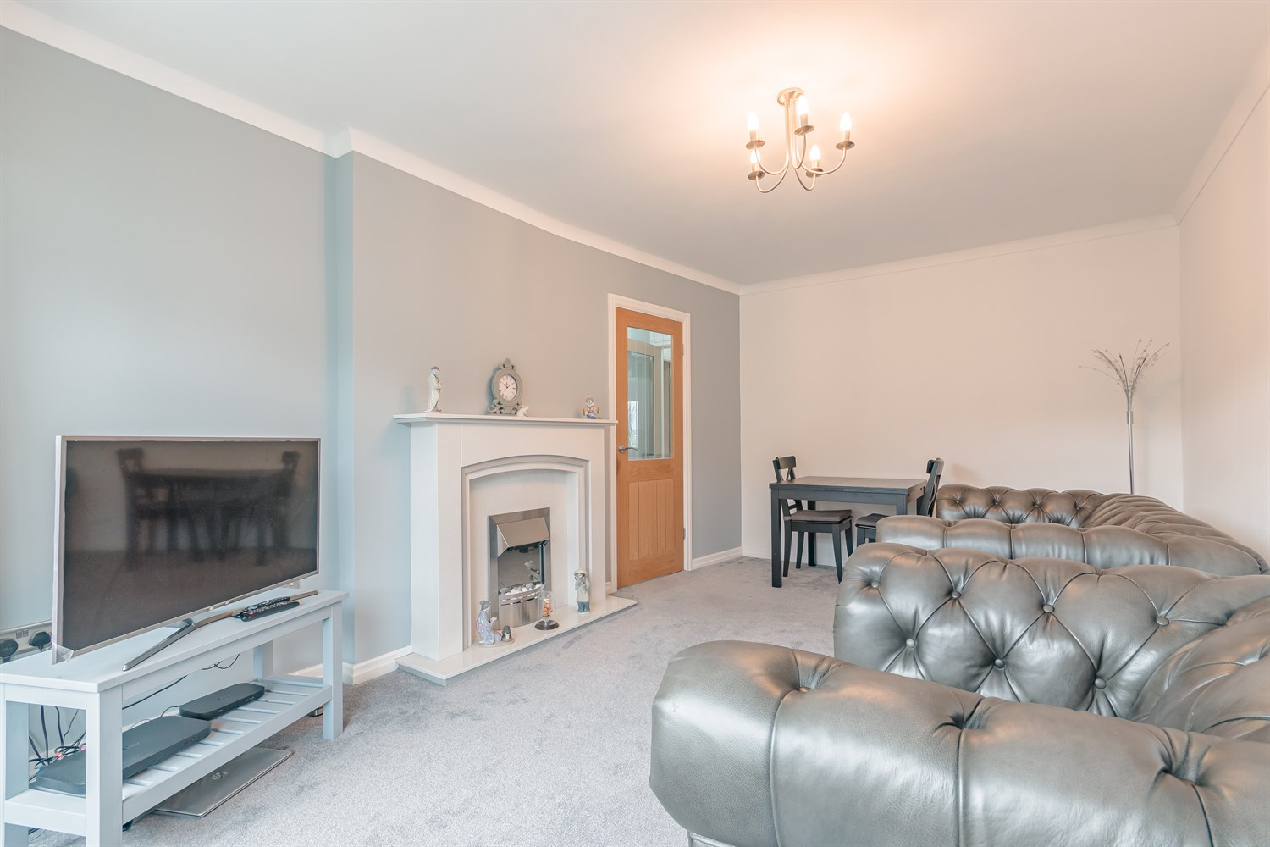
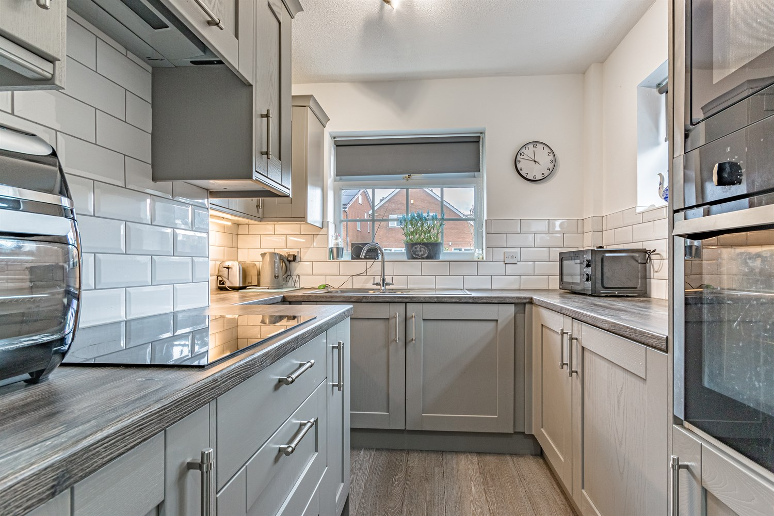
2 Bathroom(s)
1 Reception(s)
3 Bedroom(s)
00
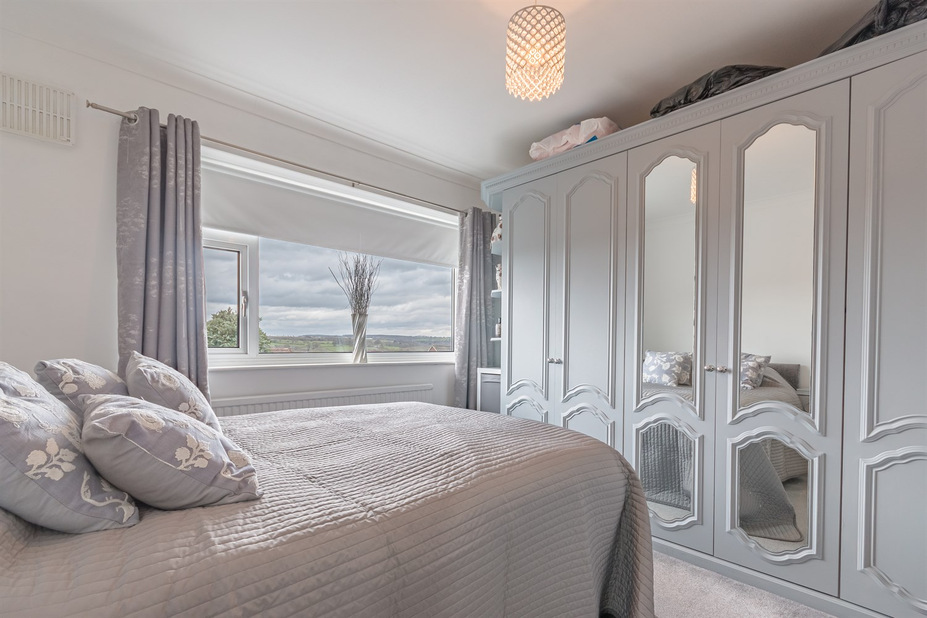
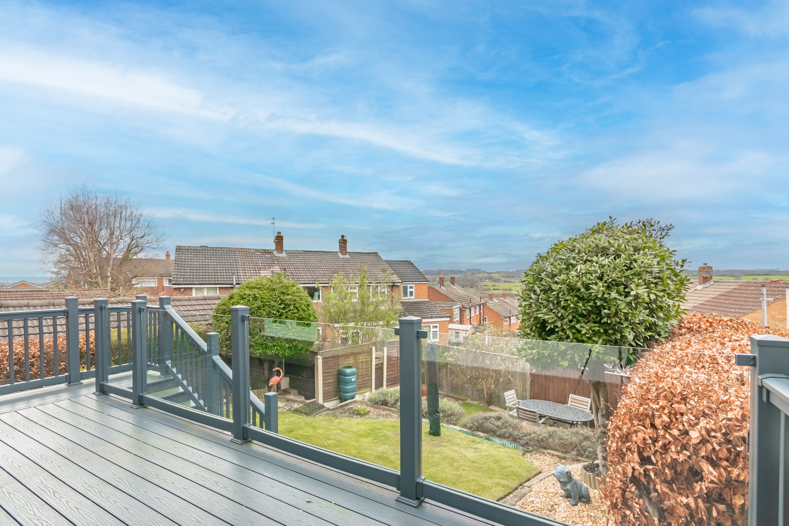
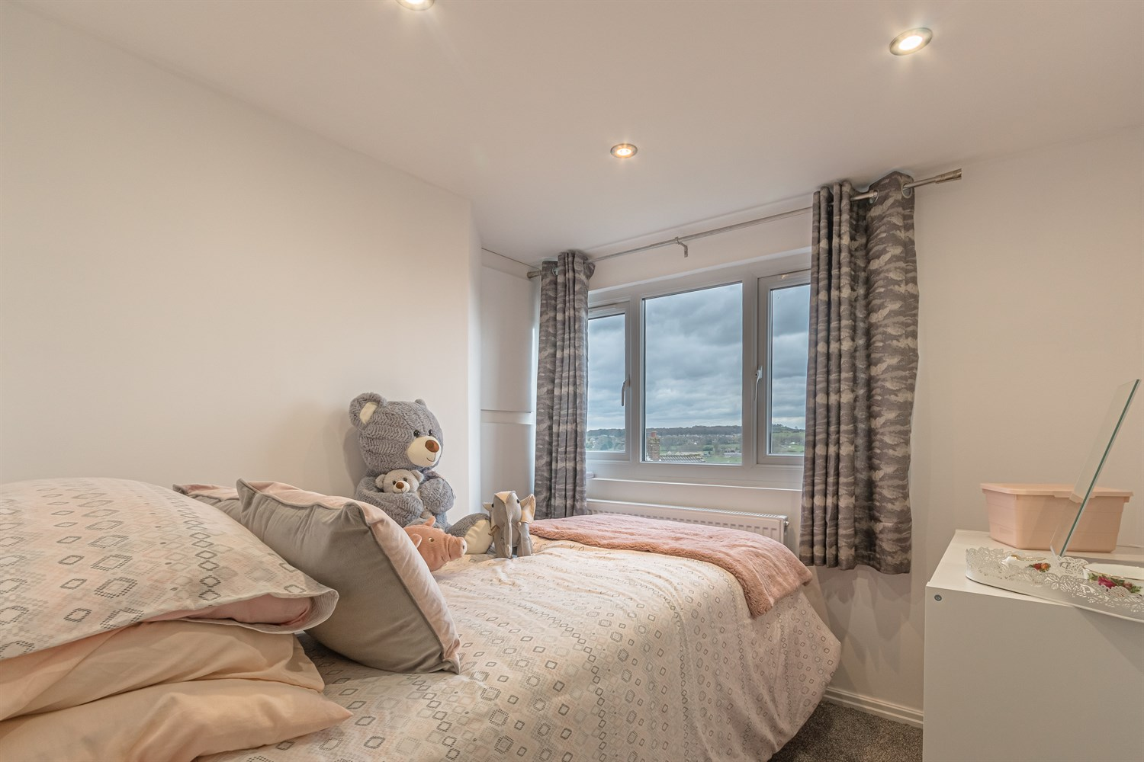
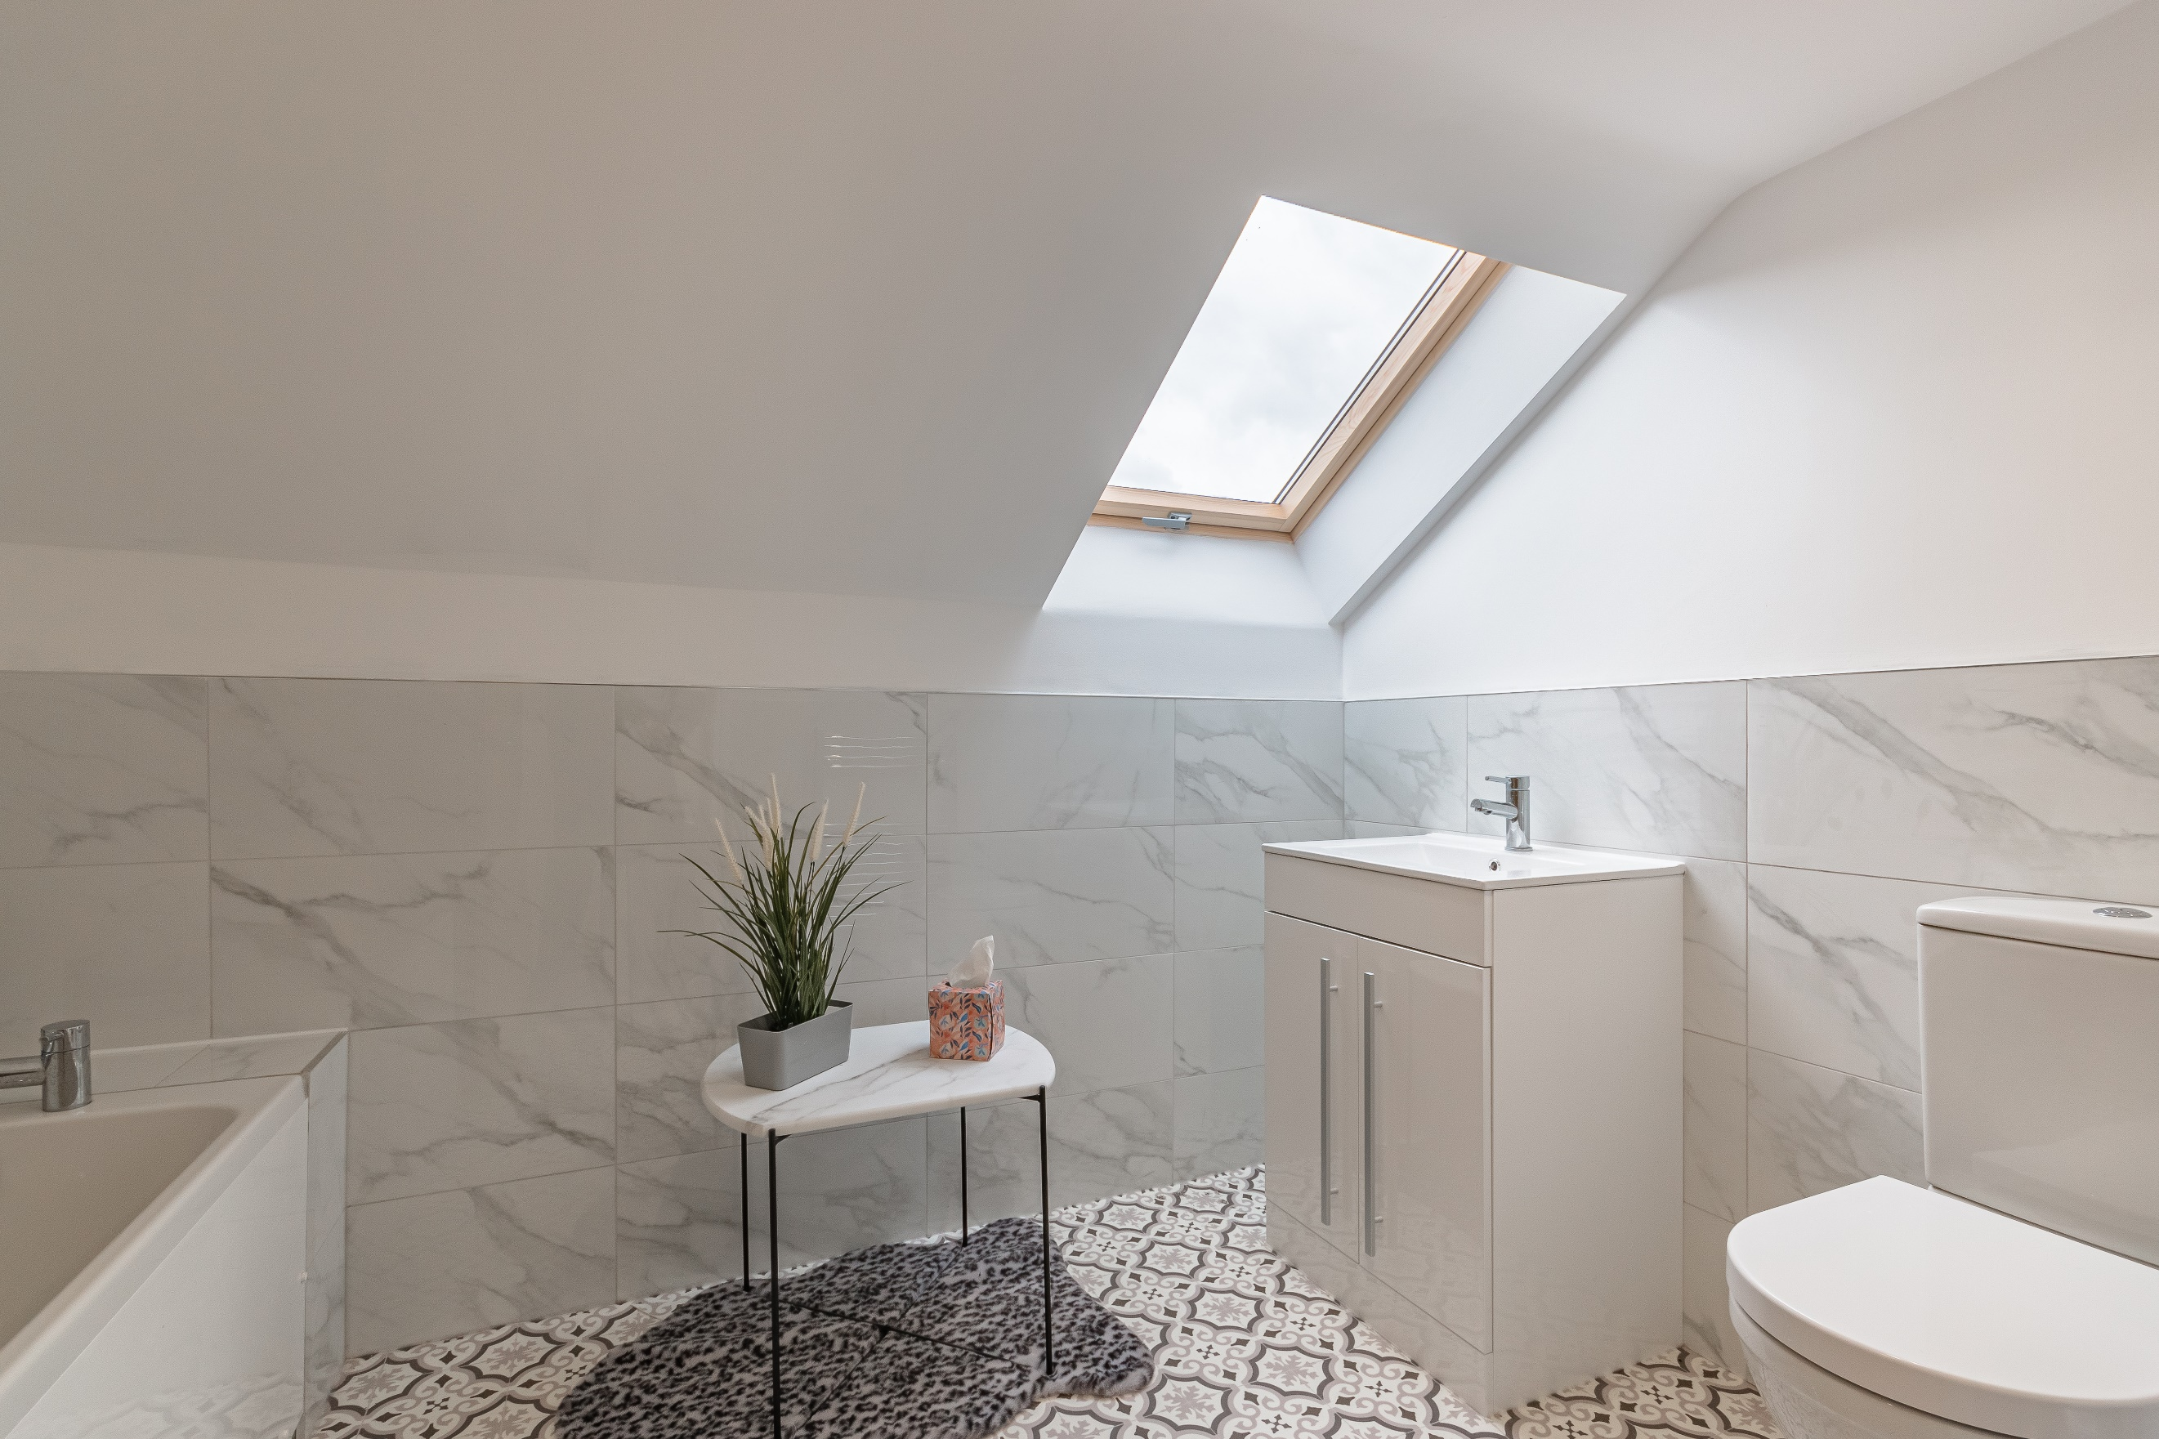
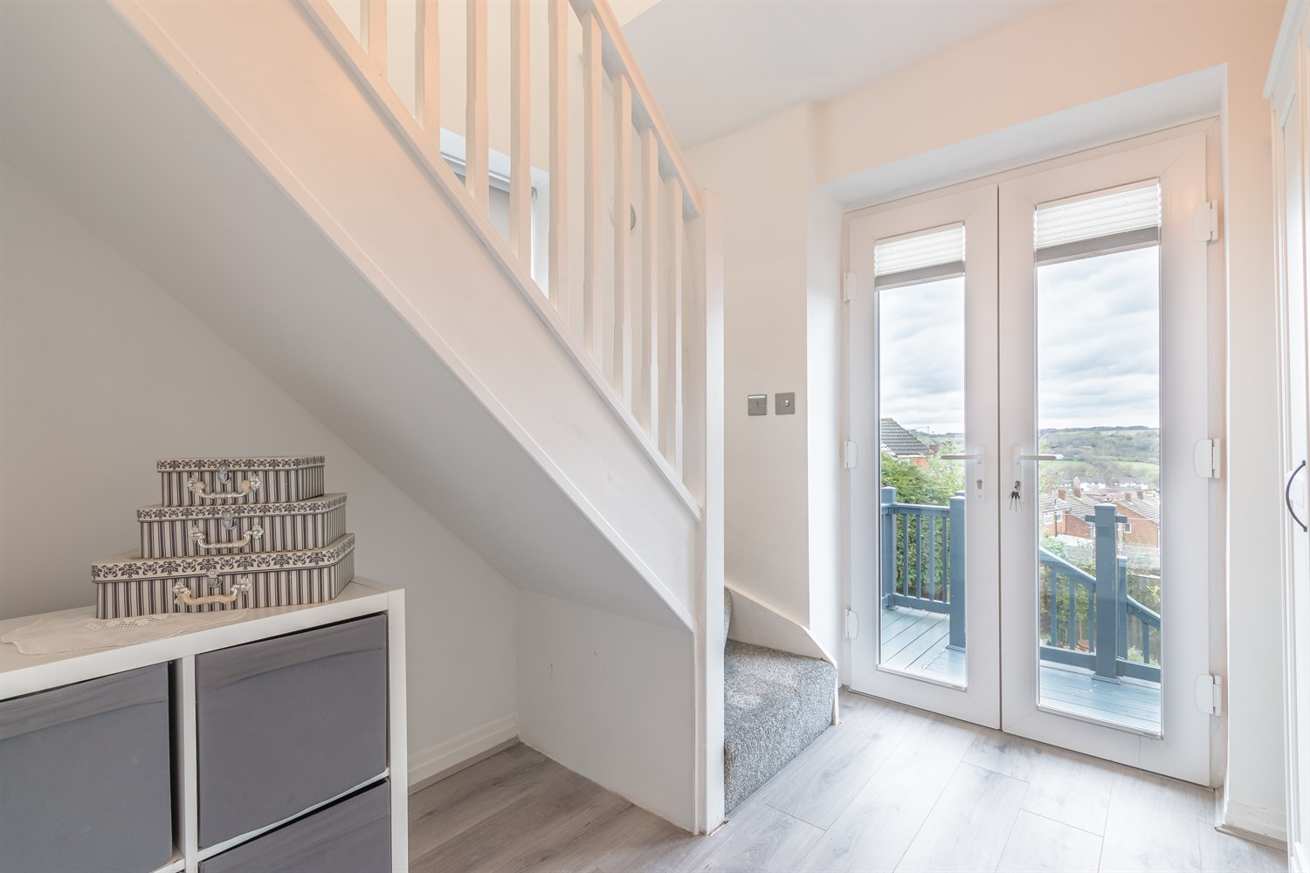
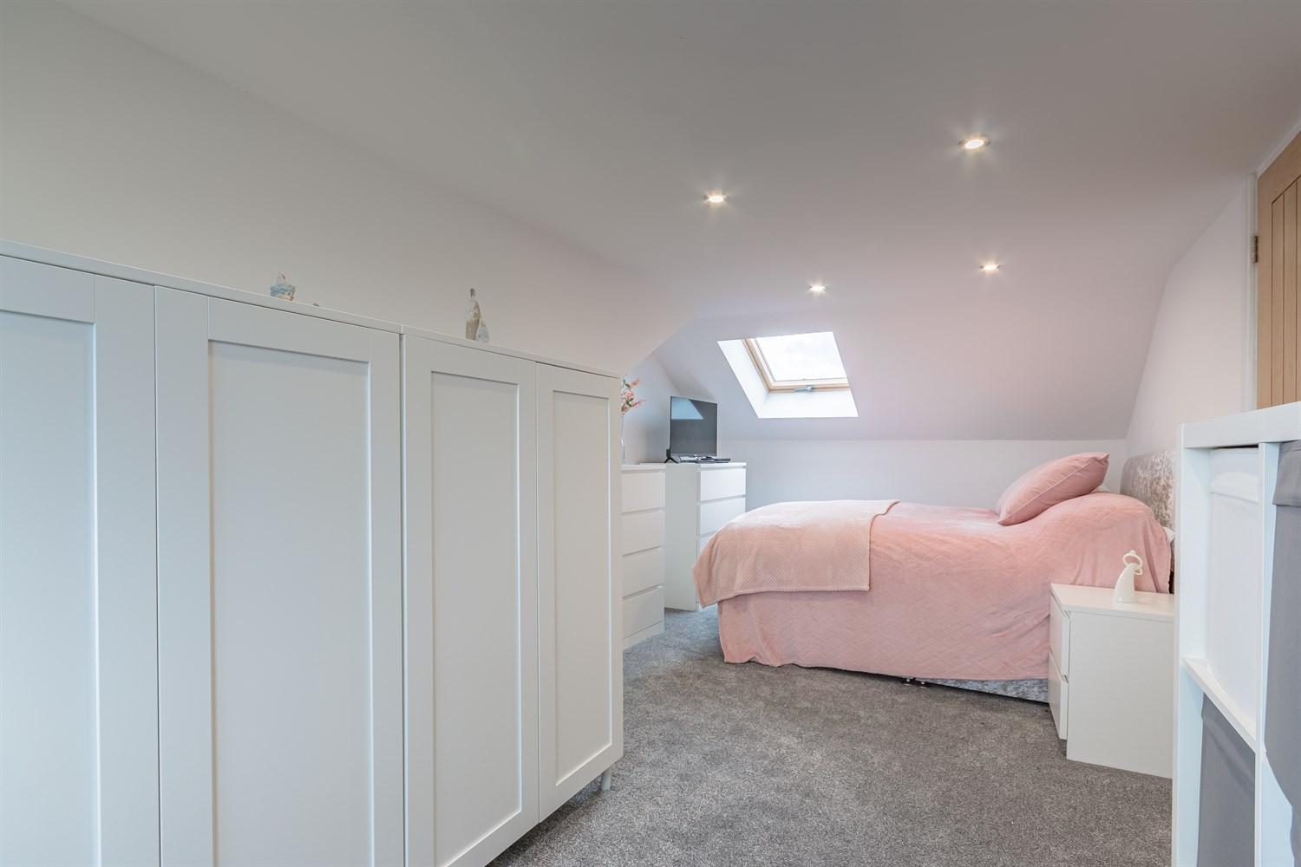
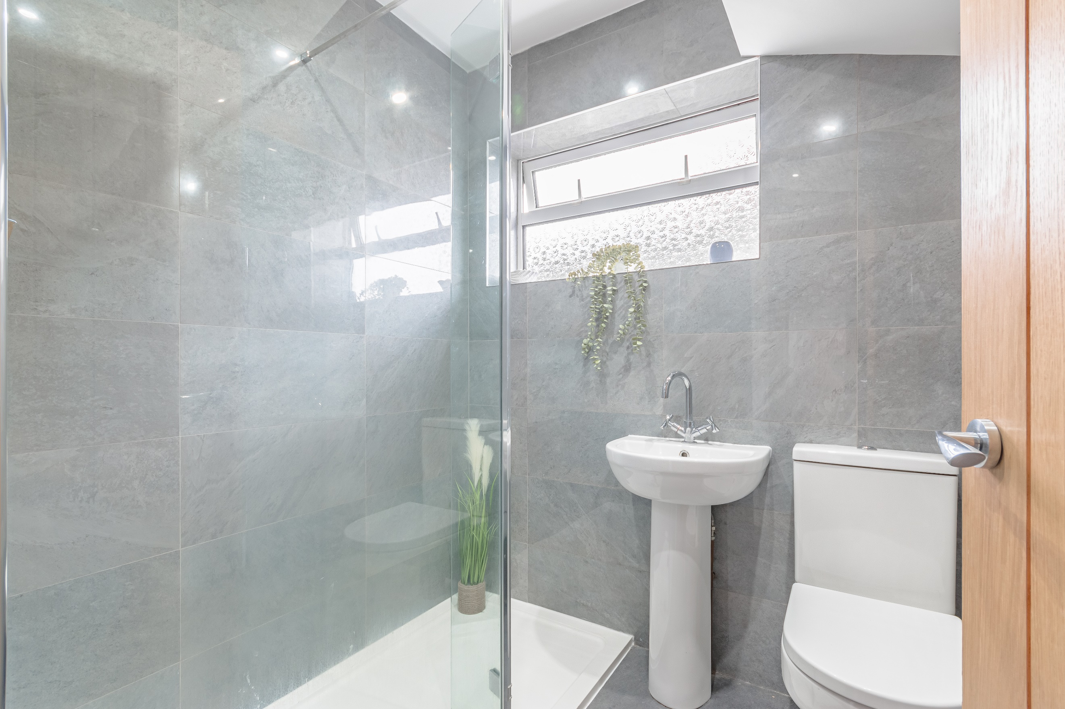
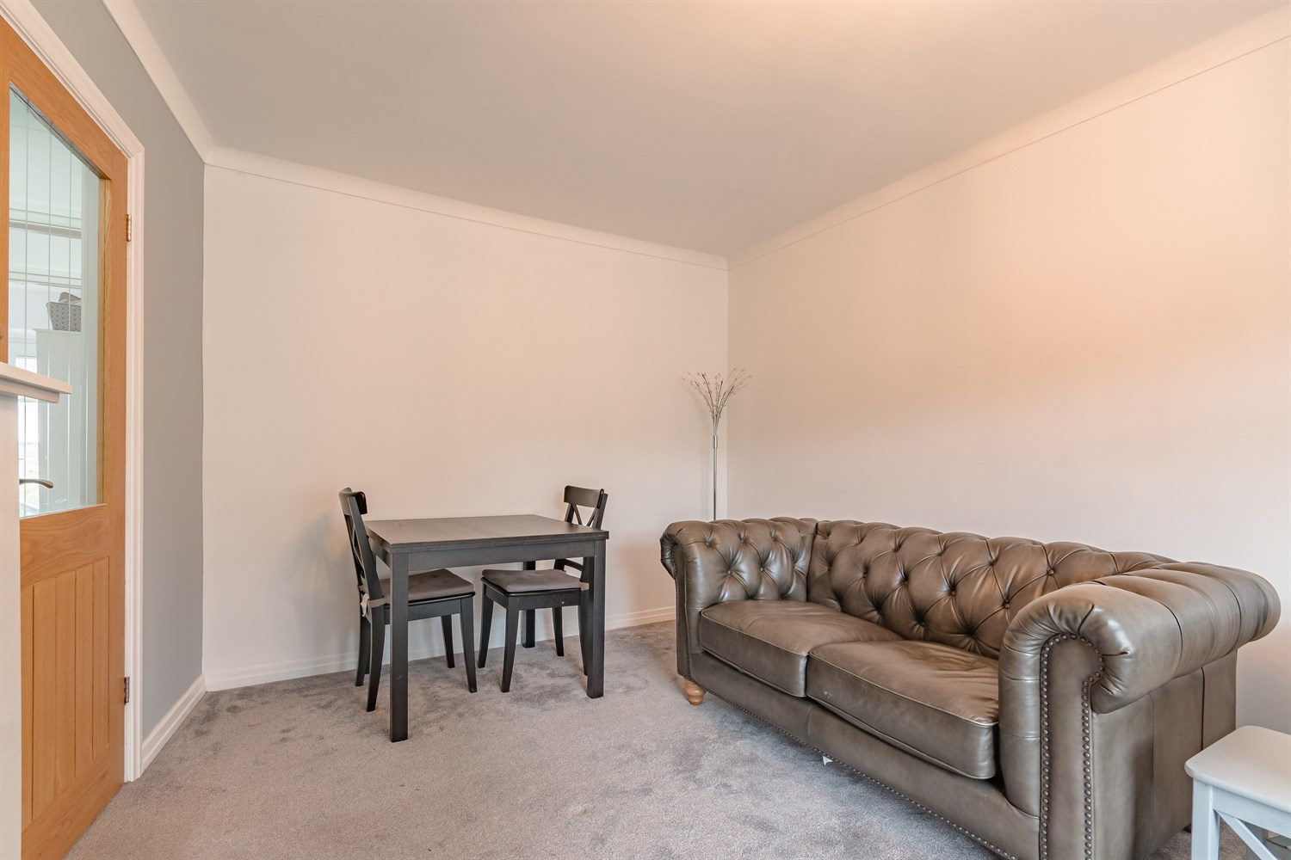

Entrance Hall
Entrance hall via side entrance door. Gas central heating radiator.

Lounge
Light and Airy living area with uPVC double glazed window to front. Gas central heating radiator.

Kitchen
A modern kitchen, fitted with a range of wall, base and drawer units with work surfaces over. Stainless steel sink and drainer with mixer tap. Integrated electric oven, induction hob, fridge and washing machine. uPVC double glazed windows to both the front and side.

Bedroom 1
Double bedroom with uPVC double glazed window to the rear offering long distance views. Fitted wardrobes providing hanging and shelving storage. Radiator.

Shower Room
Modern shower room comprising; shower cubicle, wash hand basin and WC. Tiled walls. uPVC double glazed window.

Study
Double glazed doors out to the rear garden. Stairs to first floor.

Master Bedroom
Superb master bedroom with uPVC double glazed window to rear with far reaching views. Velux window to front. Inset ceiling spotlights. Velux window to front.

Bathroom
Fitted with a three piece white suite comprising; Bath, WC and wash hand basin. Velux window. Tiled walls.

Bedroom 3
Third bedroom with uPVC double glazed window to rear with far reaching views. Gas central heating radiator.

Outside
A block paved driveway to the front provides off street parking for one car and leads to a detached garage. The garage has an electric door to the front, uPVC double glazed window and pedestrian door to the side and further benefits from power and lighting. The front garden is mostly laid to lawn with borders of flowers, trees and shrubs. To the rear there is a composite raised patio area with glass balustrade which enjoys long distance views. There are steps down to a lawned garden and further steps down to an additional lawned area.

These particulars are intended to give a fair description of the property, but their accuracy cannot be guaranteed, and they do not constitute an offer of contract. Intending purchasers must rely on their own inspection of the property. None of the above appliances/services have been tested by ourselves. We recommend purchasers arrange for a qualified person to check all appliances/services before legal commitment.  Property Ref: 1821  For more information, please contact  0113 258 1150 | sales@adairpaxton.co.uk | www.adairpaxton.co.uk | 