0113 258 1150
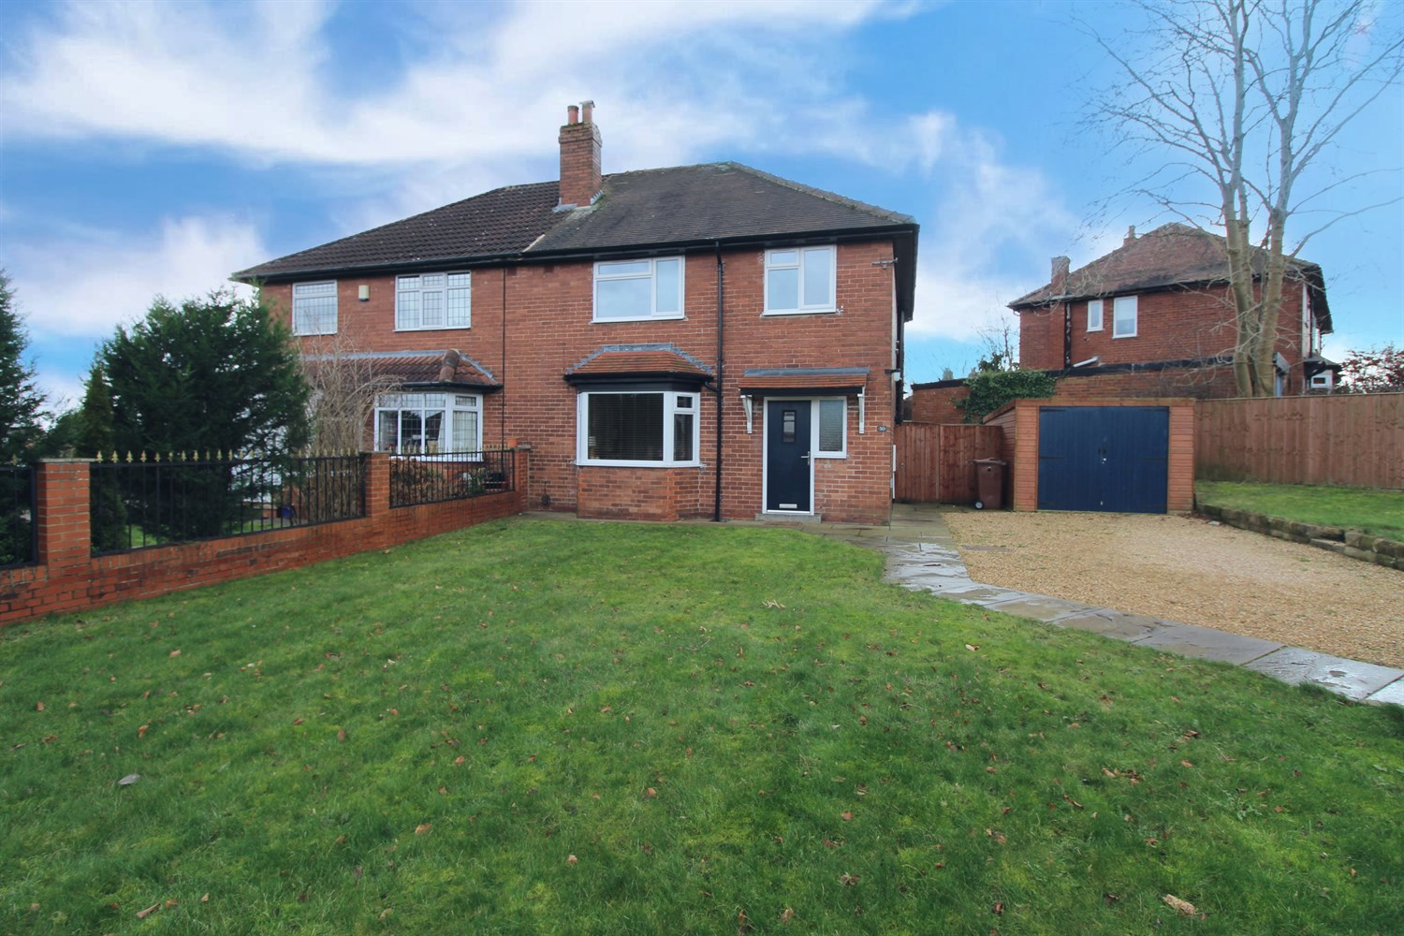
For Sale £379,950

30 Moor Allerton Crescent, Moortown, LS17 6SH

***THREE BEDROOM SEMI DETACHED HOUSE IN A GREAT LOCATION*** The property is offered for sale with NO ONWARD CHAIN and is located in the much sought after area of Moortown within easy reach of local schools, Roundhay Park and the array of amenities on Street Lane and Moortown Corner. The property briefly comprises; Entrance hall, Lounge and modern dining/kitchen to the ground floor. To the first floor there are three bedrooms and a house bathroom with an additional guest WC. Externally, the property sits on a corner plot with gardens to the front and rear, and a single garage to the side.
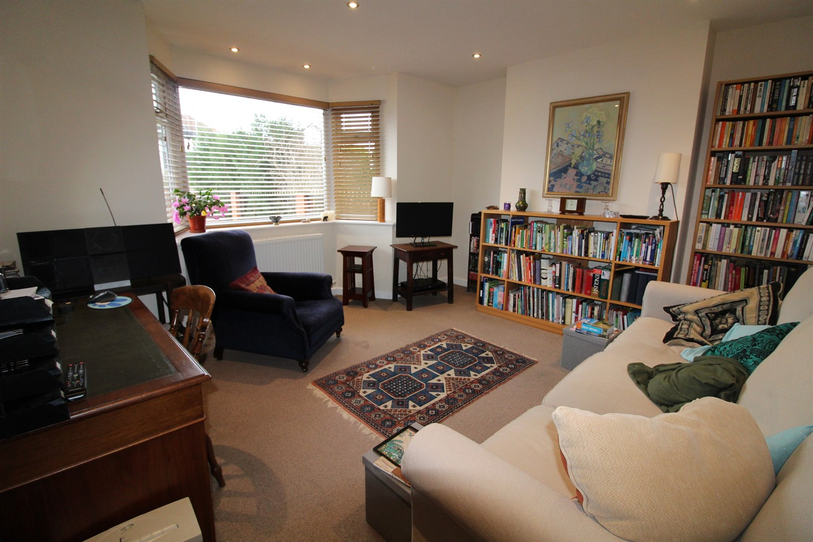
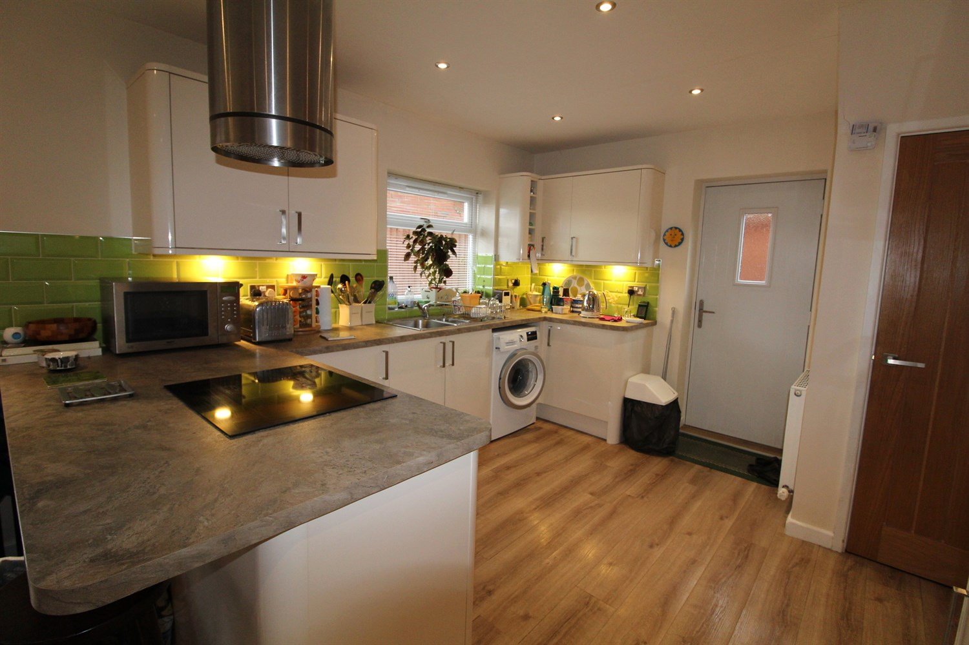
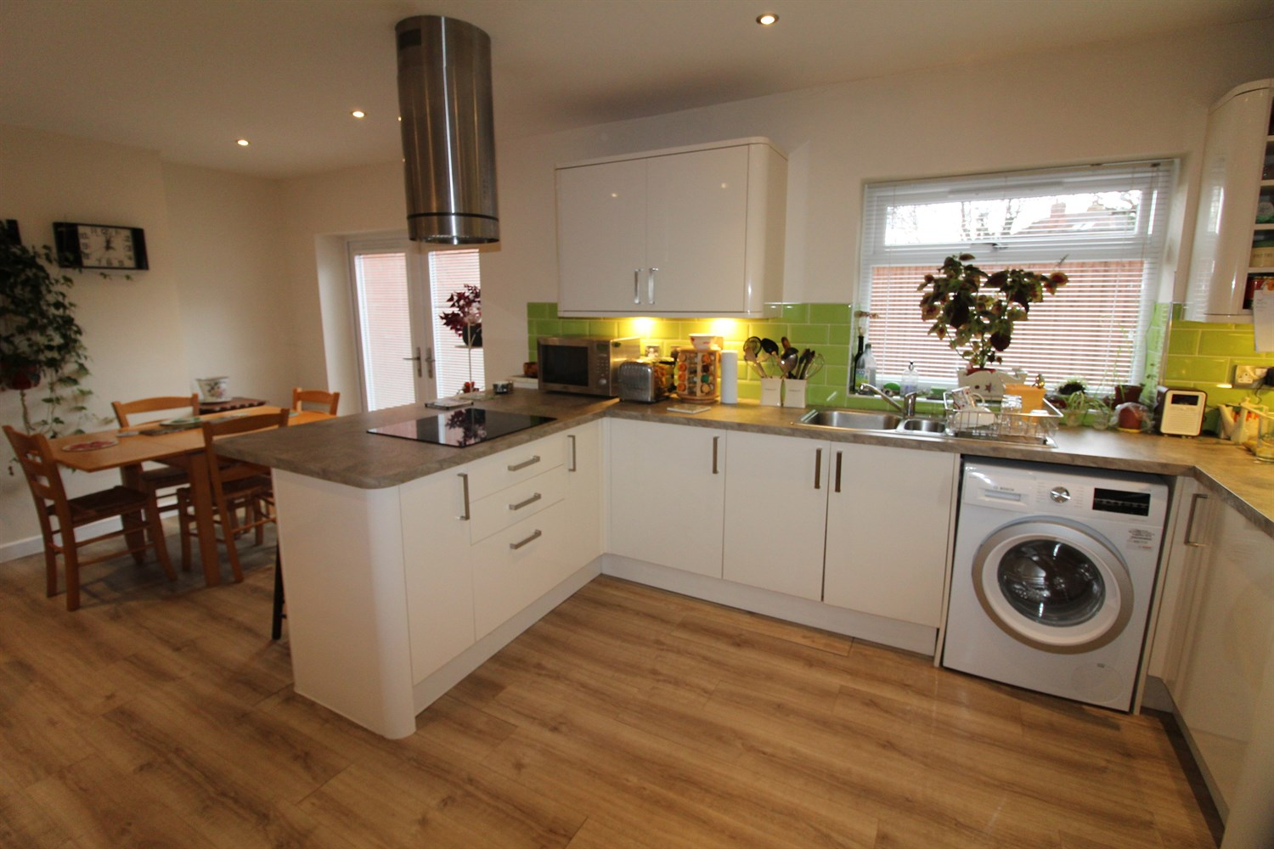
1 Bathroom(s)
2 Reception(s)
3 Bedroom(s)
00
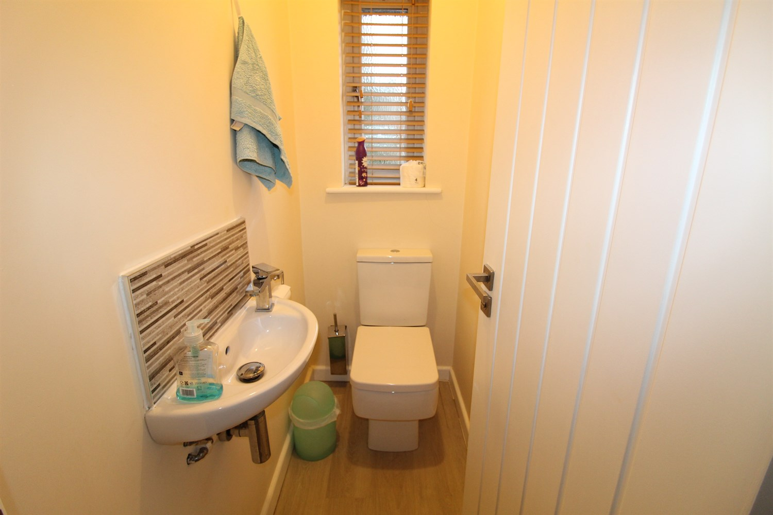
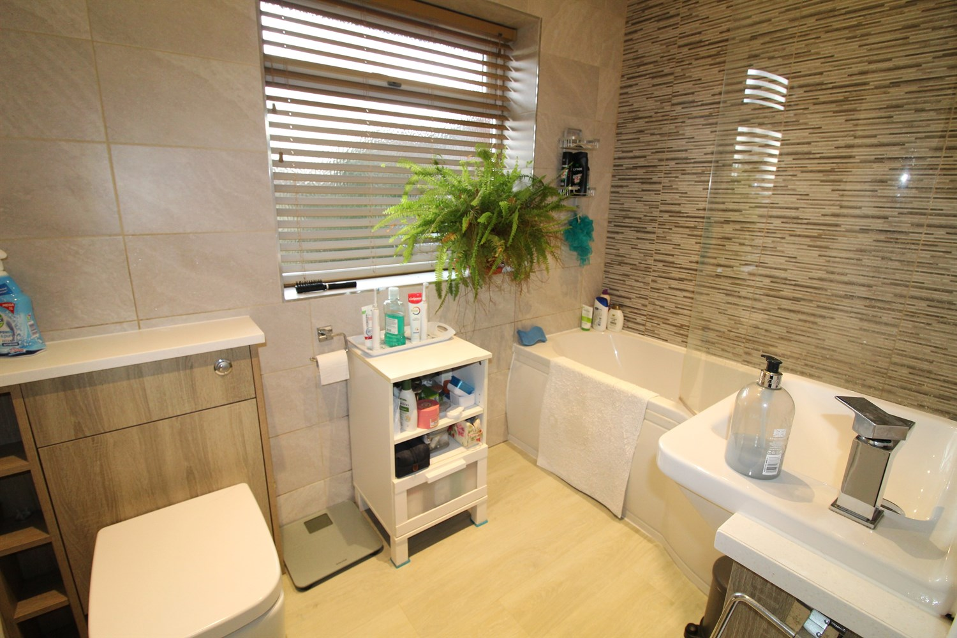
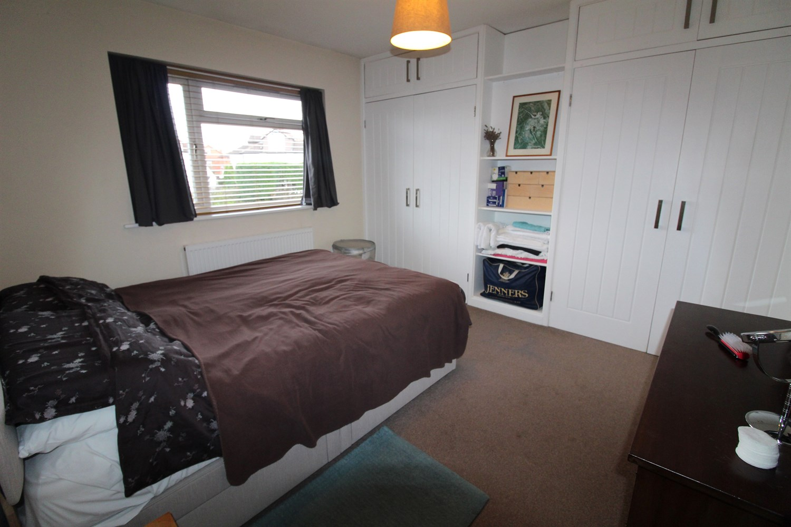
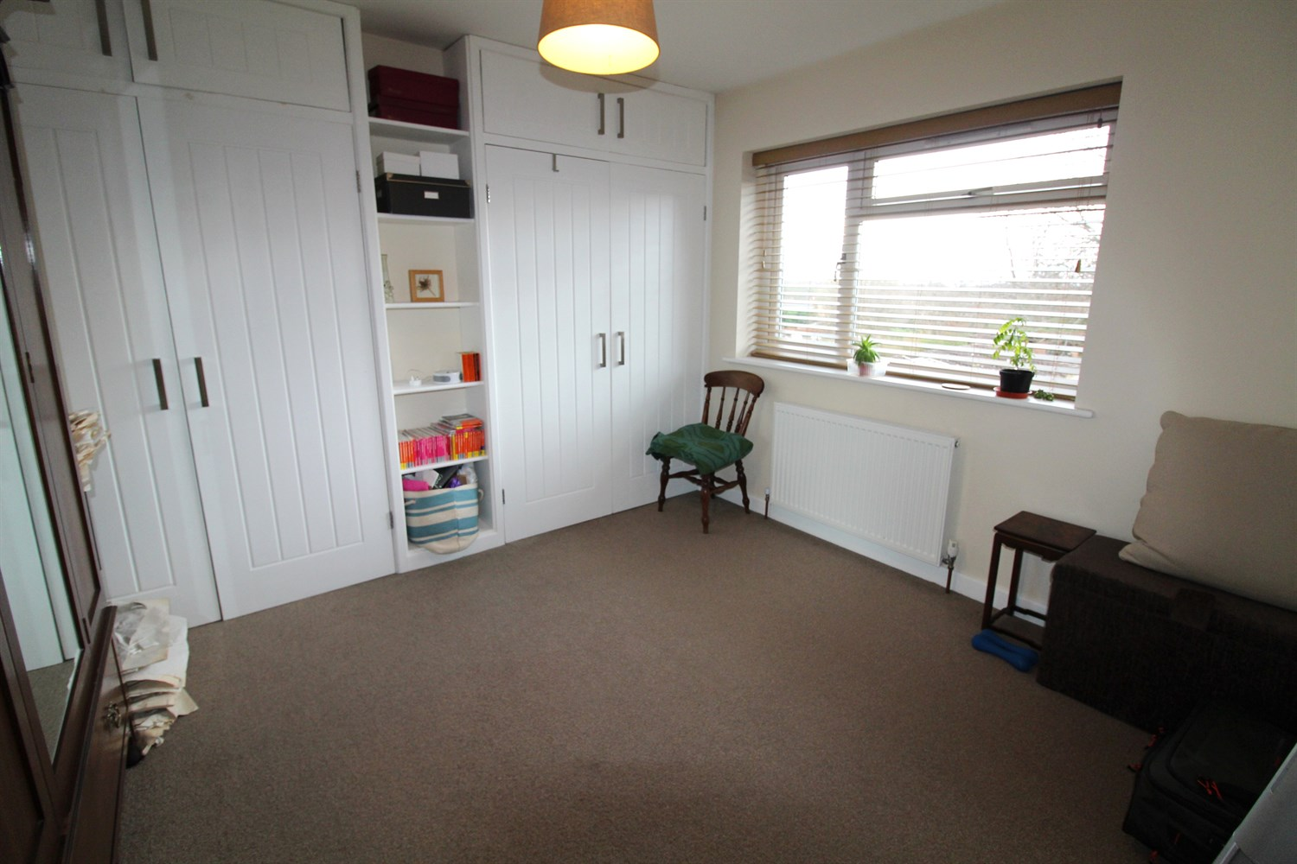
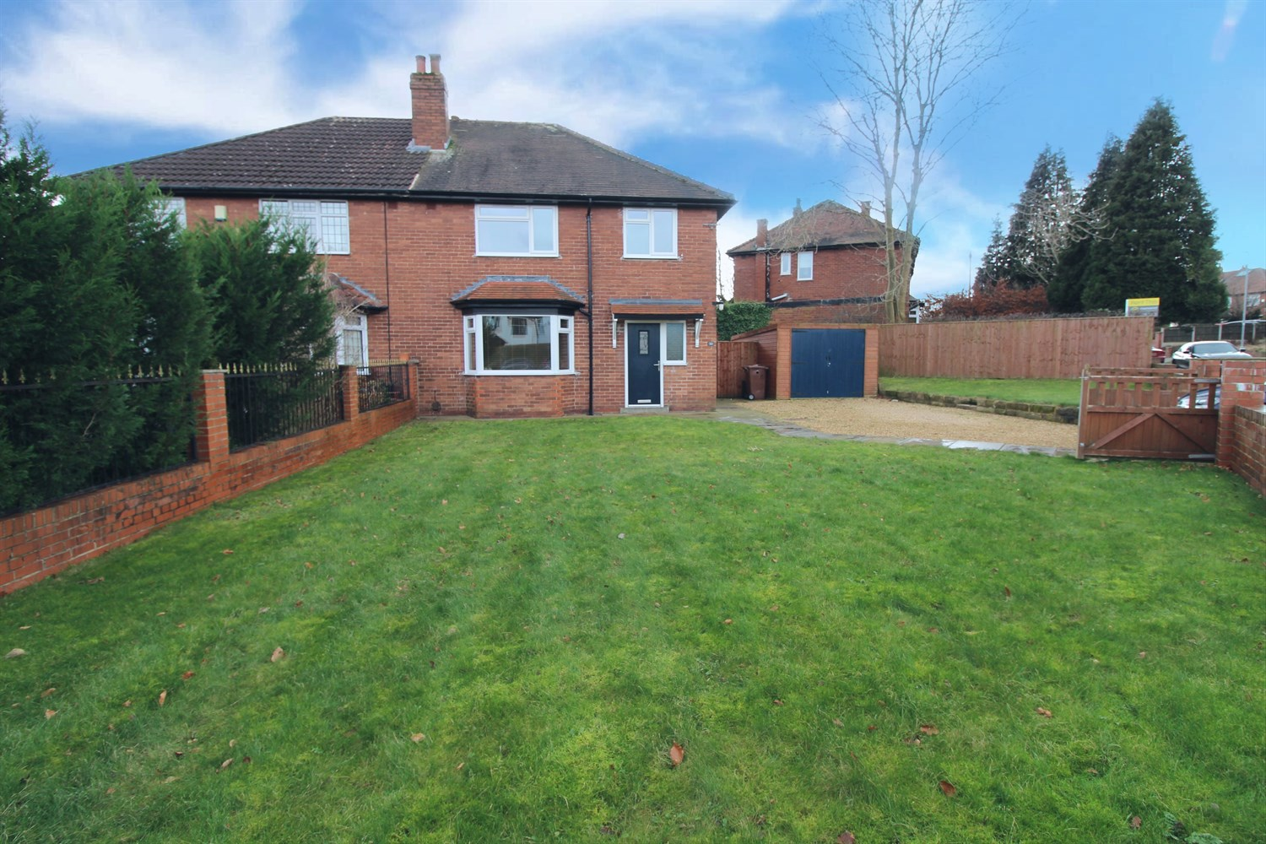
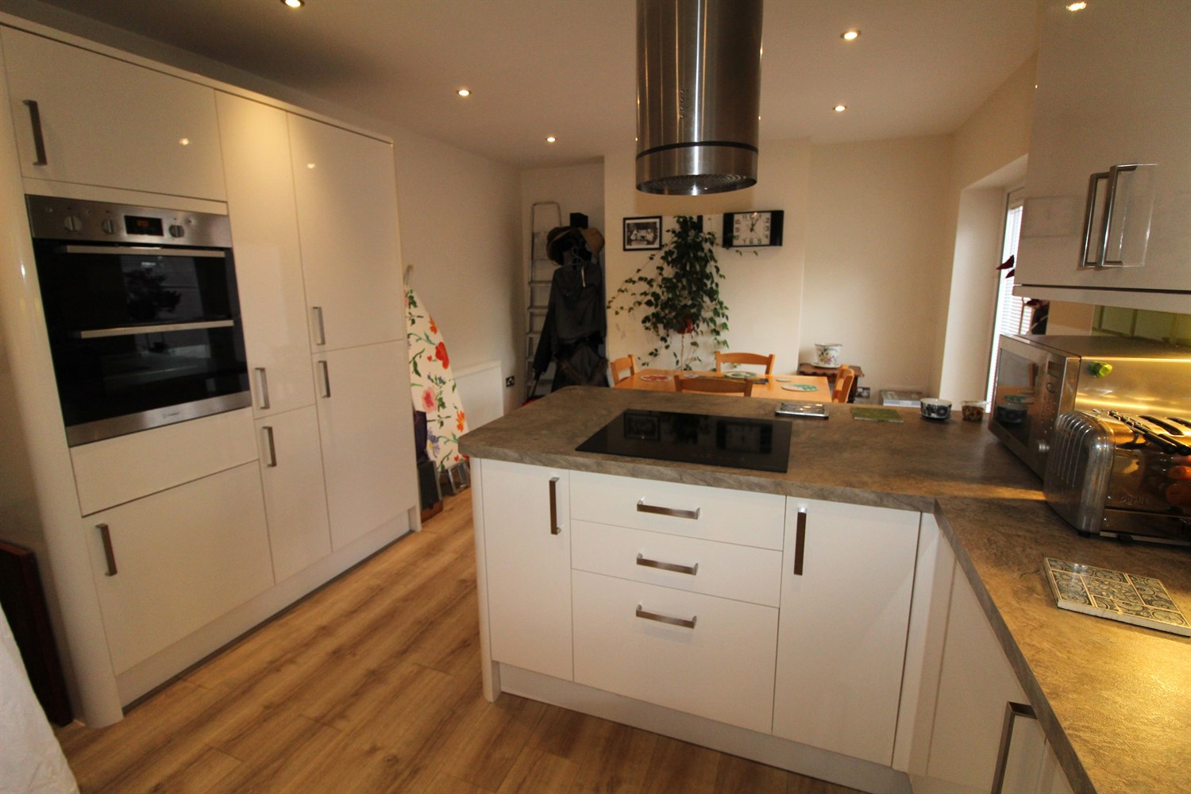
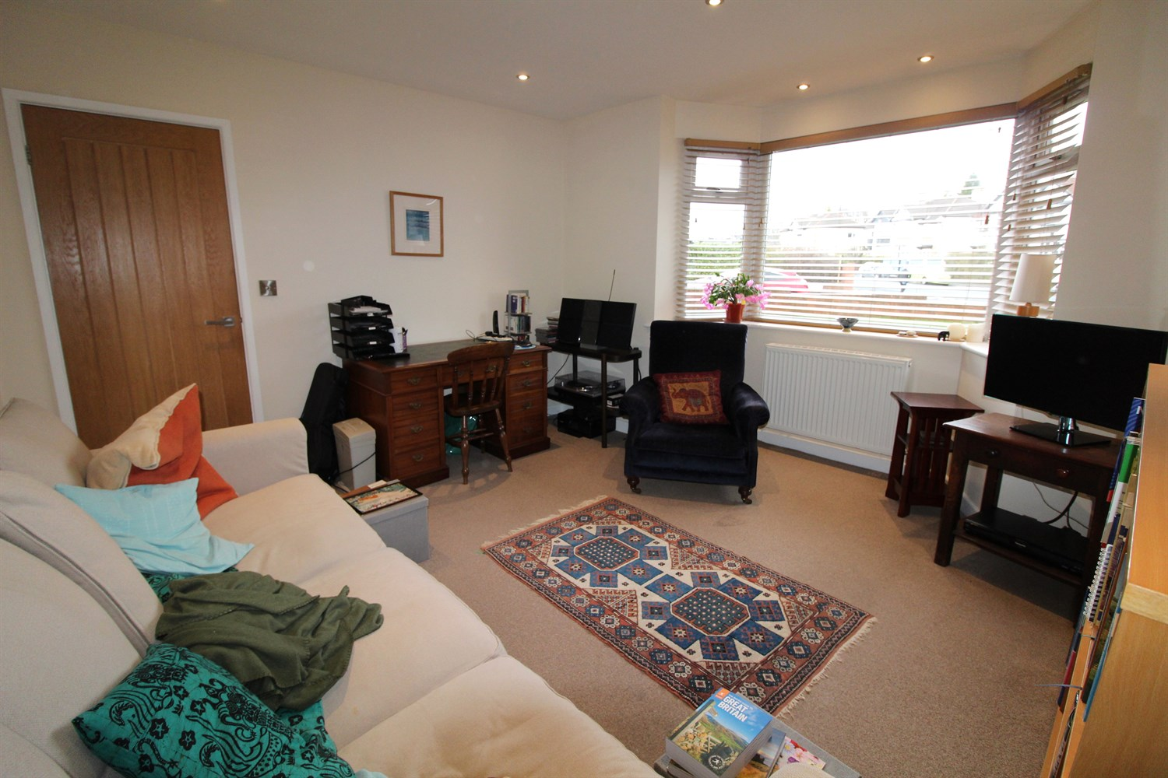
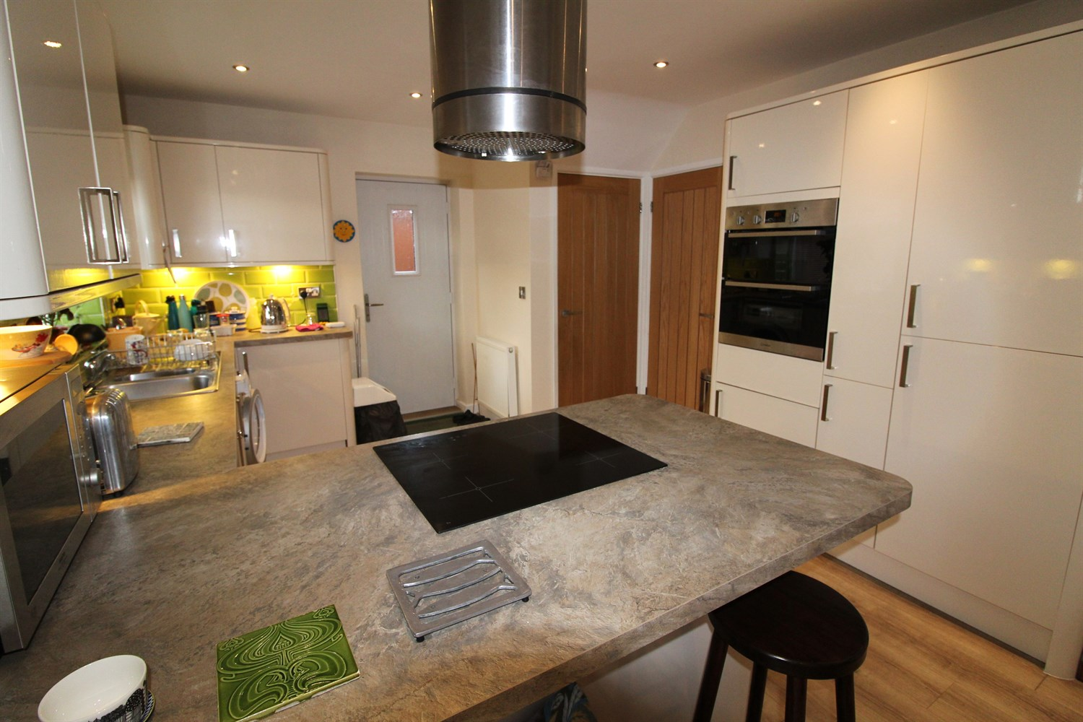

Entrance Hall
Via front entrance door. Gas central heating radiator. Stairs to first floor.

Lounge 4.2m (13'9) x 4.21m (13'10) Into Bay
Light and airy living area with uPVC double glazed bay window to front. Gas central heating radiator.

Open Plan Kitchen/Diner 6.29m (20'8) Max x 3.53m (11'7)
Fitted with a range of wall base and drawer units with worktops over. 1.5 bowl stainless steel sink with mixer tap. 4-ring induction hob with cylinder island cooker hood over. Space for washing machine. Integrated double oven. Integrated fridge/freezer. Storage cupboard. Inset ceiling spotlights. uPVC double glazed door to side. To the dining area there is uPVC double glazed patio doors to the rear garden. Gas central heating radiator.

First Floor

Bedroom 1 3.63m (11'11) x 3.48m (11'5)
Double bedroom with uPVC double glazed window to front. Gas central heating radiator. Built in wardrobes.

Bedroom 2 3.29m (10'10) x 3.44m (11'3)
Second double bedroom with uPVC double glazed window. Built in wardrobes. Gas central heating radiator.

Bedroom 3 3.43m (11'3) x 2.63m (8'8) Max
Third bedroom with uPVC double glazed window to front. Gas central heating radiator. Built in cupboard.

Bathroom
Fitted with a three piece suite comprising; bath with shower above, vanity washbasin and WC. Tiled walls. Wall mounted heated towel rail.

Guest WC
Fitted with a WC and wash hand basin. uPVC double glazed window.

Outside
To the front on the property is a driveway leading to a detached garage useful for storage. To the front of the property is a good sized enclosed lawned garden and a low maintenance courtyard style garden to the rear.
Council Tax Band - C

These particulars are intended to give a fair description of the property, but their accuracy cannot be guaranteed, and they do not constitute an offer of contract. Intending purchasers must rely on their own inspection of the property. None of the above appliances/services have been tested by ourselves. We recommend purchasers arrange for a qualified person to check all appliances/services before legal commitment.  Property Ref: 972  For more information, please contact  0113 258 1150 | sales@adairpaxton.co.uk | www.adairpaxton.co.uk | 