Tinshill Road, Cookridge
For Sale £700,000.00

***IMPRESSIVE FIVE BEDROOM DETACHED HOUSE IN SOUGHT AFTER LOCATION*** Offered to the market in this delightful location, set back from Tinshill Road and within comfortable walking distance to Horsforth train station, this property simply must be viewed to be appreciated. Finished to an exceptional standard throughout, the property is ready to move in to and boasts well proportioned rooms throughout. The property is situated in a quite cul-de-sac and Internally the property comprises: entrance hall, living room, open plan kitchen/diner, utility, guest cloakroom and integral double garage to the ground floor. To the first floor there are five bedrooms, en-suite bathroom to the master bedroom and a further house bathroom. Externally the property has a driveway to the front. To the rear of the property is an enclosed garden offering a great deal of privacy. The garden has been mainly laid to lawn with borders of shrubs and plants. There are also two patio areas ideal for entertaining. This is an ideal family home and we strongly recommend an internal viewing.
0113 258 1150
0800 000 000
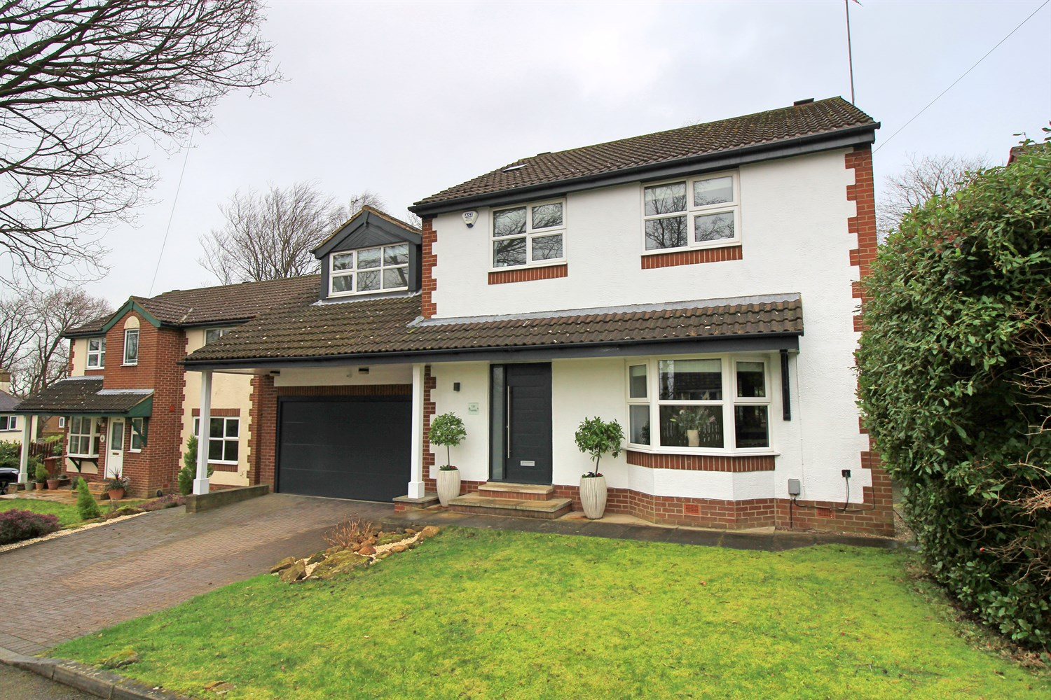
2 Reception(s)
2 Bathroom(s)
5 Bedroom(s)
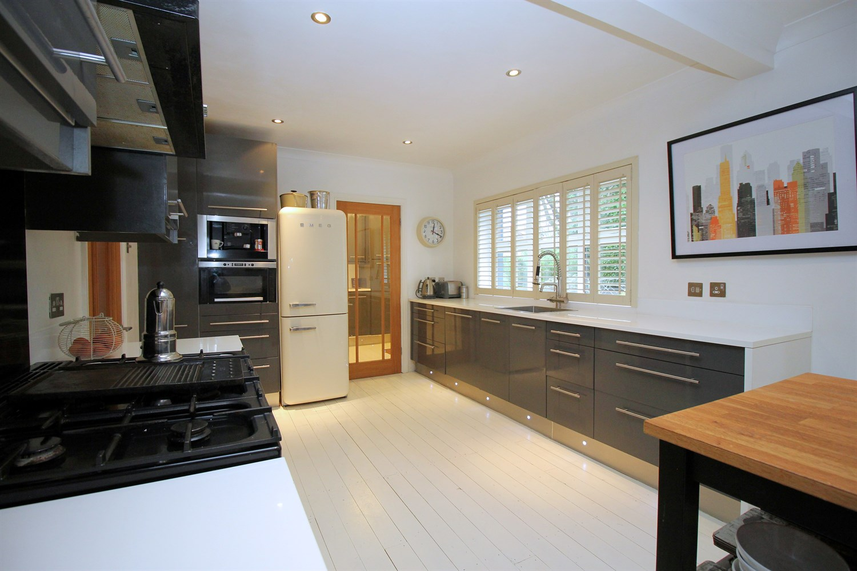
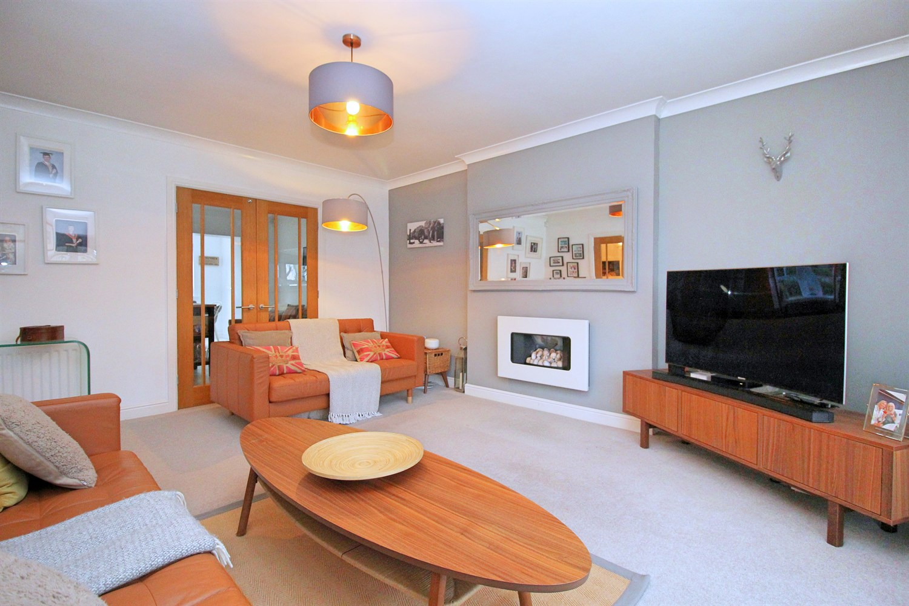
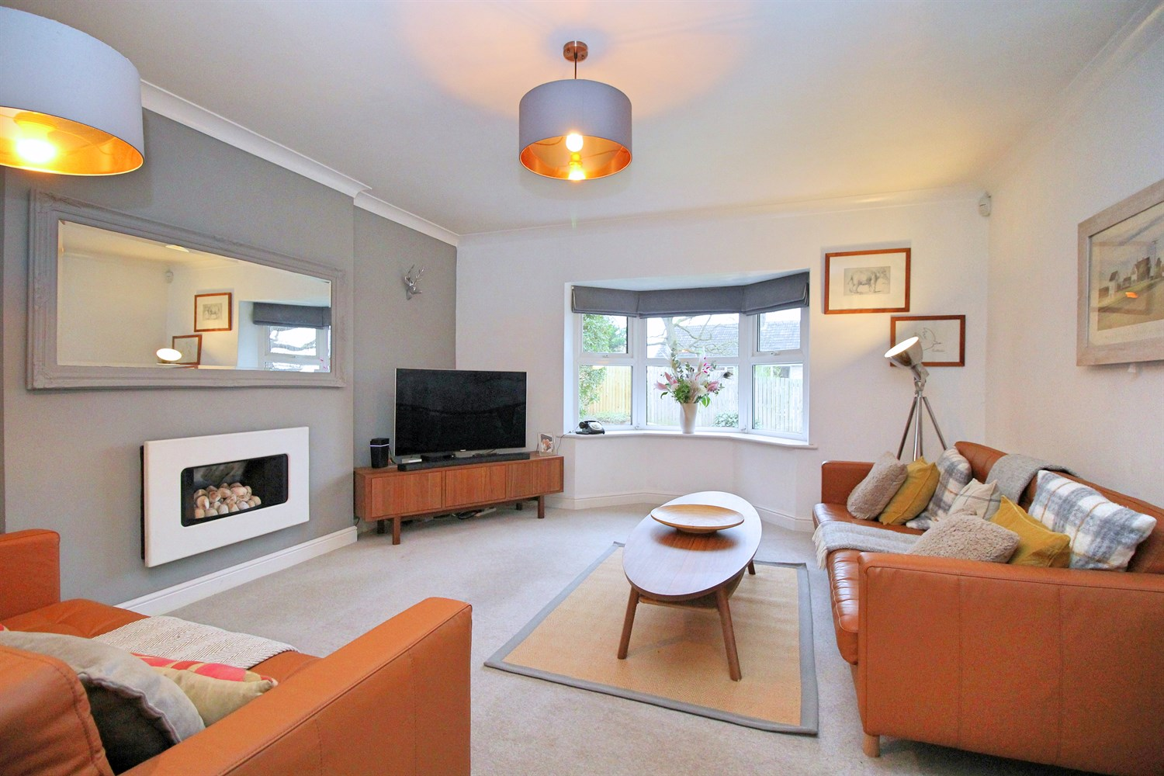
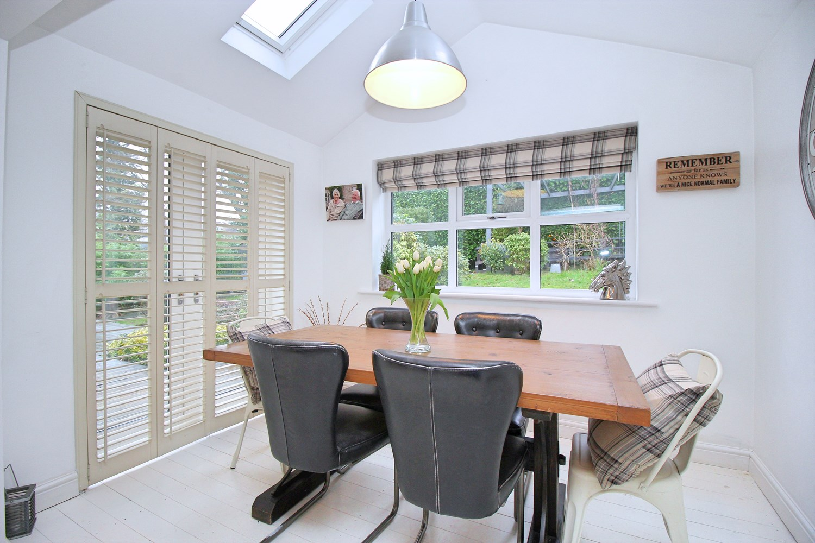
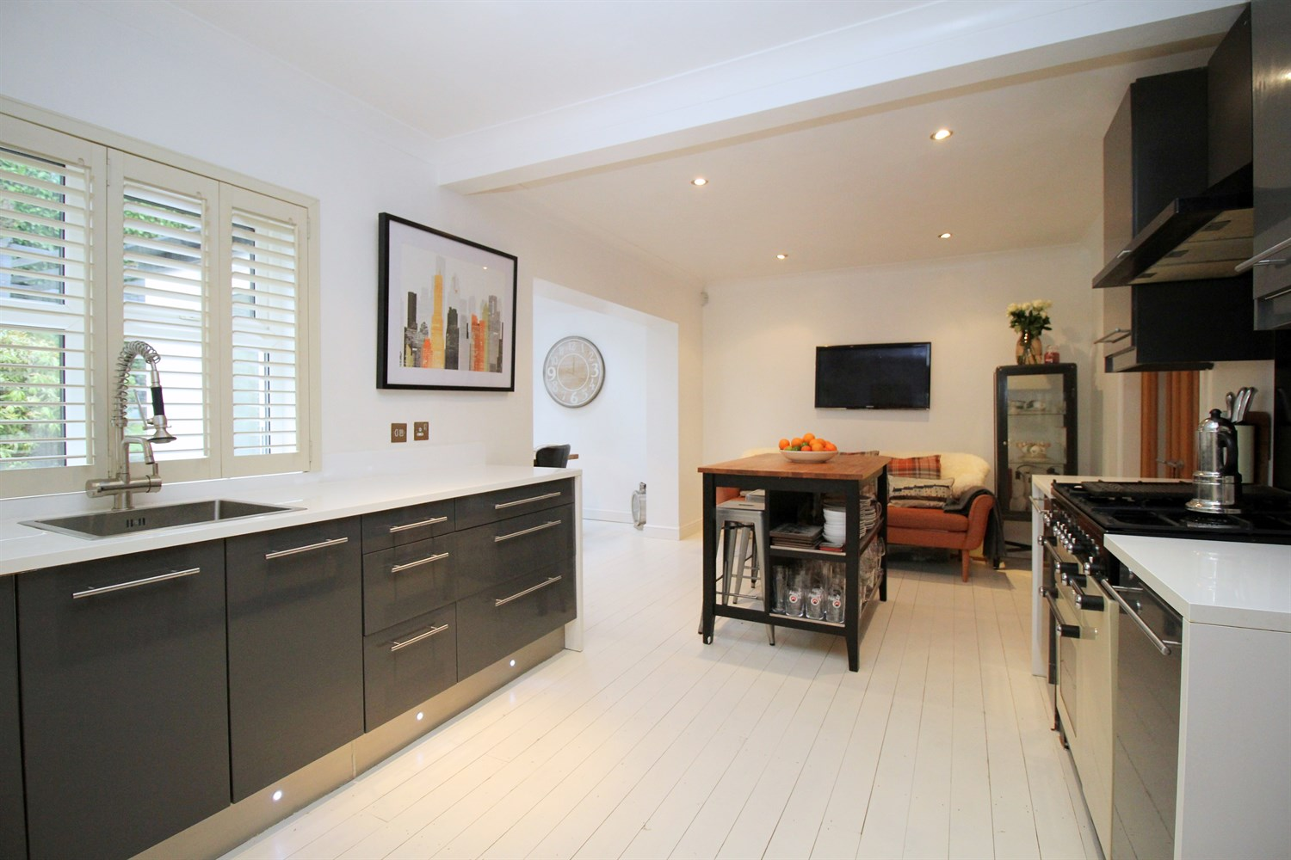
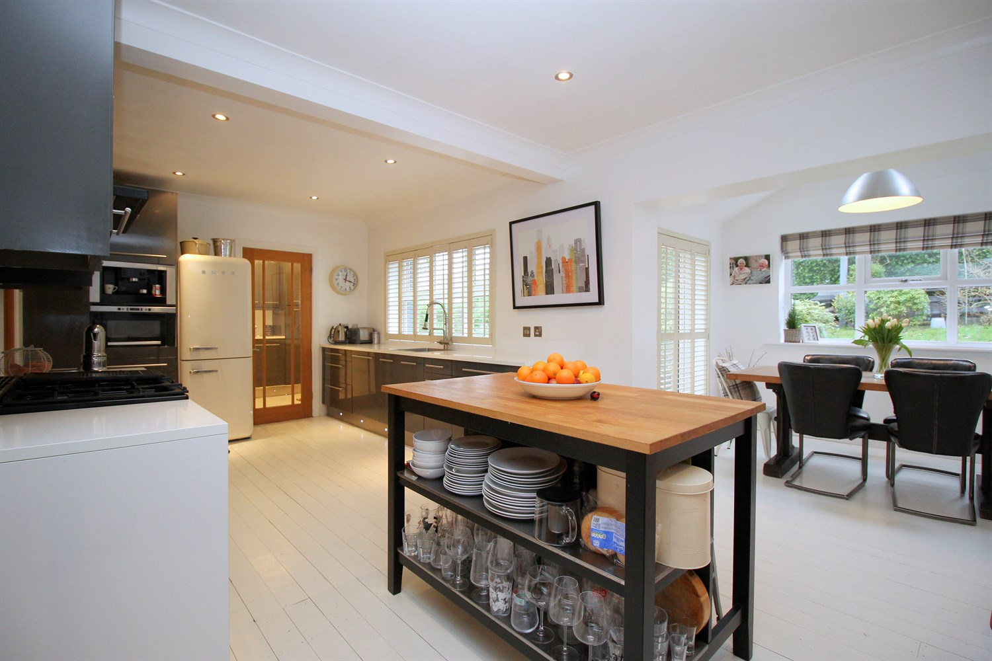
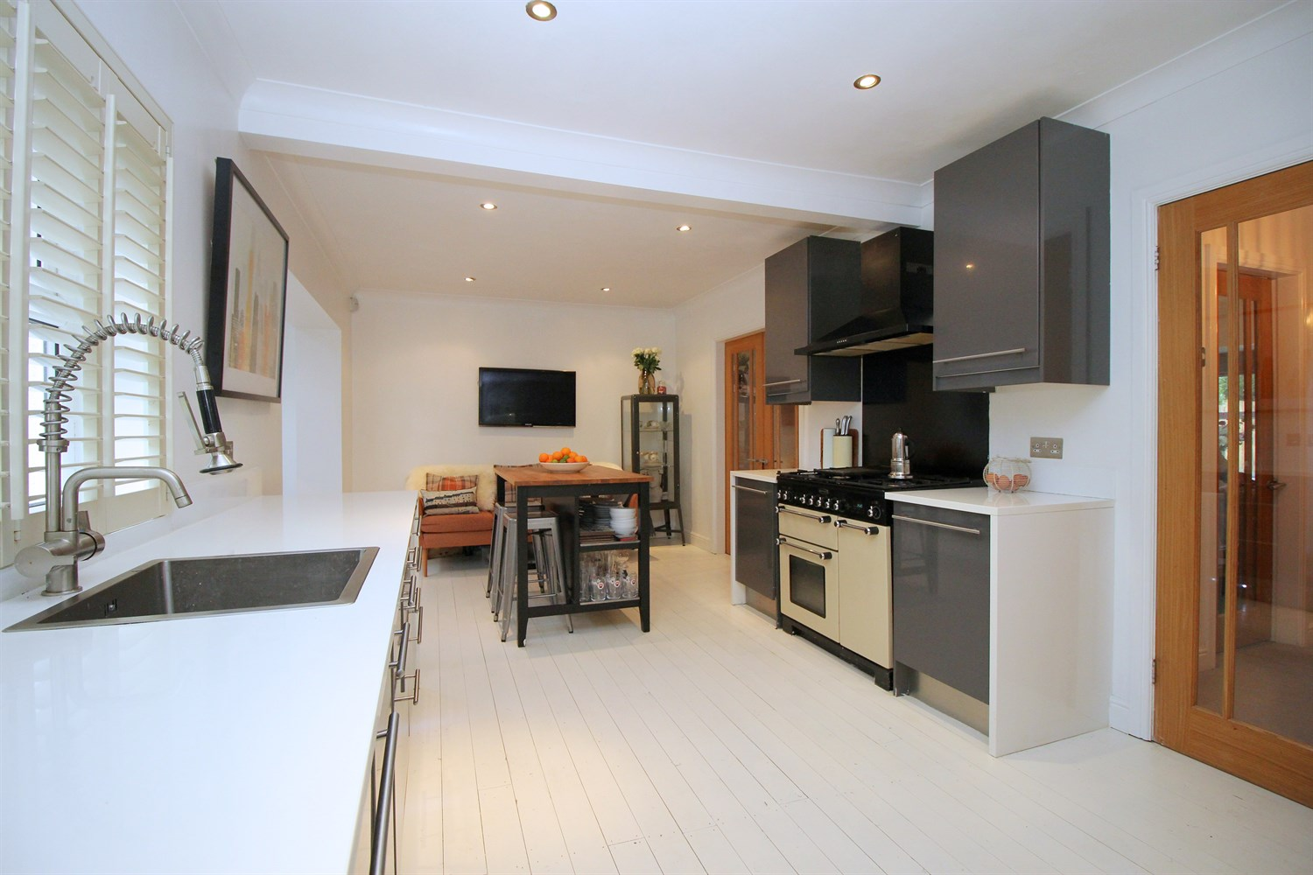
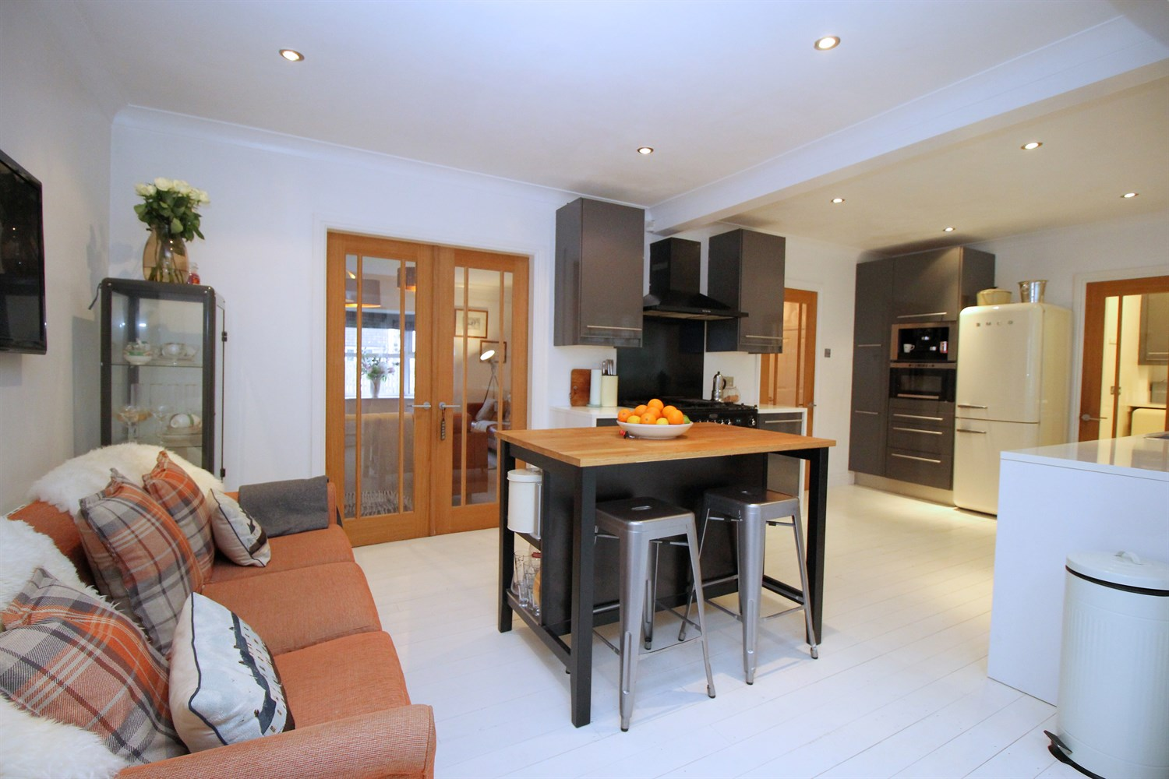

Entrance Hall
Via front entrance door. Stairs to first floor. Gas central heating radiator. Under stairs storage cupboard.

Downstairs WC
Guest WC comprising; WC and wash hand basin.

Living Room 4.2m (13'9) x 4.72m (15'6)
Light and Airy living area with uPVC double glazed bay window to front. Gas central heating radiator. Inset gas fire to chimney breast. Double doors leading to the kitchen/Diner.

Kitchen 6.63m (21'9) x 3.18m (10'5)
Fitted with a range of wall, base and drawer units with worktops over. Integrated dishwasher, coffee machine and microwave. Space for fridge/freezer and Range cooker with extractor hood over. Deep single bowl sink with mixer tap. Inset ceiling spotlights. uPVC double glazed window to rear.

Utility Room
Matching units to the kitchen. Plumbed for washing machine. Door to the garage. uPVC double glazed door leading to the rear garden.

Dining Area 3.02m (9'11) x 2.25m (7'5)
Opening from the kitchen area, boasting ample light via two Velux windows, uPVC double glazed window to rear and uPVC double glazed double doors to the rear garden.

Master Bedroom 4.92m (16'2) x 4.42m (14'6)
A spacious double bedroom with uPVC double glazed window to front. Gas central heating radiator. Door to ensuite shower room and walk in wardrobe.

En-Suite Shower Room
Fitted with a three piece suite comprising; shower cubicle, WC and vanity wash hand basin. Velux window.

Walk In Wardrobe
Walk in wardrobe with Velux window.

Bedroom 2 3.26m (10'8) x 4.46m (14'8)
Second double bedroom with uPVC double glazed window to front. Gas central heating radiator.

Bedroom 3 3.23m (10'7) x 3.02m (9'11)
Third double bedroom with uPVC double glazed window to front. Gas central heating radiator.

Bedroom 4 2.14m (7'0) x 3.44m (11'3)
Bedroom with uPVC double glazed window to rear. Gas central heating radiator.

Bedroom 5 2.06m (6'9) x 2.36m (7'9)
Bedroom with uPVC double glazed window to rear. Gas central heating radiator.

House Bathroom
Fitted with a three piece white suite comprising; bath with shower over, WC and wash hand basin. Tiled walls. uPVC double glazed window to rear.

Outside
To the front of the property is a driveway offering off street parking. To the rear of the property is an enclosed garden offering much privacy. The garden has been mainly laid to lawn with borders of shrubs and plants. A decked area and patio area with pergola to the rear of the garden offers great space for outdoor entertaining.

Integral Garage
An integral double garage with light, power and ample storage. Access via an electric front door or via the utility room.

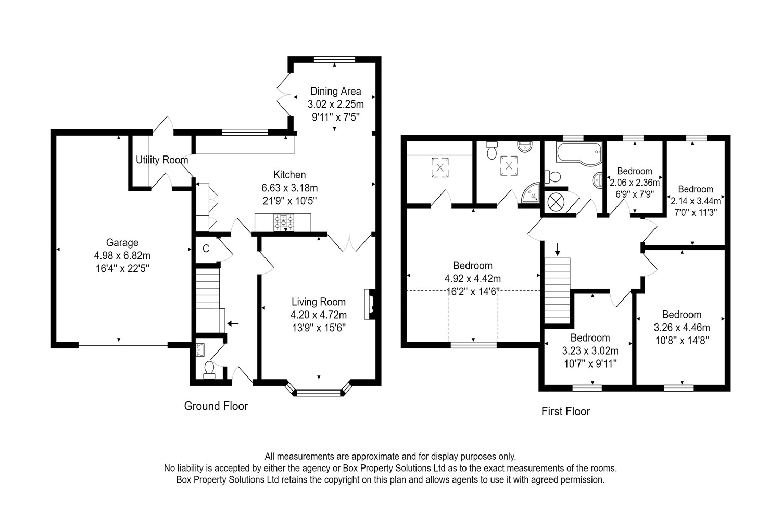

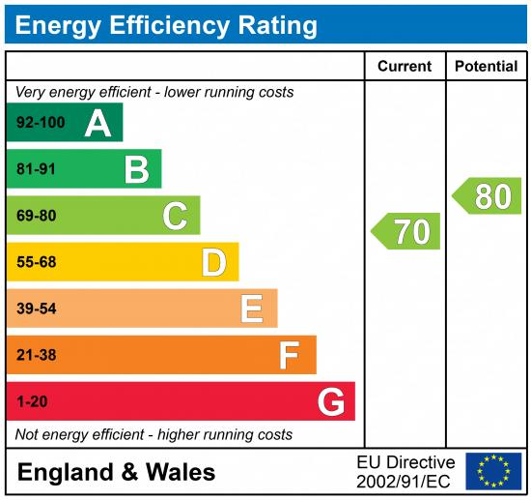

These particulars are intended to give a fair description of the property, but their accuracy cannot be guaranteed, and they do not constitute an offer of contract. Intending purchasers must rely on their own inspection of the property. None of the above appliances/services have been tested by ourselves. We recommend purchasers arrange for a qualified person to check all appliances/services before legal commitment.

Property Ref: 980

For more information, please contact

0113 258 1150 | sales@adairpaxton.co.uk | www.adairpaxton.co.uk

